 | ACTIA Automotive | XT018-F
 | MEMO | Page 1 / 4

VIII.3 Bis Send/Receive ISOTP frame

ISOTP frame is a protocol allows be useful for the transport of messages that exceed the eight bytes maximum payload of CAN frames.

→ We need 2 interfaces :
Indeed, we need to check if the frames that we are sending are well received and if there is no missing element.
Here is how it works :
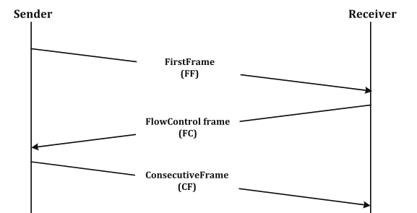

FlowControl is used to adjust the sender to the network layer capabilities of the receiver.

Bring CAN1 and CAN2 interface up @ 500kbps
ip link set up can0 type can bitrate 500 000
ip link set up can1 type can bitrate 500 000

Start isotp server
isotprecv -s 701 -d 700 can1 -z 9

→ isotprecv allows to receive only data
→ we can't see interface name, Id, data length
→ But we can use candump or wireshark to see the entire frame

Interconnect CAN1 and CAN2 buses and run:
isotpsend -s 700 -d 701 can0 -z 9 -D 16

→ This function allows to send different frames (one by one) with bytes length better than 8 bytes
Options :
- -z : portnbr → we have to change protocol number / basic it's CAN_RAW (RAW socket)
- -D : len → send a fixed PDU with len bytes from 1 to 4095 bytes (advantage of isotp)

If you're using the two previous orders, the expected result is :
Test
01 02 03 04 05 06 07 08 09 0A 0B 0C 0D 0E 0F 10 | OK

Now, we want to send several frames, so we'll use the other function : Isotpgen

What is the difference between isotpsend and isotpgen ?
- Send looped frames
- With different size of data ( Incremented or random)
- Data can changed (Incremented or random too)

But the composition of the frames differs from can frames , see Norme iso_15765 :

List of protocol control information (PCI) :
- Message of seven bytes or less : sent in a single frame
- Message longer than 7 bytes : requires segmenting the message over multiple frames

Can0 700 [8] 10 0F 01 02 03 04 05 06
Can0 701 [8] 30 00 00
Can0 700 [8] 21 07 08 09 0A 0B 0C 0D
Can0 700 [8] 22 0E 0F

Start isotp server
isotprecv -s 701 -d 700 can1 -z 9

Interconnect CAN1 and CAN2 buses and run:
isotpgen -s 700 -d 701 can0 -z 9 -D i -T i

The purpose of this application is to check if when we send message longer than 7 bytes, the receiver transcribe well the frame.
Namely, we have to know if there is a segmented transfer starts with a First Frame
Isotprecv makes it possible to if the flow control is clear , if the transfer is allowed.

We have different options for this function : See below
- -D : send PDU with len bytes
    - : enter a number 1<nbr<4095
    - 'i' : incremented length
    - 'r' : random length

- -T : Data (payload) generation mode
    - 'i' : incremented data
    - 'r' : random data

We can juggle between the different options
isotpgen -s 700 -d 701 can0 -z 9 -D r -T I
isotpgen -s 700 -d 701 can0 -z 9 -D 4095

Expected result with isotpgen -s 700 -d 701 can0 -z 9 -D i -T i | Test
01  02 00  03 00 00  04 00 00 00  05 00 00 00 00  06 00 00 00 00 00  07 00 00 00 00 00 00  08 00 00 00 00 00 00 00  09 00 00 00 00 00 00 00 00  0A 00 00 00 00 00 00 00 00 00 | OK

With a sniffer like candump , for the same command :

Expected result with isotpgen -s 700 -d 701 can0 -z 9 -D i -T i | Test
can0 700 [3] 01 01  can0 700 [3] 02 02 00  can0 700 [4] 03 03 00 00  can0 700 [5] 04 04 00 00 00  can0 700 [6] 05 05 00 00 00 00  can0 700 [7] 06 06 00 00 00 00 00  can0 700 [8] 07 07 00 00 00 00 00 00  can0 700 [8] 10 08 08 00 00 00 00 00  can0 701 [3] 30 00 00  can0 700 [3] 21 00 00  can0 700 [8] 10 09 09 00 00 00 00 00  can0 701 [3] 30 00 00  can0 700 [4] 21 00 00 00  can0 700 [8] 10 0A 0A 00 00 00 00 00  can0 701 [3] 30 00 00  can0 700 [5] 21 00 00 00 00 | OK

Explanation :

As soon as, the message is longer than 7 bytes, we could see the first frame with the data length.
Then we have, the flow control frame from the receiver (701). And the consecutive frame (with a loop from 21 to 2F )

