Mick Scanlon Final Project

User Manual –

* To run the application as I have you must download eclipse EE for Enterprise developers.
* From there, find import in the file menu.
* Then select existing maven projects and find where you’ve saved the unzipped MickScanlon-FinalProject.
* Once imported go to com.restaurant.advisor and right click RestaurantAdvisorApplication.java.
* Select run as java application then find in the console which port it is running on. (Mine was typically 8080)
* In your browser, navigate to localhost:8080/**restaurantlogin.html** where the user flow begins.
* Once logged in follow description in home.html to use site.

Technical Accomplishments –

* Streamlined many page transitions for minimal down time and increased user experience.
* Made use of mybatis annotations for easy and efficient SQL queries.
* Displays are concise and readable.
* Implemented multiple thymeleaf forms that are easy to use and efficient.

Project Legacy –

* I’ve created an application that can draw from a live database to display Information as well as insert new information into the tables of that database. Created an html site that is connected and easily navigated within both static and template html formats.
* I’ve gained skills working with html and SQL. As well as grown to be a more avid tester of my code.

Future accomplishments –

* Given more time I’d certainly want to update the UI of the site and give it a little more life.
* Users could login but I did not implement a way for their emails to be saved so it is currently more like an authentication then a profile login. I’d like to find a way to save user preferences as well as their identity in the future.

Appendix –

* I worked alone and accomplished everything on my own.

Test cases

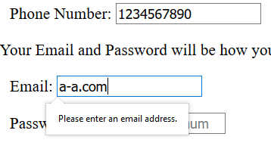

* Prevents invalid Phone and Email format
* Can’t really screenshot it but prevents using the back key after logout
* Fails to prevent direct access of other pages without login (typing /home.html bypasses login)

* Requires a rating between 1 and 5
* Wherever restID is required it must match a 4 digit number but if invalid is entered it just displays an empty menu