

**User’s Manual**

**AFMS Online Onboarding Learning Resource**

**Team Parrots**

**December 2019**

**Revision Sheet**

|  |  |  |
| --- | --- | --- |
| **Version No.** | **Date** | **Revision Description** |
| **Rev. 0** | **12/8** | **Initial User’s Manual** |
| **Rev. 1** | **12/10** | **Edit based on Effective Writing Tips** |
|  |  |  |
|  |  |  |

User’s Manual

Table of Contents

## Section Title Page Number

1. General Information………………………………………………………………………………….5
   1. System Overview……………………………………………………………………………6
   2. Project References…………………………………………………………………………..6
   3. Authorized Use Permission…………………………………………………………………6
   4. Point of Contact…………………………………………………………………………......7
   5. Information………………………………………..……....…..…………….……………….7
      1. Coordination…………………………………………………………....……….7
      2. Help Desk……………………………………………………………………….7
   6. Organization of the Manual…………………………………………………………………7
   7. Acronyms and Abbreviations……………………………………………………………….7
2. System Summary…………………………………………………………………………………….8
   1. System Configuration……………………………………………………….………………9
   2. Data Flows……………………………………………………………………………………9
   3. User Access Levels……………………………………………………….…………………9
   4. Contingences and Alternate Modes of Operation……………………..…………………9
3. Getting Started………………………………………………………………………………………10
   1. Logging In……………………………………………………………...……………………11
   2. Navigation Bar…………...…………………………………………………………………11
   3. Homepage……………………………………………………………………..……………12
   4. Logging Out…………………………………………………………………………………13
4. Using the System Online………………………………………………………..…………………14
   1. Take a Quiz…………………………………………………………………………………15
      1. Pre-Quiz Page…………………………………………………………………15
         1. Taking a Quiz Interface………………………………………………16
         2. Questions and Answers…………..…………………………………16
         3. Display Correct Answers……………….……………………………17
      2. Results………………………………………….………………………………17
   2. Create a Quiz……………………………………………….………………………………18
      1. Create a Quiz Manually………………………………………………………18
         1. New Quiz Information………………………………………..………18
         2. Quiz Overview……………………………………………………...…19
         3. Add Question………………………………………………………….19
            1. MC………………………………………………………...20
            2. SATA……………………………………………………..20
            3. FR…………………………………………………………21
         4. Edit Quiz Information…………………………………………………21
         5. Adding Quiz Subjects………………………………………………..22
      2. Upload a Quiz…………………………………………………………………22
   3. Manage a Quiz………………………..……………………………………………………22
      1. Edit Quiz………………….……………………………………………………23
         1. Quiz Overview………..………………………………………………23
         2. Editing Questions……………….……………………………………24
         3. Deleting Questions………………………..…………………………24
         4. Adding Questions…………………………………….………………24
         5. Edit Quiz Information…………………………………………………24
         6. Edit Quiz Subjects……………………………………………………25
      2. Toggle Visibility………………………………………………………………..25
      3. Delete…………………………………………………………………………..25
   4. Mentor……………………………………………………………………………………….25
      1. View User………………………………………………………………………26
         1. Viewing the User……………………………………………………..26
            1. Viewing User Metrics……………………………………26
            2. Change User Password……...…………………………27
            3. Deleting User………………….…………………………27
            4. Change User Privilege……………….…………………27
         2. Creating a User………………………………………………….……28
      2. Metrics………………………………………………………………………….28
      3. Manage Subjects……………………………………………………………...28
         1. Deleting Subjects……………………………………………………..28
         2. Creating Subjects…………………………………………………….28
   5. User Options………………………………………………………………………………..29
      1. My Grades……………………………………………………………………..29
      2. My Quizzes…………………………………………………………………….29
      3. Logout…………………………………………………………………………..29

1.0 General Information

1. **General Information**
   1. **System Overview**

This system is:

* A system designed to quiz the user to test their knowledge on concepts and material.
  + Allows an administrator, who we will now refer to in this manual as the “mentor”, or a user, which we will now refer to in this manual as the “employee”, to upload new keywords, technology, concepts, or other material specific to a functional area within AFMS.
  + Allows mentors and employees to take quizzes that have been created
  + Records performance on quizzes taken by users
* A Web-based system, which can be accessed and utilized on a Web browser.
* System Name: AFMS Online Onboarding Learning Resource
* System category:
  + *Major application*: performs clearly defined functions for which there is a readily identifiable security consideration and need
  + *General support system* provides general ADP or network support for a variety of users and applications
* Operational Status:
  + Partially Operational
  + Under Development
  1. **Project References**

References that were used in preparation of this document in order of importance to the end user.

<https://www.asrcfederal.com/terms>

* 1. **Authorized Use Permission**

The AFMS Online Onboarding Learning Resource is designed and created for the use of AFMS, and for their members’ use. This system provides information and services for the use of AFMS and ASRC. As a result, this system is subject to the following Terms of Use, unless we have provided those items to you under more specific terms.

ASRC provides their Terms and Conditions for the use of their websites on their webpage, which is provided below:

<https://www.asrcfederal.com/terms>

* 1. **Points of Contact**
     1. Information

The points of organizational contact (POCs) that may be needed by the document user for informational and troubleshooting purposes are currently not available.

* + 1. Coordination

The list of organizations that require coordination between the project and its specific support function (e.g., usage, security, etc.) are currently not available.

* + 1. Help Desk

Help desk information including responsible personnel phone numbers for emergency assistance is currently not available.

* 1. **Organization of the Manual**

This manual is structure to guide the user through the system. Each heading is meant to discuss and introduce a functionality the system provides, with each subheading being a part of that webpage or function.

The following headings list the main functions of this system:

1. General Information – provides general information
2. System Overview – provides
3. Getting Started – shows the user how to login and how to navigate the website
4. Using the System – provides a detailed overview of the functions the system provides
   1. **Acronyms and Abbreviations**

This manual uses several acronyms and abbreviations. This table explains what they are and what they stand for.

|  |  |
| --- | --- |
| **Term** | **Description** |
| MC | Multiple Choice questions |
| SATA | Select All that Apply questions |
| FR | Free Response questions |
| Mentor | Refers to the Administrator accounts |
| Employee | Refers to the Employee accounts |

2.0 System Summary

1. **System Summary**

This section provides a general overview of the system written in non-technical terminology. The summary should outline the uses of the system in supporting the activities of the user and staff

* 1. **System Configuration**

The AFMS Online Onboarding Learning Resource is a system that was built for online use. It features several webpages linked together with buttons and links. Each page has a navigation bar that simplifies navigating through the system.

* 1. **Data Flows**

Users are able to input information through the use of a mouse and keyboard. Forms can consist of checkable options, when provided, or text forms that take text input. Forms are typically submitted with clickable on-screen buttons.

* 1. **User Access Levels**

This system has three user access levels:

1. Guest – guests can able to access the login screen only
2. Employee – employee accounts may create and edit their own quizzes, and can view their grades, and may take quizzes.
3. Mentors – mentor accounts are able to manage all quizzes on the system, can look at the grades and performance of all users and are able to manage subjects and users.

3.0 Getting Started

1. **Getting Started**
   1. **Logging In**

A username and a password are required in order to log into the system. The username and password are provided to the user by a mentor.

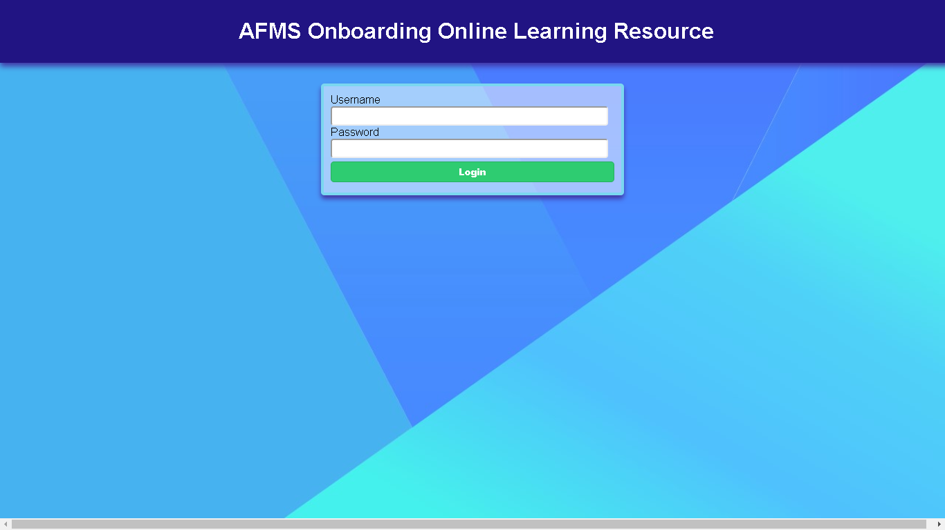

*Image of the login page*

The user must enter this information in their respective text areas. A login button will verify the information and redirect the user to the homepage. If the information provide is invalid, the browser will alert the user.

* 1. **Navigation Bar**

A majority of the pages contain the navigation bar, displayed below:

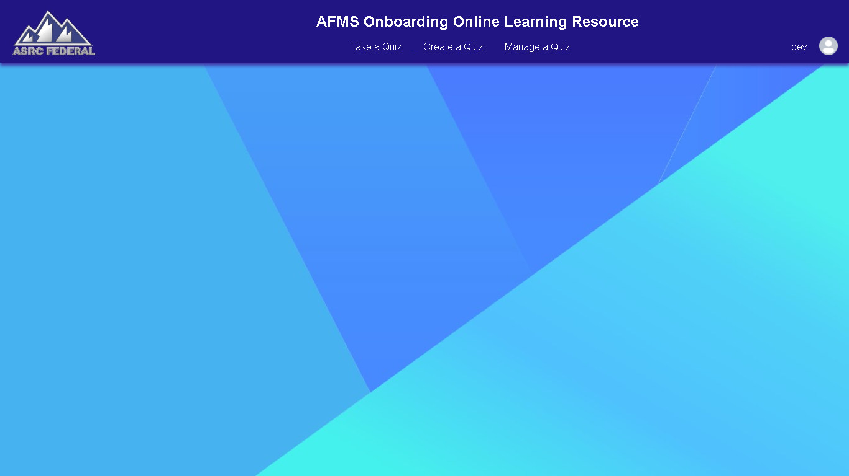

*Image of the navigation bar*

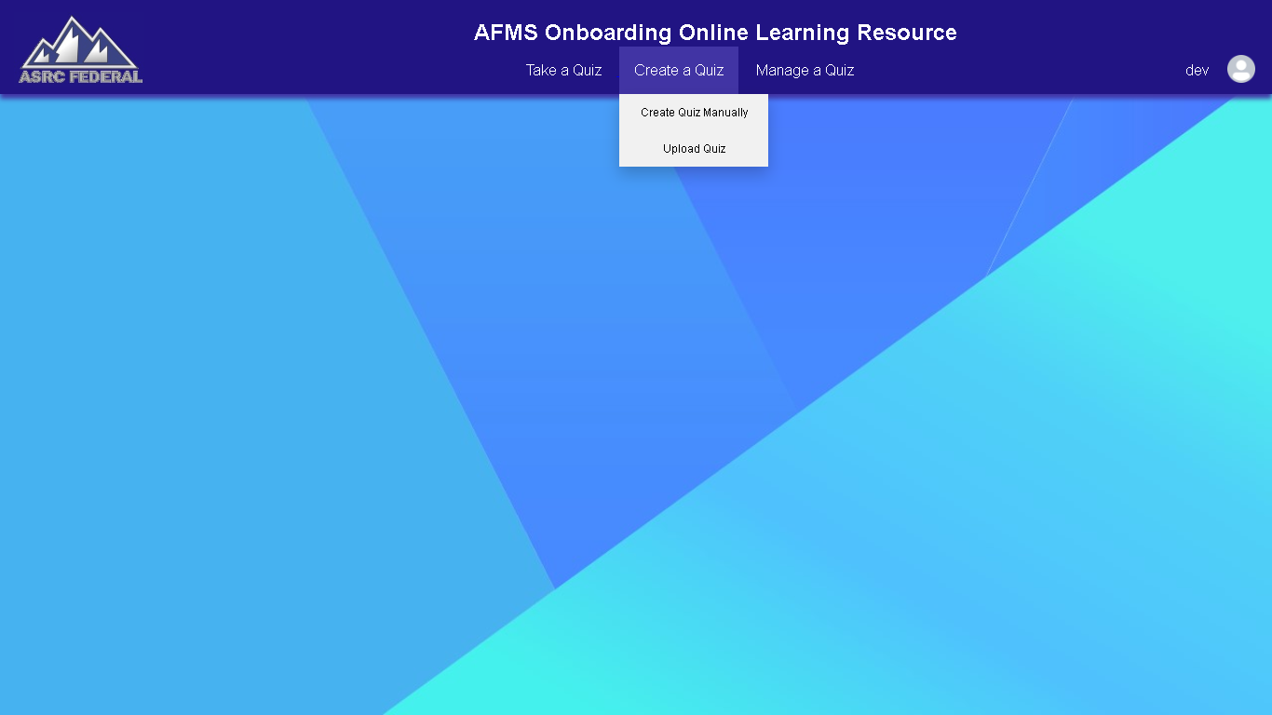The navigation bar has the ASRC Federal logo on the left side, which can also be clicked on to redirect the user back to the homepage from other pages.

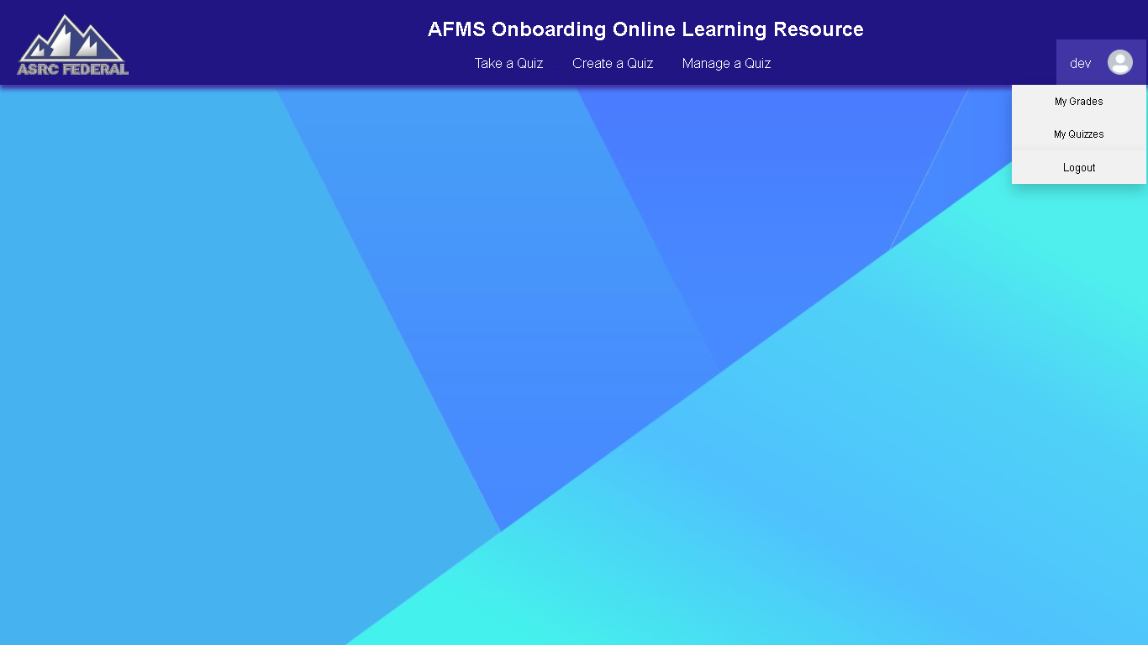

*Image displaying a dropdown menu Image displaying the user options*

The navigation bar consists of several hover-able buttons, in which some will display dropdown menus that allows users to navigate to pages they want to visit, as shown above.

On the right side of the navigation bar, there is an icon with the user’s username displayed (in this example, the user is “dev”), and hovering over will display user options, as shown above.

* 1. **Homepage**



*Image of the homepage*

The homepage consists of a navigation bar and other content to be displayed (In the example picture above, only the navigation bar and background are currently being displayed).

* 1. **Logging Out**

In the User Options dropdown menu, on the navigation bar, there is an option titled “Logout”. When a user selects this option, it will redirect the user to the login page, and end their session.

4.0 Using the System Online

1. **Using the System Online**

This section serves as a guide for the user once they have logged into the system.

* 1. **Take a Quiz**

When the user navigates to the Take a Quiz page, their screen should be similar to the one displayed below:

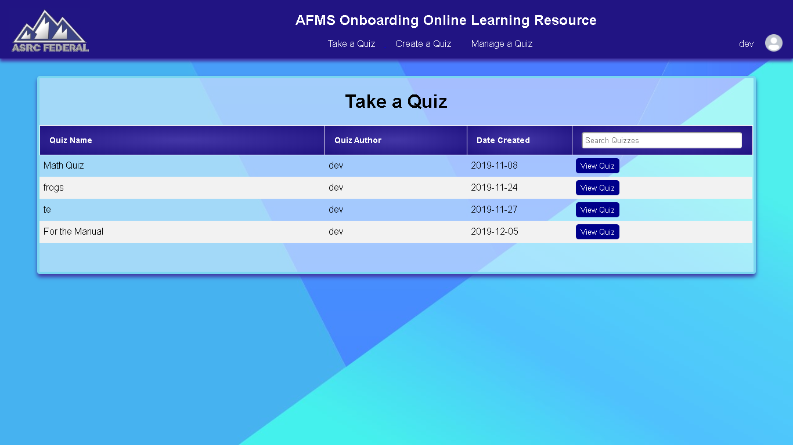

*Image of the Take a Quiz page*

This page displays a table of available quizzes that the user is allowed to take. Each quiz has a name, an author, date created, and a view quiz button. The table also has a search bar that filters out quizzes from the table by name.

* + 1. Pre-Quiz Page

When a user clicks the View Quiz button on one of the quizzes, they are redirected to the Pre-Quiz page. An example is shown on the next page.

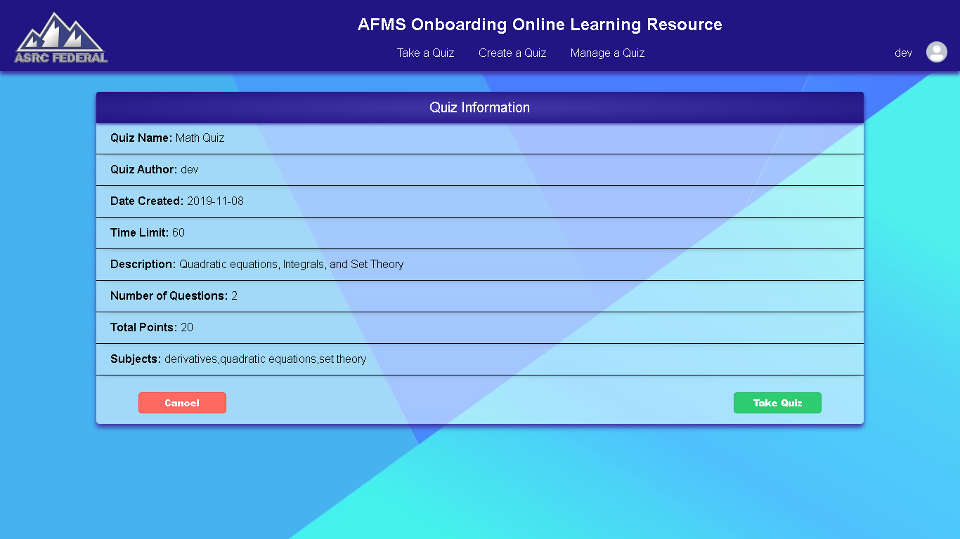

*Image of Pre-Quiz page for the Math Quiz*

This page displays the name, author, date created, of the quiz. It also displays the time limit in minutes, description, number of questions, total number of points, and the subjects that are associated with the quiz.

On the bottom, the user can select to cancel the selection, which would bring them back to the Take a Quiz page, or to take the quiz, which lets them take the quiz.

* + 1. Taking A Quiz Interface

Taking a quiz is split into 2 sections: Questions and Answers and Displaying the Correct Answer.

* + - 1. **Questions and Answers**

There are 3 types of questions in this system, currently: MC, SATA, and FR. Each question can be only one type at a time.

MC questions have only one answer, SATA questions can have one or more answers, and FR question can have a word or line as an answer.

Examples are shown on the next page.

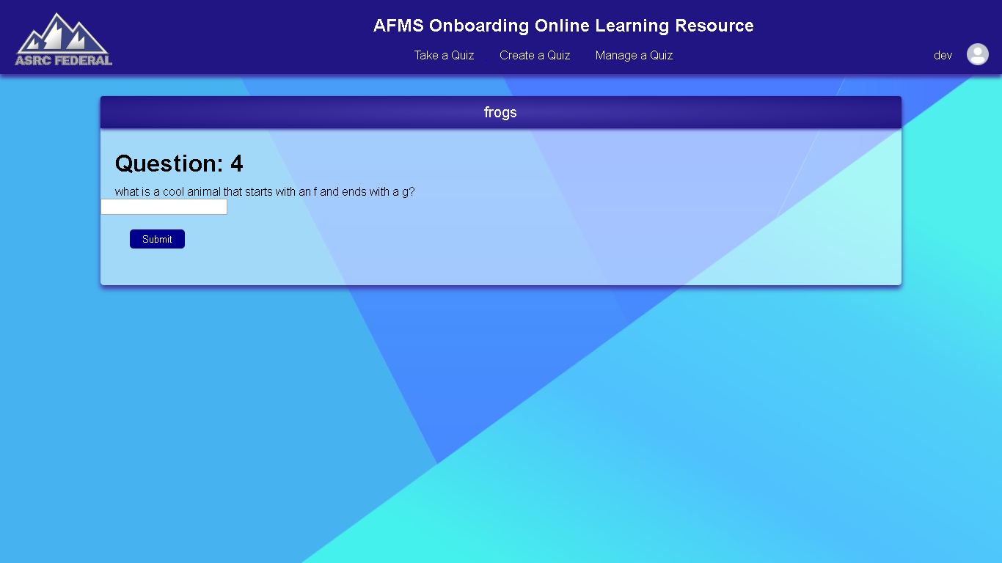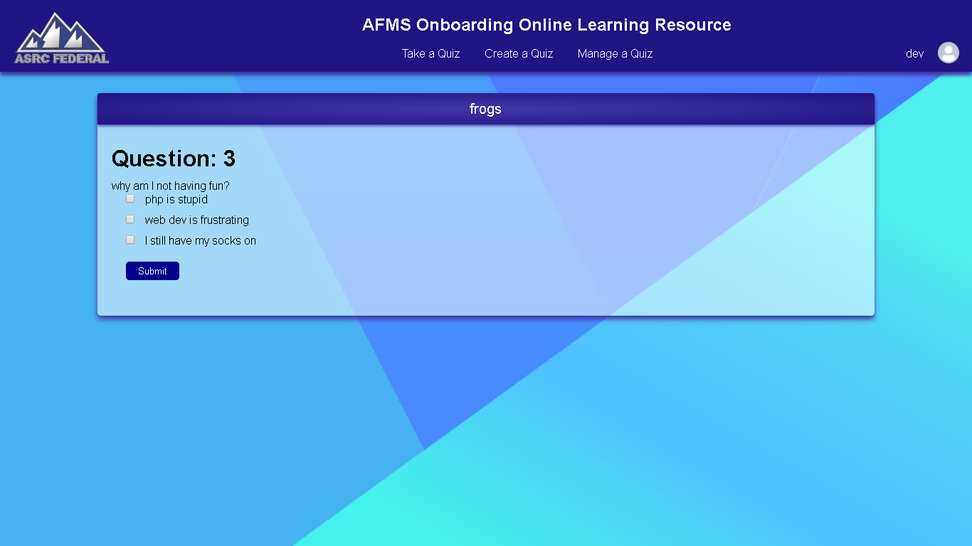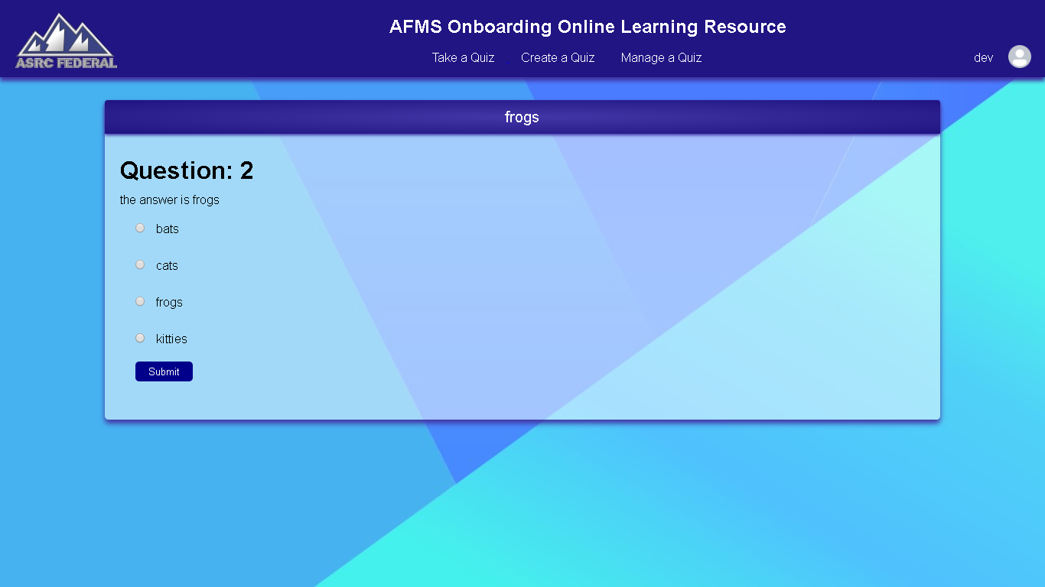

*Image of MC question (left), SATA question (middle), and FR question (right).*

* + - 1. **Display Correct Answers**

After a question is answered, the correct question is displayed to the user and a button is provided that will allow the user to continue with the quiz.

* + 1. Results

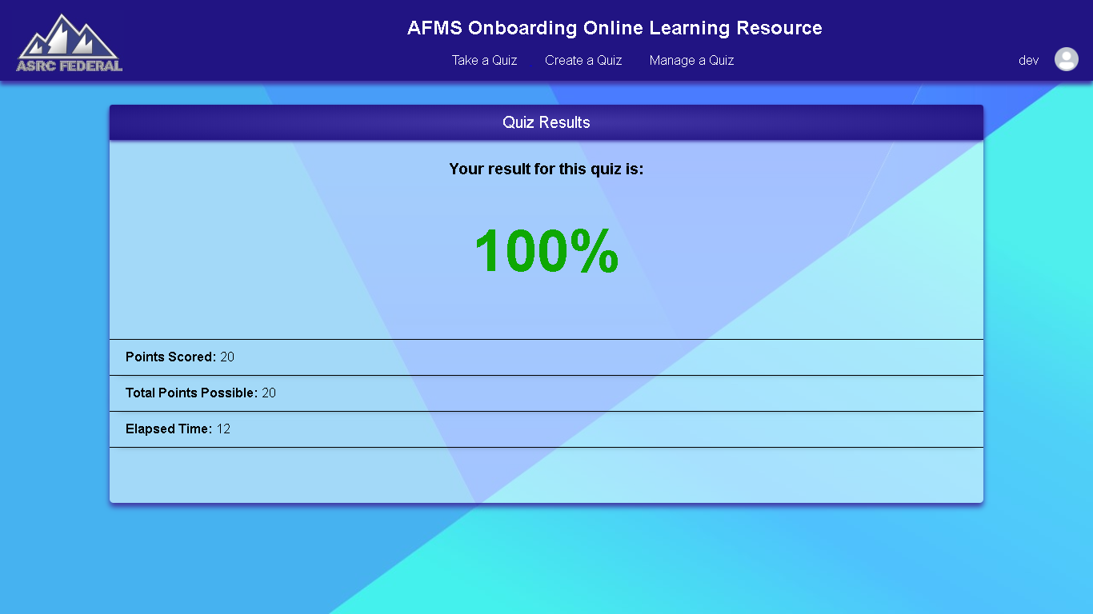

*Image of the Results page*

Displayed above is the results page. This page is shown when the user finishes a test. It displays the user’s grade, the points they score, the total points possible, and the elapsed time.

**Note:** To exit the results page, the user should navigate to the page they wish to go to with the navigation bar on the top of the page.

* 1. **Create a Quiz**

Creating a Quiz is split up into 2 forms: Creating a quiz manually and uploading a quiz from a .csv file.

* + 1. Create a Quiz Manually

Navigating to the Create a Quiz Manually page will initiate the process of making a quiz from scratch.

**NOTE:** **When you create a quiz manually, the visibility of the quiz will be set to ‘no’ by default. This means that once you finish creating a new quiz, it will not appear in the Take a Quiz page UNTIL you toggle its visibility in the Manage Quiz section.**

**An example situation would be that the user, named Matt, wants to create a quiz. He selects the Create a Quiz manually option, adds several questions, and decides that he wants to go on a coffee break and logs off the system. He was not finished making the quiz. However, other users cannot take the quiz because he did not toggle its visibility, and he is free to finish his quiz and make it public when he had his coffee break.**

* + - 1. **New Quiz Information**

First, the user is asked to enter the information of the quiz. The page that is first shown to the user is similar to the one shown below:

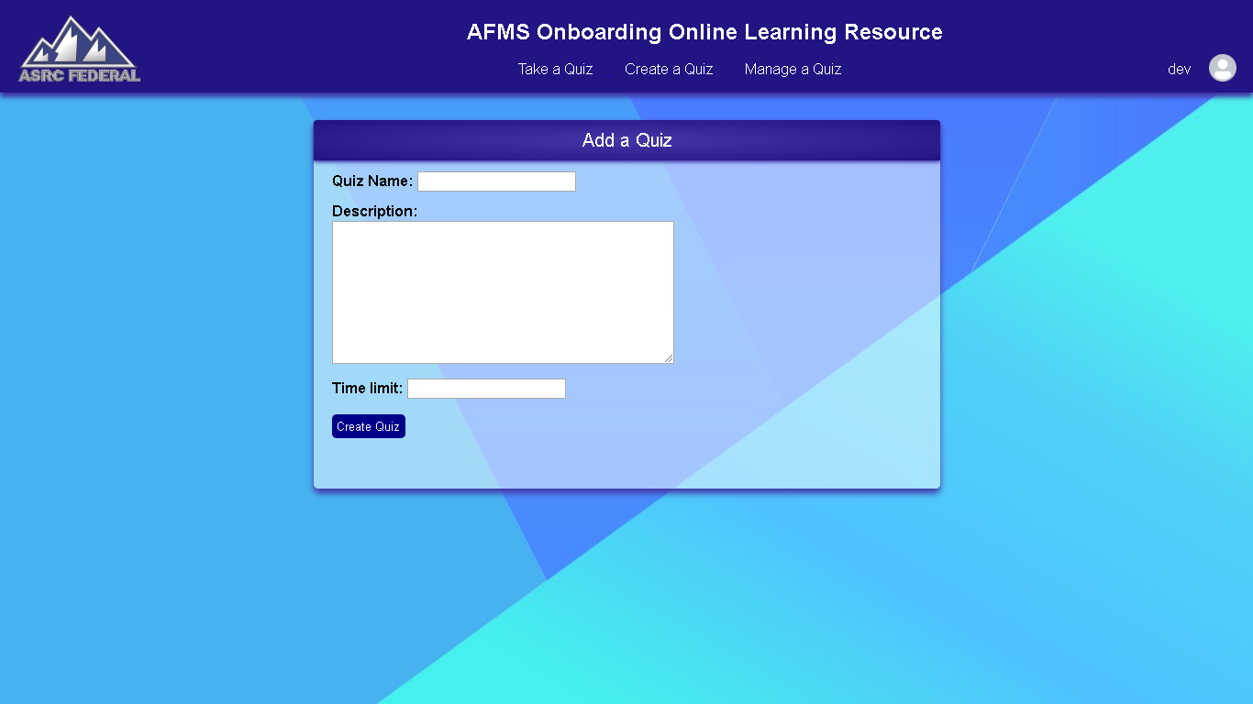

*Image of Create a Quiz Manually page*

Information about the quiz includes the quiz name, description of the quiz, and the time limit in minutes. Once the information is entered, the user must click on the create quiz button.

* + - 1. **Quiz Overview**

Once the quiz is created, they will be shown a page that shows the overview of the quiz. A new quiz looks like this:

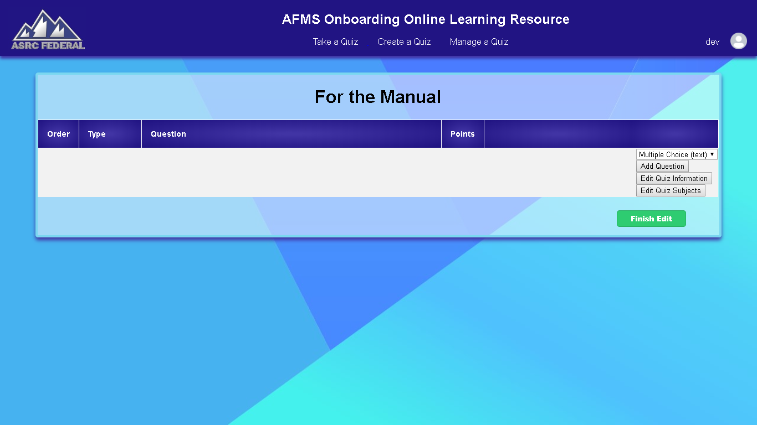

*Image of the Quiz Overview*

The Quiz Overview page displays a list of all the questions that the quiz currently contains. It also has buttons to edit quiz information, edit the subjects associated with the quiz, and to add questions.

**Note:** The Quiz Overview page is shared by both the creating a quiz process and editing a quiz process since it provides the same functionality for both processes.

* + - 1. **Add Question**

On the quiz overview page, there is a dropdown menu followed by a button titled “Add Question”. When the button is clicked, it will redirect the user to a form. The form varies depending on the option selected in the dropdown menu, next to the button.

**Note:** The dropdown defaults to creating a MC question.

* + - * 1. **MC**

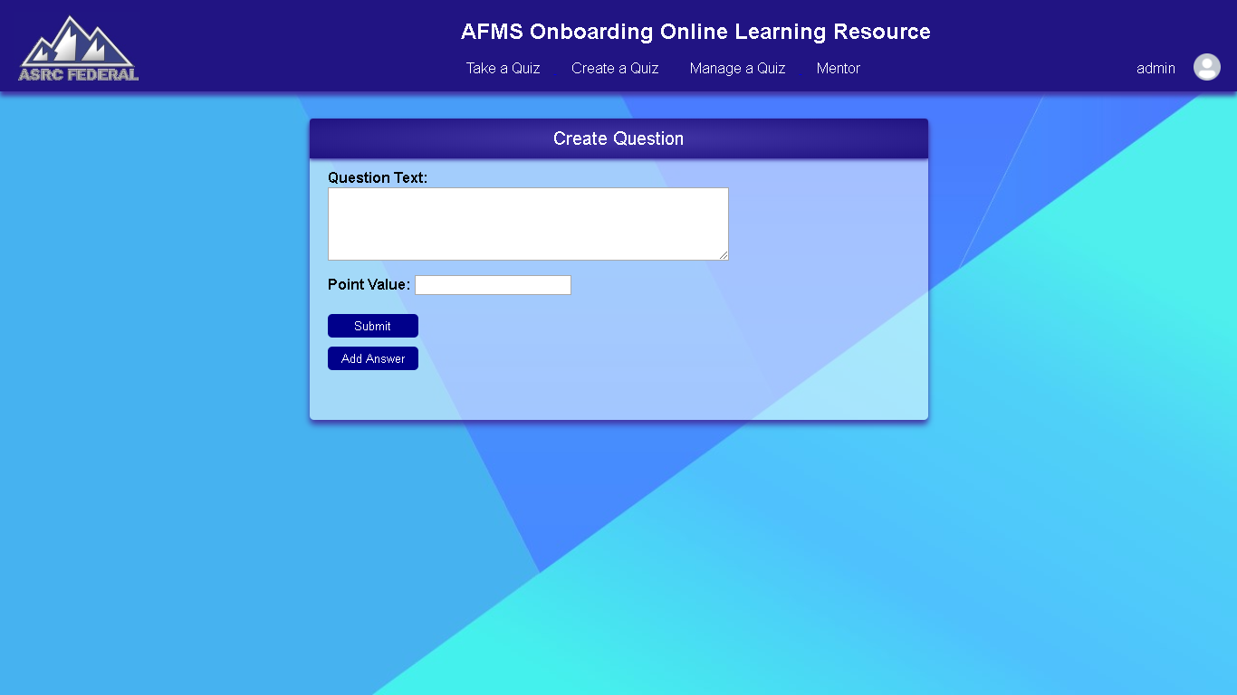

*Image of Creating a MC Question*

When adding a MC question, the user must enter what the question text is, as well as the point value for the question. Two buttons exist in this form, titled “Submit” and “Add Answer”.

Clicking “Add Answer” will cause a text box to appear, an input, and a “delete” button. This button can be clicked on multiple times to allow adding multiple possible answers to the question.

The user must enter the text for a possible answer in the text field. If the user wants to make a specific possible answer the correct answer, they must click on the input field to select it as valid. **ONLY ONE ANSWER IS MEANT TO BE VALID IN A MC QUESTION.**

Clicking on delete will cancel adding the answer or will delete an existing possible answer.

* + - * 1. **SATA**

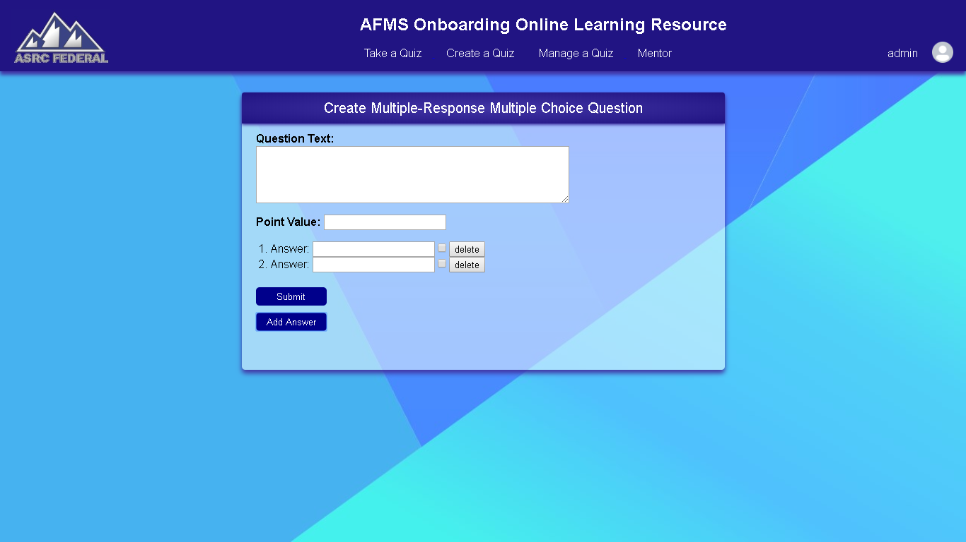

When adding a SATA question, the user must enter what the question text is, as well as the point value for the question. Two buttons exist in this form, titled “Submit” and “Add Answer”.

Clicking “Add Answer” will cause a text box to appear, an input, and a “delete” button. This button can be clicked on multiple times to allow adding multiple possible answers to the question.

The user must enter the text for a possible answer in the text field. If the user wants to make a specific possible answer the correct answer, they must click on the input field to select it as valid. **MULTIPLE VALID ANSWERS ARE ALLOWED IN A SATA QUESTION.**

Clicking on delete will cancel adding the answer or will delete an existing possible answer.

* + - * 1. **FR**

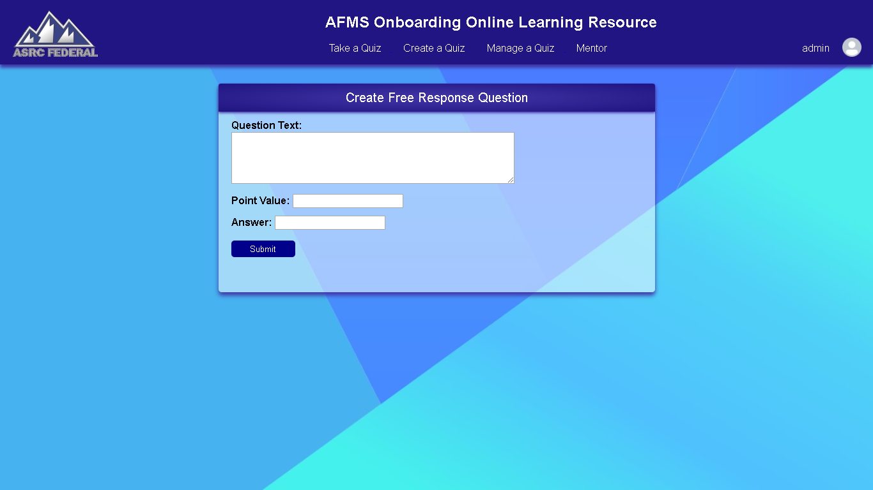

When adding a FR question, the user must enter what the question text is, as well as the point value for the question. The user also needs to enter the answer to the free response question.

**NOTE:** The answer for the FR questions will have the whitespace trimmed and will be converted to a single case by the system and matched with the test-taker’s input. The test-taker’s input will also be trimmed and converted to the same case.

Therefore, answers are not case sensitive, and the system will handle unprecedented or unneeded spacing in answers.

* + - 1. **Edit Quiz Information**

Clicking on this button on the Quiz Overview screen will allow the user to change the quiz information that was used when the quiz was first created.

**Note:** This page is the same page as the one shown when you first create the quiz. However, it is now pre-filled with the information that was provided when the quiz was first created.

Clicking on the “Submit Edits” button will cause the information to be updated.

* + - 1. **Adding Quiz Subjects**

**TO BE IMPLEMENTED**

* + 1. Upload a Quiz

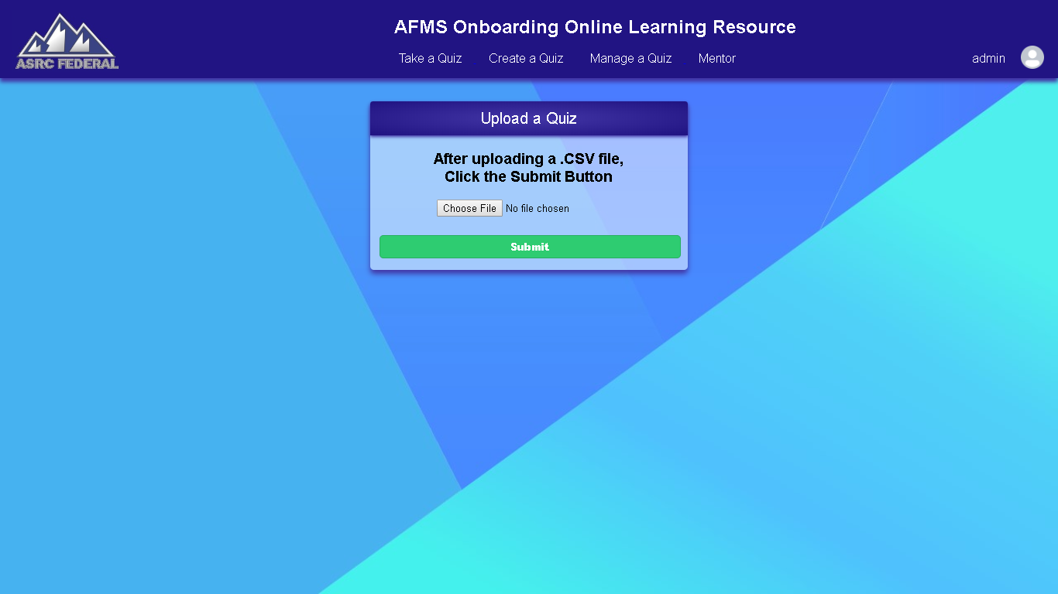

*Image of the Upload Quiz page*

When the user navigates to the Manage a Quiz page, their screen will display the form shown above. This form allows the user to select a .CSV file from their computer. Once the form is selected, the user must click on the “Submit” button, in order to upload the .CSV file.

Once the file has been submitted, the .CSV is used in order to create a new quiz.

* 1. **Manage a Quiz**

When the user navigates to the Manage a Quiz page, their screen should be similar to the one displayed below:

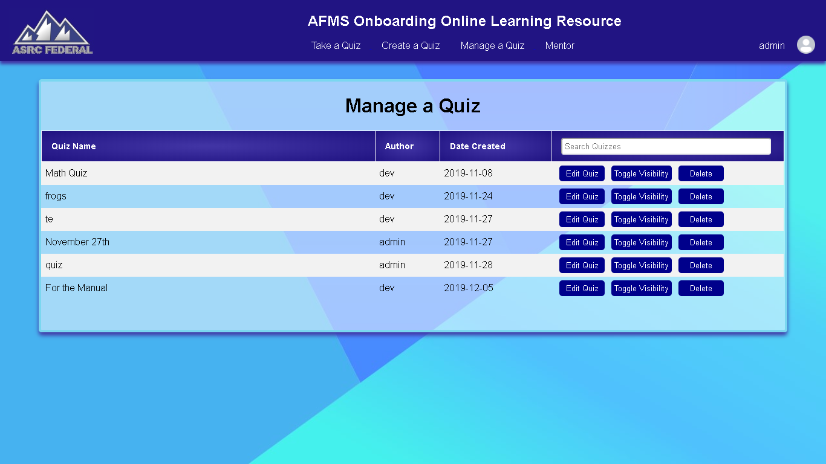

*Image of the Manage a Quiz page*

This page displays a table of all quizzes that the user is allowed to view and edit (See the note below). Each quiz has a name, an author, and date created. The table also has a search bar that filters out quizzes from the table by name.

Below the search bar, each quiz has 3 buttons: “Edit Quiz”, “Toggle Visibility”, and “Delete”.

**Note:** **The quizzes displayed depend on the level of privilege of the user. Employees are allowed to view and edit their own quizzes, while mentors are allowed to view and edit all quizzes, meaning their own and those of other users.**

* + 1. Edit Quiz

Clicking this button will redirect the user to the Quiz Overview page for the respective quiz.

* + - 1. **Quiz Overview**

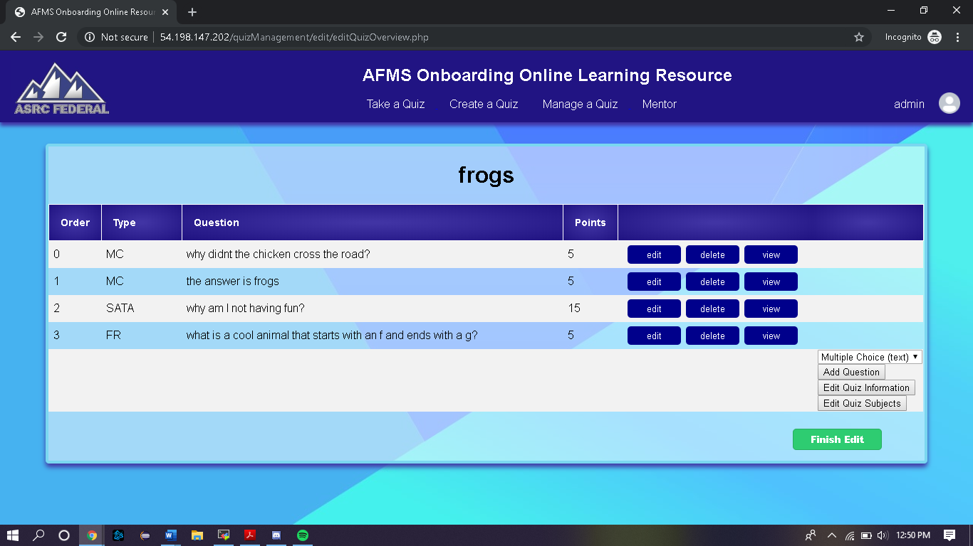

*Image of the Quiz Overview*

The Quiz Overview page displays a list of all the questions that the quiz currently contains. It also has buttons to edit quiz information, edit the subjects associated with the quiz, and to add questions.

**Note:** The Quiz Overview page is shared by both the creating a quiz process and editing a quiz process since it provides the same functionality for both processes.

* + - 1. **Editing Questions**

To edit a question on a quiz, the user must click on the “Edit” button on the same row as the question they choose to edit.

**Note:** Editing a question uses a webpage that is near identical to the ones used for creating the question. It also displays a different form depending on the type of question that is being edited (MC, SATA, and FR).

The edit question page will display a form, that is already prefilled with the question text, point value, answers and validity, to the user. The user can then choose to change these fields, add, or remove answers.

Clicking on the submit button will save changes made.

* + - 1. **Deleting Questions**

Clicking on the delete button will remove the question from the table of questions that exists for the quiz.

**NOTE:** Deleting a question cannot be undone. There is also no warning prompt for deleting a question.

* + - 1. **Adding Questions**

On the quiz overview page, there is a dropdown menu followed by a button titled “Add Question”. Selecting an option from the dropdown causes a different form to appear for each type of question when the button is clicked.

**Note:** The dropdown defaults to creating a MC question.

**If you want to know how to add specific types of questions (MC, SATA, and FR), please refer to the individual types of questions in the Add Question section in** **Creating a Quiz section ( 4.2.1.3 ).**

* + - 1. **Edit Quiz Information**

Clicking on this button on the Quiz Overview screen will allow the user to change the quiz information that was used when the quiz was first created.

**Note:** This page is the same page as the one shown when you first create the quiz. However, it is now pre-filled with the information that was provided when the quiz was first created.

Clicking on the “Submit Edits” button will cause the information to be updated.

* + - 1. **Edit Quiz Subjects**

**TO BE IMPLEMENTED**

* + 1. Toggle Visibility

Clicking on the “Toggle Visibility” button will allow the selected quiz to be visible to other users in the Take a Quiz section. This quiz can also be taken by users, as a result.

**Note:** Toggle Visibility is set to false by default when creating a quiz. It must be toggled to show a newly created quiz.

* + 1. Delete

Clicking on the “Delete” button will cause the selected quiz to be deleted from the system.

**NOTE:** Deleting a quiz cannot be undone. There is also no warning prompt for deleting a quiz. Do so at your own expense.

* 1. **Mentor**

The Mentor tab is on the navigation bar, and displays several options for mentors: Viewing Users, Metrics, and Managing Subjects.

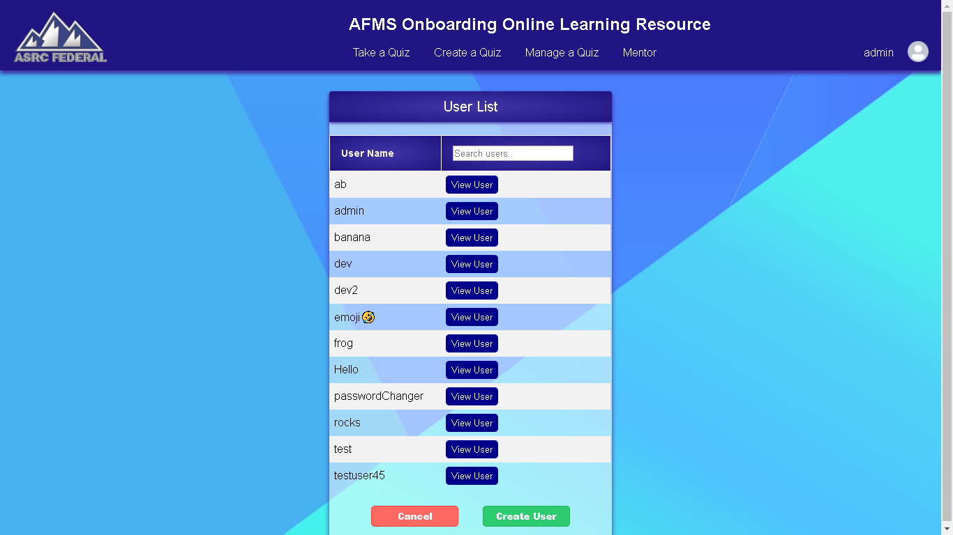

*Image of the Mentor tab on the Navigation Bar*

**Note:** The Mentor tab is only meant to be seen by mentors. Therefore, it will only be displayed on the navigation bar to users who have the user privilege of a mentor.

* + 1. View User

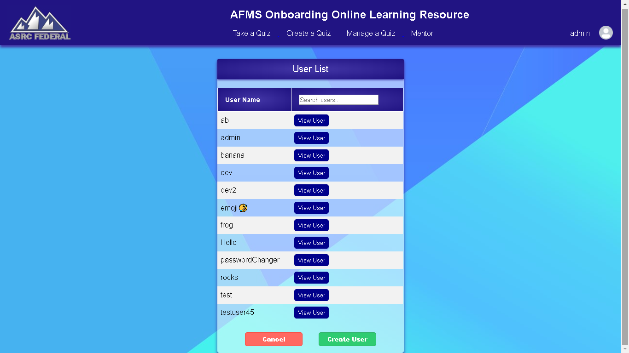

*Image of the View User page*

Navigating to the View User page as a mentor will display a table. This table consists of all the users in the system. The table provides a search bar that will filter out users based on their username.

There is a “View User” button for every user, and a “Create User” button on the bottom.

* + - 1. **Viewing the User**

Clicking on the “View User” button will redirect the mentor to a page for that specific user.

The page consists of the Username, a Mentor Status indicator, a “View Metrics” button, a “Change Password” button, a “Delete User” button, and a “Change Privilege” button.

* + - * 1. Viewing User Metrics

**TO BE IMPLEMENTED**

* + - * 1. Changing User Password

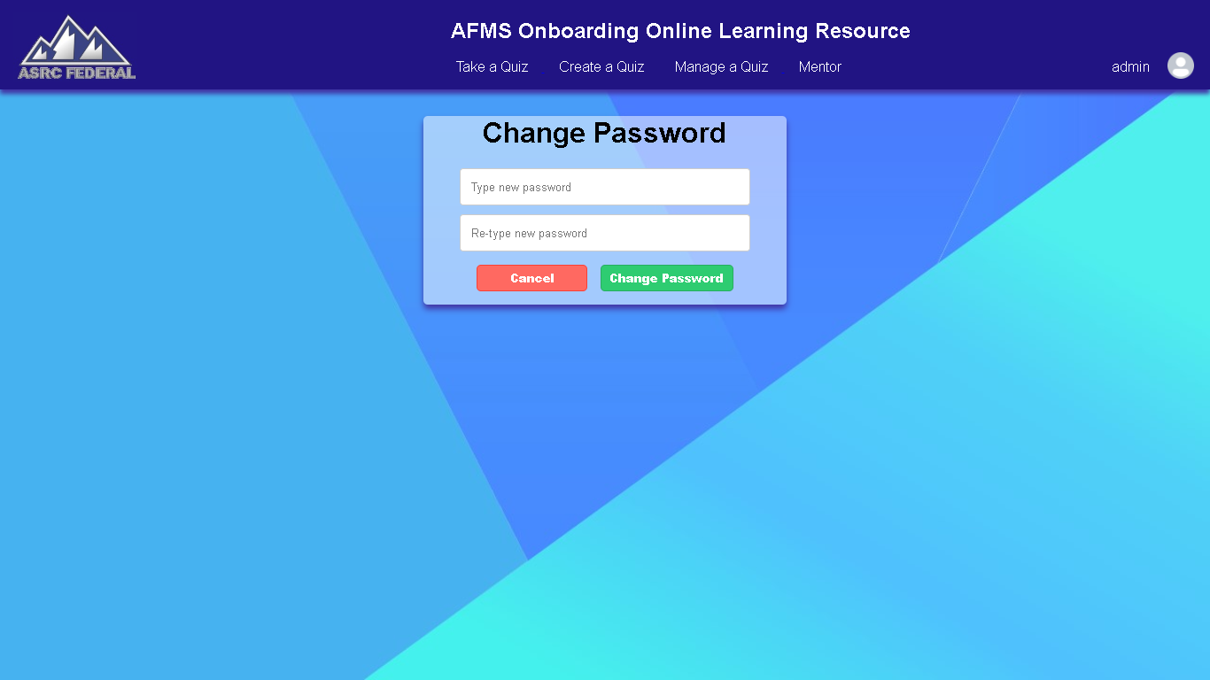

*Image of Changing Password page*

Selecting “Change Password” will redirect the mentor to the Change Password page. This page displays a form for the mentor, and the mentor must enter a new password, and reenter the same password.

If the mentor chooses to not change the password, they can cancel by clicking on the “Cancel” button.

To confirm the password change, the mentor must click on the “Change Password” button. An alert will appear when the change has been successful.

* + - * 1. Deleting User

Clicking on “Delete User” will cause an alert to appear to the mentor, stating whether they wish to confirm this action.

Clicking Yes on the alert will confirm the deletion and delete the user from the system.

* + - * 1. Change User Privilege

Clicking on “Change User Privilege” will cause an alert to appear to the mentor, stating whether they wish to confirm this action.

Clicking Yes on the alert will confirm the change and change the user’s privilege on the system to a mentor.

* + - 1. **Creating a User**

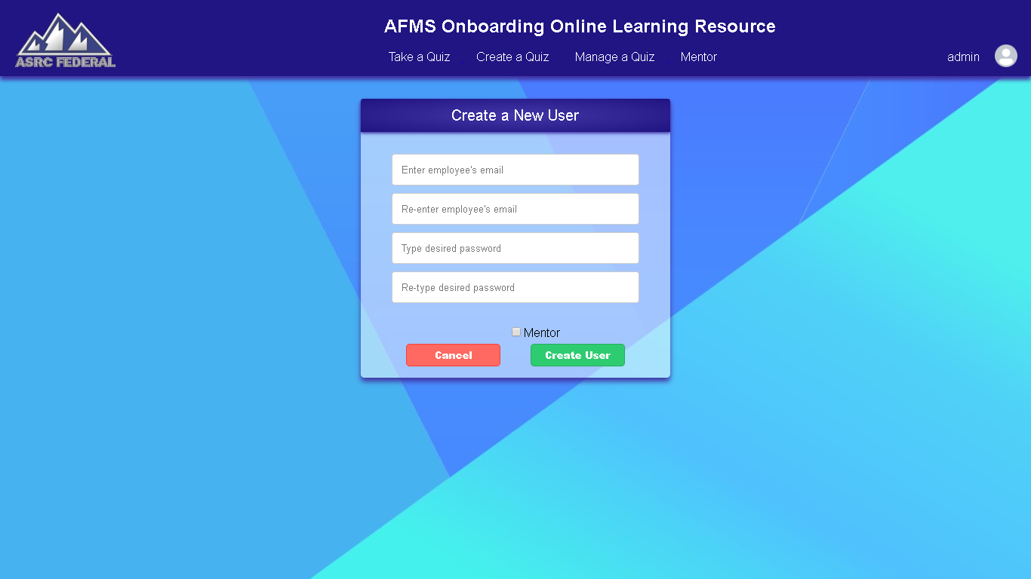

*Image of the Create a User page*

Clicking on the “Create User” page will redirect the mentor to the Create User page.

This page consists of a form that the mentor must fill out to create a user.

The form asks for the new user’s email and a desired password and confirms that these values are correct by having the mentor reenter them.

On the bottom, there is a checkbox option labeled “Mentor”, which also the new user to be added as a mentor to the system.

To cancel the process, the mentor must select the “Cancel” button on the bottom of the form.

To confirm the addition of the user, the mentor must click on the “Create User” button. An alert will appear stating that the user creation was successful and redirect back to the create user page.

**Note:** Although the form asks for the user’s email, it is not required to be in email format. Only the initial part of an email is used, if an email is utilized.

* + 1. Metrics

TO BE IMPLEMENTED

* + 1. Manage Subjects

TO BE IMPLEMENTED

* + - 1. **Deleting Subjects**
      2. **Creating Subjects**
  1. **User Options**

On the right-hand side of the navigation bar, the user’s name and icon will be displayed. Hovering over this will display user options.

* + 1. My Grades

Selecting this option will redirect the user to the My Grades page. This page will display the user’s performance on quizzes, and their proficiency on certain subjects.

* + 1. My Quizzes

TO BE IMPLEMENTED

* + 1. Logout

Clicking on this option will end the user’s session and redirect them to the login page of the system.