Swine Flu Expert System

Artificial Intelligence

Group Assignment

Wembley Williams – 1406949

Mikhail Renè Shaw – 1406944

University of Technology, Jamaica

Table of Contents

Introduction 3

The Console 4

How to Run 4

Functionality 5

H1N1 Diagnosis 5

Update Prevention Database 6

Update Drug Database 7

Statistical Report 7

The Web Application 9

How to Run 9

Pages and Functionality 12

Homepage 12

About Page 14

Checkup Page 14

Status Report Page 18

# Introduction

The Swine Flu Expert System is an intelligent system designed for use by the Jamaica Ministry of Health. The SFES was designed and implemented by a group of students of the University of Technology, Jamaica. There are two versions of this system, a console version and web version. The purpose of this system is to collect and process patient data then determine their risk of having Swine Flu (H1N1). Both versions of the system were designed and implemented using the prolog programming language.

# The Console

The Console version of the system is the regular interface of using prolog applications. With this version you only need SWI-Prolog, properly, installed and the machine and the editor to “consult” the code.

## How to Run

In order to run The Swine Flu Expert System from the console, you will need:

* SWI-Prolog (properly installed)
* SFES_Console.pl

Firstly, you’ll need to open your SWI-Prolog Editor.

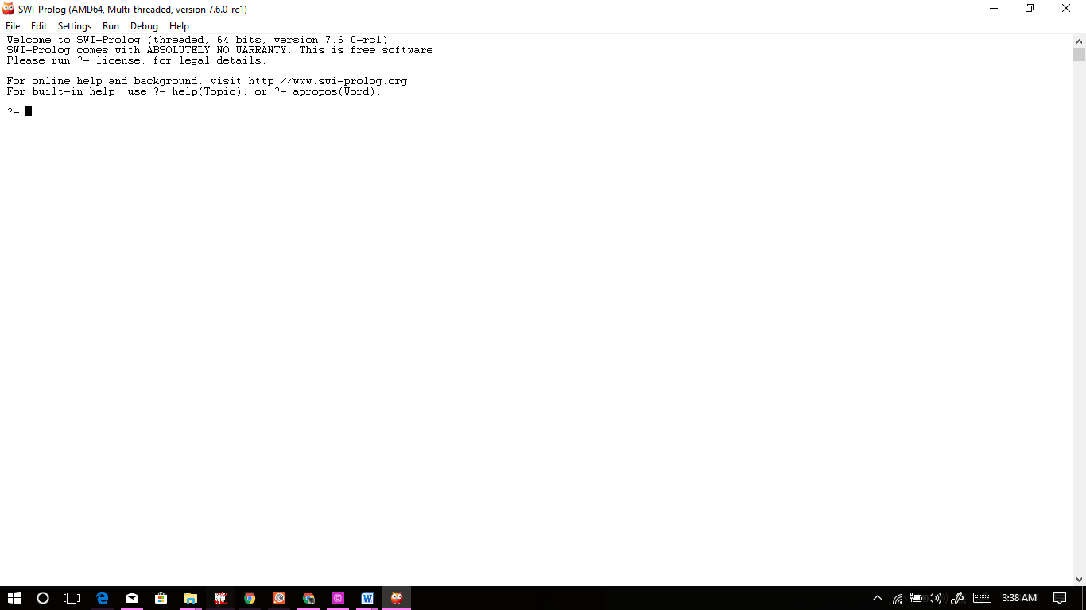

*Figure 1.0 Showing Opened SWI-Prolog Editor*

Next, you’ll need to find and consult the code.

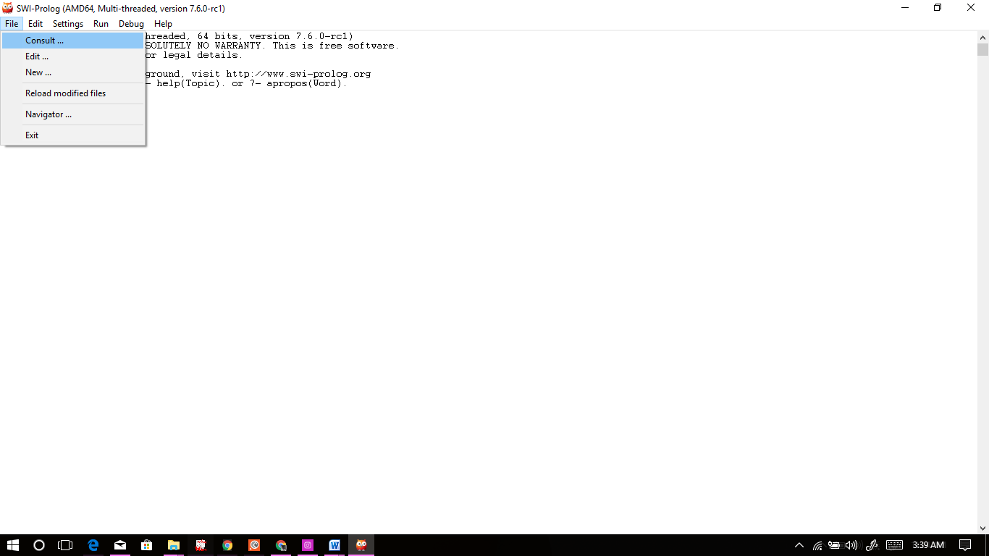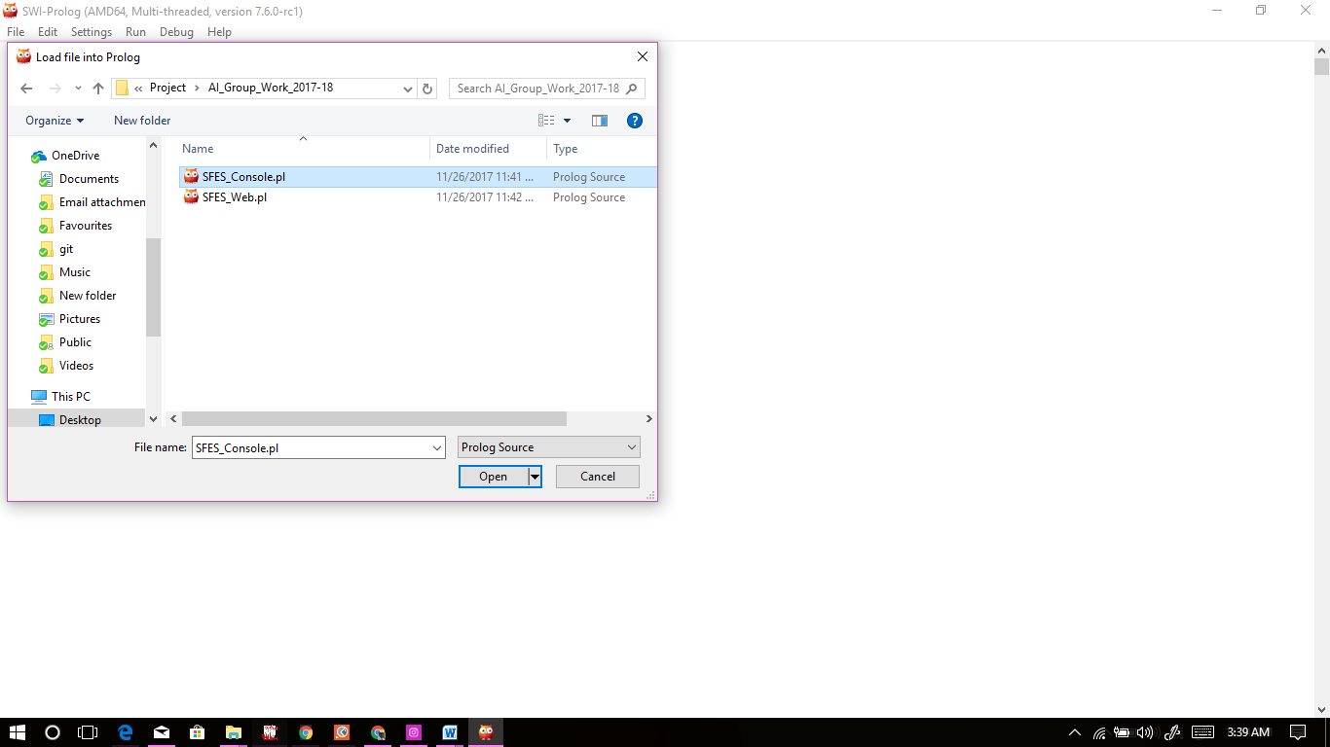

*Figure 1.1 Requesting Consult Figure 1.2 Finding and Consulting SFES_Console.pl*

Voila, SFES Console version is now up and running.

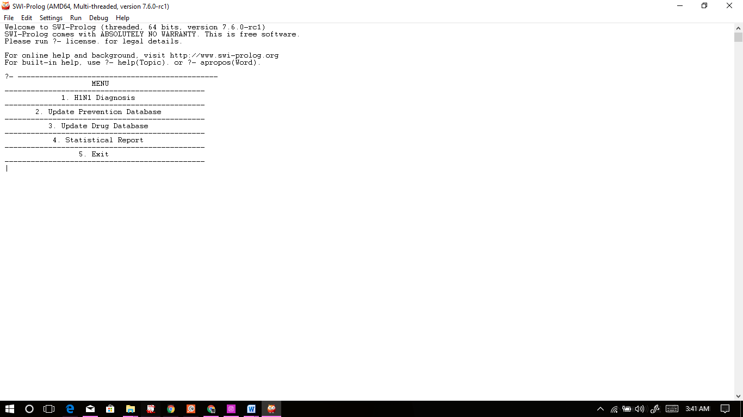

*Figure 1.3 Showing SFES_Console.pl Successfully Consulted*

## Functionality

### H1N1 Diagnosis

In this section, specific patient data is collected then further processed to determine the said patient’s probability of having Swine Flu (H1N1).

The System will first collect some patient personal data and temperature.

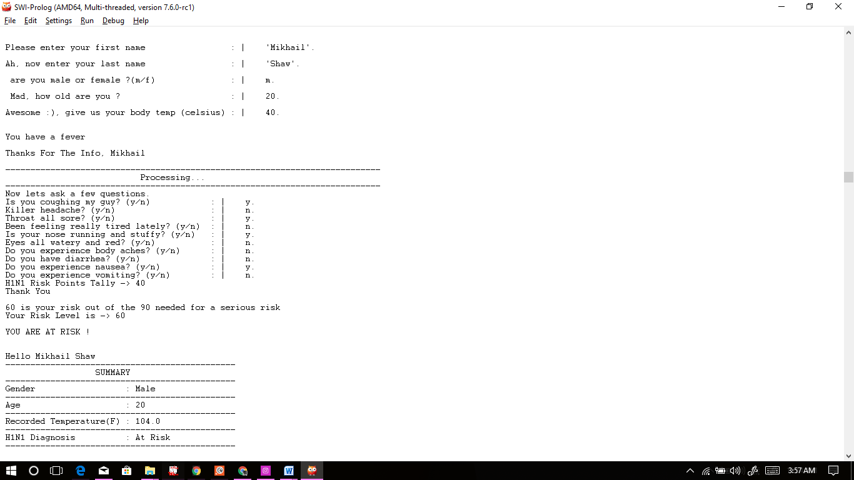

*Figure 2.0 Showing the type of data collected in the first section of the diagnosis*

After that data has been collected and process then the system will ask about the symptoms, which relate to H1N1, that the patient may be experiencing. The system will then use the data it collected and determined the Swine Flu(H1N1) risk level at which said patient is at.



*Figure 2.1 Showing the symptom data collected and the determined risk level*

After all the data is collected a check is done on gender and age and if the patient is female of fertility age then they are shown another section to input data regard pregnancy checking.

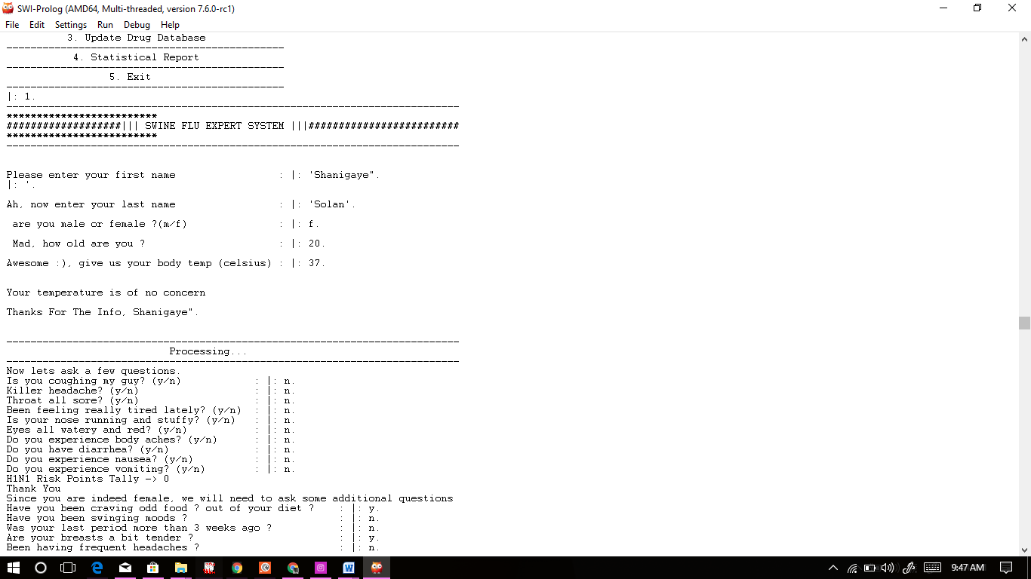

### Update Prevention Database

In this section, an admin is allowed to add more cautionary measures that patients can take to avoid getting or spread Swine Flu(H1N1) or Influenza A.

The system will ask for and accept the admins suggestion then give you the option to add another if they so choose.

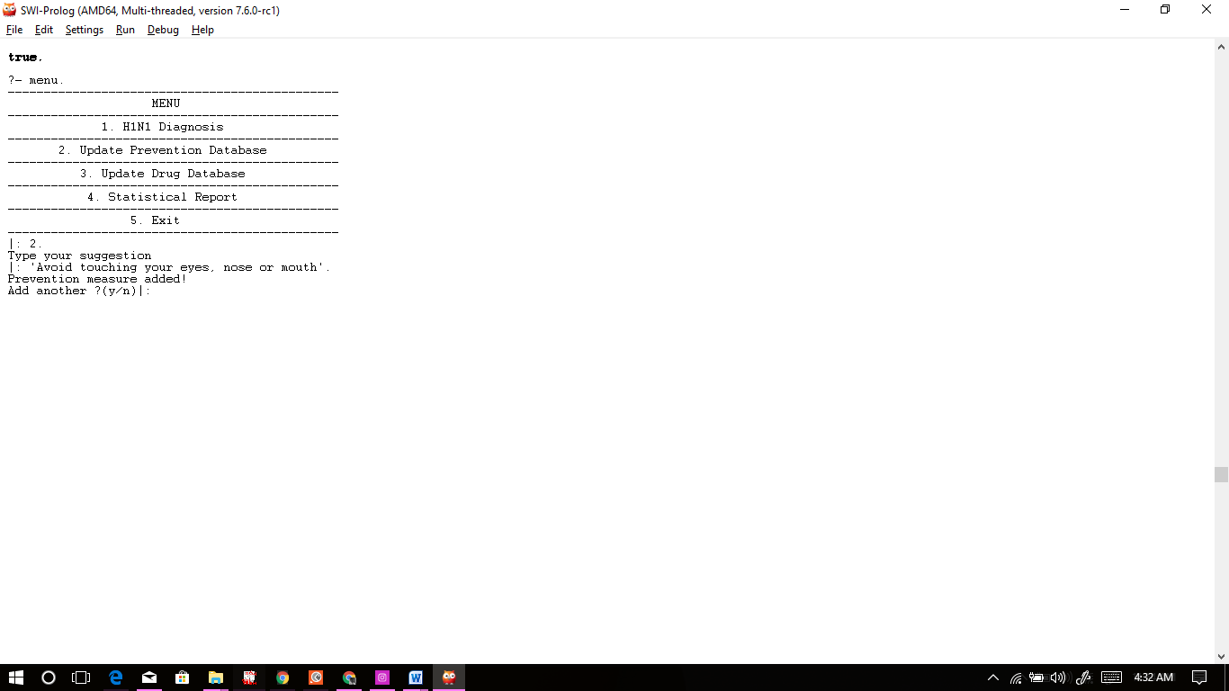

*Figure 2.2 Showing the Update Prevention Database Functionality*

### Update Drug Database

In this section, an admin is allowed to add new drug data for the symptoms within the system. i.e. Symptoms that the patients will queried about.

The admin is first asked for the new drug they’d like to add then the symptom that it helps with. After that the system will inform the admin that the drug has been added and give said admin the option to add another drug if they so choose.

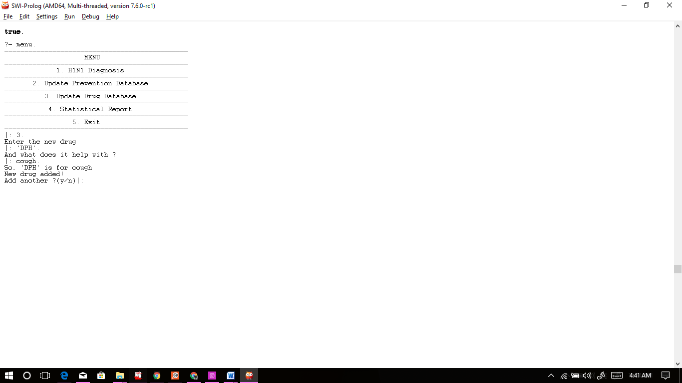

*Figure 2.3 Showing the Update Drug Database Functionality*

### Statistical Report

In this section, one can view session’s statistical report:

* The current number of patients
* The current number of infected patients
* The current number of at risk patients
* The current percentage of infected patients

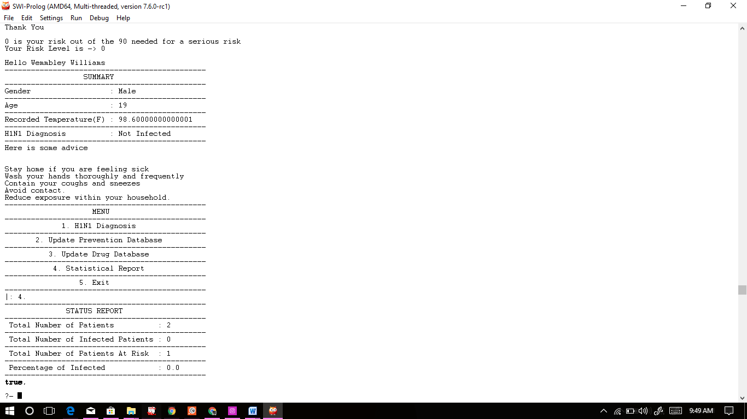

*Figure 2.4 Showing results of Statistical Report*

# The Web Application

The Web Application version of the system is uses prolog server-client modules to produces a web application that does the same job as the Console version but in a more web app kind of way. With this version you only need SWI-Prolog, properly, installed on the machine, the editor to “consult” the code and a browser to navigate to the web application.

## How to Run

The instructions to run the Web App are similar to those of the Console version.

In order to run The Swine Flu Expert System from the console, you will need:

* SWI-Prolog (properly installed)
* SFES_Console.pl
* Web Browser

Firstly, you’ll need to open your SWI-Prolog Editor.



*Figure 3.0 Showing Opened SWI-Prolog Editor*

Next, you’ll need to find and consult the code.



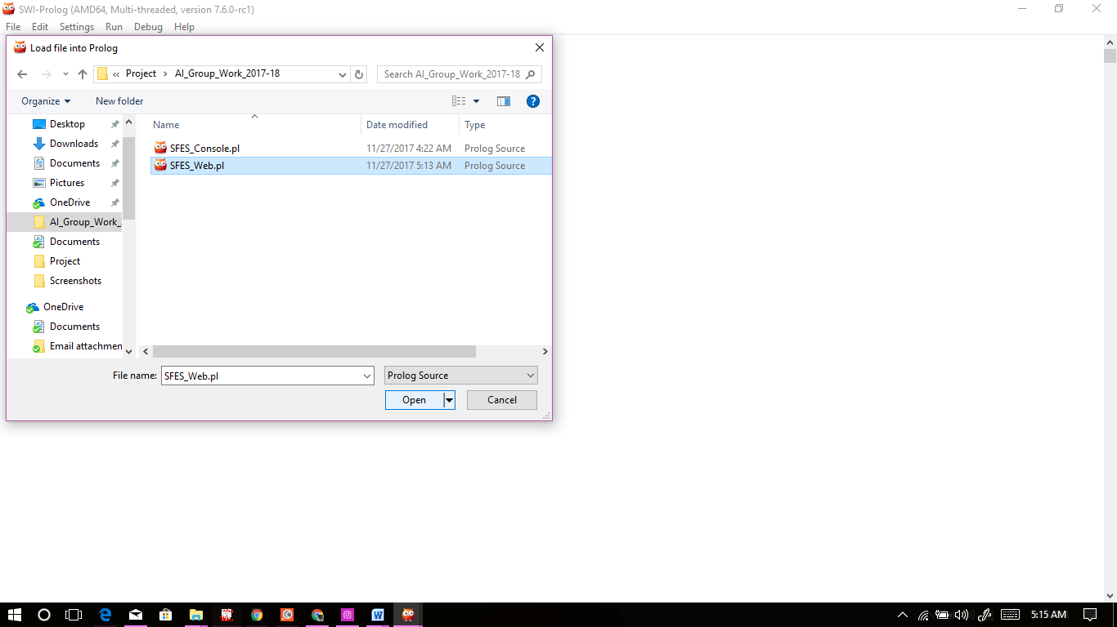

*Figure 3.1 Requesting Consult Figure 3.2 Finding and Consulting SFES_Web.pl*

Voila, SFES Console version is now up and running.

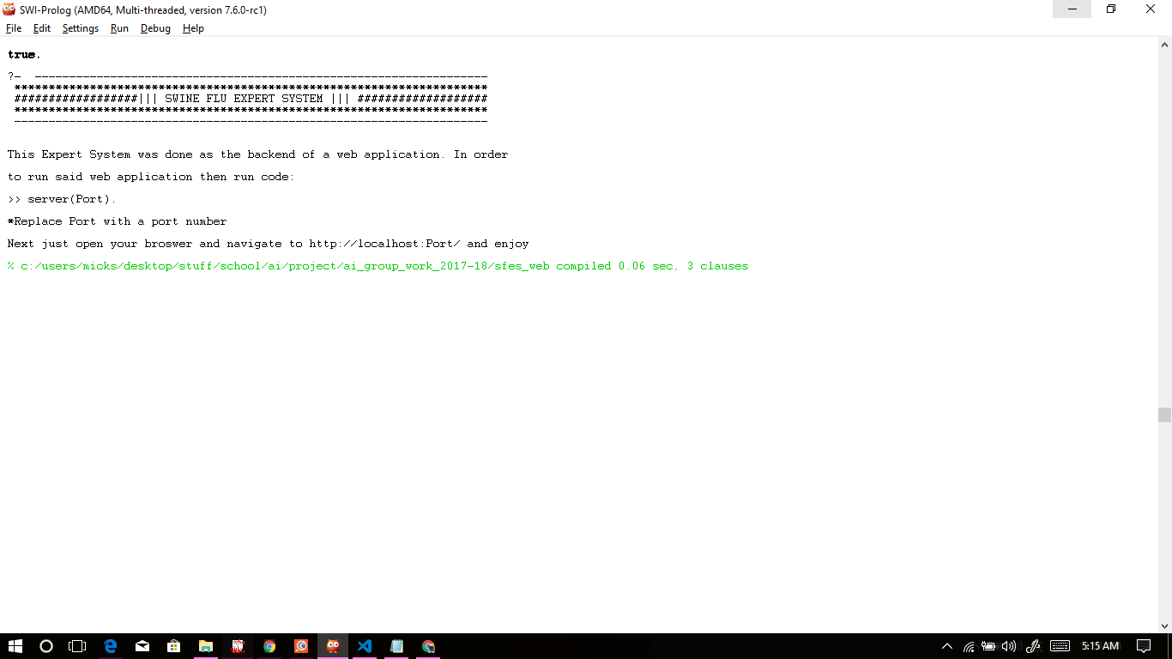

*Figure 3.3 Showing SFES_Web.pl Successfully Consulted*

Now we have one more step. You’ll need to follow the instructions on screen.

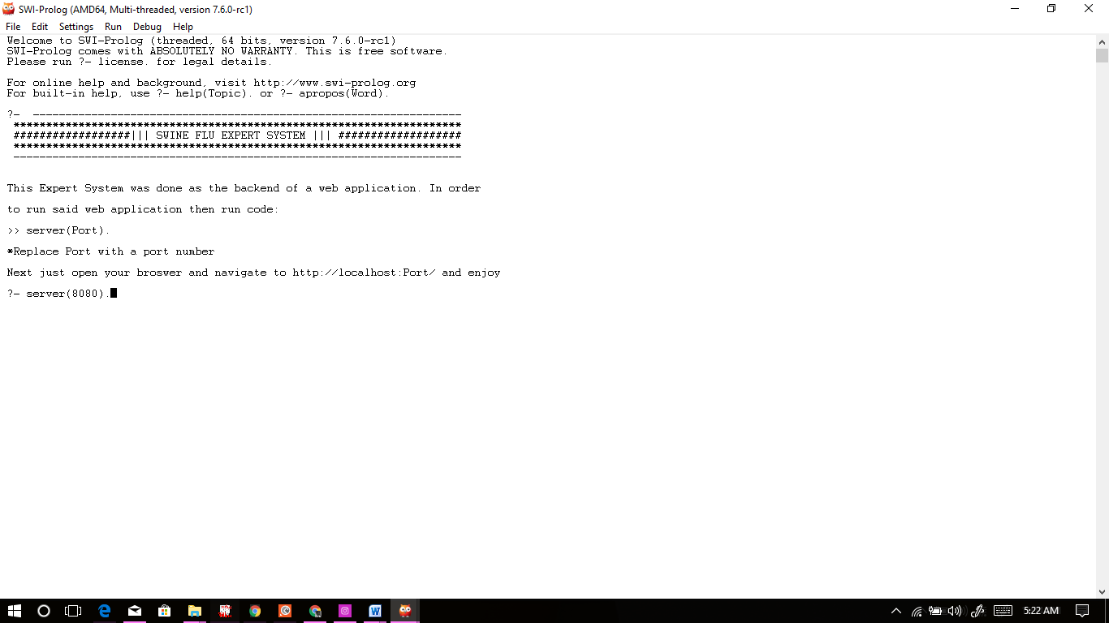

*Figure 3.4 Running the server at port 8080*

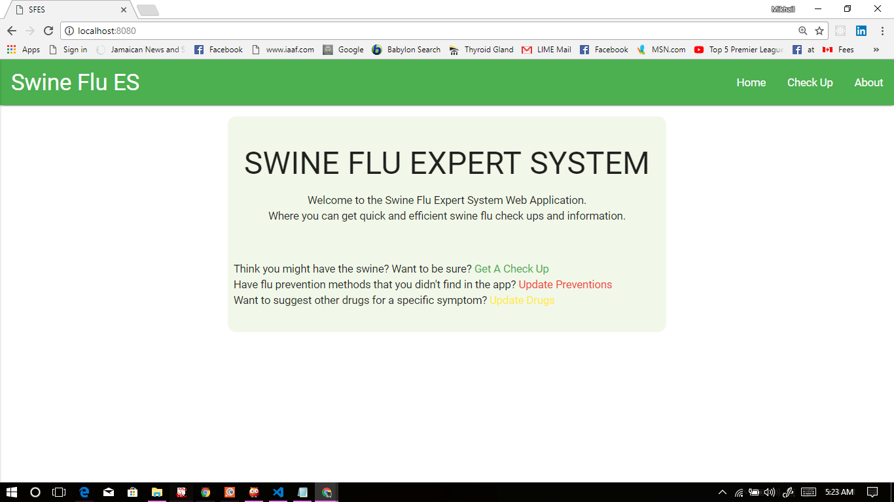

*Figure 3.5 Navigating to the web app in the browser at* [*http://localhost:8080*](http://localhost:8080)

## Pages and Functionality

### Homepage

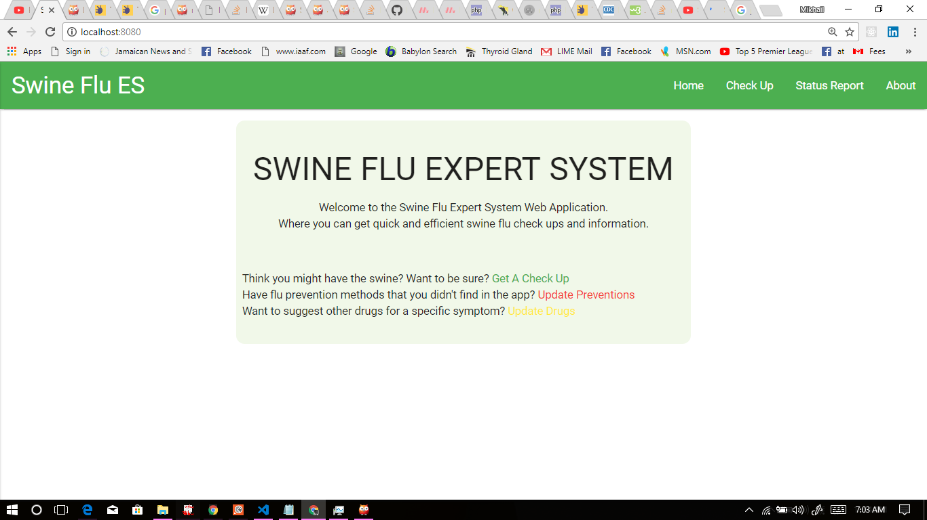

*Figure 5.0 Showing the Homepage of SFES_Web.pl*

The Homepage is the first page you come across when you navigate to the Web Application. On this page you’re greeted with a welcome message and few options. From here you have the option to ignore the options provided under the welcome message and use the navigation bar to go around. With the options below the welcome though, a patient can go straight to doing a checkup or an admin can do an update on the prevention or drug databases.

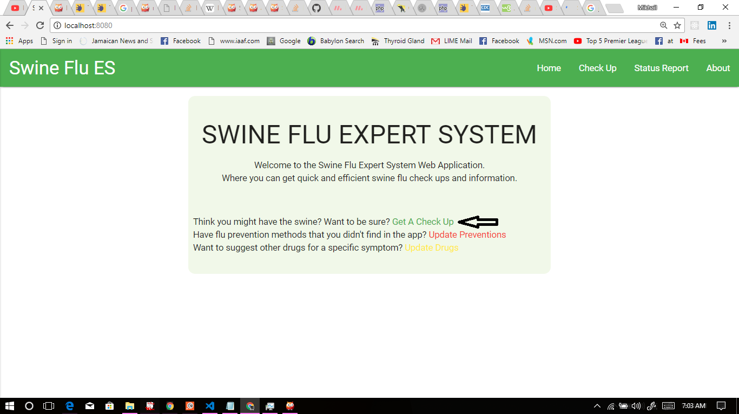

*Figure 5.0.1 Showing homepage link to checkup page*

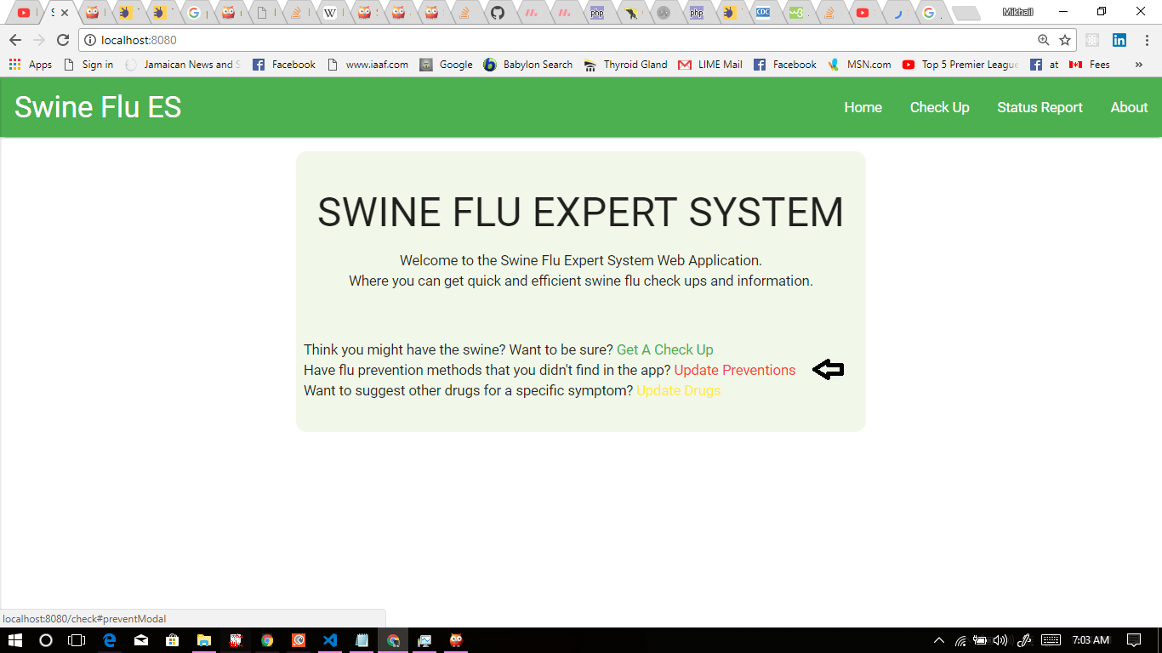

*Figure 5.0.2 Showing homepage link to updating prevention database*

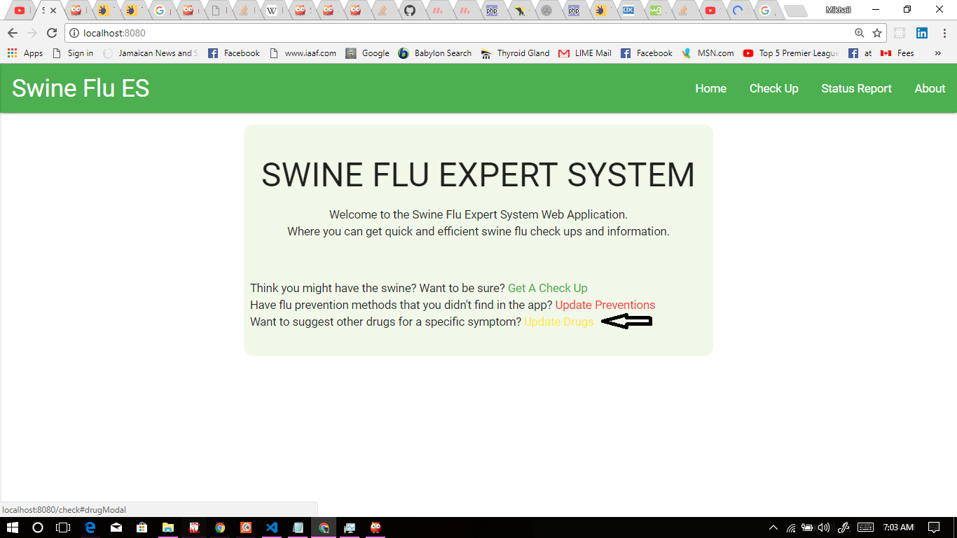

*Figure 5.0.3 Showing homepage link to updating drug database*

### About Page

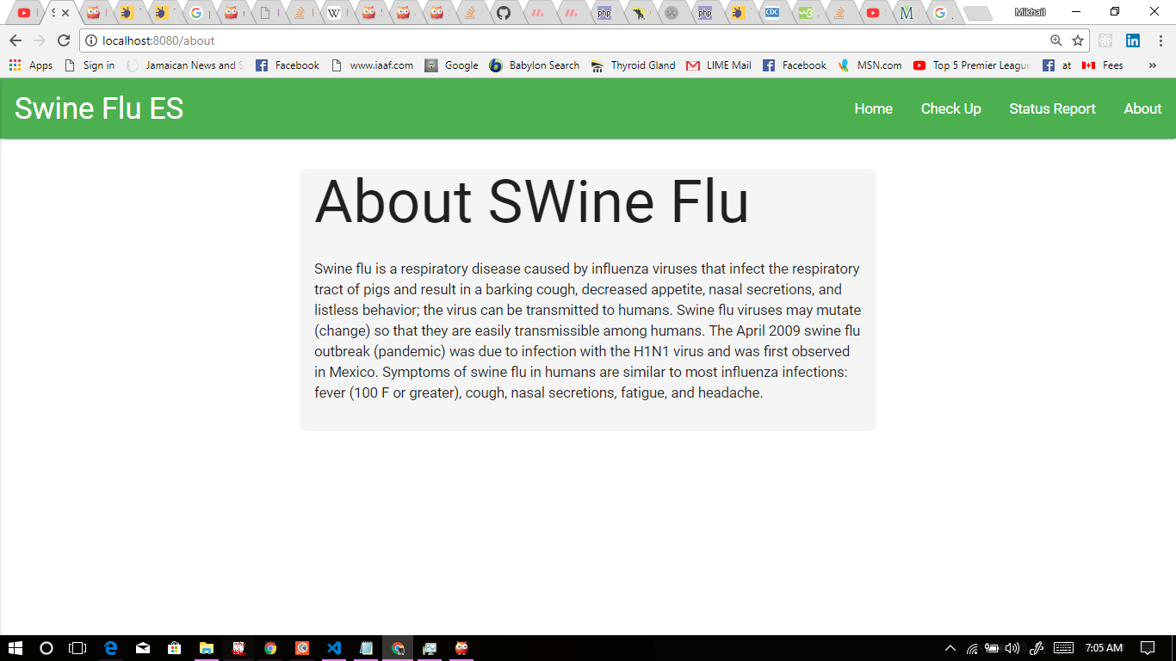

*Figure 5.1 Showing the About Page*

The About Page is just a simple information page. Here you may find just a small amount of information about a bit of history on Swine Flu (H1N1).

### Checkup Page

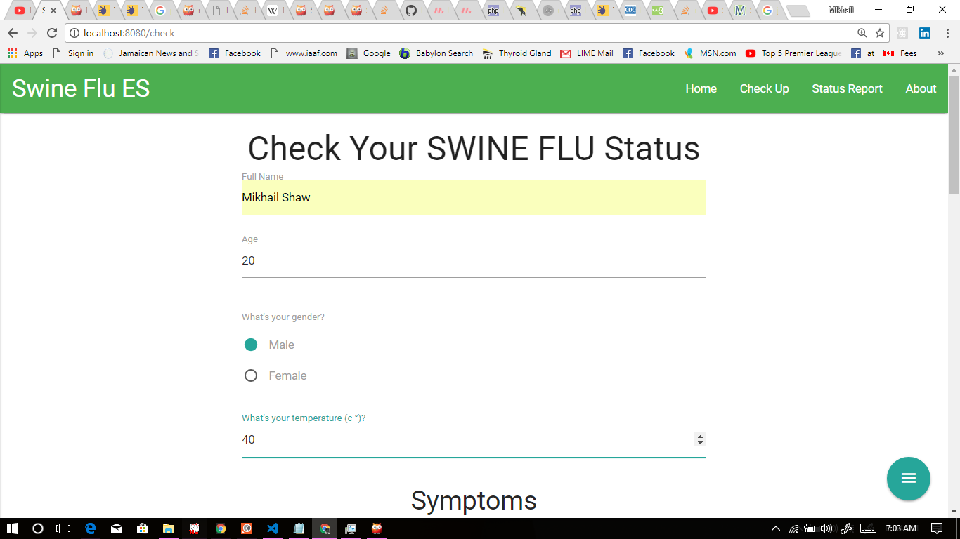

*Figure 5.2 Showing the Checkup Page*

The Checkup page has multiple purposes and can be used by both patients and admins.

When a patient is using the checkup page they fill out the checkup form and answer the same questions as they would in the “H1N1 Diagnosis” section of the SFES Console. For dynamic answers (eg. Name or age), then a text field is used to collect the data but for static answers (eg. Gender or “yes or no”), then radio buttons are used to collect the data.

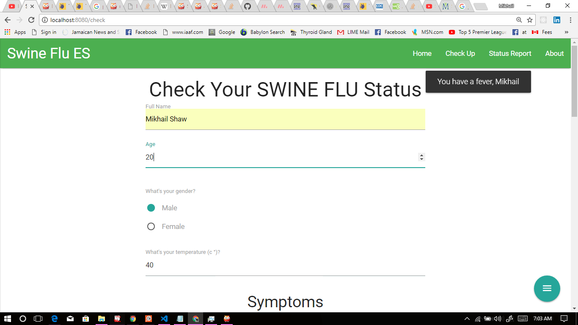

*Figure 5.2.1 Showing the system alerting patient about their fever issue*

After submitting the form from the Checkup Page the server does a check on the gender and age and if the patient is a female within the age of fertility then they will be redirected to another form to do a simple pregnancy check.

*Figure 5.2.2 Showing Pregnancy Check Form*

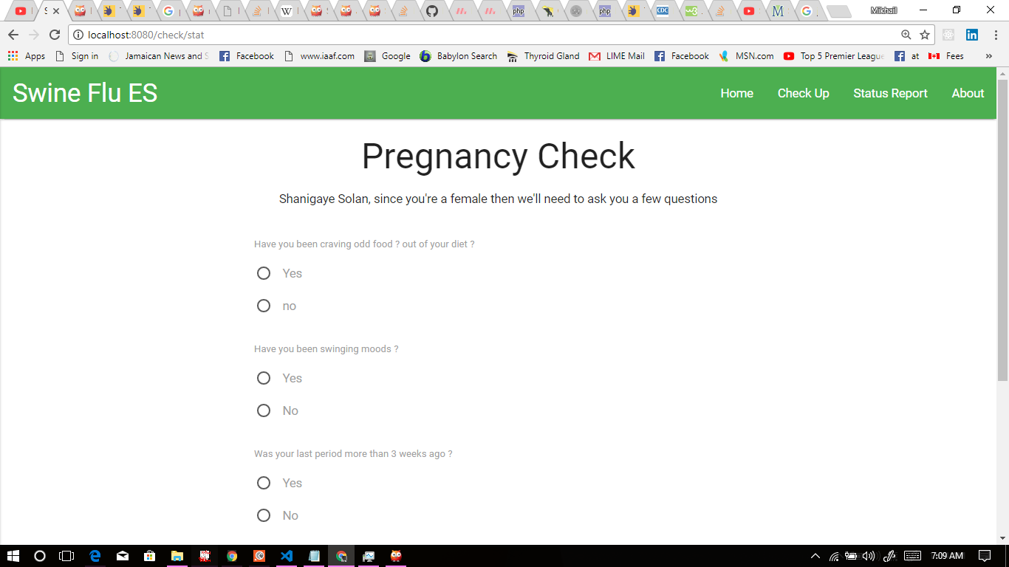

After all forms have submitted then the backend server will process the data and determine the patient’s level of risk for have Swine Flu (H1N1). From here the patient will also, if needed, be provided with a list of cautionary measures they can take to prevent or decrease the spread of swine flu and also a list of drugs for the symptoms they are displaying.

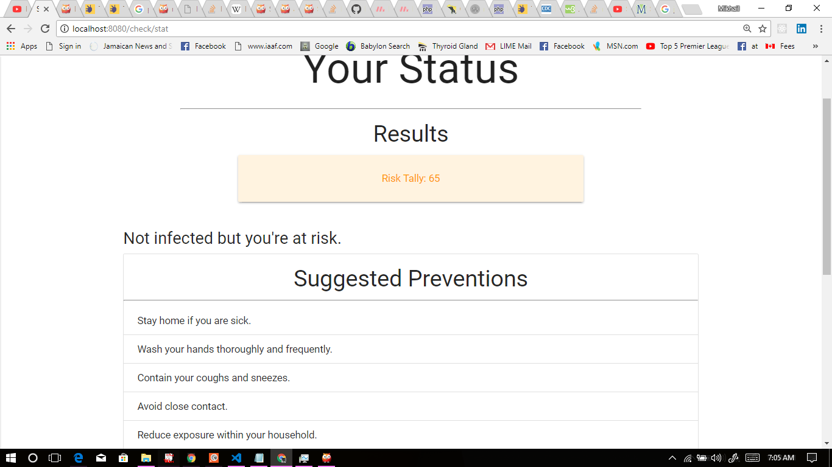

*Figure 5.2.3 Showing the patient’s risk level and cautionary measures to take*

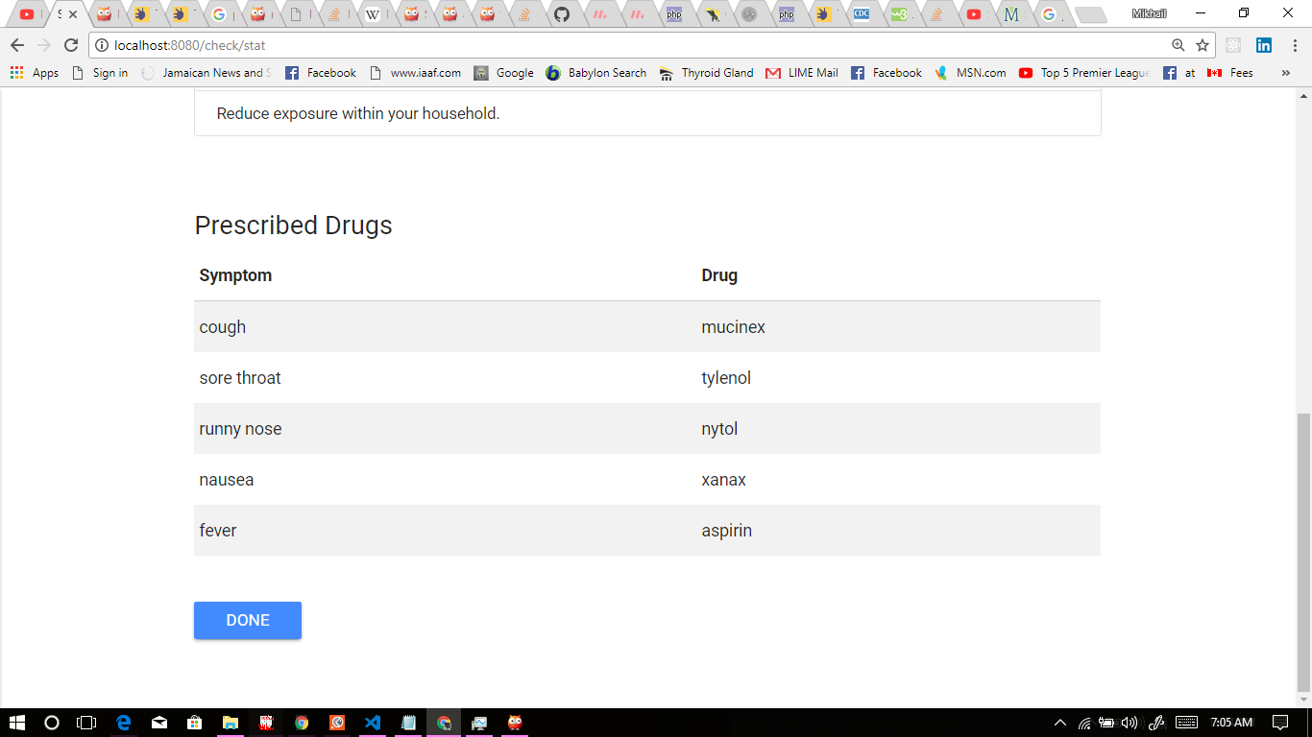

*Figure 5.2.4 Showing the list of drugs for each of the patient’s symptoms*

#### Updating Prevention and Drug Databases

From the checkup page, or homepage, an admin has the ability to update the preventions and drugs databases with simple forms. From this page the admin may access the update functionalities by hovering over the “Update Options” menu icon at the bottom right of the page.

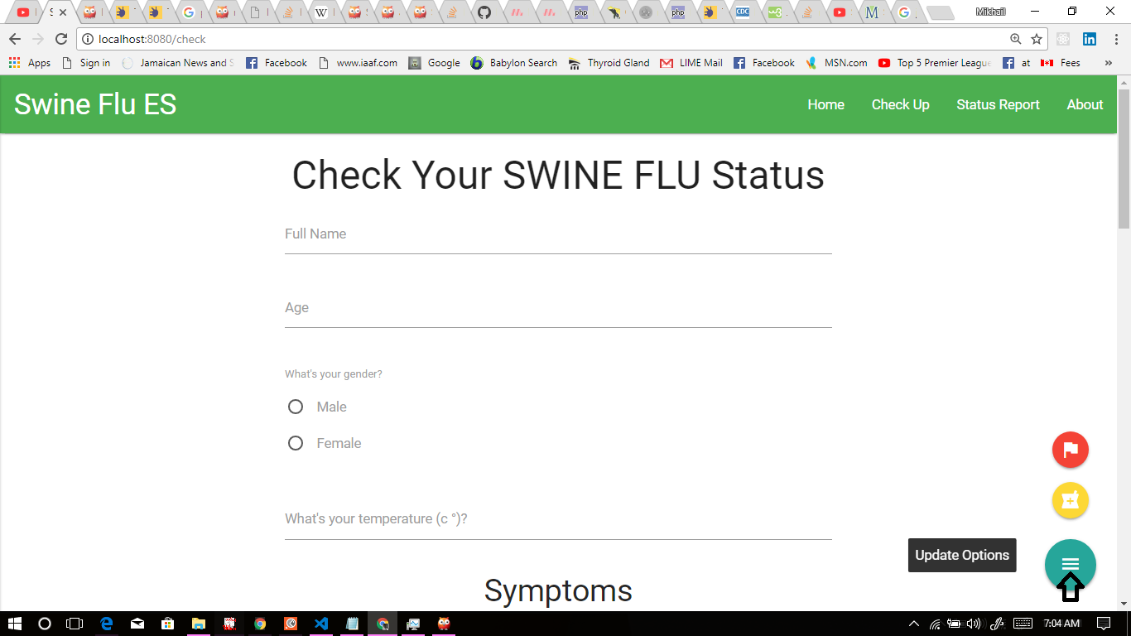

*Figure 5.2.5 Showing the Update Options Menu*

From here the admin can choose to update the prevention or drug databases by clicking each’s specific buttons in the “Update Options” menu.

*Figure 5.2.6 Showing Update Drug Database Option Figure 5.2.7 Showing Update Prevention Database Option*

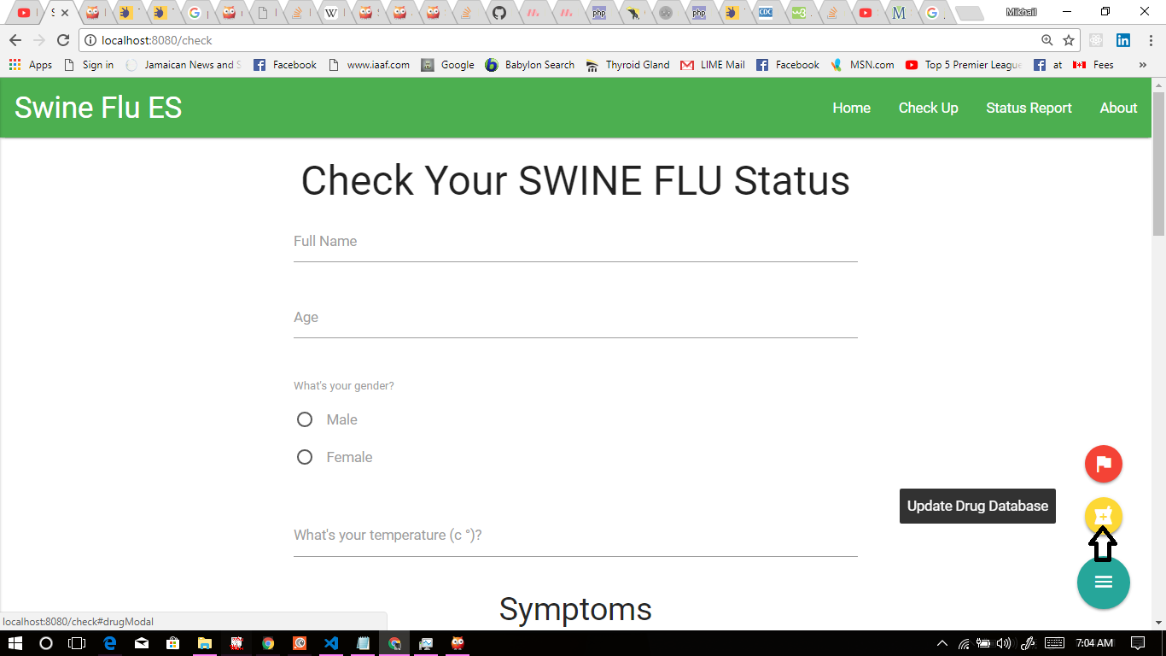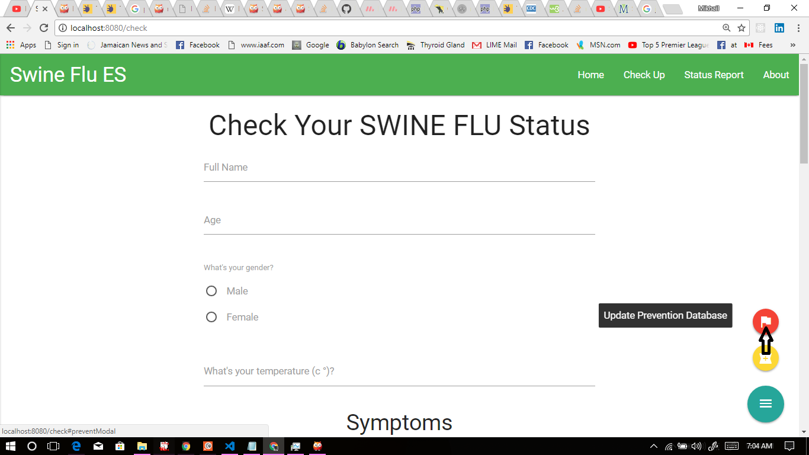

After clicking either buttons the admin will be given a simple form to fill out and submit. After submission the admin will be directed to the homepage.

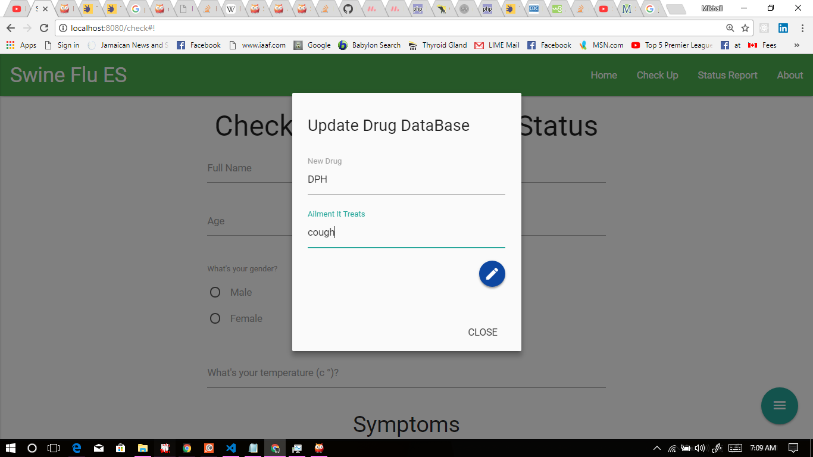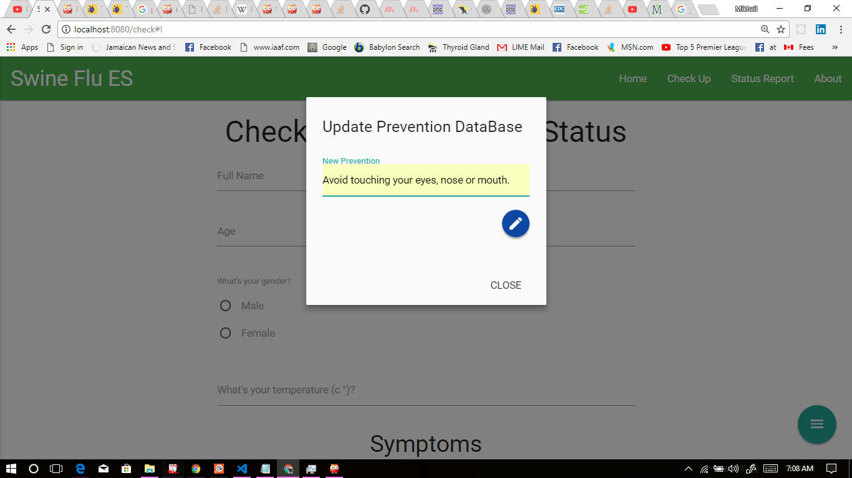

*Figure 5.2.8 Showing Update Drug Database Form Figure 5.2.9 Showing Update Prevention Database Form*

### Status Report Page

*Figure 5.3 Showing The Status Report Page.*

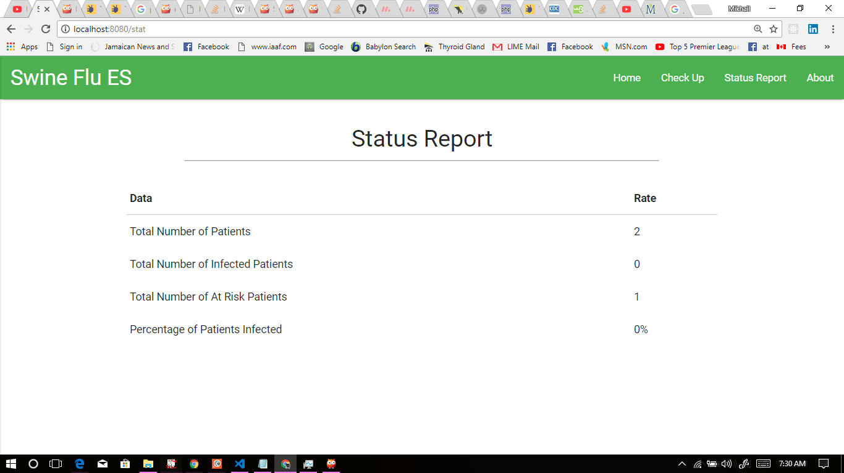

Just like in the Console version, the Status Report page displays a table displaying the session’s statistical report:

* The current number of patients
* The current number of infected patients
* The current number of at risk patients
* The current percentage of infected patients