Mickael Siar

BTS CIEL IR1

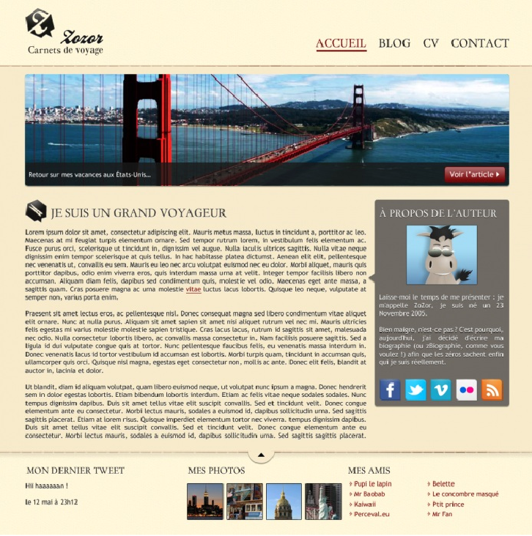

Contenu <aside>

Contenu section/section

footer

DIV

header