Relation between helical axis and joint angles:

 equals 

 with 

(i.e. inverse of the determinant of **A** times the matrix of co-factors)



These thetas about **e**1, **e**2 and **e**3 are almost equivalent to the Euler angles (see Figure 1).

How the uncertainty (variability) propagate from **k***θ* to the joint angles shall be theoretically (e.g. Farrance & Frenkel, 2012) and experimentally analysed (Figure 1).

Ian Farrance and Robert Frenkel, 2012. Uncertainty of Measurement: A Review of the Rules for Calculating Uncertainty Components through Functional Relationships. Clin Biochem Rev; 33(2): 49–75

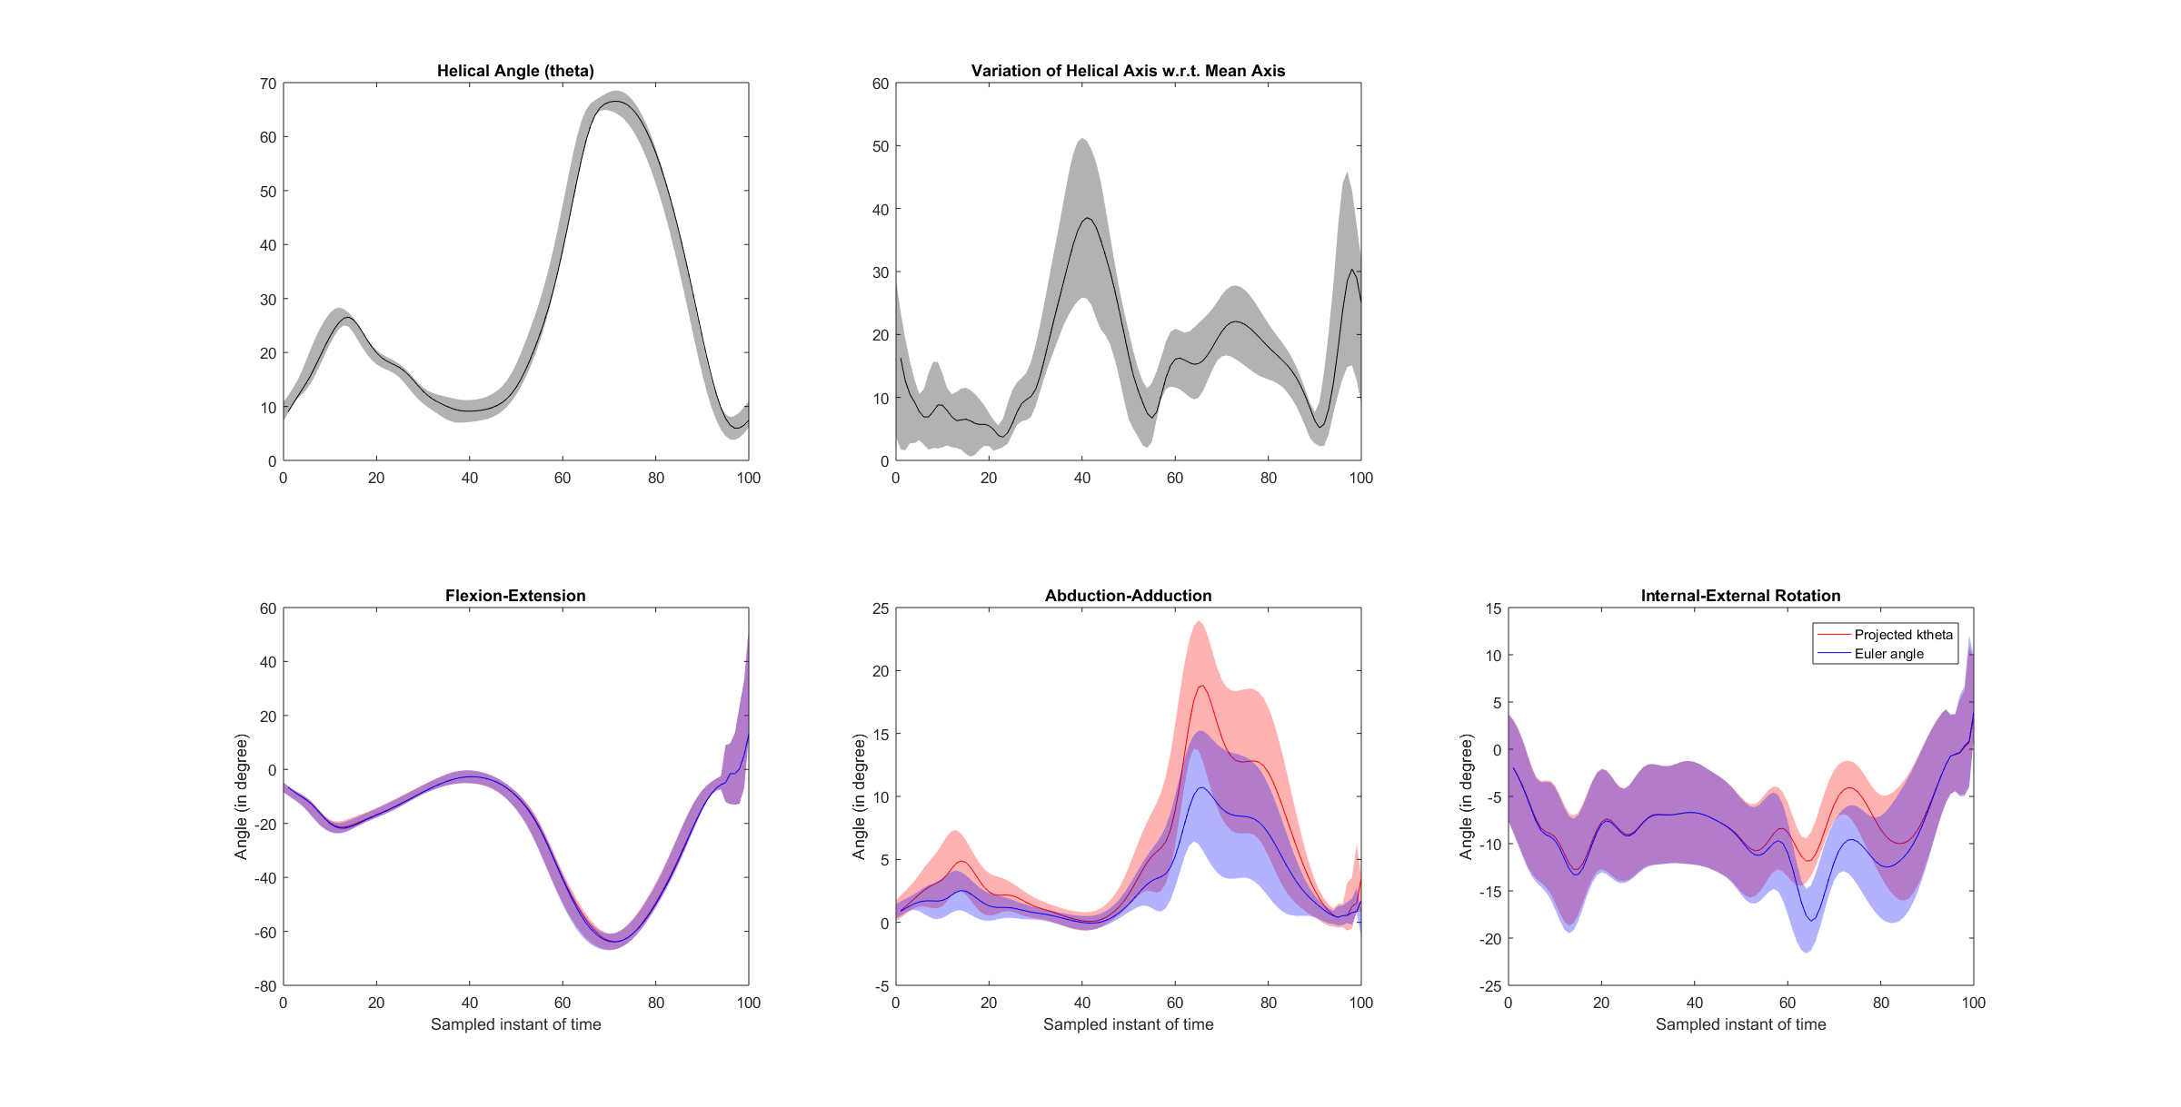

Figure 1