Capstone Project

Springboard

Angelo Pacifico

How estimate the loss of load for a pump measuring the tension and the intensity. This pump provides the water consumed by intelligent greenhouse. The hydroponic culture use in water different nutriment that will be consumed by the vegetable. This element in water after a given saturation level will produce a filter clogging. The filter are changed today at a regular internal, every 15 days. So, the idea is to alert the user of the greenhouse on the time when the filter must be changed and optimize this maintenance to reduce operation when filter are clean.

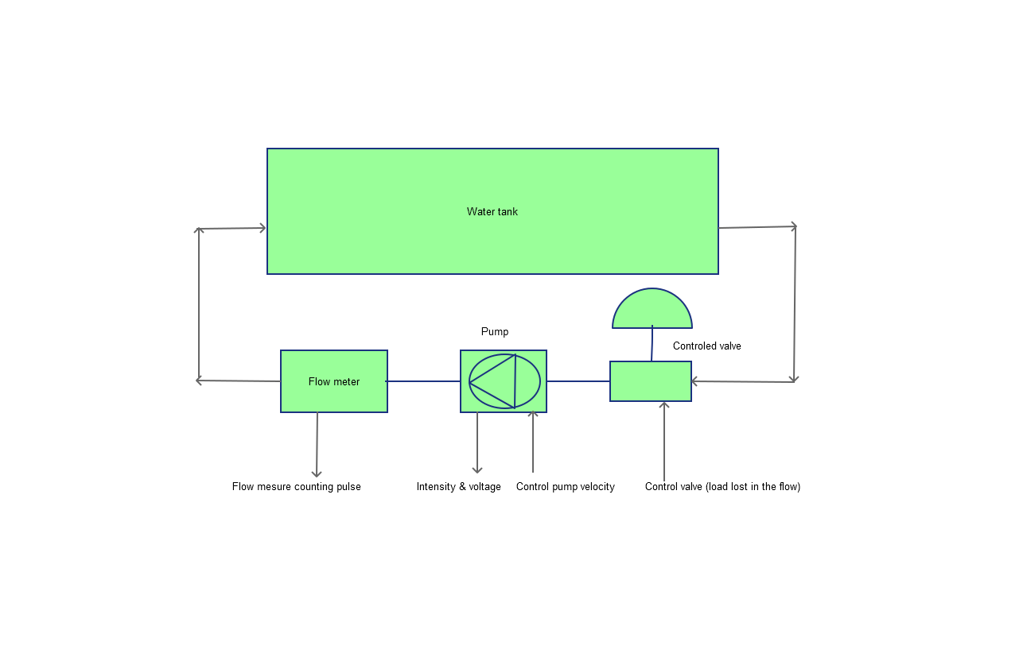

This schema represents the lab that will be used to capture the measure.

The idea is to use the valve to simulate pump filter clogging. The valve is controlled by a voltage varying from 0 to 10V representing the completely close to the completely open valve position.

The velocity of the pump is also controlled

The intensity and the voltage of the pump will be measured.

A flow meter is used to provide a real measure of the flow after the pump.

For each type of pump the lab will automatically pilot the load generated by the valve and the velocity of the pump.

For different combination of (valve load and pump velocity), the intensity, the voltage of the pump and a flow measure will be measured.

So the flow meter will be the judge providing the real measure of the flow and:

-Pump intensity

-Pump intensity

-Pump velocity control

- Valve load control

- Pump Model

Will be recorded combined to the flow meter and this will provide the information used in the dataset measure.

The loss of load created by the valve must be estimated with the other information. The idea will be to provide an alert to the user indicated the filter must be replaced.