Impact of the thresh on precision and recall

Formula:

> Precision = TP / (TP + FP)
> Recall = TP / (TP + FN)

With: TP = True positive, FP = False positive, FN = False negative

> Here are some screenshot of the result for the same models but with different value of thresh
> Thresh = 0.5
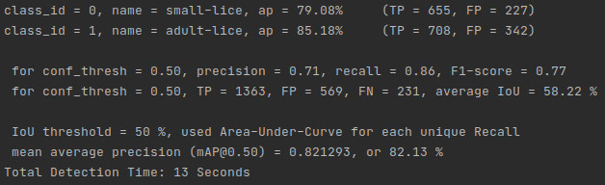
> Thresh = 0.7
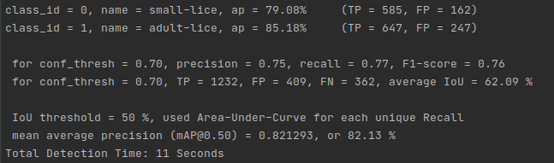
> Thresh = 0.8
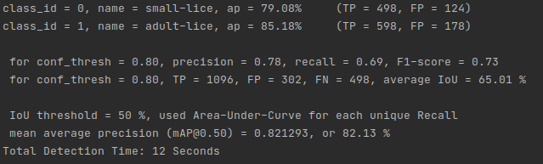

> We can see that when the threshold value increase, the number of FP decrease and the precision score increase.
> We can also notice that when the threshold value increase, the number of FN increase as well and the Recall score decrease

Conclusion: It’s important to find the right threshold if we want to maximize both precision and recall

