localhost:8080/consume

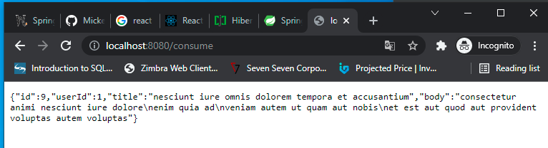

localhost:8080/consume/7

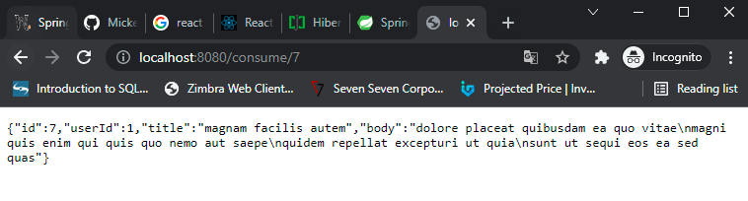

Localhost:8080/consume/all

