Reference: <https://devcenter.heroku.com/articles/deploying-spring-boot-apps-to-heroku#preparing-a-spring-boot-app-for-heroku>



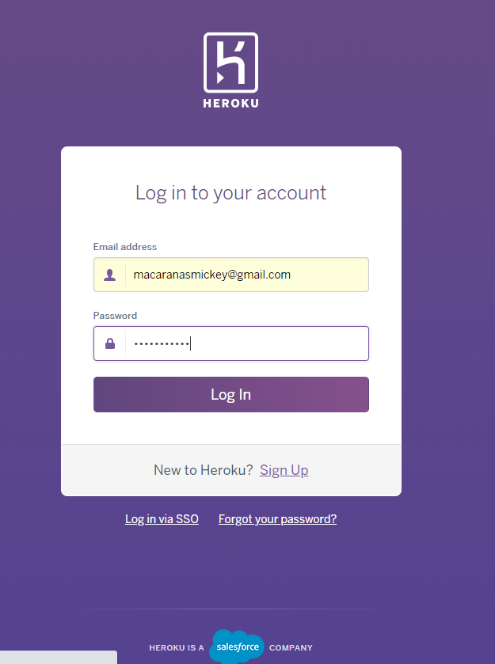

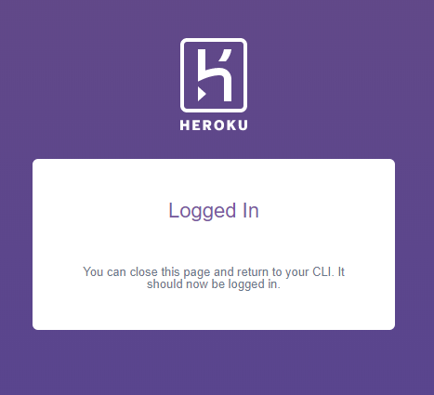

------------------------------------------------------------------------------------------------------------------------------------------

Go to the directory of the app to be deployed:

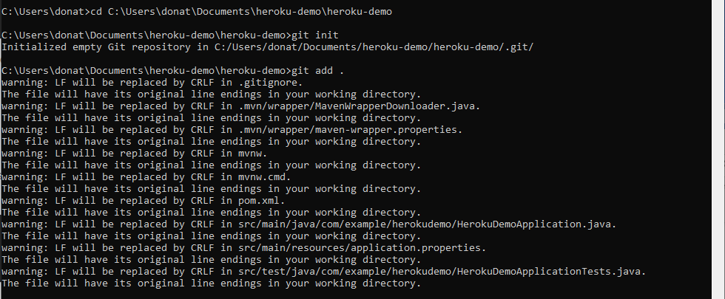

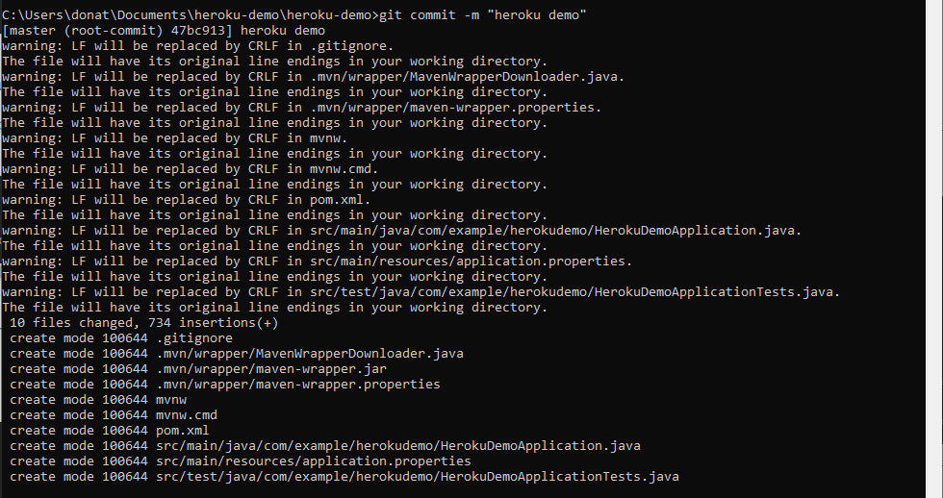

------------------------------------------------------------------------------------------------------------------------------------------

Create Heroku app



------------------------------------------------------------------------------------------------------------------------------------------

Deploy the app

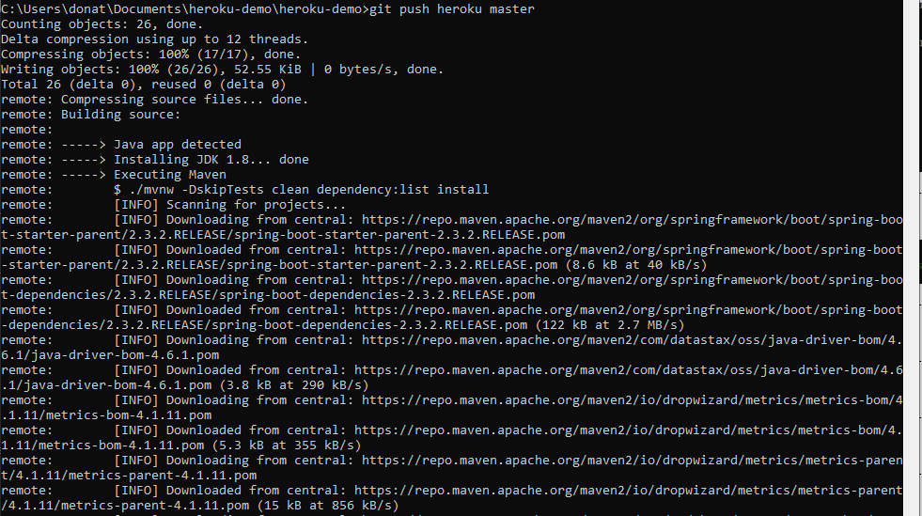

………..

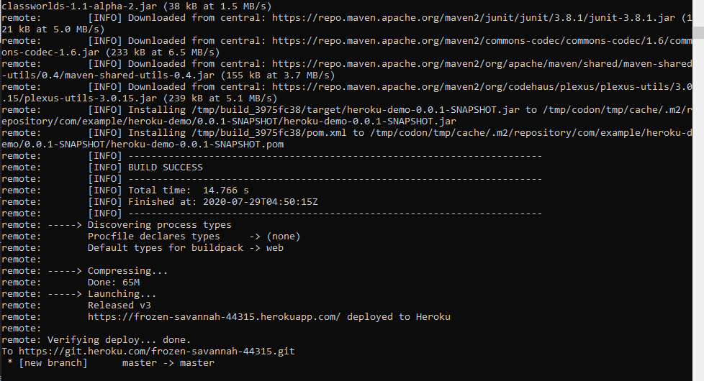

------------------------------------------------------------------------------------------------------------------------------------------

Check the deployed app



Browser will open

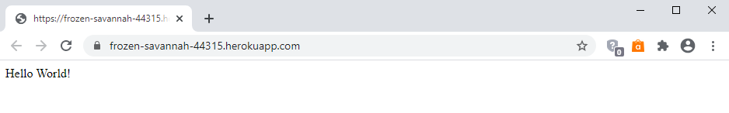

------------------------------------------------------------------------------------------------------------------------------------------

View logs

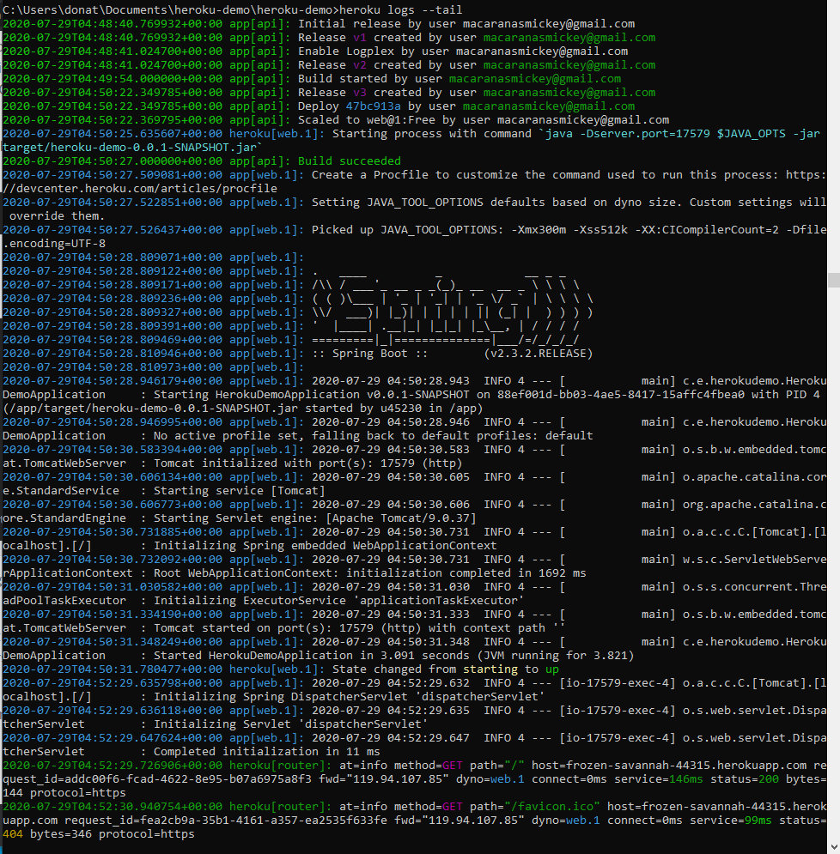

------------------------------------------------------------------------------------------------------------------------------------------

Logging out



------------------------------------------------------------------------------------------------------------------------------------------

Error encountered:

remote: [INFO] BUILD FAILURE

remote: [INFO] ------------------------------------------------------------------------

remote: [INFO] Total time: 12.608 s

remote: [INFO] Finished at: 2020-01-23T18:20:18Z

remote: [INFO] ------------------------------------------------------------------------

remote: [ERROR] Failed to execute goal org.apache.maven.plugins:maven-compiler-plugin:3.8.1:compile (default-compile) on project milliapp: Fatal error compiling: invalid target release: 11 -> [Help 1]

remote: [ERROR]

remote: [ERROR] To see the full stack trace of the errors, re-run Maven with the -e switch.

remote: [ERROR] Re-run Maven using the -X switch to enable full debug logging.

remote: [ERROR]

remote: [ERROR] For more information about the errors and possible solutions, please read the following articles:

remote: [ERROR] [Help 1] http://cwiki.apache.org/confluence/display/MAVEN/MojoExecutionException

remote:

remote: ! ERROR: Failed to build app with Maven

remote: We're sorry this build is failing! If you can't find the issue in application code,

remote: please submit a ticket so we can help: https://help.heroku.com/

remote:

remote: ! Push rejected, failed to compile Java app.

remote:

remote: ! Push failed

remote: Verifying deploy...

remote:

remote: ! Push rejected to deploymilliapp.

remote:

To https://git.heroku.com/deploymilliapp.git

! [remote rejected] master -> master (pre-receive hook declined)

error: failed to push some refs to 'https://git.heroku.com/deploymilliapp.git'

Solution: <https://stackoverflow.com/questions/59885015/failed-to-execute-goal-org-maven-pluginsmaven-compiler-plugin3-8-1compile-de>

Solved. Deleted this part of code

<properties>

<java.version>11</java.version>

</properties>

------------------------------------------------------------------------------------------------------------------------------------------

[how to delete heroku app and switch to the new app created from the same files?](https://stackoverflow.com/questions/48016683/how-to-delete-heroku-app-and-switch-to-the-new-app-created-from-the-same-files)

<https://stackoverflow.com/questions/48016683/how-to-delete-heroku-app-and-switch-to-the-new-app-created-from-the-same-files>

Try destroying the old app:

heroku apps:destroy app1

Note that this will **permanently and irrevocably destroy** app1.

------------------------------------------------------------------------------------------------------------------------------------------

# [Heroku login and logout does not work?](https://stackoverflow.com/questions/11675698/heroku-login-and-logout-does-not-work)

<https://stackoverflow.com/questions/11675698/heroku-login-and-logout-does-not-work#:~:text=Hit%20the%20command%20%22Heroku%20Logout%22%20from%20you%20cli%20terminal.>

Hit the command "**Heroku Logout**" from you cli terminal.

------------------------------------------------------------------------------------------------------------------------------------------