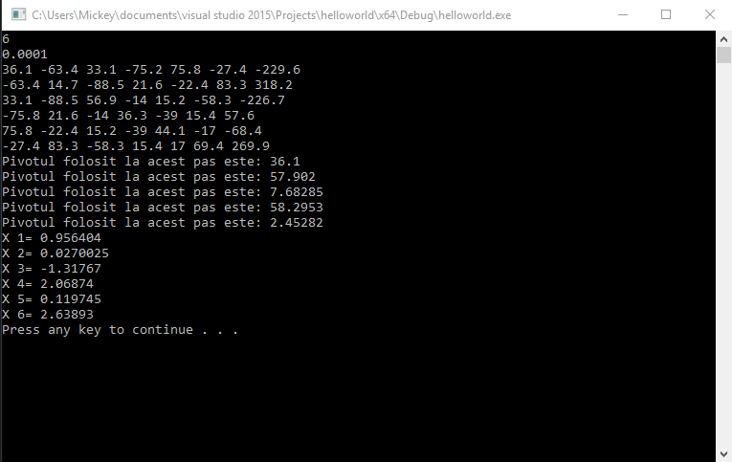

Problema 1:
#include<iostream>
#include<stdlib.h>
#include<stdio.h>
#include<math.h>
#include<conio.h>
using namespace std;
int n, j, i, k, lin, col, c[100][100], npc;
float a[100][100], s, piv, aux, eps;
int main()
{
cin >> n >> eps;
for (i = 1;i <= n;i++)
for (j = 1;j <= n + 1;j++)
cin >> a[i][j];
npc = 0;
for (k = 1;k <= n - 1;k++)
{
piv = fabs(a[k][k]);
cout << "Pivotul folosit la acest pas este: " << piv << endl;
lin = k;
col = k;
for (j = k;j <= n;j++)
for (i = k + 1;i <= n;i++)
{
if (piv<fabs(a[i][j]))
{
piv = fabs(a[i][j]);
lin = i;
col = j;
}
}
if (piv<eps)
{
cout << "Sistemul nu are solutia unica.";
break;
}
if (lin != k)
for (j = k;j <= n + 1;j++)
{
aux = a[k][j];
a[k][j] = a[lin][j];
a[lin][j] = aux;
}
if (col != k)
{
npc++;
c[npc][1] = k;
c[npc][2] = col;
for (i = 1;i <= n;i++)
{
aux = a[i][k];
a[i][k] = a[i][col];
a[i][col] = aux;
}
}
for (i = k + 1;i <= n;i++)
{
a[i][k] = a[i][k] / a[k][k];
for (j = k + 1;j <= n + 1;j++)
a[i][j] = a[i][j] - a[i][k] * a[k][j];
}
}
if (fabs(a[n][n])<eps)
{
cout << "Sistemul nu are solutia Unica.";
return 0;
}
a[n][n + 1] = a[n][n + 1] / a[n][n];
for (i = n - 1;i >= 1;i--) {
s = 0;
for (j = i + 1;j <= n;j++)
s = s + a[i][j] * a[j][n + 1];
a[i][n + 1] = (a[i][n + 1] - s) / a[i][i];
}
if (npc != 0)
for (i = npc;i >= 1;i--)
{
aux = a[c[i][1]][n + 1];
a[c[i][1]][n + 1] = a[c[i][2]][n + 1];
a[c[i][2]][n + 1] = aux;
}
for (i = 1;i <= n;i++)
cout << "X " << i << "= " << a[i][n + 1] << endl;

system("pause");
return 0;
}
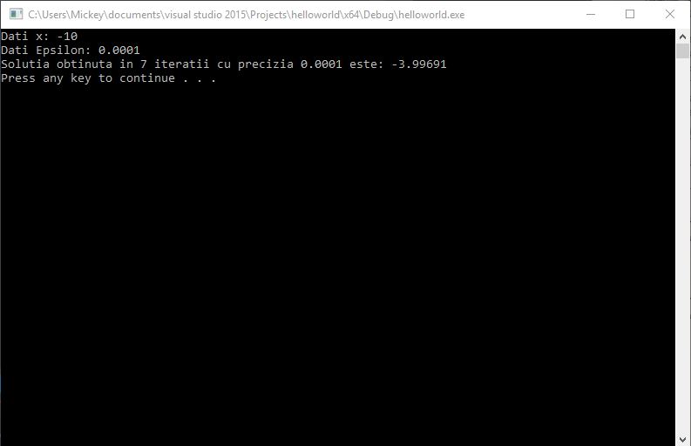

Problema 4:

#include<stdio.h>
#include<conio.h>
#include<iostream>
#include<math.h>
#include<stdlib.h>
using namespace std;
float f(float x)
{
return pow(x,4)-5*pow(x,3)- 12 * pow(x,2)+ 76*x-79;
}
float fprim(float x)
{
return 4 * pow(x, 3) - 15 * pow(x, 2) - 24 * x + 76;
}
float it, eps, dif, x0, x1;
int main()
{
cout<<"Dati x: ";
cin >> x0;
cout<<"Dati Epsilon: ";
cin >> eps;
it = 0;
do
{
x1 = x0 - (f(x0) / fprim(x0));
dif = fabs(x1 - x0);
x0 = x1;
it = it + 1;
} while (dif>eps && it <= 59999);
if (it>59999)
{
cout<<"Nu se poate obtine solutia in "<<59999<<" iteratii cu precizia "<< eps;
return 0;
}
cout<<"Solutia obtinuta in "<<it<<" iteratii cu precizia "<<eps<<" este: "<<x1<<endl;
system("pause");
}

