CSC 555: Mining Big Data
Assignment 1 (due Sunday, January 20th)

Suggested reading: Mining of Massive Datasets: Chapter 1, Chapter 2 (sections 2.1, 2.1 only). Hadoop: The Definitive Guide: Appendix A (available on D2L)
Supplemental document UsingAmazonAWS.doc.

Part 1
- Compute (you can use any tool you wish, but if you do not know to perform this computation, please talk to me about prerequisite courses):
2¹⁰

>>> 2**10
1024

4¹⁰

>>> 4**10
1048576

8⁴

>>> 8**4
4096

842 MOD 100 (MOD is the modulo operator, a.k.a. the remainder)

>>> 842 % 100
42

837 MOD 20

>>> 837 % 20
17

15 MOD 37

>>> 15 % 37
15

37 MOD 15

>>> 37 % 15
7

- Given vectors V1 = (1, 2, 3) and V2 = (2, 1, 3) and a 3x3 matrix M = [(2, 1, 3), (1, 2, 1), (1, 0, 2)], compute:
>>> import numpy as np
>>> V1 = np.array([1, 2, 3])
>>> V2 = np.array([2, 1, 3])
>>> M = np.matrix([[2,1,3],[1,2,1],[1,0,2]])

V2 – V1

>>> V2-V1
array([ 1, -1, 0])

V2 + V1

>>> V2+V1
array([3, 3, 6])

|V1| (vector length, not the number of dimensions)

>>> np.linalg.norm(V1)
3.7416573867739413

|V2|

>>> np.linalg.norm(V2)
3.7416573867739413

M * V1 (matrix times vector, transpose it as necessary)

>>> M * np.transpose(V1[np.newaxis])
matrix([[13],
[ 8],
[ 7]])

M * M (or M²)

>>> M**2
matrix([[ 8, 4, 13],
[ 5, 5, 7],
[ 4, 1, 7]])
M³

>>> M**3
matrix([[33, 16, 54],
[22, 15, 34],
[16, 6, 27]])

- Suppose we are flipping a coin with Head (H) and Tail (T) sides. The coin is not balanced with 0.6 probability of H coming up (and 0.4 of T). Compute the probabilities of getting:
HTTT

>>> 0.6 * 0.4 * 0.4 * 0.4
0.038400000000000004

THTT

>>> 0.4 * 0.6 * 0.4 * 0.4
0.038400000000000004

Exactly 1 Head out of a sequence of 4 coin flips.

# Each combination has the same probability, simply add the probabilities
>>> (0.6 * 0.4 * 0.4 * 0.4) + (0.4 * 0.6 * 0.4 * 0.4) + (0.4 * 0.4 * 0.6 * 0.4) + (0.4 * 0.4 * 0.4 * 0.6)
0.15360000000000004

Exactly 1 Tail out of sequence of 4 coin flips.

# Each combination has the same probability, simply add the probabilities
>>> (0.4 * 0.6 * 0.6 * 0.6) + (0.6 * 0.4 * 0.6 * 0.6) + (0.6 * 0.6 * 0.4 * 0.6) + (0.6 * 0.6 * 0.6 * 0.4)
0.3456

- Consider a database schema consisting of two tables, Employee (ID, Name, Address), Project (PID, Name, Deadline), Assign(EID, PID, Date). Assign.EID is a foreign key referencing employee’s ID and Assign.PID is a foreign key referencing the project.
Write SQL queries for:
- Find unassigned projects (PID and Name of the project).

SELECT PID, Name
FROM Project p
WHERE NOT EXISTS (
SELECT 1
FROM Assign a
WHERE a.PID = p.PID
)

- Find employees that are assigned to more than 3 projects.

SELECT e.ID
, e.Name
, e.Address
, COUNT(a.PID) AS ProjectCount -- not required to return
FROM Employee e
-- Inner join is okay here, we don’t care about employees with no projects
INNER JOIN Assign a
ON a.EID = e.ID
GROUP BY
e.ID
, e.Name
, e.Address
HAVING COUNT(a.PID) >= 3

- Find all projects that have fewer than 3 employees assigned to them (note that this should include 2, 1 and 0 in order to be correct – if you )

SELECT p.PID
, p.Name
, p.DueDate
, COUNT(a.PID) AS EmployeeCount-- not required to return
FROM Project p
LEFT JOIN Assign a
ON a.PID = p.PID
GROUP BY
p.PID
, p.Name
, p.DueDate
HAVING COUNT(a.PID) <= 2

- Mining of Massive Datasets, Exercise 1.3.3

Justify your answer – simply naming a constant will not provide credit.

For c, all nonnegative integers will work except for 0, 3, 5, and their multiples. Meaning in this case, c cannot be a factor or multiple of 15, nor can it have can it have a shared factor with 15. Examples of unacceptable values for c are 0, 3, 5, 6, 9, 10, 12, 15, and multiples of these numbers.

Acceptable values include 1, 2, 4, 7, and any other number not divisible by 3 or 5. The three examples below show equal distributions among buckets.

Using 1 |  |  |  | Using 4 |  |  |  | Using 7
 |  | MOD |  |  |  | MOD |  |  |  | MOD
1 | 15 | 1 |  | 1 | 15 | 1 |  | 1 | 15 | 1
2 | 15 | 2 |  | 5 | 15 | 5 |  | 8 | 15 | 8
3 | 15 | 3 |  | 9 | 15 | 9 |  | 15 | 15 | 0
4 | 15 | 4 |  | 13 | 15 | 13 |  | 22 | 15 | 7
5 | 15 | 5 |  | 17 | 15 | 2 |  | 29 | 15 | 14
6 | 15 | 6 |  | 21 | 15 | 6 |  | 36 | 15 | 6
7 | 15 | 7 |  | 25 | 15 | 10 |  | 43 | 15 | 13
8 | 15 | 8 |  | 29 | 15 | 14 |  | 50 | 15 | 5
9 | 15 | 9 |  | 33 | 15 | 3 |  | 57 | 15 | 12
10 | 15 | 10 |  | 37 | 15 | 7 |  | 64 | 15 | 4
11 | 15 | 11 |  | 41 | 15 | 11 |  | 71 | 15 | 11
12 | 15 | 12 |  | 45 | 15 | 0 |  | 78 | 15 | 3
13 | 15 | 13 |  | 49 | 15 | 4 |  | 85 | 15 | 10
14 | 15 | 14 |  | 53 | 15 | 8 |  | 92 | 15 | 2
15 | 15 | 0 |  | 57 | 15 | 12 |  | 99 | 15 | 9
16 | 15 | 1 |  | 61 | 15 | 1 |  | 106 | 15 | 1
17 | 15 | 2 |  | 65 | 15 | 5 |  | 113 | 15 | 8
18 | 15 | 3 |  | 69 | 15 | 9 |  | 120 | 15 | 0
19 | 15 | 4 |  | 73 | 15 | 13 |  | 127 | 15 | 7
20 | 15 | 5 |  | 77 | 15 | 2 |  | 134 | 15 | 14
21 | 15 | 6 |  | 81 | 15 | 6 |  | 141 | 15 | 6
22 | 15 | 7 |  | 85 | 15 | 10 |  | 148 | 15 | 13
23 | 15 | 8 |  | 89 | 15 | 14 |  | 155 | 15 | 5
24 | 15 | 9 |  | 93 | 15 | 3 |  | 162 | 15 | 12
25 | 15 | 10 |  | 97 | 15 | 7 |  | 169 | 15 | 4
26 | 15 | 11 |  | 101 | 15 | 11 |  | 176 | 15 | 11
27 | 15 | 12 |  | 105 | 15 | 0 |  | 183 | 15 | 3
28 | 15 | 13 |  | 109 | 15 | 4 |  | 190 | 15 | 10
29 | 15 | 14 |  | 113 | 15 | 8 |  | 197 | 15 | 2
30 | 15 | 0 |  | 117 | 15 | 12 |  | 204 | 15 | 9

- Describe how you would implement a MapReduce job consisting of Map and Reduce description. You do not have to write code or even pseudo-code. Just describe, in your own words, what the Map and Reduce tasks are going to do. Map task reads the input file and produces (key, value) pairs. Reduce task takes a list of (key, value) pairs for each key and combines all values for each key.
Please remember that Map operates on individual blocks and Reduce on individual keys with a set of values. Thus, for Mapper you need to state what your code does given a block of data (i.e., for each block, not for the whole file) and for Reduce you need to state what your reducer does for each key (without being able to see other keys).
For a data file that contains the following columns: (ID, First, Last, Grade)

  - Find the average of all grades in the input file, i.e.,
SELECT AVG(Grade) FROM Student.
(hint: the number of distinct keys used should match the number of results you expect)

For this query, for all of the data in all blocks of data, the mapper(s) will produce a single key for all values because every record is to be aggregated into a single result. A single reducer will receive all of the Grade values associated with the single key and will perform the averaging of Grade values. In this case, the key itself is arbitrary.

  - For each first name, find the GPA (grade point average) of each student, i.e.,
SELECT First, AVG(Grade) FROM Student GROUP BY First.

For each block, the mapper will use the First column to determine the key and pair the associated Grade value with the key. The reducer(s) will calculate the average grade values for each of the keys, i.e. first name.

  - For each full student name, find the best grade, i.e.,
SELECT First, Last, MAX(Grade) FROM Student GROUP BY First, Last.

For each block of data, the mapper(s) will use both the First and Last columns as a combined key and pair the combination with the associated Grade value for that pair. The reducer(s) will evaluate the Grade values for each of the keys and determine the maximum grade for each key, i.e. first and last name.

Part 2: Linux Intro

This part of the assignment will serve as an introduction to Linux. Make sure you go through the steps below and submit screenshots where requested – submit the entire screenshot of a command terminal.

Use at least a t2.small instance or Hadoop may not run properly with insufficient memory.
All Linux commands are in Berlin Sans FB. Do not type the “$” symbol. The “$” represents the prompt “[ec2-user@ip-xxx-xx-xx-xxx ~] $ ” in your particular Linux instance.

0. Login to your Amazon EC2 Instance (NOTE: instructions on how to create a new instance and log in to it are provided in a separate file, UsingAmazonAWS.doc)

Connect to your instance through Putty.
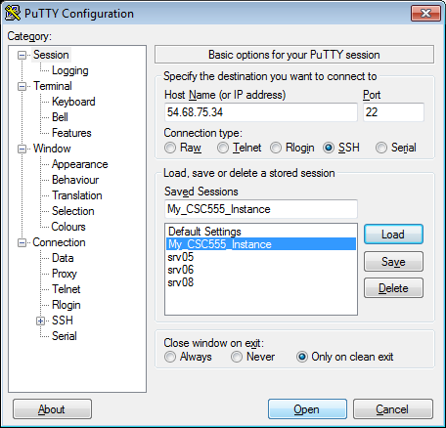

Your instance should look like as the following image:

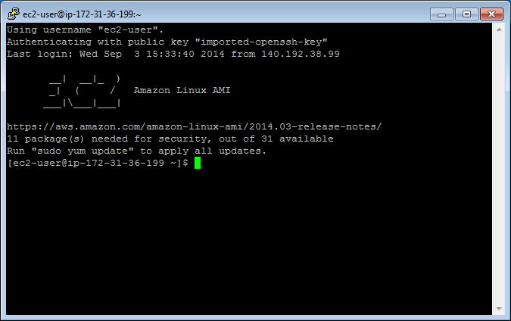

1. Create a text file.
Instructions for 3 different text editors are provided below. You only need to choose one editor that you prefer. nano is a more basic text editor, and is much easier to start. vim and emacs are more advanced and rely on keyboard shortcuts quite a bit and thus have a steeper learning curve.
• Tip: To paste into Linux terminal you can use right-click. To copy from the Linux terminal, you only need to highlight the text that you want to copy with your mouse. Also please remember that Linux is case-sensitive, which means Nano and nano are not equivalent.

Nano Instructions(Option 1):

$ nano myfile.txt
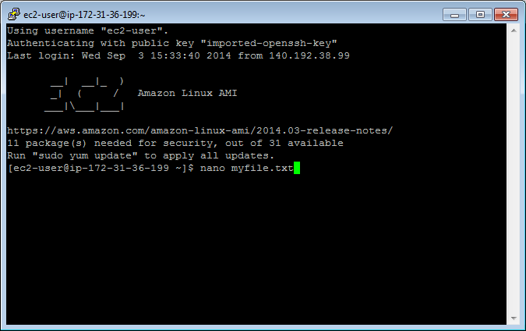

Type something into the file: “This is my text file for CSC555.”
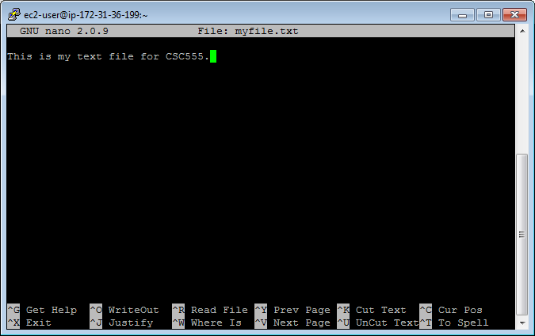
Save changes: Ctrl-o and hit Enter.
Exit: Ctrl-x

Emacs Instructions(Option 2):

You will need to install emacs.
$ sudo yum install emacs
Type “y” when asked if this is OK to install.

$ emacs myfile.txt
Type something into the file: “This is my text file for CSC555.”
Save changes: Ctrl-x, Ctrl-s
Exit: Ctrl-x Ctrl-z

Vim Instructions(Option 3):
• NOTE: When vim opens, you are in command mode. Any key you enter will be bound to a command instead of inserted into the file. To enter insert mode press the key “i”. To save a file or exit you will need to hit Esc to get back into command mode.

$ vim myfile.txt
Type “i” to enter insert mode
Type something into the file: “This is my text file for CSC555.”
Save changes: hit Esc to enter command mode then type “:w”
Exit: (still in command mode) type “:x”

Confirm your file has been saved by listing the files in the working directory.
$ ls
You should see your file.
Display the contents of the file on the screen.
$ cat myfile.txt

Your file contents should be printed to the terminal.
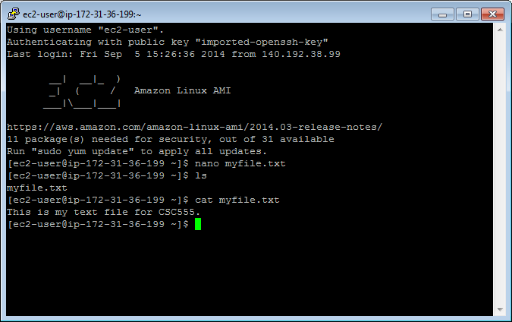

• Tip: Linux will fill in partially typed commands if you hit Tab.
$cat myfi
Hit Tab and “myfi” should be completed to “myfile.txt”. If there are multiple completion options, hit Tab twice and a list of all possible completions will be printed. This also
applies to commands themselves, i.e. you can type in ca and see all possible commands that begin with ca.

2. Copy your file.

Make a copy.
$ cp myfile.txt mycopy.txt
Confirm this file has been created by listing the files in the working directory.
Edit this file so it contains different text than the original file using the text editor instructions, and confirm your changes by displaying the contents of the file on the screen.

SUBMIT: Take a screen shot of the contents of your copied file displayed on the terminal screen.

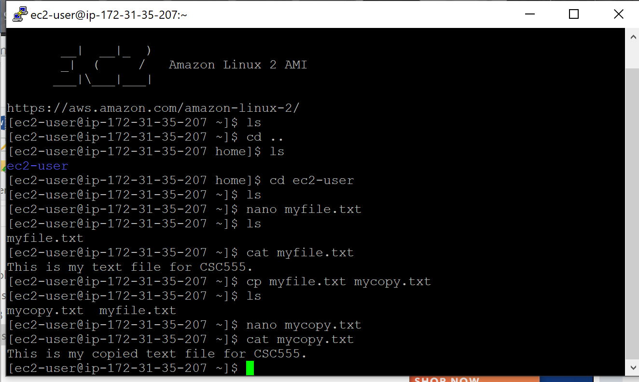

3. Delete a file

Make a copy to delete.
$ cp myfile.txt filetodelete.txt
$ ls

Remove the file.
$ rm filetodelete.txt
$ ls

4. Create a directory to put your files.

Make a directory.
$mkdir CSC555

Change the current directory to your new directory.
$cd CSC555

Print your current working directory
$pwd

5. Move your files to your new directory.

Return to your home directory.
$cd
OR
$cd ..
OR
$ cd /home/ec2-user/

• NOTE: cd will always take you to your home directory. cd .. will move you up one directory level (to the parent). Your home directory is “/home/[user name]”, /home/ec2-user in our case

Move your files to your new directory.

$ mv myfile.txt CSC555/
$ mv mycopy.txt CSC555/

Change the current directory to CSC555 and list the files in this directory.

SUBMIT: Take a screen shot of the files listed in the CSC555 directory.

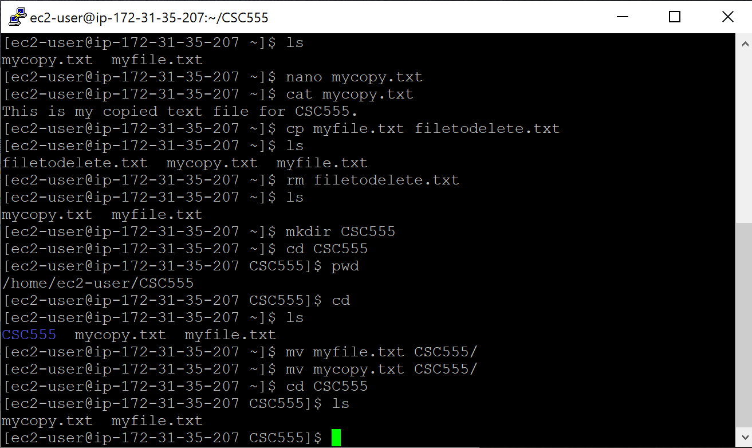

6. Zip and Unzip your files.

Zip the files.
$ zip myzipfile mycopy.txt myfile.txt
OR
$ zip myzipfile *

• NOTE: * is the wildcard symbol that matches everything in current directory. If there should be any additional files in the current directory, they will also be placed into the zip archive. Wildcard can also be used to match files selectively. For example zip myzipfile my* will zip-up all files beginning with “my” in the current directory.

Move your zip file to your home directory.
$ mv myzipfile.zip /home/ec2-user/

Return to your home directory.
Extract the files.
$ unzip myzipfile.zip

SUBMIT: Take a screen shot of the screen after this command.

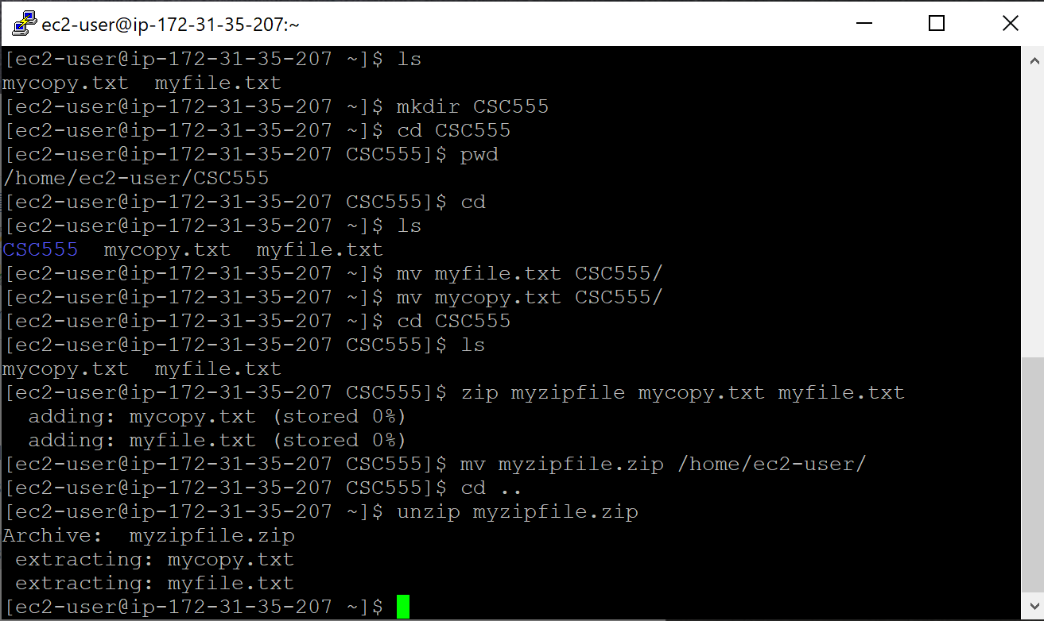

7. Remove your CSC555 directory.

• Warning: Executing “rm -rf” has the potential to delete ALL files in a given directory, including sub-directories (“r” stands for recursive). You should use this command very carefully.
Delete your CSC555 directory.
$ rm -rf CSC555/

8. Download a file from the web.

Download the script for Monty Python and the Holy Grail.
$ wget http://www.textfiles.com/media/SCRIPTS/grail

The file should be saved as “grail” by default.

9. ls formats

List all contents of the current directory in long list format.
• Note: the option following “ls” is the character “l”; not “one”.
$ ls -l

The 1st column gives information regarding file permissions (which we will discuss in more detail later). For now, note that the first character of the 10 total will be “-“ for normal files and “d” for directories. The 2nd Column is the number of links to the file. The 3rd and 4th columns are the owner and the group of the file. The 5th column displays the size of the file in bytes. The 6th column is the date and time the file was last modified. The 7th column is the file or directory name.

List all contents of the current directory in long list and human readable formats. “-h” will put large files in more readable units than bytes.
$ ls -lh

SUBMIT: The size of the grail file.

74,635 bytes or 73K

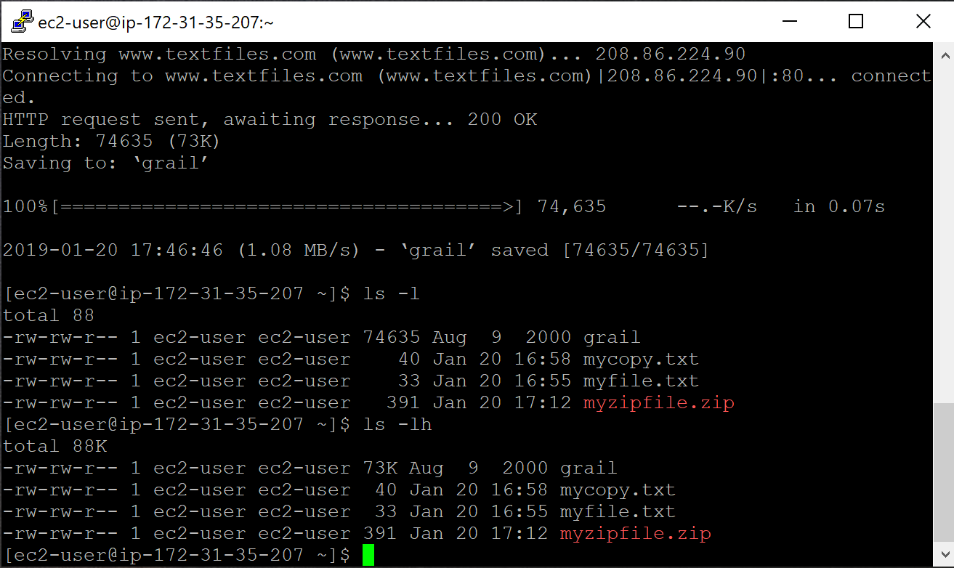

10. More on viewing files.

If you issue “cat grail”, the contents of grail will be printed. However, this file is too large to fit on the screen.

Show the grail file one page at a time.
$ more grail
Hit the spacebar to go to the next page. Type “b” to go page up, hit “space” key to go page down. Type “q” to quit.

OR

$ less grail
Less has more options than more (“less is more and more is less”). You can now use the keyboard Arrows and Page Up/Down to scroll. You can type “h” for help, which will display additional options.

View the line numbers in the grail file. The cat command has the -n option, which prints line numbers, but you may also want to use more to view the file one page at a time. A solution is to pipe the output from cat to more. A pipe redirects the output from one program to another program for further processing, and it is represented with “|”.

$ cat -n grail | more

Redirect the standard output (stdout) of a command.
$ cat myfile.txt > redirect1.txt
$ ls -lh > redirect2.txt

Append the stdout to a file.
$ cat mycopy.txt >> myfile.txt
mycopy.txt will be appended to myfile.txt.

• Note: “cat mycopy.txt > myfile.txt” will overwrite myfile.txt with the contents output by “cat mycopy.txt”. Thus using >> is crucial if you want to preserve the existing file contents.

11. Change access permissions to objects with the change mode command.

The following represent roles:
u – user, g – group, o – others, a - all

The following represent permissions:
r – read, w – write, x – execute

Remove the read permission for your user on a file.
$ chmod u-r myfile.txt
Try to read this file. You should receive a “permission denied” message because you are the user who owns the file.

SUBMIT: The screenshot of the permission denied error
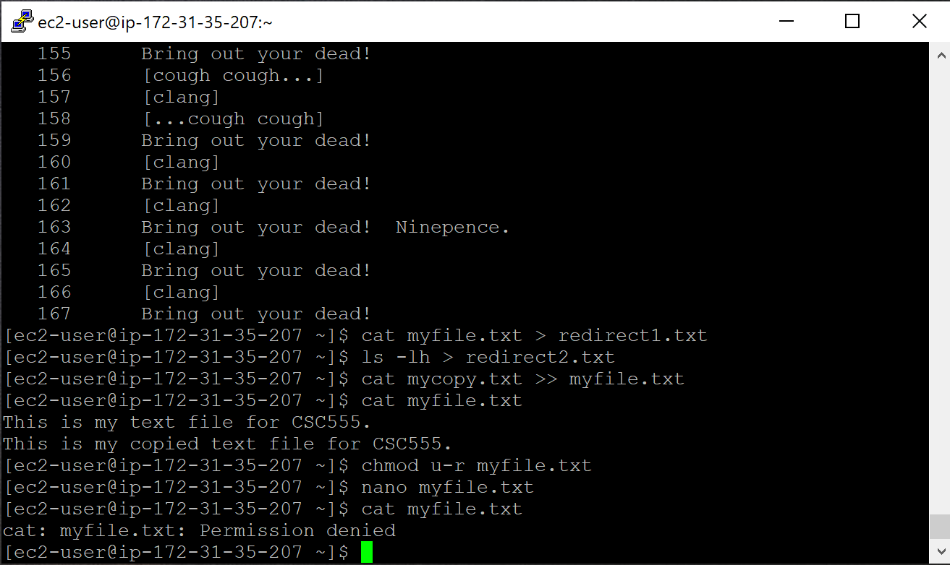

Give your user read permission on a file. Use the same file you removed the read permission from.
$ chmod u+r myfile.txt
You should now be able to read this file again.

12. Python examples

Install Python if it is not available on your machine.

$ sudo yum install python

Create a Python file. These instructions will use Emacs as a text editor, but you can still chose the text editor you want.

$ emacs lucky.py
(Write a simple Python program)
print "*"*22
print "My Lucky Numbers".rjust(20)
print "*"*22

for i in range(10):
lucky_nbr = (i + 1)*2
print "My lucky number is %s!" % lucky_nbr

Run your Python program.
$ python lucky.py

Redirect your output to a file
$ python lucky.py > lucky.txt

Pipe the stdout from lucky.py to another Python program that will replace “is” with “was”.
$ emacs was.py

import sys

for line in sys.stdin:
print line.replace("is", "was")

$ python lucky.py | python was.py

Write python code to read a text file (you can use myfile.txt) and output “word 1 True” if the word had already occurred in that file before or “word 1 False” if this is the first time you encounter this word.

SUBMIT: The screen output from running your python code and a copy of your python code. Homework submissions without code will receive no credit.

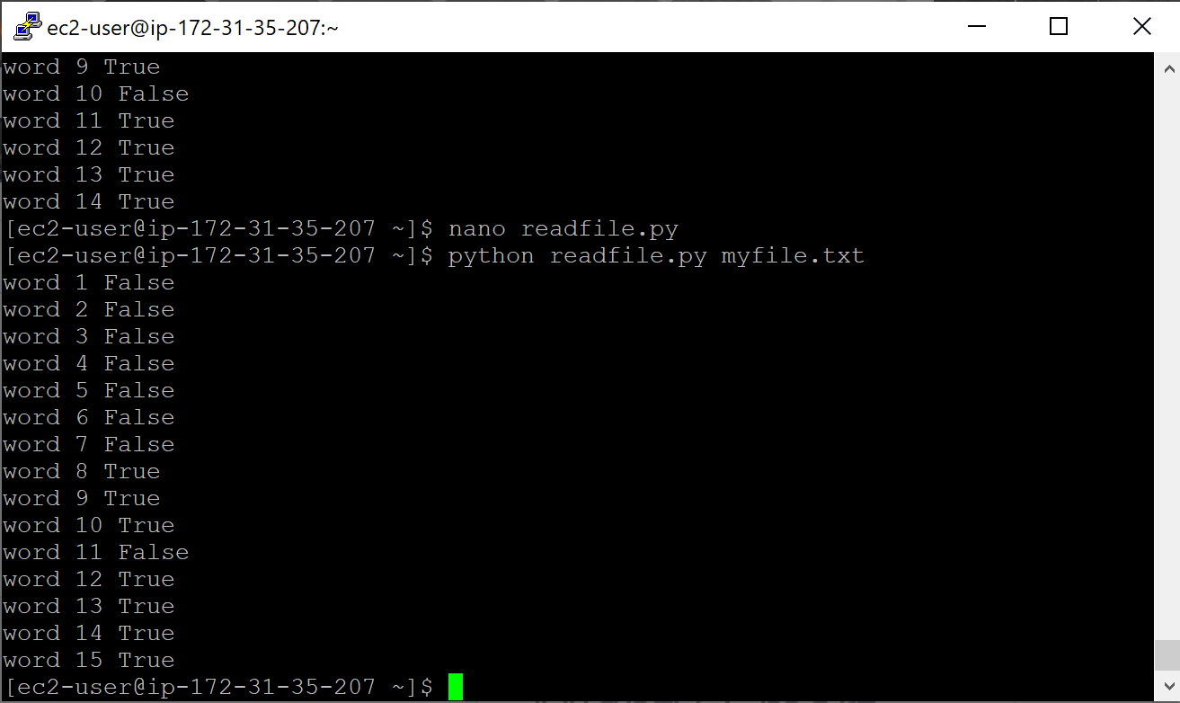

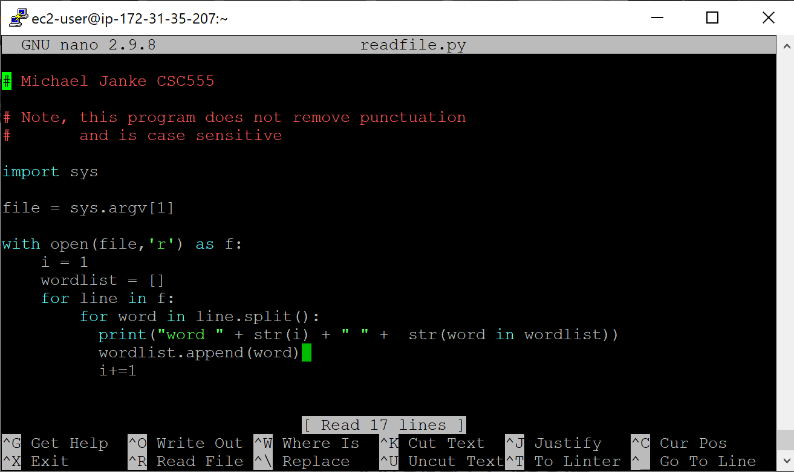

# Michael Janke CSC555

# Note, this program does not remove punctuation
# and is case sensitive

import sys

file = sys.argv[1]

with open(file,'r') as f:
i = 1
wordlist = []
for line in f:
for word in line.split():
print("word " + str(i) + " " + str(word in wordlist))
wordlist.append(word)
i+=1

Part 3: Lab
For this part of the assignment, you will run wordcount on a single-node Hadoop instance. I am going to provide detailed instructions to help you get Hadoop running. The instructions are following Hadoop: The Definitive Guide instructions presented in Appendix A: Installing Apache Hadoop.

You can download 2.6.4 from here. You can copy-paste these commands (right-click in PuTTy to paste, but please watch out for error messages and run commands one by one)
Install ant to list java processes
sudo yum install ant

(wget command stands for “web get” and lets you download files to your instance from a URL link)
wget http://rasinsrv07.cstcis.cti.depaul.edu/CSC555/hadoop-2.6.4.tar.gz

(unpack the archive)
tar xzf hadoop-2.6.4.tar.gz

Modify the conf/hadoop-env.sh to add to it the JAVA_HOME configuration
You can open it by running (using nano or your favorite editor instead of nano).
nano hadoop-2.6.4/etc/hadoop/hadoop-env.sh
Note that the # comments out the line, so you would comment out the original JAVA_HOME line replacing it by the new one as below.

NOTE: you would need to determine the correct Java configuration line by executing the following (underlined) command
[ec2-user@ip-172-31-16-63 ~]$ readlink -f $(which java)
which will output:
/usr/lib/jvm/java-1.8.0-openjdk-1.8.0.191.b12-0.amzn2.x86_64/jre/bin/java

In my case, Java home is at (remove the bin/java from the output above):
/usr/lib/jvm/java-1.8.0-openjdk-1.8.0.191.b12-0.amzn2.x86_64/jre/

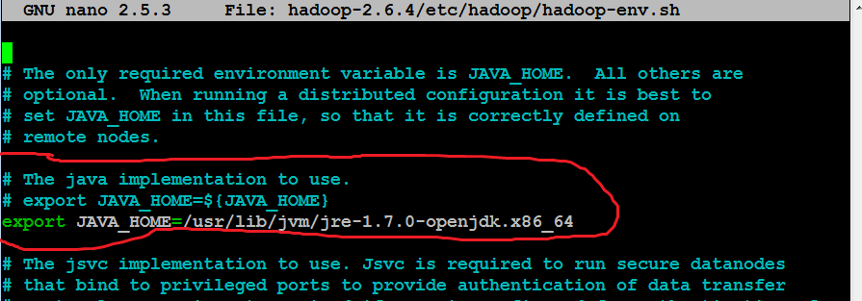

modify the .bashrc file to add these two lines:
export HADOOP_HOME=~/hadoop-2.6.4
export PATH=$PATH:$HADOOP_HOME/bin:$HADOOP_HOME/sbin

.bashrc file contains environment settings to be configured automatically on each login. You can open the .bashrc file by running
nano ~/.bashrc

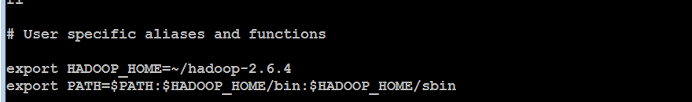

To immediately refresh the settings (that will be automatic on next login), run
source ~/.bashrc

Next, follow the instructions for Pseudodistributed Mode for all 4 files.

(to edit the first config file)
nano hadoop-2.6.4/etc/hadoop/core-site.xml

Make sure you paste the settings between the <configuration> and </configuration> tags, like in the screenshot below. NOTE: The screenshot below is only one of the 4 files, all files are different. The contents of each file are described in the Appendix A in the Hadoop book, the relevant appendix is also included with the homework assignment. I am also including a .txt file (HadoopConfigurationText) so that it is easier to copy-paste.

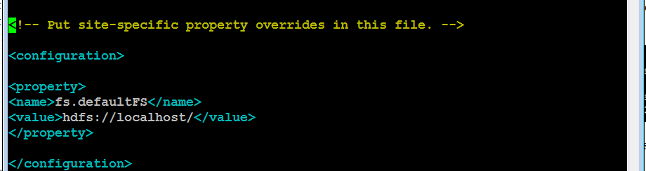

nano hadoop-2.6.4/etc/hadoop/hdfs-site.xml
(mapred-site.xml file is not there, run the following single line command to create it by copying from template. Then you can edit it as other files.)
cp hadoop-2.6.4/etc/hadoop/mapred-site.xml.template hadoop-2.6.4/etc/hadoop/mapred-site.xml
nano hadoop-2.6.4/etc/hadoop/mapred-site.xml
nano hadoop-2.6.4/etc/hadoop/yarn-site.xml

To enable passwordless ssh access (we will discuss SSH and public/private keys in class), run these commands:
ssh-keygen -t rsa -P '' -f ~/.ssh/id_rsa
cat ~/.ssh/id_rsa.pub >> ~/.ssh/authorized_keys

test by running (and confirming yes to a one-time warning)
ssh localhost
exit

Format HDFS (i.e., first time initialize)

hdfs namenode -format

Start HDFS, Hadoop and history server (answer a 1-time yes if you asked about host authenticity)

start-dfs.sh
start-yarn.sh
mr-jobhistory-daemon.sh start historyserver

Verify if everything is running:
jps

(NameNode and DataNode are responsible for HDFS management; NodeManager and ResourceManager are serving the function similar to JobTracker and TaskTracker. We will discuss function of all of those on Thursday.)

Create a destination directory
hadoop fs -mkdir /data
Download a large text file using

wget http://rasinsrv07.cstcis.cti.depaul.edu/CSC555/bioproject.xml

Copy the file to HDFS for processing

hadoop fs -put bioproject.xml /data/

(you can optimally verify that the file was uploaded to HDFS by hadoop fs -ls /data)
Submit a screenshot of this command

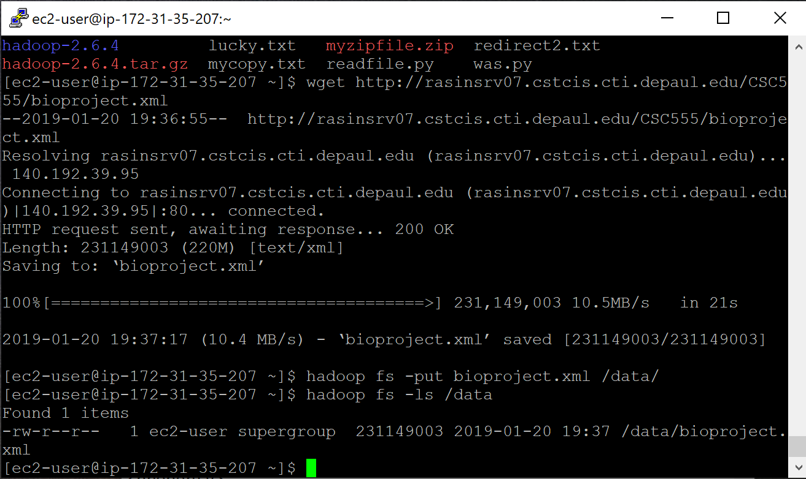
Run word count on the downloaded text file, using the time command to determine the total runtime of the MapReduce job. You can use the following (single-line!) command. This invokes the wordcount example built into the example jar file, supplying /data/bioproject.xml as the input and /data/wordcount1 as the output directory. Please remember this is one command, if you do not paste it as a single line, it will not work.

time hadoop jar hadoop-2.6.4/share/hadoop/mapreduce/hadoop-mapreduce-examples-2.6.4.jar wordcount /data/bioproject.xml /data/wordcount1

Report the time that the job took to execute as screenshot

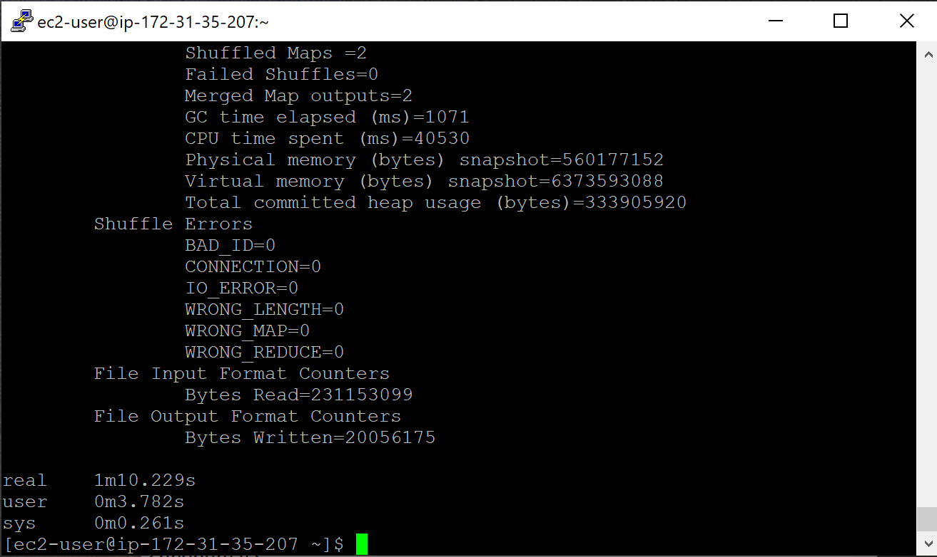
(this reports the size of a particular file or directory in HDFS. The output file will be named part-r-00000)
hadoop fs -du /data/wordcount1/

(Just like in Linux, the cat HDFS command will dump the output of the entire file and grep command will filter the output to all lines that matches this particular word). To determine the count of occurrences of “subarctic”, run the following command:

hadoop fs -cat /data/wordcount1/part-r-00000 | grep subarctic

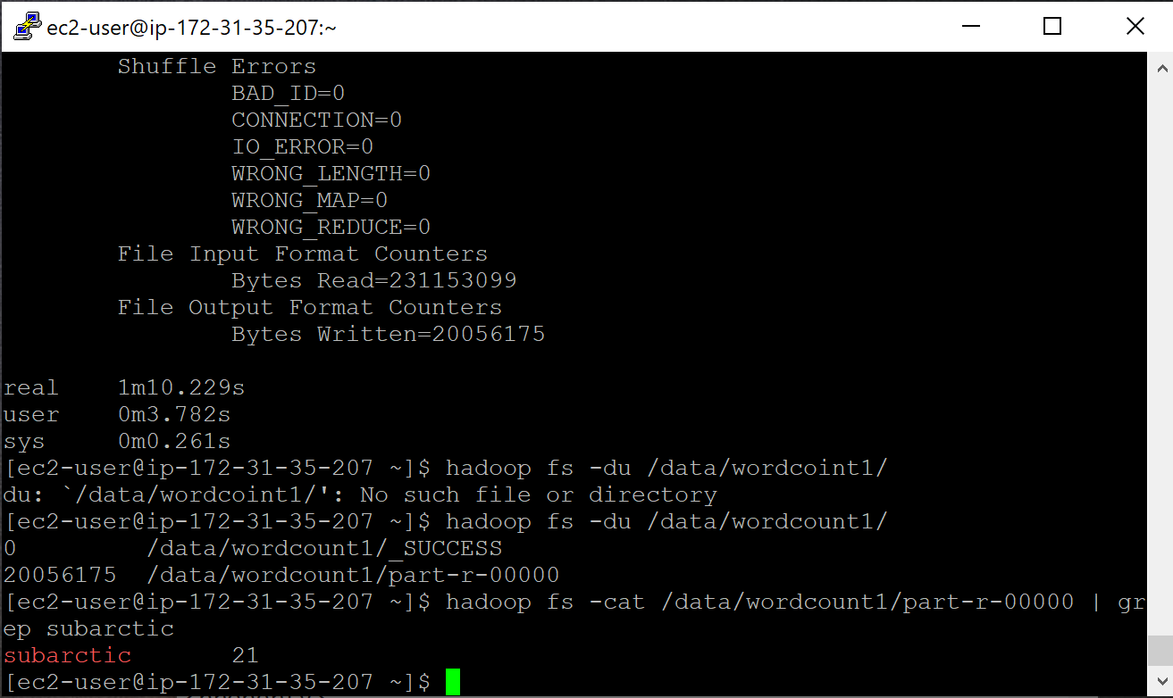

It outputs the entire content of part-r-00000 file and then uses pipe | operator to filter it through grep (filter) command. If you remove the pipe and grep, you will get the entire word count content dumped to screen, similar to cat command.

Congratulations, you just finished running wordcount using Hadoop.

Submit a single document containing your written answers. Be sure that this document contains your name and “CSC 555 Assignment 1” at the top.

