**The Report of ITP4506 - Assignment**

**(Human Computer Interaction & GUI Programming)**

**IT114105 - 2B**

**Group number:**

**B06**

|  |  |  |  |
| --- | --- | --- | --- |
| **Student ID** | **Name** | **Contribution** | **Signature** |
| 180146445 | Tse Kai Chun | 50% |  |
| 180145798 | Mak Ho Ying | 50% |  |

**A.** **User Analysis** 3

**1.** **User Characteristics** 3

**2.** **Techniques for observing and listening to users** 4

**1. Viewer** 4

**2. Operator** 4

**3.** **Environment Analysis** 5

**4.** **Recruiting Users** 5

**5.** **Task Analysis (HTA)** 6

**Register** 6

**Login** 7

**Searching restaurants** 8

**View restaurants information** 9

**Order a take-away menus** 10

**Comment to restaurant** 10

**Add a restaurant to my favorite** 11

**View my favorite restaurants** 11

**Delete a restaurant from my favorite restaurants** 12

**Contact us** 12

**About us** 13

**Edit personal detail (profile)** 13

**Manage restaurant** 14

**Manage user** 14

**B. Web Design Concepts** 15

**Design Principles** 15

1. **User Analysis**
2. **User Characteristics**

Our target users are public diners who have the basics of Information Technology such as teenager and adults. There are three main types of users, which are non-members diners, member diners and restaurant manager. We will develop a clear, concise and user-friendly restaurants online portal service system. Therefore, we fostered the understanding of users to satisfy their needs.

Most of our users have computer experience with search on Internet, use social platforms such as Facebook in daily life, so we see them as “do-then-read” and “Expert” users. This type of users are get used to use this type of system that they do not need detailed teaching required. So that, there maybe have not teaching required in our service system. However, we will add some hints if need.

We also considered our users’ preferred web tools, interaction techniques and interaction with the interface. For example, we reference some common popular sites such as Google, social platforms such as Facebook and other restaurants service system. So that, we make the navigation bar on the top of page that can able to match user habits. In addition, there are the list on the page of left that can show classified restaurants information.

As we know, different users maybe have physical differences. So we use the font size will not very small that can take care of a wider range of people. Also, we reduced use of black and dark backgrounds at the same time.

For the cultural differences, people in Hong Kong are from all over the world that they will have different cultural. Also, there are a lot of restaurants dishes in Hong Kong too. So we will provide different type of restaurants to suit with the need of our customers. Therefore, users from different regions can also use our system suitably. According to the above, English is the international language that can take care of more people. So that we will use English in our system.

About our restaurants online portal service system, it is provide the general restaurants online portal service to meet our user need for searching service with their basic personal preferences and take-away order. Moreover, operator such as restaurant manager can manage their restaurant and administrator has highest permission to manage all user data in the system. Therefore, all signed up user can add their favorite restaurant to their my favorite and comment in the restaurant page.

1. **Techniques for observing and listening to users**

Our target users can be simplify divided into 2 types:

1. Viewer 2. Operator

**1. Viewer**

Viewers are who have the basics of Information Technology such as teenager and adults. The age are between 12 to 65. Traditional techniques will more suitable to them. We need to provide a short and convenient way for them to gain their needs information and express their opinions.

For each type of user, sending email with survey to them is a great choice. It is great for users who are busy but still want to express their own mind. The system is provide contact page for all viewer to give a feedback. As the questioner should have experience or facing some problem on using the system, we can gain more that information to planning in future.

**2. Operator**

Operator is the restaurant manager that we will have a lot of operator. Other than that, they also have their own work that it is very difficult to have a meeting with operators. So, some non-face-to-face interviewing techniques should be the best choice for them.

Online surveys and role playing will be optimal techniques. Online surveys will not use a lot of time and resources that we can send the link of Google Form to all our target user at the same time. Ask simple but deeply question like “What feelings do you have when you click this button with the animation?”, “Where would you be irritating in this page?”

On the other hand, although they are operator, they also can be the diners (viewer) in our system. Other than that, they also can know how their customers place their orders. Because of they are stakeholders, maybe we can have more detailed feedback from them. For example, “Do you have any difficult when using the system?”

1. **Environment Analysis**

Before starting develop the system, we figure where do our users use the interface?

Normally, our users will use our system in everywhere that include quiet place, dazzling environment, but also use the system when walking on the street. So, we provide two interface using for desktop-user and mobile-user. Moreover, the system is pretty quiet.

The mobile interface will adjust to the most suitable size. It may more focus on the main usage, users can see all the functions at once.

The desktop interface may include more items and users can display more detail information. It will adjust to the screen size and the object will change size according to the interface. It is convenient for users who is sitting down or stay in a safety and static environment.

In order to suit the environment, we use a clearly and succinct interface. The background color is white which the main color is in our system. The navigation bar is use dark grey color that it seems tidy and formal. Also, our interface do not included any sound or using bright color. We not only used some lighter color, but also cooperate complementary and analogous color scheme. For the page of operation, we used analogous color scheme of low saturation from yellow to red to separate their function. As for the page of administrator, we also used analogous color scheme of low saturation from green to blue to cooperate. After that, we used complementary color scheme which is lighter blue and yellow at restaurant page that will not spoil comfort and separate different areas on the page. It hopes to provide a comfortable and tidy feelings in any place.

1. **Recruiting Users**

To increase the visibility and popularity of our system, we will create a Operating Agency Page on each most popular social media platforms and share some reviews video and more information about their restaurant.

Regarding recruit colleague (operator)**,** we would like to contact some restaurants and invite them to try our system with free price. That can help us to increase the member of operator in limited time.

1. **Task Analysis (HTA)**

**Register**

0. Register

1. go to “Yummy Everywhere” login page
2. click the hyperlink for “Sign up” to get the form
3. Sign up

Plan 0:

Do 2-3

If the user is not registered, do plan 1-3

Plan 1:

Do plan 1.1-1.2

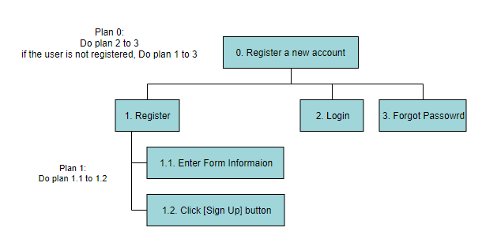

**Login**

0. Login

1. go to “Yummy Everywhere” login page
2. enter the username
3. enter the password
4. tick the remember me if user want to remember (username and password)

Plan 0:

do 2-3

if the user is not registered, do plan 1-3

Plan 2:

do 2.1-2.2

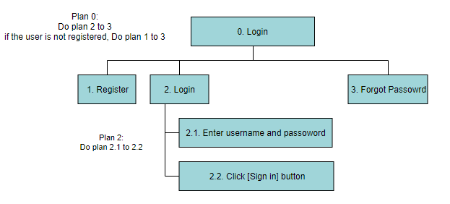

**Searching restaurants**

0. Searching restaurants

1. find the “restaurant” in the navigation bar
2. search by keywords or tags and click the button[search] or click the keyboard[enter] in “The Searching of Restaurant”
3. display the result of searching restaurants

Plan 0:

Do 1-3

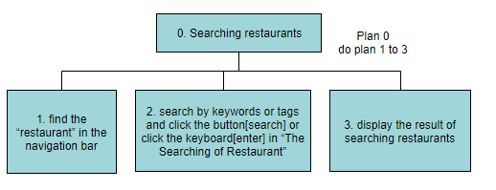

**View restaurants information**

0. View restaurants information

1. click “View more” what restaurants user want
2. View different information with the list on left

2.1. View information

2.2. View menus

2.3. View branches

Plan 0:

Do 1-2

Plan 2:

Do 2.1-2.3

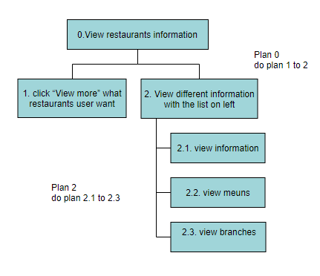

**Order a take-away menus**

0. Order a take-away menus

1. view restaurants information
2. find take-way-menu in menus
3. tick what user want and enter the correct quantity

Plan 0:

Do 1-3

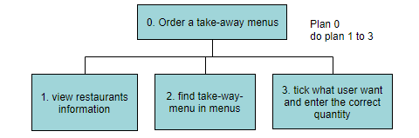

**Comment to restaurant**

0. Comment to restaurant

1. view restaurants information
2. find the review in information
3. Leave review

3.1. Enter what user want to talk

3.2. Click the [leave] button

Plan 0:

Do 1-3

Plan 3:

Do 3.1-3.2

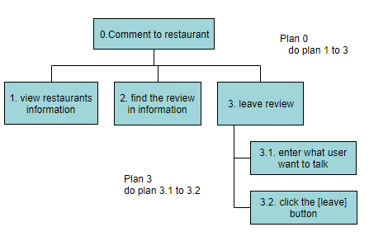

**Add a restaurant to my favorite**

0. Add a restaurant to my favorite

1. view restaurants information
2. view information
3. click the “heart” button

Plan 0:

do 1-3

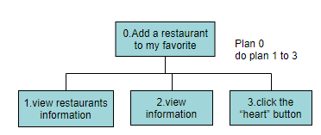

**View my favorite restaurants**

0. View my favorite restaurants

1. find the “Human” logo and hold it from navigation bar
2. choose and click my favorite
3. find which one restaurants user want to view and click the button [view more]

Plan 0:

Do 1-3

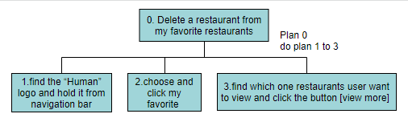

**Delete a restaurant from my favorite restaurants**

0. Delete a restaurant from my favorite restaurants

1. find the “Human” logo and hold it from navigation bar
2. choose and click my favorite
3. find which one restaurants user want to remove and click the button [remove]

Plan 0:

do 1-3

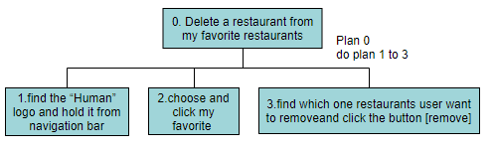

**Contact us**

0. Contact us

1. find the “Contact us” from navigation bar
2. to contact us

2.1 enter your name, email address and the issues.

2.2 click [submit] button

Plan 0:

Do 1-2

Plan 2:

Do 2.1-2.2

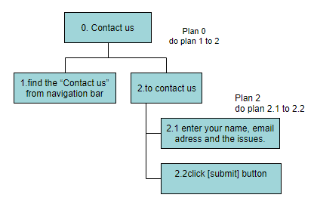

**About us**

0. about us

1. find the “About us” from navigation bar
2. go to about us page

Plan 0:

Do 1-2

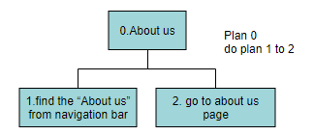

**Edit personal detail (profile)**

0. Edit personal detail (profile)

1. find the “Human” logo and hold it from navigation bar
2. choose and click profile
3. click button [edit]
4. enter personal information and click the button [submit]

Plan 0:

Do 1-4

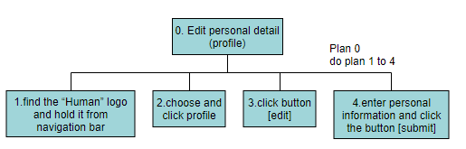

**Manage restaurant**

0. Manage restaurant

1. find the “Manage restaurant” from navigation bar
2. edit restaurant information
3. click the [save] button if user want

Plan 0:

Do 1-3

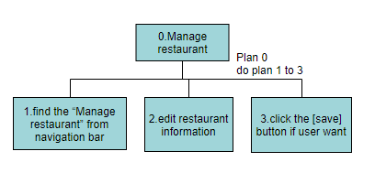

**Manage user**

0. Manage user

1. find the “Manage user” from navigation bar
2. edit user information
3. click the [save] button if user want

Plan 0:

Do 1-3

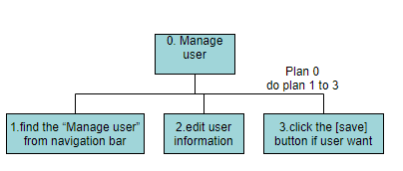

**B. Web Design Concepts**

**Design Principles**

|  |
| --- |
| **Design Principles 1: Mental Models** |
| Description:   * + Mental Model means to use knowledge to understand or make predictions about new situations.   + We use user icon to relate to user in the navigation bar. When user see this icon, they know this is user’s function.   + In the administrator page, we use a pen and a trash can to relate to edit and delete function. Lots of other websites are use this design too, so it is not difficult to relate it. Also, we always use pen to edit something and drop whatever we do not need to trash can in real. And then, we use the human and add icon to means add user. |
|  |

|  |
| --- |
| **Design Principles 2: Affordance** |
| Description:   * + Checkboxes afford user to choose zero or more options, it can make it ideal for choosing something optional or with multiple criteria.   + Number of input type box we default the value of “0” and it have a increase or decrease options on the right when you hover it. It can make user know it is for input number habitually. |
|  |

|  |
| --- |
| **Design Principles 3: Content Organization** |
| Description:   * + Ambiguous Organizational Schemes: Task-oriented   Our navigation bar design form service to functionality   * + Organizational structures:   Structure the pages by restaurant information importance. |
|  |

|  |
| --- |
| **Design Principles 4: Visual Organization** |
| Description:   * Proximity:   We group the related content together, e.g. Restaurant Name, restaurant type.   * Alignment:   The structure of entire system pages except login page are centered. Results of searching restaurant are horizontal alignment. Restaurant information, operator’s, administrator’s page are vertical alignment.   * Consistency:   We use the same color scheme and similar design in operator and administrator manage page. The navigation bar in all page are same.   * Contrast:   The title of difficult details header is larger than body text. Also, the background color of title is difficult than body text. |
| Proximity:  Alignment, Consistency, Contrast:      --------------------------  Operator page      ----------------------------  Administrator page |

|  |
| --- |
| **Design Principles 5: Navigaion** |
| Description:   * Hierarchical:  Our interface organized by hierarchical organizational structure that user can move around the interfaces. * Pop-up menus:   We used pop-up menus on the “user” on the navigation bar. |
|  |