GitHub.IO Pages

# Create a GitHub account

Make sure the account name is appropriate as this could be a username you may use for a very long time on many projects across the industry.

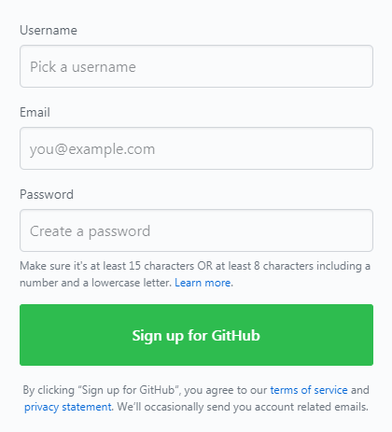

# Create a new repository

In the top right-hand corner of the website you can click the plus icon to open and create a “New repository” this will direct to a new web page.

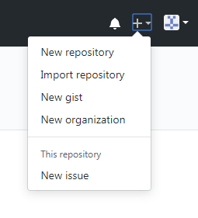

# Define the repository

When creating the repository, you must name the repository the same as your username followed by github.io

Make the repository public or private either way works.

Make sure you tick Initialize this repository with a README.

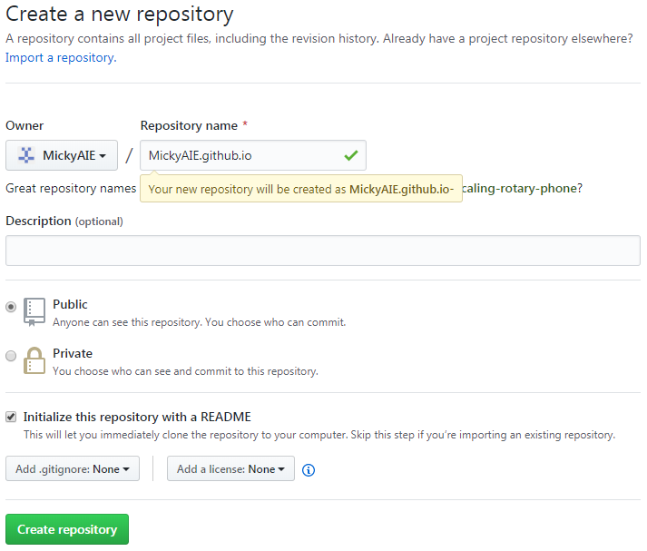

# Clone the repository to your pc

Navigate to where you want to clone it (On Campus it is highly recommended on your student locker drive.)

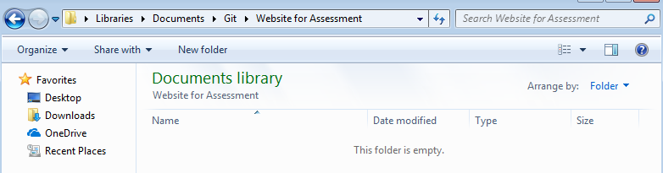

## Open Git CMD

Navigate or search for the program Git CMD.

(For Online: There are other tools that can also be used to with Git, E.g. GitHub Desktop, SourceTree and more.)

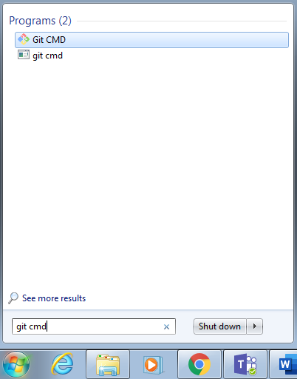

## Navigate to your directory in Git CMD

Once the program is open you will need to change the directory to where you want the project to be cloned too. The CD command allows you to change directory, to change drive consult the documentation though “CD D:” ( CD DriveLetter: ) may work.

The full command would be “CD Drive:/Directory”



## Clone the project

When using any git command, you must include git before any of the commands.

E.g. Git clone “repository”



## Push to repository

When you have made changes to the project and it is time to push to the repository you must ensure you are in the right folder and navigate to the directory once more.



Then proceed with “git add –all” which will add changed files from the repository.



Followed by “ git commit -m “Commit Message” ”



Then the last step is to push the work to the server, this can be done using “git push -u origin master” which will push the work to the master branch of the project.

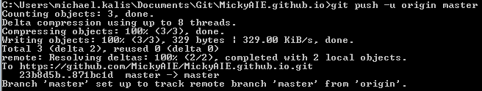

## Open your website in the browser

Finally you can now navigate to the website in your browser https://YourUserName.github.io