Working with Git

# Cloning an existing project

1. First create a new folder or locate a directory that you would like to use to store the project.

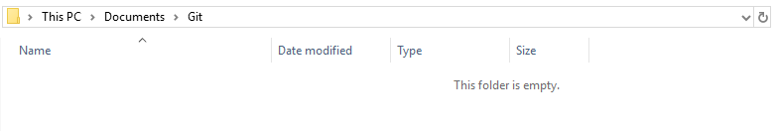

1. Open Git and navigate to the directory that you want the project in.
   1. Use CD to change directory
   2. If you need to change drive use CD DriveLetter:/ e.g. CD C:/



1. When ready get the URL from the repository e.g. https://github.com/MickyAIE/ProjectName.git then in Git Bash/CMD use git clone URL .

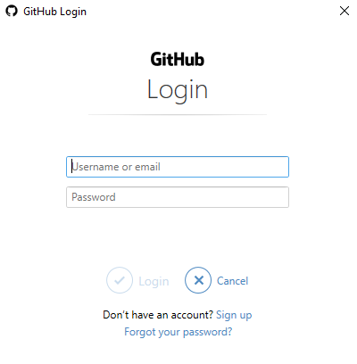

You will be asked to login to the Git Repository that you are using, this should only need to be done once per PC, per User.

1. If it is correct, it should clone the project to the given directory that we navigated to before.

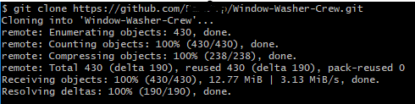

1. You should now see in Explorer that the project is now cloned to the location.

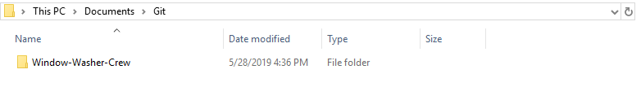

1. Your project is ready to use!

# Committing and pushing changes to the repository

1. When you are ready navigate to the directory, ensure this is inside the folder as per previously cloning a project.



1. In Git Bash/CMD use git add –all



1. Nothing should popup during this, it would have added any file/s that have changed.
2. Now that they are added, we can commit the changes to the repository, do this by using git commit -m “Commit Message” the commit message is important as it tells others who are working on the project what this commit was about.

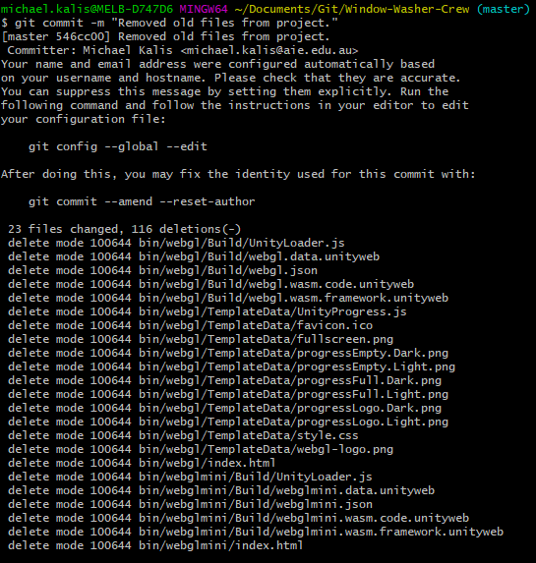

1. The commit will output all the changes that were just done.



1. Now at last we can push these changes to the repository server, we can do this by using git push this last step may take some time depending on your internet connection and how large the changes were to the project.

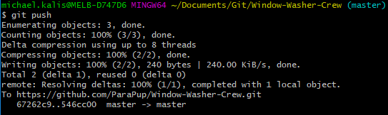

1. During this last stage you may encounter conflicts, follow onwards with Updating your project before you start work particularly after part 4.

# Updating your project before you start work

1. A very important part about using Git is making sure your project is up to date, before starting to work on your project make sure you have the latest copy of the project.
2. You can do this by opening Git Bash/CMD from the location of the project as we have done in prior steps.



1. Now using git pull this will pull any changes since the project was last opened/updated.

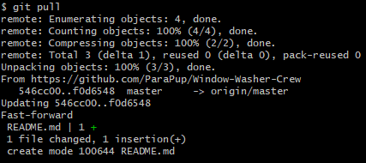

1. During this stage you may encounter conflicts you will need to pull once more.
2. Now proceed by locating the conflicted piece of work if it has headers, clean up the file and repeat “Committing and pushing changes to the repository”.

