NetZero Hub — Service-Oriented Software Engineering
Part E — Microservices Design and Implementation

E.0 Approach and Service Selection
This section selects five services from the platform designed in Parts A–C and implements each as an independently deployable microservice, backed by a working, containerised system rather than a design exercise alone (Week 12 requires a live product demonstration of this part specifically).
Rather than picking five arbitrary services, the selection deliberately reuses work already established in earlier parts, so that Part E's design is traceable end-to-end back to the BSRL specifications (Part A), the BPMN process models (Part B) and the SoaML service contracts (Part C), instead of starting a parallel design:
# | Microservice | Part A service | Part B process (lane) | Part C service contract | Communication pattern
1 | ev-reservation-service | 3.2 Charging Bay Reservation | Process 4 (RSVP management, 4.1–4.8) | Contract 3 (Fig. C.8–C.9) | Synchronous, alt fragment
2 | ev-billing-service | 3.3 Automated EV Billing & Payment | Process 4 (Billing, 4.9–4.12) | Contract 4 (Fig. C.10–C.11) | Asynchronous, event-driven
3 | footprint-service | 5.1 Individual Carbon Footprint Calculator | Process 6 (Assessment, 6.1–6.4, 6.13) | Contract 6 (Fig. C.14–C.15) | Synchronous
4 | offset-service | 5.2 Carbon Offset Purchasing | Process 6 (Offset marketplace, 6.5–6.12) | Contract 7 (Fig. C.16–C.17) | Asynchronous, event-driven
5 | journey-planner-service | 2.1 Carbon-Optimized Journey Planner | Process 3 (3.1–3.13) | Contract 2 (Fig. C.6–C.7) | Synchronous, scatter-gather

Services 1–2 and 3–4 are exactly the two compositions built in Part C §C.3 (EV Charging Session, and Environmental Services). Implementing both halves of each composition as separate microservices lets Part E demonstrate genuine inter-service communication: one service's completed transaction is what triggers the next, rather than five unrelated services that never talk to each other. Service 5 broadens coverage to a third provider (EcoTransit Authority) and exercises a different microservices concern: a stateless aggregating/orchestrating service that calls other data sources in parallel.
The service boundaries follow the BPMN swim-lanes. In Process 4, the "RSVP management" lane (reservation, arrival, pre-authorisation, charging) is ev-reservation-service and the "Billing" lane is ev-billing-service. In Process 6, the "Assessment Service" lane is footprint-service and the offset marketplace is offset-service. Each microservice therefore owns one coherent business capability and its data, which is the decomposition-by-business-capability rule for microservices.
Three architectural decisions were made once and applied consistently across all five services:
- Database-per-service. Each of the four data-owning services has its own SQLite file in its own Docker volume. No service ever queries another's database directly; the only way to read or change another service's data is through its public API (for example, offset-service updates a citizen's net-emissions score by calling footprint-service, not by writing to its table). journey-planner-service is deliberately stateless.
- Synchronous where the outcome is known immediately, asynchronous where it genuinely isn't. This mirrors the distinction Part C draws between its service contracts (§C.0): a contract is asynchronous "because its underlying BPMN model from Part B genuinely involves a delay before the outcome is known". ev-billing-service cannot settle until a session has ended and the payment gateway responds, and offset-service cannot certify until the payment and the registry retirement complete. Both are therefore event consumers rather than functions with a return value, and RabbitMQ carries the asynchronous outcome. ev-reservation-service, footprint-service and journey-planner-service resolve in a single round trip and are plain REST endpoints.
- Every BPMN activity is observable. Each service writes a case-correlated process-event log keyed to the Part B element numbers (§E.5). This makes Part F's process mining possible without changing the services.

E.1 Overall Architecture
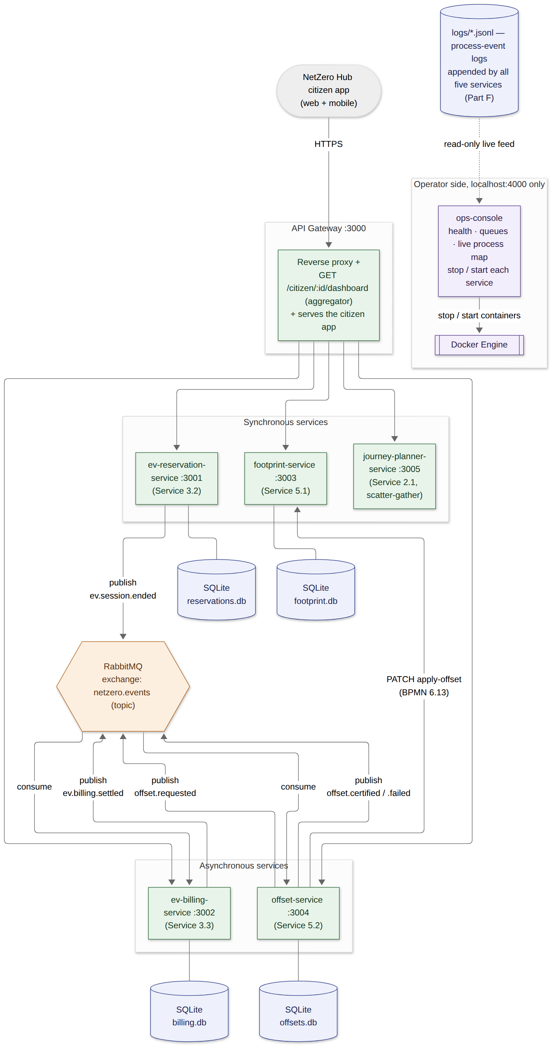
Figure E.1 — Deployment/component architecture: API Gateway, five microservices, RabbitMQ, one SQLite database per data-owning service, the shared process-event log, and the operator console.
The system is deployed as six application containers plus a broker, with an operator console beside them:
- api-gateway is the platform's single external entry point, corresponding directly to the Aggregator port on the Hub side of Part C's Figure C.2 ParticipantArchitecture. It reverse-proxies /api/<resource> to the owning service, and exposes one genuine aggregation endpoint, GET /api/citizen/:userId/dashboard. That endpoint fans out to footprint-service, offset-service and ev-reservation-service in parallel and, for every ended charging session, cross-references ev-billing-service, composing a single citizen view from four services. It also serves the NetZero Hub citizen app, and nothing else: operator tooling is kept off the citizen port.
- ops-console (port 4000, published on localhost only) is the operator side of the platform. It reports every service's health, RabbitMQ queue depth and consumer count, and a read-only tail of the process-event logs, and it can stop and start each microservice and the broker through the Docker Engine API. Because the Docker socket is root-equivalent on the host, the control endpoints are restricted to this compose project's own services (the gateway excluded), to the two actions stop and start, and to requests carrying an X-Ops-Console header, which a browser will not send cross-site without a CORS preflight the console never approves.
- RabbitMQ provides one durable topic exchange, netzero.events. ev-reservation-service publishes ev.session.ended, which ev-billing-service consumes; billing then publishes ev.billing.settled. offset-service publishes and consumes its own offset.requested event to hand work to its background worker, then publishes offset.certified or offset.failed. A real broker (rather than delayed HTTP callbacks) was chosen so the asynchronous nature of these two contracts is genuine: the publisher returns immediately, messages survive a consumer restart (durable queue, persistent messages), and a consumer that is down catches up when it returns.
- Each service is independently built, deployed and scaled (docker-compose.yml), and each stateful service owns an isolated volume.

E.2 Per-Service Design and Implementation

E.2.1 EV Charging Reservation Service (ev-reservation-service, port 3001)
Realises Part A Service 3.2, Part C Service Contract 3, and the "RSVP management" lane of Process 4. Every endpoint is synchronous. The reservation itself returns the alt fragment of Figure C.9: either a confirmed reservation, or a list of alternate stations if the slot is taken.
Endpoint | Method | Purpose | BPMN
/reservations | POST | Reserve a bay for a station/time slot (201, or 409 + alternates) | 4.1, 4.2, 4.3, 4.4
/reservations/:id/start | POST | Driver arrives: authenticate, pre-authorise the estimated cost; 402 if declined (retry by calling again) | 4.5, 4.6, 4.7/4.7a, 4.8 start
/reservations/:id/complete | POST | Driver unplugs; publishes ev.session.ended (only from charging, so a repeat call gets 409) | 4.8 complete
/reservations/:id/no-show | POST | Arrival window lapsed (fired by a scheduler in production) | — (not in Part B)
/reservations/:id/abandon | POST | Driver gives up after declined pre-authorisations | — (not in Part B)
/reservations/:id/cancel | POST | Driver cancels a confirmed booking (frees the bay) | — (not in Part B)
/stations | GET | Station catalogue with live status (available, reserved now, in use), Part A Service 3.1
/stations/:id/availability?from=&to= | GET | Booked intervals at one station, so a client can grey out taken slots (no user data exposed)
/reservations/:id | GET | Retrieve one reservation
/reservations?userId= | GET | A citizen's reservations (used by the gateway dashboard)

Data model: reservations(id, station_id, user_id, slot_start, slot_end, status, confirmation_code, preauth_attempts, hold_id, hold_amount, session_started_at, kwh_consumed, created_at, updated_at). The reservation's lifecycle is an explicit state machine, and every endpoint checks the current state before acting:
confirmed ──start(approved)──► charging ──complete──► session_ended
│ └──start(declined)──► preauth_declined ──start(approved)──► charging
│ └──abandon──► abandoned
└──no-show──► expired
Part A's QoS factor for this service is explicit: "Double Booking Rate = 0%". Slots are compared as intervals, not just by start time. A 09:15–09:45 request is rejected if 09:00–09:30 is already booked. The overlap test and the insert run inside one SQLite transaction, so two overlapping requests can never both succeed:
const tryBook = db.transaction((id, stationId, userId, slotStart, slotEnd, code) => {
const conflict = db.prepare(
`SELECT id FROM reservations
WHERE station_id = ? AND status IN ('confirmed','preauth_declined','charging','session_ended')
AND slot_start < ? AND slot_end > ? -- standard interval-overlap test
LIMIT 1`
).get(stationId, slotEnd, slotStart);
if (conflict) return { booked: false, conflict };
db.prepare(`INSERT INTO reservations (...) VALUES (?, ?, ?, ?, ?, 'confirmed', ?)`).run(/* ... */);
return { booked: true };
});
Timestamps are normalised to ISO-8601 UTC on the way in, so string comparison in SQL is time comparison. Requests with an end before their start are rejected with 400. Expired and abandoned reservations no longer occupy the bay.
Pre-authorisation follows BPMN 4.6/4.7/4.7a exactly: a declined hold returns 402 with an alert, and the driver retries by calling /start again, which loops back to 4.6 without repeating authentication (4.5). The estimated hold (60 kWh × tariff = AU$27.00) is carried in the ev.session.ended event, so billing can capture against it.

E.2.2 EV Billing Service (ev-billing-service, port 3002)
Realises Part A Service 3.3, Part C Service Contract 4, and the "Billing" lane of Process 4 (4.9–4.12). It is asynchronous by necessity: settlement cannot start until the session ends, and the capture outcome comes from the payment gateway. The service never receives a direct HTTP call to start billing; it is driven entirely by consuming ev.session.ended, mirroring Part C's note that the consumer role is the charging session rather than the driver.
Endpoint | Method | Purpose
/billing/:sessionId | GET | Poll for the (asynchronously produced) receipt
/billing?userId= | GET | A citizen's billing history
(consumes) ev.session.ended | — | Triggers settlement (4.9 → 4.12)
(publishes) ev.billing.settled | — | CustomerNotificationInterface-equivalent event

Data model: bills(session_id, user_id, station_id, kwh, session_seconds, tariff_per_kwh, cost, hold_id, hold_amount, released_amount, transaction_id, status, receipt_id, created_at, updated_at).
RabbitMQ delivers at least once, so the consumer is idempotent. It claims the session with an INSERT … ON CONFLICT DO NOTHING before doing any work, and a redelivered event is acknowledged and ignored instead of producing a second charge:
const claimed = db.prepare(
`INSERT INTO bills (session_id, ..., status) VALUES (?, ..., 'settling')
ON CONFLICT(session_id) DO NOTHING`
).run(sessionId, /* ... */);
if (claimed.changes === 0) return; // duplicate delivery: already billed

// 4.9 final kWh and duration -> 4.10 cost from tariff
const cost = Number((kWhConsumed * TARIFF_PER_KWH).toFixed(2));
// 4.11 / 4.11a capture against the pre-authorisation hold, release the remainder
const result = await capture(holdId, holdAmount, cost);
// 4.12 issue receipt, then announce it
await publishEvent("ev.billing.settled", { sessionId, userId, cost, receiptId, releasedAmount: result.released });
Payment failure is handled where Part B puts it, at pre-authorisation (4.7a, in ev-reservation-service). Once a hold is approved, capture against it does not fail in Part B's model, so settlement has no retry branch.

E.2.3 Carbon Footprint Calculation Service (footprint-service, port 3003)
Realises Part A Service 5.1, Part C Service Contract 6, and the assessment lane of Process 6.
Endpoint | Method | Purpose | BPMN
/footprint | POST | Calculate and store a citizen's footprint report; returns its caseId | 6.1, 6.2, 6.3
/footprint/:userId/decline-offset | POST | Citizen answers "No" at 6.4: baseline recorded, case ends | 6.4 (No)
/footprint/:userId/apply-offset | PATCH | Called by offset-service once credits are retired | 6.13
/footprint/:userId | GET | Retrieve the stored report, including the energy, transport and food breakdown

Data model: footprints(user_id, case_id, energy_kwh_month, transport_km_week, diet_score, total_co2_kg_year, peer_average_co2_kg_year, percentile_vs_peers, net_offset_applied_kg, created_at, updated_at).
Emission factors are named, adjustable constants rather than a black-box formula. That transparency is what Part A's QoS factors imply ("Calculation Accuracy ≥ 90%" is only meaningful if the calculation itself is inspectable):
const GRID_EMISSION_FACTOR_KG_PER_KWH = 0.7; // AU national grid average, illustrative
const TRANSPORT_EMISSION_FACTOR_KG_PER_KM = 0.17; // average passenger car
const DIET_FACTOR_KG_PER_YEAR = { 1: 500, 2: 1000, 3: 1500, 4: 2000, 5: 2600 };
const PEER_AVERAGE_CO2_KG_YEAR = 14500;
Inputs are validated: energy and transport must be non-negative numbers, and the diet score must be an integer from 1 to 5.

E.2.4 Carbon Offset Purchase Service (offset-service, port 3004)
Realises Part A Service 5.2, Part C Service Contract 7, and the offset-marketplace lane of Process 6 (6.5–6.12). A purchase is accepted synchronously (202 pending) and fulfilled asynchronously by a worker that consumes the service's own offset.requested event.
Endpoint | Method | Purpose
/offsets | POST | Accept a purchase (6.4 = Yes, 6.5); returns 202 pending. Optional caseId = the footprint's case
/offsets/:id | GET | Poll for the certificate and the fulfilment stage (queued, reserving, paying, retiring, certified or payment_failed); the payment token is never returned
/offsets?userId= | GET | A citizen's offset history
(publishes + consumes) offset.requested | — | Hand-off to the fulfilment worker
(publishes) offset.certified / offset.failed | — | OffsetNotificationInterface-equivalent events

Data model: offsets(id, case_id, user_id, amount_co2_kg, project_types, price_aud, payment_token, status, certificate_id, retired_serials, retry_count, created_at, updated_at). Project types are validated against the three branches of Part B's inclusive gateway 6.6: reforestation, renewable and waste-recycling.
The worker reproduces each BPMN construct of Process 6: the inclusive split/join over the selected project types (6.6/6.7) runs as concurrent branches; payment (6.8) retries with back-off after a decline (6.9); then registry retirement (6.10/6.11), certificate (6.12) and the callback that updates the citizen's score (6.13):
async function fulfil(offsetId: string) {
// Idempotent: only a 'pending' request is claimed, so a redelivered message cannot charge twice.
const claimed = db.prepare(`UPDATE offsets SET status='processing' WHERE id=? AND status='pending'`).run(offsetId);
if (claimed.changes === 0) return;
const row = db.prepare(`SELECT * FROM offsets WHERE id = ?`).get(offsetId);

await reserveCredits(row.case_id, offsetId, JSON.parse(row.project_types), row.amount_co2_kg); // 6.6 ‖ 6.7
if (!(await takePayment(row))) { // 6.8 with the 6.9 retry loop
markCancelled(offsetId); // after MAX_RETRIES: not modelled in Part B
return publishEvent("offset.failed", { offsetId /* ... */ });
}
const serials = await retireCredits(row); // 6.10 / 6.11 (registry round trip)
const certificateId = mintCertificate(row, serials); // 6.12
await publishEvent("offset.certified", { offsetId, certificateId /* ... */ });
await notifyFootprintService(row.user_id, row.case_id, row.amount_co2_kg, certificateId); // 6.13
}
(Abridged from fulfil() in services/offset-service/src/index.ts. In the source, the retirement, certificate and cancellation steps are written inline rather than as the helper functions named here.)

E.2.5 Carbon-Optimized Journey Planner Service (journey-planner-service, port 3005)
Realises Part A Service 2.1, Part C Service Contract 2, and Process 3. Architecturally distinct from the other four: a stateless orchestrator that scatters two calls in parallel, gathers them, then prepares one option per qualifying mode behind an inclusive gateway.
Endpoint | Method | Purpose
/journeys/plan | POST | {origin, destination, maxDurationMins?, modes?} → modes ranked by CO₂, plus a driving baseline

// 3.2 parallel split: both upstream calls in flight at once
const [transitOptions, emissionFactors] = await Promise.all([timetableP, factorsP]);
// 3.7 parallel join: execution only reaches here once both have resolved

// 3.10 inclusive split: every mode meeting the traveller's constraints, one, some or all
let qualifying = candidates.filter(
(c) => preferredModes.includes(c.mode) && (maxDurationMins == null || c.durationMins <= maxDurationMins));
if (qualifying.length === 0) qualifying = [fastest(candidates)]; // invariant: at least one mode qualifies
await Promise.all(qualifying.map(prepareOption)); // 3.11 joins exactly the activated branches
const ranked = [...qualifying].sort((a, b) => a.co2Kg - b.co2Kg); // 3.12
The modes are the three branches drawn in the Part B diagram: bus, train and bike share. Train is offered only where a rail link exists, and bike share only for trips of 15 km or less, so each branch is genuinely optional. Driving is returned as a comparison baseline ("CO₂ saved versus driving"), not as a recommended option.

E.3 Asynchronous Choreography in Detail
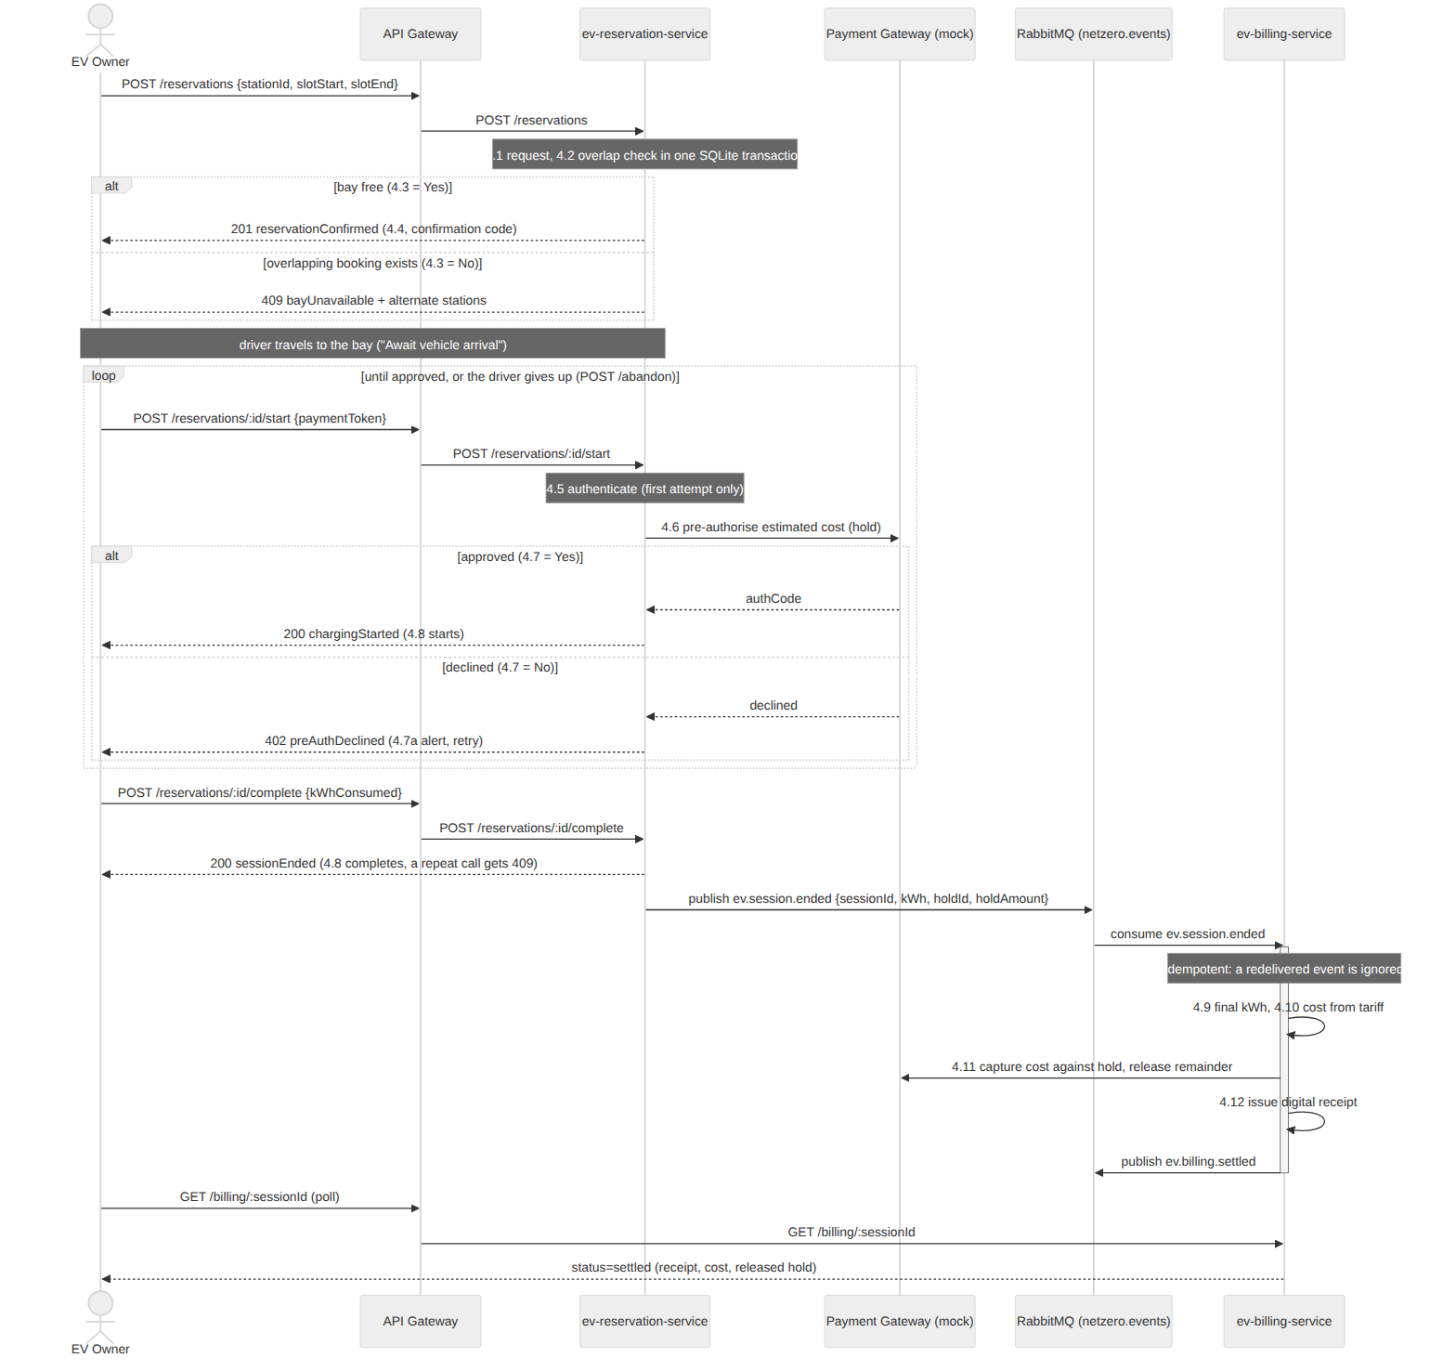
Figure E.2 — Sequence: EV Charging Session. Reservation (synchronous, with alt fragment), arrival and pre-authorisation with its retry loop, then billing settlement delivered asynchronously over RabbitMQ once the session ends.
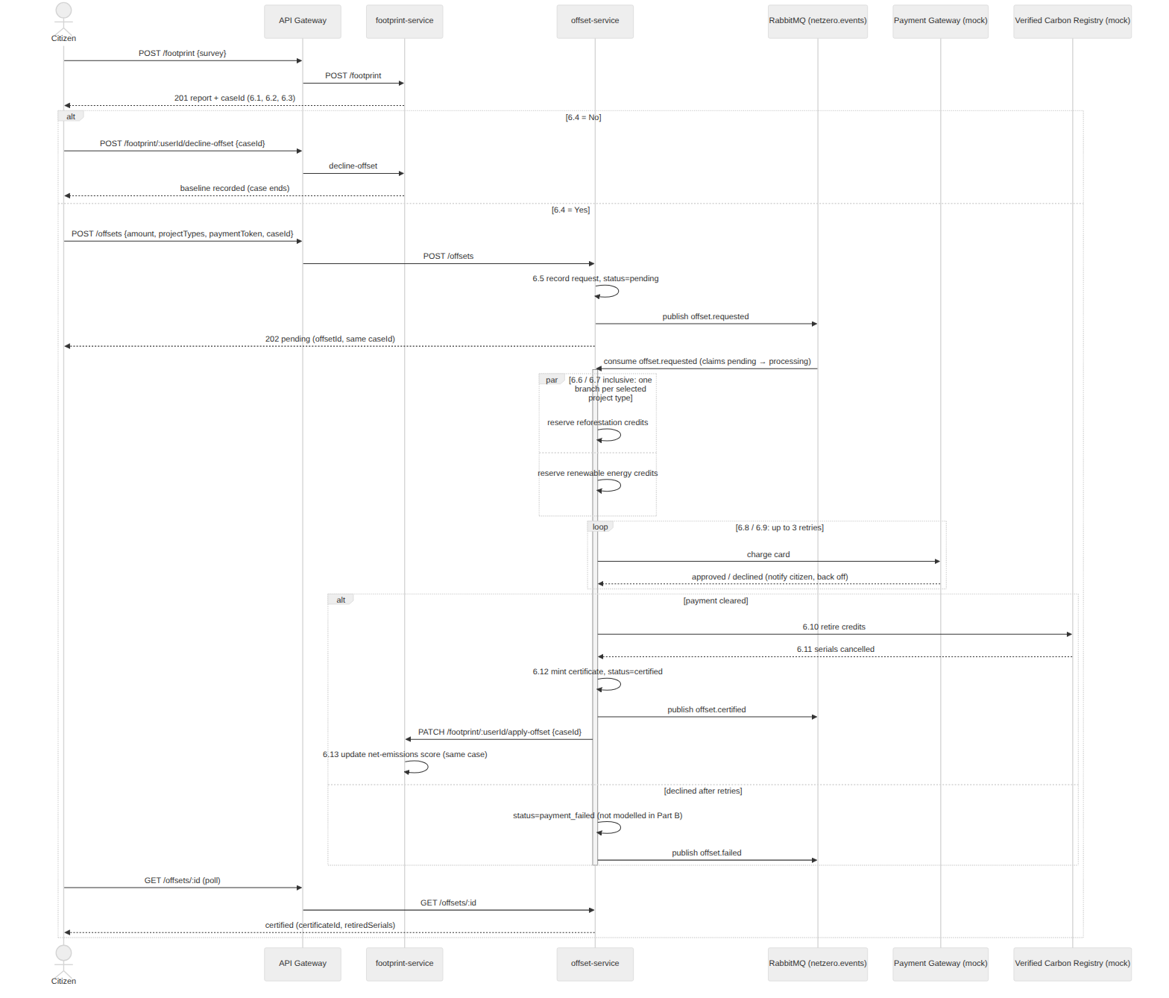
Figure E.3 — Sequence: Environmental Services. Footprint (synchronous), the 6.4 decision, then the offset purchase accepted synchronously (202) and fulfilled asynchronously, closing the loop back on the same case in footprint-service.
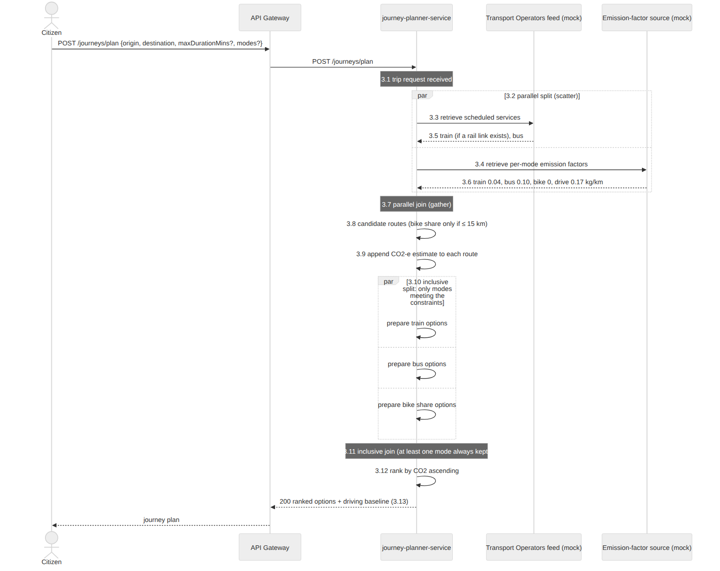
Figure E.4 — Sequence: Carbon-Optimized Journey Planner. One synchronous request that scatters two calls in parallel, gathers both, and prepares the qualifying modes behind an inclusive gateway.
Both event flows use the same event-bus module (src/eventBus.ts, identical in the three services that use RabbitMQ). It is built so that a broker restart or a network failure delays business events but never loses them:
- Automatic reconnection with exponential back-off (1 s up to 15 s), triggered by the connection's close and error events.
- Re-subscription. Every subscription is remembered, and its durable queue is re-declared, re-bound and re-consumed after each reconnect.
- Publisher confirms. Messages are published on a confirm channel and count as sent only once RabbitMQ has accepted them.
- Outbox. A publish that fails is held in an outbox and re-sent in order once the broker is back. (This is in memory here; a production system would persist it in the service's own database, the transactional-outbox pattern.)
- Consumer acknowledgements are sent only after the handler succeeds. A failed message is requeued once and dropped on a second failure, so one poison message cannot block the queue.

export async function publishEvent(routingKey: string, payload: unknown) {
if (outbox.length) { outbox.push({ routingKey, payload }); void flushOutbox(); return; } // keep ordering
try {
await publishNow(routingKey, payload); // confirm channel: resolves once the broker has the message
} catch (err) {
outbox.push({ routingKey, payload }); // broker unreachable: hold it and retry in order
scheduleReconnect(); // back-off reconnect; flushOutbox() runs on success
}
}
This was tested by stopping RabbitMQ completely while a charging session was ending. ev-reservation-service logged "held in outbox for retry", reconnected when the broker returned, and delivered ev.session.ended. The consumer re-subscribed automatically and the session was billed 13 seconds after the broker came back. A second test stopped ev-billing-service itself: the event waited in the durable queue (visible in the operator console as "1 waiting · no consumer") and was settled as soon as billing restarted.
External systems that a university project cannot call for real (the bank card network, the Verified Carbon Registry, transport timetable feeds) are mocked inside the owning service with realistic latency. The mock payment gateway is deterministic by token, so the demo and the Part F simulator can drive every BPMN branch on purpose: tok_ok approves, tok_decline_<n> declines the first n attempts, and tok_decline_all always declines.

E.4 Deployment
The full stack (API gateway, five microservices and RabbitMQ) is defined in one docker-compose.yml and brought up with one command:
docker compose up --build -d
Each data-owning service gets its own named volume (reservation_data, billing_data, footprint_data, offset_data), so the database-per-service boundary is enforced by the deployment topology, not just by convention. ev-reservation-service, ev-billing-service and offset-service wait for RabbitMQ's health check before starting. Schema changes are versioned with SQLite's user_version, so an older demo database is rebuilt automatically rather than crashing the service.
The Part F tooling (simulator, log exporter, process miner) is defined in the same file under a tools profile, so it is never started by up and runs on demand (./partf.sh).

E.5 Logging and Process-Mining Readiness
Every one of the five services is instrumented with two independent logging layers:
Application logging. A small dependency-free structured logger (src/logger.ts, identical across all six components) writes JSON lines (timestamp, level, service, msg, plus call-site fields) to stdout. An Express middleware logs every HTTP request/response pair with a generated requestId, status code and duration. This is conventional operational logging, orthogonal to process mining.
Process (event) logging. src/processLog.ts appends one JSON line per BPMN activity to logs/<service>.jsonl:
interface ProcessEvent {
process: string; // Part B process, e.g. "EV Charging Session"
caseId: string; // process instance; shared across services for a composed process
activity: string; // the BPMN task label from the Part B diagram
lifecycle: "start" | "complete";
resource: string; // the BPMN lane/participant, e.g. "RSVP Management", "Billing", "Citizen"
bpmnRef?: string; // Part B element number, e.g. "4.6/4.6a" -- absent for unmodelled behaviour
data?: Record<string, unknown>;
timestamp: string; // ISO-8601, generated at log time
}
Design decisions that target process-mining fidelity:
- One case per process instance, including across service boundaries. The reservation id is minted before step 4.1, so every attempt is exactly one case. A rejected double-booking is its own short case ending in "Suggest alternate charging bays/time", and a confirmed booking's case runs uninterrupted from 4.1 to 4.12. ev-billing-service continues the same case because the event carries the reservation id. footprint-service mints the caseId for an assessment, POST /offsets accepts that same caseId, and offset-service passes it back in the 6.13 callback, so one Environmental Services case spans two independently deployed, independently data-owned services.
- Activity names and resources come from the Part B diagrams. Activities use the task labels from the BPMN models, and resources are the swim-lanes, so a mined process map can be laid next to the Part B diagram and read directly. Gateways are decisions, not work, so they are recorded as data attributes (for example bayAvailable, approved, offsetDecision) rather than as activities.
- Real concurrency evidence. Parallel and inclusive branches (3.3‖3.4, the per-mode preparations at 3.10, and the per-project reservations at 6.6) are logged as overlapping start/complete pairs at the moment each branch actually starts and finishes, so discovery algorithms see true parallelism rather than an artificial sequence.
- All paths are logged, including those Part B does not model. Retry loops (4.7a, 6.9), the 6.4 "No" branch, and the alt-fragment rejection each have their own activity. Three behaviours the system supports but Part B's models do not are logged without a bpmnRef: a driver no-show, a driver abandoning after declined pre-authorisations, and an offset purchase cancelled after repeated payment declines. Part F's conformance checking is expected to find exactly these.

Export. tools/log-exporter groups every service's events by process and case, sorts each case chronologically, and writes one XES 1.0 file and one CSV per process into exports/. The XES declares the standard Concept/Lifecycle/Organizational/Time extensions and both classifiers, so it opens directly in Disco or Apromore with no column mapping. Part F (docs/PART-F.md) uses it.

E.6 The Citizen App, Verification and Live Demo

E.6.1 NetZero Hub citizen app
The platform's user-facing front end is a citizen app served by the gateway at / (gateway/public/index.html and app/). It is a dependency-free single-page app (plain ES modules, bundled fonts, no build step) with a web layout on desktop and an app layout with bottom tabs on phones, matching the Project Description's "mobile applications, web portals" channels. A resident signs up once, then uses every Part A service from the six providers in one place:
Provider | Services in the app | Backed by
EcoTransit Authority | 2.1 low-carbon journey planner; 2.2 transit passes; 2.3 share bikes | 2.1: journey-planner-service; 2.2–2.3 simulated
ChargeNet EV | 3.1 charger finder with live status and map; 3.2 bay booking; 3.3 charging session, pre-authorisation, receipt; 3.4 road-trip range planner | 3.1–3.3: ev-reservation-service + ev-billing-service; 3.4 simulated
GovEnvironment Agency | 5.1 footprint calculator; 5.2 offset purchase and certificate; 5.3 green business lookup | 5.1–5.2: footprint-service + offset-service; 5.3 simulated
GreenEnergy Co. | 1.1 renewable plan switch; 1.2 solar feasibility; 1.3 smart-meter insights; 1.4 solar buy-back registration | simulated
GreenWaste Solutions | 4.1 e-waste pickup (Process 5 checks and fix loop); 4.2 which-bin guide; 4.3 compost bin | simulated
EcoCommunity Action | 6.1 events with tickets and calendar invites; 6.2 garden plots; 6.3 volunteer matching | simulated

The simulated providers are clearly separated in the code (app/data.js and the provider views). They follow the same rules as the real services (for example, the payment-card behaviour of the platform's payment gateway) and the Part B processes where one exists (Process 1 and 2 checks for energy, Process 5 for e-waste). Cross-cutting features tie the services together: a wallet of payment cards, green points for sustainable choices (the Project Description's "incentives for sustainable practices") with redeemable rewards, and notifications.
The app makes the microservice behaviour visible in a citizen's terms rather than a developer's:
- The home screen's carbon ring is the user's footprint from footprint-service, filling in as offset-service certifies offsets. The gateway's aggregation endpoint supplies it in one call.
- Asynchronous outcomes become notifications. After a charging session or an offset purchase, the app keeps a watch list and tells the user when the receipt or certificate is issued. If billing is down, the user is told the receipt will follow, and the notification arrives once billing recovers.
- Failure paths are plain language. A declined pre-authorisation (BPMN 4.7a) is explained with a retry button; offset payment retries (6.9) are shown in the progress tracker; a rejected e-waste booking lists exactly what to change.

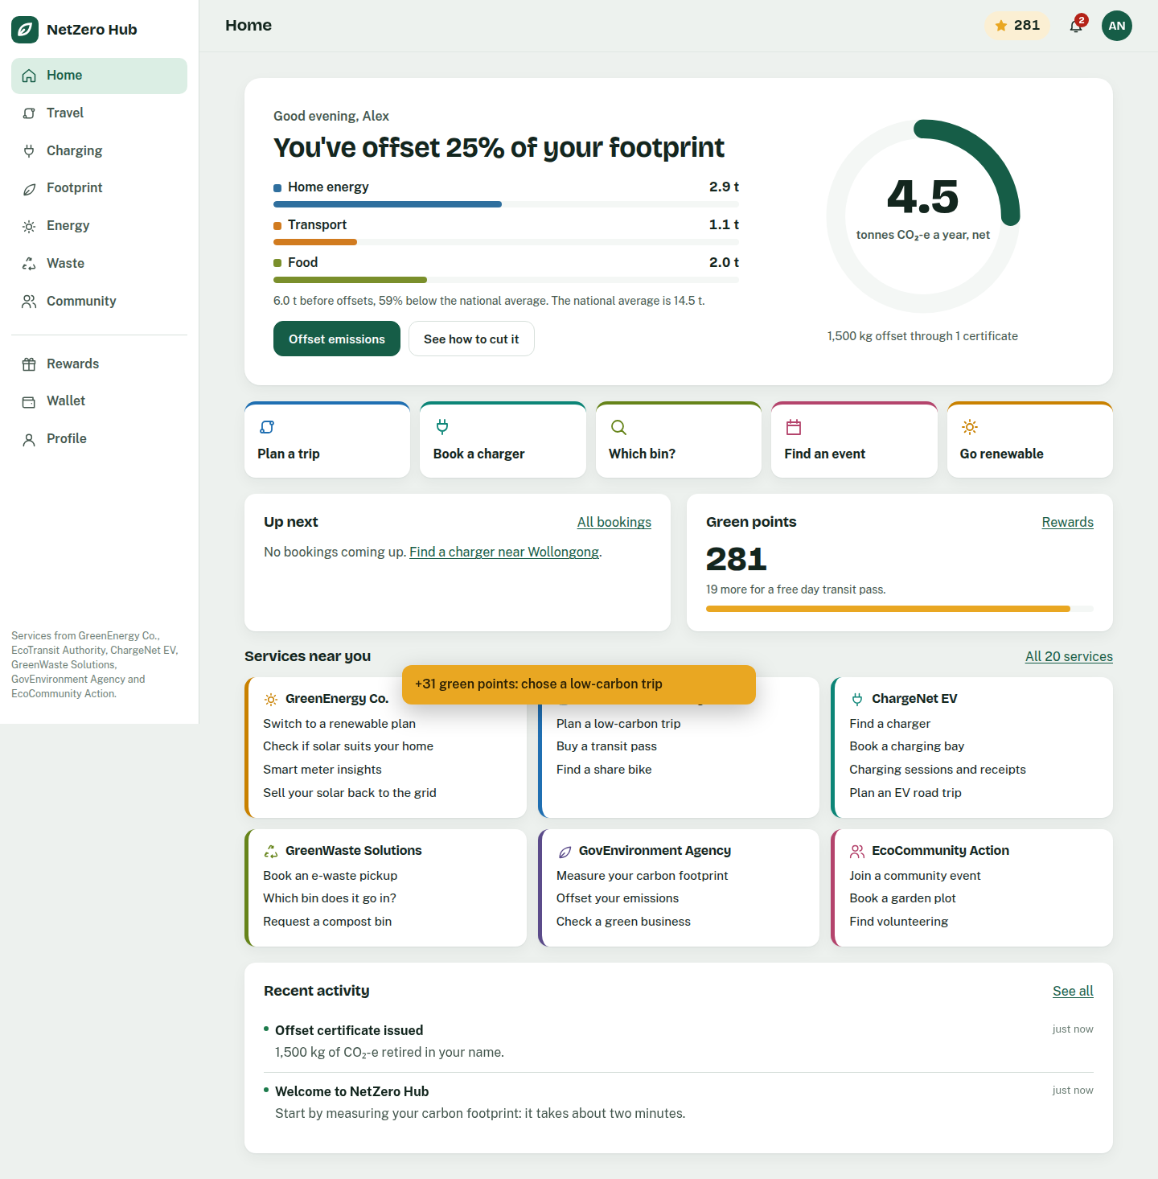
Figure E.5 — Citizen app home: the carbon ring (footprint net of certified offsets), green points, and notifications fed by asynchronous service outcomes.
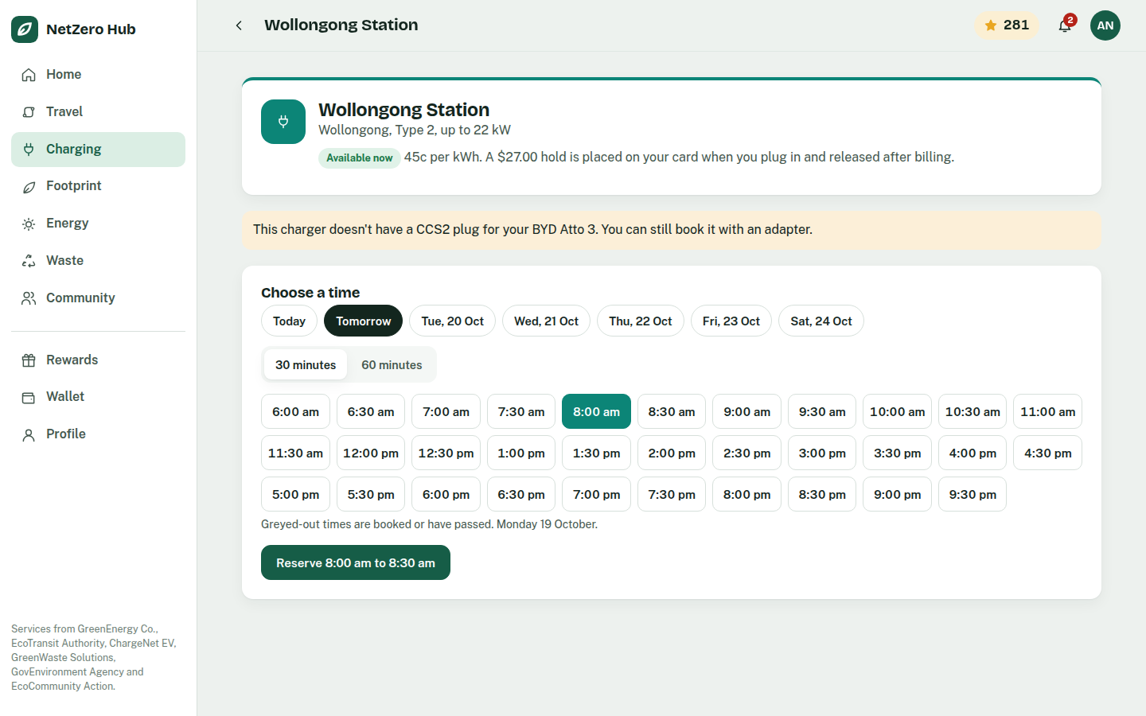
Figure E.6 — Booking a charging bay: slot availability from ev-reservation-service; booked or past times are disabled.
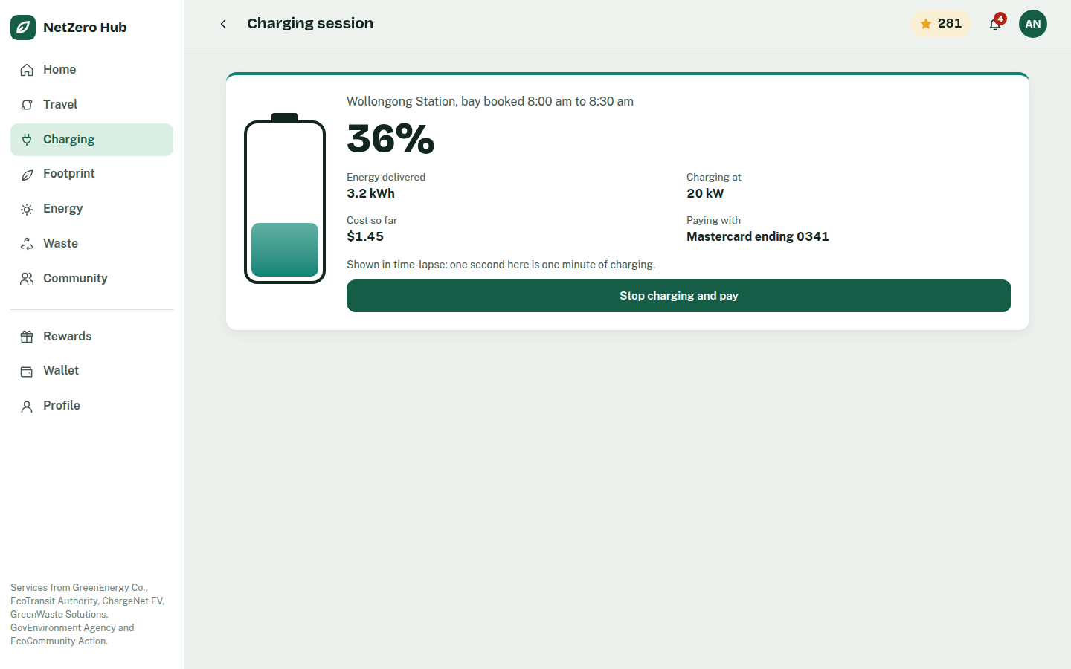
Figure E.7 — Live charging session after the pre-authorisation hold, then the asynchronous receipt (app-screenshots/06-async-receipt.png).
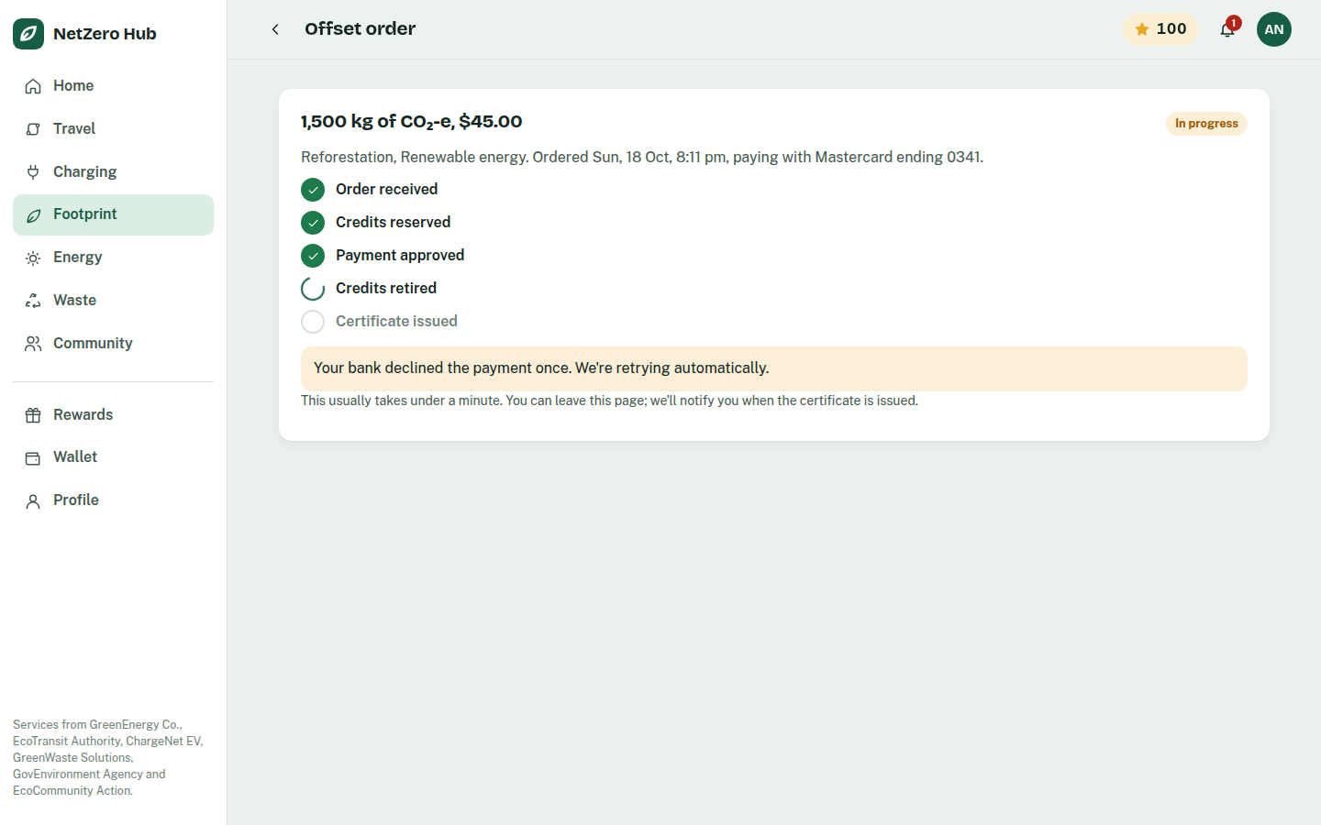
Figure E.8 — Offset order tracking the fulfilment stages from offset-service, including an automatic payment retry, ending in the certificate (app-screenshots/08-offset-certificate.png).

E.6.2 Verification
The system was run end to end before being written up: all five services and the gateway with RabbitMQ, every endpoint above, both asynchronous round trips, and the gateway aggregation. The services pass TypeScript's strict type check (tsc --noEmit). The operator console's Stop/Start controls were exercised against the running stack (including a charging session ended while billing was stopped from the panel), and its security checks were confirmed: requests without the header, for the gateway, or for any other action are refused. The citizen app was driven through every screen in a headless browser at desktop and phone widths, with no script errors and no horizontal overflow, including the full flows of booking, declined card, retry, charging, billing (also with billing stopped and restarted), footprint, offset with a declined-then-approved card, and journey planning.

E.6.3 Live demo
The Week 12 demo is told from the citizen's side on the stage view (localhost:4000/stage/): the citizen app (localhost:3000) in a phone frame beside the operator console (localhost:4000). The console shows:
- Microservices panel: each service's container state with a Stop/Start button, and the RabbitMQ queues. Stopping a service mid-flow is how the demo shows fault tolerance: the app keeps working and asynchronous work waits in its queue until the consumer is back.
- Architecture: the deployment diagram, animated by the services' own events. Calls travel as tokens from the app through the gateway; asynchronous hops travel through RabbitMQ; RabbitMQ shows each queue's depth and consumer count; a stopped service turns red.
- Process map: a directly-follows process map built in the browser from the live event stream, with behaviour outside the Part B model highlighted. It previews Part F's process mining during the demo.
- Events: the raw per-activity event feed, with a click-to-filter on any case id.

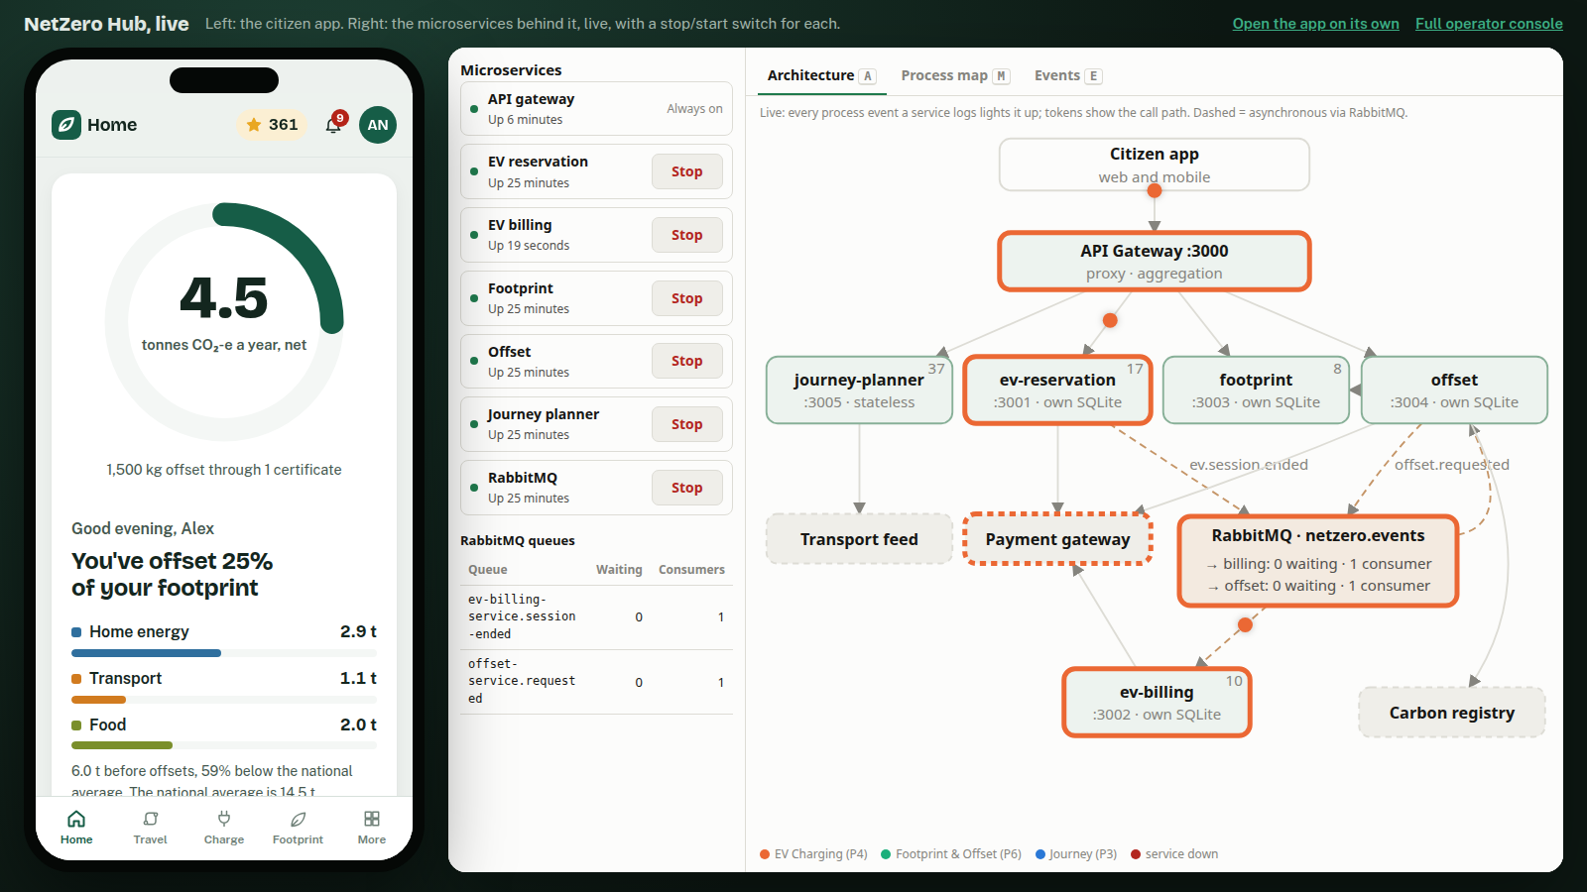
Figure E.9 — Stage view: the citizen app (left) and the operator console (right) with its service controls and live architecture.
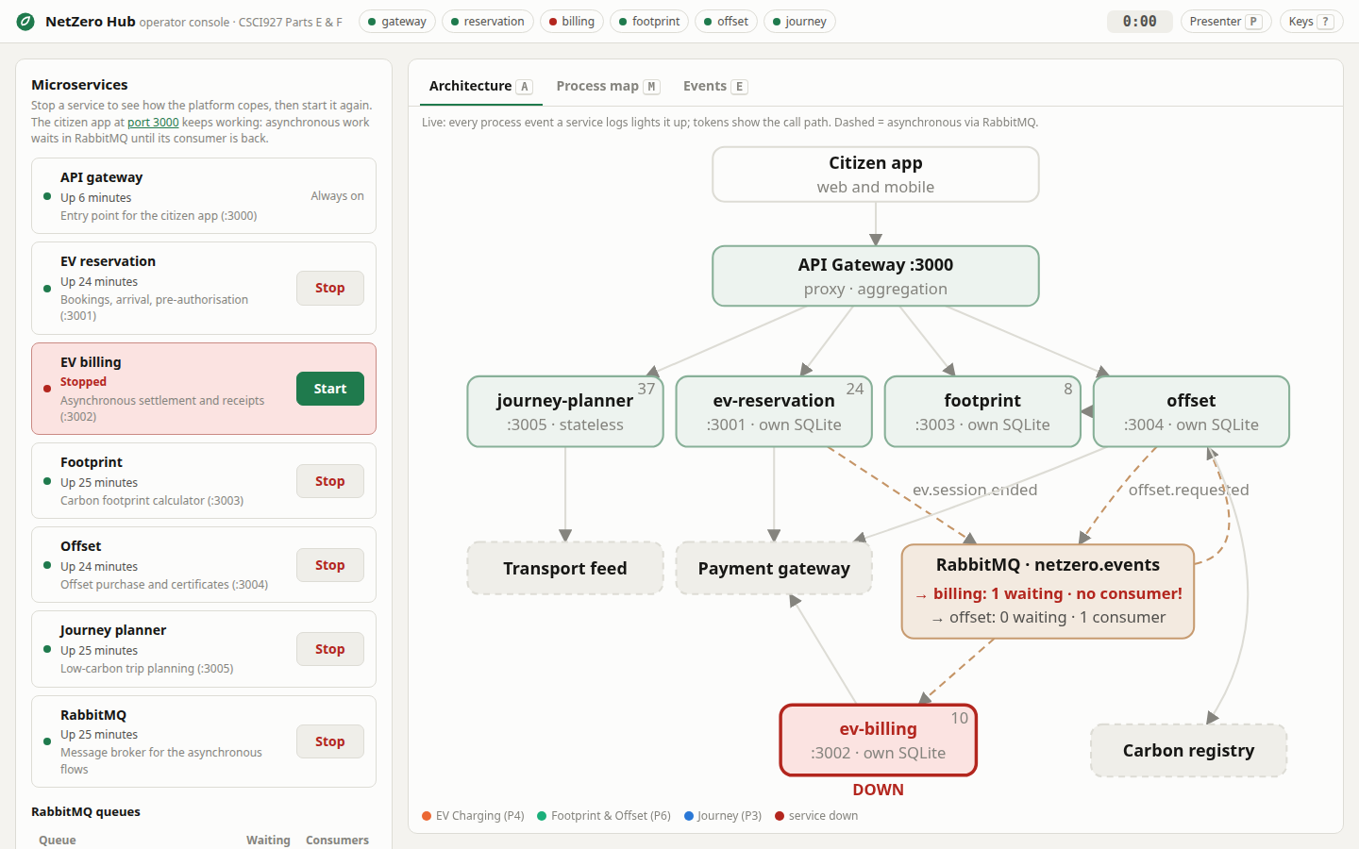
Figure E.10 — Failure test: ev-billing-service stopped from the console's service panel while a session ends. The service turns red and RabbitMQ shows the billing queue with one message and no consumer; after Start the receipt arrives without any retry by the user (demo-screenshots/console-billing-recovered.png).
demo.sh (terminal, PAUSE=1 for step-by-step presenting) remains as an API-level walkthrough and fallback. rehearse.sh times the 8-minute run-of-show segment by segment. See docs/DEMO.md for the Week 12 runbook.

E.7 Traceability Summary
Part A Service | Part B Process (elements) | Part C Contract | Part E Microservice | Verified
3.2 Charging Bay Reservation | Process 4 (4.1–4.8) | Contract 3 | ev-reservation-service | ✔
3.3 Automated EV Billing & Payment | Process 4 (4.9–4.12) | Contract 4 | ev-billing-service | ✔
5.1 Individual Carbon Footprint Calculator | Process 6 (6.1–6.4, 6.13) | Contract 6 | footprint-service | ✔
5.2 Carbon Offset Purchasing | Process 6 (6.5–6.12) | Contract 7 | offset-service | ✔
2.1 Carbon-Optimized Journey Planner | Process 3 (3.1–3.13) | Contract 2 | journey-planner-service | ✔

All five emit Part-F-ready process event logs (§E.5), keyed to the Part B element numbers in the table above.
NetZero Hub — Service-Oriented Software Engineering
Part F — Service / Process Analytics

F.0 Approach and Process Selection
Part F asks for at least three Part B business processes to be executed to generate event logs, mined with process-mining tools, and the procedure and outcomes demonstrated in detail. We mine the three processes that Part E implements as running microservices:
Part B process | Executed by (Part E) | Why it is worth mining
Process 3 — Carbon-Optimised Journey Planner | journey-planner-service | Parallel split/join (3.2/3.7) and an inclusive gateway (3.10/3.11): tests whether mining recovers concurrency
Process 4 — EV Charging Session | ev-reservation-service + ev-billing-service (RabbitMQ) | Exclusive choice (4.3), a retry loop (4.7a), an asynchronous hand-off between two services, and long human waiting times
Process 6 — Carbon Footprint & Offset Purchase | footprint-service + offset-service (RabbitMQ) | Exclusive choice (6.4), inclusive split over project types (6.6/6.7), a payment retry loop (6.9), and one case spanning two services

The logs are not synthetic. Each process is executed by the real, running microservices from Part E, and every event is written by the service that performed the activity. A simulator only plays the human and external actors (drivers, citizens, card issuers) and makes their decisions stochastically. This matters for analytics: the logs contain genuine service behaviour (asynchronous delivery over RabbitMQ, real concurrency, real retries and idempotency) as well as the variation that business users introduce.
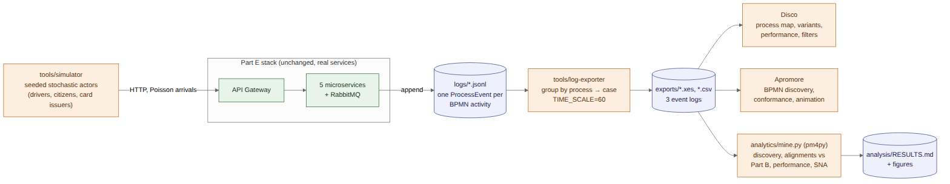
Figure F.1 — Part F pipeline: simulator → Part E services → process-event logs → exporter (XES/CSV) → Disco, Apromore and a scripted pm4py analysis.
The whole pipeline is one command (./partf.sh, see F.6). The numbers in this section come from the run with CASES=120 SEED=2026; the same seed reproduces the same decisions. A snapshot of that run's logs and results is kept in docs/part-f-results/.

F.1 Process Execution (Simulation over the Real Services)
tools/simulator/simulate.mjs drives the stack through the API gateway exactly as a client application would. For each process it generates cases as a Poisson arrival stream (mean inter-arrival 0.4 s) and runs them concurrently, so cases genuinely overlap in time, as they would in production.
Actor decisions. Each case makes its decisions with a seeded random generator (mulberry32), so a run is reproducible:
Process | Decision point (Part B) | Simulated behaviour
3 | Traveller constraints (3.10) | 45% set a time budget of 20–75 min; 20% refuse to cycle; 14 Illawarra/Sydney locations, about one pair in four has no rail link, and bike share is offered only for trips of 15 km or less
4 | Bay available? (4.3) | 8 stations × 5 days × peak-weighted slots (07:00–19:00); 30% of bookings are 60 min, so overlaps arise naturally rather than being scripted. Half of rejected drivers immediately try a suggested alternate station (a new case)
4 | Driver arrives | 10–60 min after booking; 7% never arrive (no-show)
4 | Pre-auth approved? (4.7) | Card behaviour: 82% approve, 10% decline once, 4% decline twice, 4% always decline. After a decline, drivers retry; after 2–3 declines they may give up
4 | Charging (4.8) | 20–60 min, 0.35–0.9 kWh per minute
6 | Purchase offsets now? (6.4) | 75% say yes if the footprint is above 10 t CO₂-e/yr, otherwise 50%
6 | Project types (6.6) | Reforestation 70%, renewable 50%, waste recycling 30% (at least one)
6 | Payment successful? (6.9) | 84% approve, 8% decline once, 4% decline twice, 4% always decline (cancelled after 3 retries)

Time compression. Human and physical waiting times are compressed so that 360 cases run in about 2.5 minutes: one wall-clock second stands for one simulated minute. The exporter undoes this with TIME_SCALE=60 (t′ = t₀ + (t − t₀) × 60), a linear transform that preserves every ordering and every ratio between durations, so Disco and Apromore show business-scale durations (a 40-minute charging session reads as 40 minutes). Automated service steps are scaled by the same factor, so for real service response times we use the unscaled logs in exports/raw/ (F.4.4).
Execution outcome (seed 2026, 120 cases per process):
Process | Outcomes
3 — Journey Planner | 55 plans with 2 options, 26 with 1, 24 with 3, 15 where no mode met the constraint and the fastest was kept
4 — EV Charging | 131 cases (120 + 11 retries at an alternate station): 95 charged and billed, 17 rejected (bay unavailable), 10 abandoned after declined pre-authorisation, 9 no-shows
6 — Footprint & Offset | 60 baseline only (declined), 56 offsets certified (32 with one project type, 20 with two, 4 with three), 4 cancelled after repeated payment failure

F.2 The Event Logs
Every service appends one JSON line per BPMN activity to logs/<service>.jsonl (design in Part E §E.5). tools/log-exporter merges the services' files, groups events by process and then by case, sorts each case chronologically and writes, per process:
File | Format | Best for
<process>.xes | XES 1.0 (IEEE 1849) with Concept, Lifecycle, Organizational and Time extensions | Disco, Apromore, ProM, pm4py: imports with no mapping
<process>.activities.csv | One row per activity instance, with Start Timestamp and Complete Timestamp | CSV import into Disco/Apromore with activity durations
<process>.csv | One row per event, lifecycle as a column, all event data flattened to data.* columns | Spreadsheet inspection, attribute filtering

Log attribute | XES key | Source
Case ID | concept:name (trace) | reservation id (P4), footprint assessment id (P6), request id (P3)
Activity | concept:name (event) | BPMN task label from the Part B diagram
Lifecycle | lifecycle:transition | start / complete (start events only where an activity has real duration)
Resource | org:resource | BPMN lane, e.g. RSVP Management, Billing, Citizen, Verified Carbon Registry
Timestamp | time:timestamp | generated by the service at the moment the activity started/completed
BPMN reference, service | bpmnRef, service | Part B element number; the microservice that logged the event
Case outcome, user | outcome, userId (trace) | final activity of the case; the citizen/driver

Log | Cases | Events | Activity instances | Variants
carbon-optimized-journey-planner | 120 | 1,526 | 1,063 | 23
ev-charging-session | 131 | 1,483 | 1,161 | 7
environmental-services | 120 | 1,072 | 845 | 20

Data-quality checks made before mining: every case belongs to exactly one process instance (a rejected booking is its own case and never merges with the booking that blocked it); cross-service cases are continuous (P4: reservation → billing, P6: footprint → offset → footprint), with no orphan fragments; every start has a matching complete; and events within each case are in chronological order.

F.3 Tools and Method
Two process-mining tools analyse the same XES logs independently. Apromore is the interactive tool from the lectures; pm4py makes every number reproducible from a script and adds the conformance checking that Apromore's open-source edition does not include. Disco is described as an equivalent alternative for team members on Windows or macOS.
Tool | How it was run | Used for
Apromore Community Edition 8.1 | Locally in Docker (tools/apromore/, http://localhost:8181) | Process maps with frequency and duration overlays, BPMN discovery (Split Miner), log statistics, filtering, log animation, viewing the Part B reference models
pm4py 2.7 (analytics/mine.py) | In its own container (docker compose run --rm process-miner) | Scripted discovery (DFG, Inductive Miner), alignment-based conformance against the Part B models, performance and organisational analysis
Disco (Fluxicon), optional | Desktop app, Windows/macOS, free academic licence | The same map/variant/performance analysis as Apromore's Process Discoverer

The Part B models are encoded for conformance checking as process trees in analytics/mine.py (sequence, exclusive choice, parallel, and loops for the retry cycles). mine.py also exports them as BPMN 2.0 XML (<process>/reference-model.bpmn), and those files were imported into Apromore next to the logs. Activities that the system logs but Part B does not model (no-show, abandonment, purchase cancellation) are deliberately left out of the reference models, so that conformance checking can find them.

F.3.1 Apromore — what was done
The full procedure is in tools/apromore/README.md; the screenshots are in docs/part-f-results/apromore/.
- Start and import. docker compose -f tools/apromore/docker-compose.yml up -d, log in, then Upload the three .xes logs and the three reference-model.bpmn files. Apromore imports XES with no column mapping (Figure F.6).
- Process Discoverer, frequency overlay. Select a log → Discover → Discover model. Raise Arcs to 100% (the default of 10% hides infrequent arcs such as the retry loops) and fit the map to the screen. Each activity and arc shows its case frequency.
- Duration overlay. Switch the primary overlay to Duration (average) to show the mean time on every arc and activity. This is the performance view used to find bottlenecks.
- BPMN view. Flip Process map → BPMN model. Apromore runs Split Miner on the log and draws a BPMN model with gateways. Compare it with the Part B diagram and with the reference model opened through Discover → Edit model.
- Filtering and animation. Filter narrows the log (for example, the trace attribute outcome ≠ Issue digital receipt keeps only unsuccessful EV cases). Animate replays the cases as tokens on the map. Animation is shown live in the demo, since it doesn't come across in a still image.

Apromore Community Edition has no conformance checker (that is in the commercial edition), so fitness, precision and deviation counts come from pm4py (F.4). The visual comparison between Apromore's discovered model and the imported reference model shows the same gaps.

F.3.2 Disco (alternative) — step by step
- Import. Open file → a .xes file → Start import. The XES needs no mapping. For CSV, open <process>.activities.csv and map Case ID → Case, Activity → Activity, both Start Timestamp and Complete Timestamp → Timestamp (pattern yyyy-MM-dd'T'HH:mm:ss.SSSX), and Resource → Resource.
- Map. Activities and Paths at 100% give the full map, equivalent to Apromore at 100%/100%. Switch the overlay to Performance → Mean duration for the performance view.
- Statistics and Cases. Case-duration distribution, activity frequencies and the variant list (P4: Variant 1 = 85 cases).
- Filters. An Attribute filter on outcome (everything except Issue digital receipt) isolates the 36 unsuccessful EV cases; a Follower filter "Alert driver… eventually followed by Driver abandons charging session" isolates the abandonments.
- Animation. Animate replays the log on the map.

F.3.3 pm4py — scripted analysis
analytics/mine.py runs inside its own container (docker compose run --rm process-miner). For each log it:
- profiles the log (cases, events, variants, outcomes, case durations);
- discovers a directly-follows graph (frequency and performance), and a BPMN model with the Inductive Miner;
- replays the log on the Part B reference model with alignments, reporting fitness, precision and every deviation by activity, and compares against the discovered model;
- computes activity service times from start/complete pairs, the slowest transitions, a resource × activity matrix and hand-over-of-work counts.

Results go to analysis/RESULTS.md (snapshot: docs/part-f-results/RESULTS.md), with every figure referenced below.

F.4 Results

F.4.1 Summary
Process | Cases | Variants | Fitness vs Part B | Precision vs Part B | Deviating cases | Mean case duration
3 — Journey Planner | 120 | 23 | 1.000 | 0.917 | 0 | 0.8 min*
4 — EV Charging Session | 131 | 7 | 0.938 | 0.997 | 19 (14.5%) | 59.7 min
6 — Footprint & Offset | 120 | 20 | 0.988 | 0.923 | 4 (3.3%) | 6.0 min

* Process 3 is fully automated, so its "duration" is the service's response time multiplied by the time scale: a 0.78 s mean response (F.4.4).

F.4.2 Process 3 — Carbon-Optimised Journey Planner
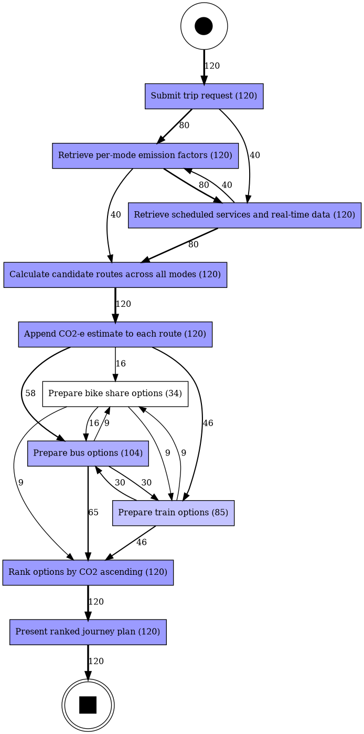
Figure F.2 — Process 3, directly-follows graph (frequency).
- Discovery recovers the parallelism. The 23 variants are not 23 different behaviours. They are interleavings of the same behaviour: the timetable and emission-factor retrievals finish in either order (80 cases emission factors first, 40 timetable first), and the qualifying modes are prepared concurrently in any order. The Inductive Miner model (discovered-bpmn.png) puts both retrievals in a parallel block and the three mode preparations in a parallel block of optional branches, which is the Part B structure of 3.2/3.7 and 3.10/3.11.
- Conformance: perfect fitness (1.000). Every one of the 120 cases is allowed by the Part B model. Precision is 0.917 rather than 1 because our encoding of the inclusive gateway (each branch optional) also allows "no mode prepared", which never happens: the service enforces Part B's invariant that at least one mode always qualifies (15 cases needed the fallback).
- Inclusive gateway in practice: bus was prepared in 104 cases, train in 85 and bike share in 34. The time-budget constraint was the main reason options were dropped.

F.4.3 Process 4 — EV Charging Session
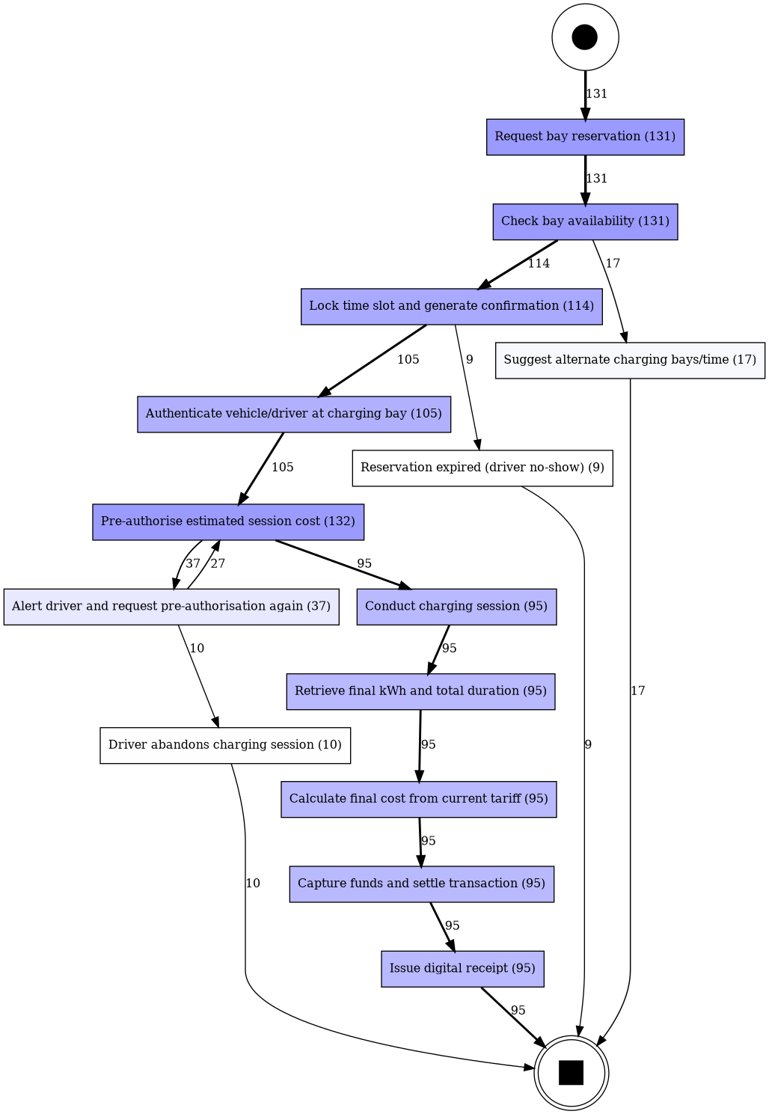
Figure F.3 — Process 4, directly-follows graph (frequency). The happy path carries 85 of 131 cases; rejection, no-show, retry and abandonment branches are visible.
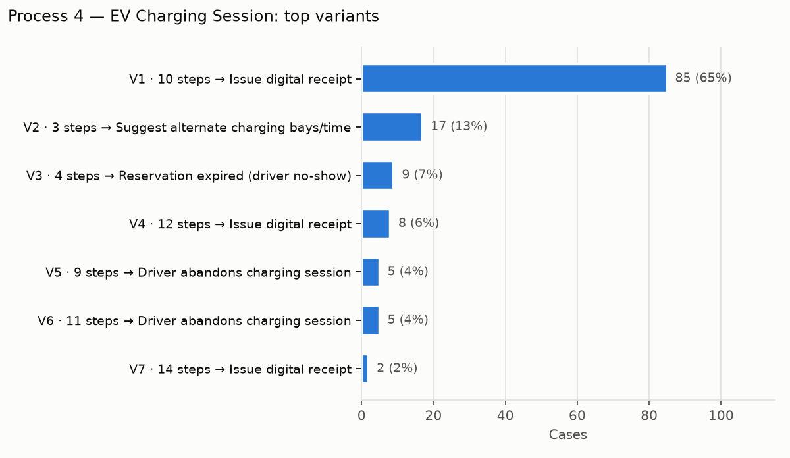
Figure F.4 — Process 4 variants.
- Variants. V1, the Part B happy path, covers 85 cases (65%). V2, rejected at 4.3 with alternates suggested, covers 17 (13%). V3, the no-show, covers 9 (7%). V4, one declined pre-authorisation then success, covers 8 (6%). V5 and V6, two or three declines then abandonment, cover 10 (8%). V7, three declines then success, covers 2.
- Conformance: fitness 0.938; 19 cases (14.5%) deviate from the Part B model. The alignments name the two gaps in Process 4:
  - Driver no-show (9 cases). Part B's timer "Await vehicle arrival" has no path for a driver who never arrives. The alignment reports Reservation expired (driver no-show) as a log move. It also reports Lock time slot… as a log move and Suggest alternate… as a model move: the cheapest way to fit a confirmed-then-expired case into a model with no expiry path is to pretend it was rejected.
  - Abandonment after declined pre-authorisation (10 cases). Part B's 4.7a loop has no exit, so it implicitly assumes every driver eventually pays. The alignment reports Driver abandons charging session (and the extra Alert driver…) as log moves, and every Billing task 4.8–4.12 as a skipped model move.
The discovered model fits all cases (1.000), but at lower precision (0.826 vs 0.996): it generalises beyond what was observed, the usual fitness/precision trade-off.

- Performance (simulated time):

Measure | Mean | Median
Booking → arrival (Lock 4.4 → Authenticate 4.5) | 35.9 min | 37.6 min
Charging session (4.8 start → complete) | 38.4 min | 39.6 min
No-show detected after booking | 35.1 min | 30.3 min
Alert 4.7a → retry 4.6 | 1.5 min | 1.4 min
Alert 4.7a → abandon | 2.4 min | 2.4 min
Pre-authorisation 4.6, capture 4.11 (service time) | 0.1 min | 0.1 min

Almost all of the 59.7-minute mean case duration is customer time (travelling and charging). The platform's own steps are not the bottleneck: pre-authorisation and capture take seconds, and the asynchronous billing hand-off is milliseconds (F.4.4).
- Organisational. The hand-over network is EV Owner → RSVP Management (131) → Billing (95). The 10 hand-overs from RSVP Management back to the EV Owner are exactly the abandonments: the driver, not the platform, ends those cases.

F.4.4 Service performance (unscaled logs)
From exports/raw/ (real wall-clock timing of the running microservices):
Interaction | n | Mean | Median | p95
Reservation 4.1 → 4.4 (synchronous, inc. overlap-checking transaction) | 114 | 0.6 ms | 1 ms | 1 ms
RabbitMQ hop: session ended (reservation-service) → billing 4.9 (billing-service) | 95 | 2.7 ms | 3 ms | 5 ms
Billing 4.9 → receipt 4.12 (inc. capture at the payment gateway) | 95 | 111 ms | 103 ms | 167 ms
Offset 6.5 → first credit reservation (offset.requested round trip) | 49 | 3.5 ms | 2 ms | 8 ms
Certificate 6.12 → score updated 6.13 (HTTP callback to footprint-service) | 56 | 2.7 ms | 2 ms | 6 ms
Offset purchase end to end, 6.5 → 6.13 | 56 | 2.12 s | 1.93 s | 4.89 s
Journey plan 3.1 → 3.13 | 120 | 776 ms | 786 ms | 933 ms

The asynchronous decoupling costs almost nothing (a few milliseconds per broker hop). End-to-end time is dominated by the external systems: the registry retirement (about 1.2 s) in P6, and payment-decline back-off in the long tail (p95 4.9 s). The journey planner's response time is the slower of its two parallel upstream calls (timetable, mean 0.5 s) plus mode preparation. Running the calls in parallel saves roughly the 0.4 s that the emission-factor call would add if they ran in sequence.

F.4.5 Process 6 — Carbon Footprint Calculation & Offset Purchase
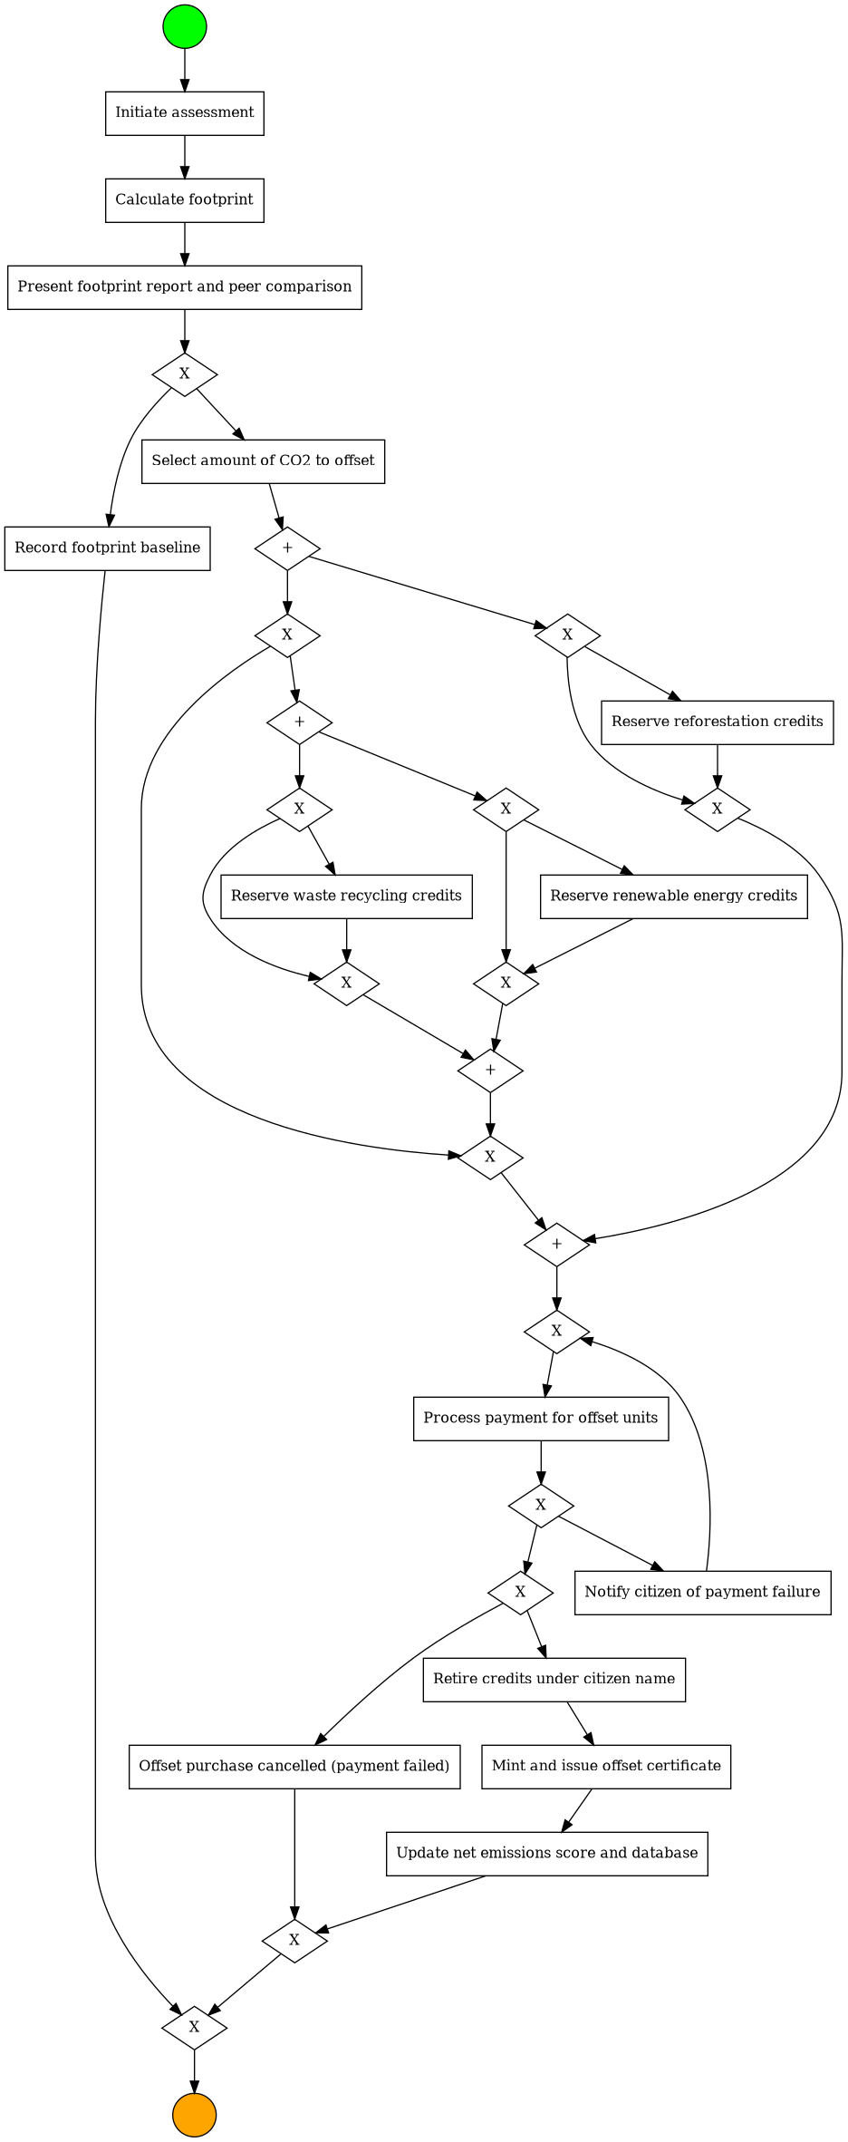
Figure F.5 — Process 6, BPMN discovered by the Inductive Miner: exclusive choice after the report, optional parallel project-type reservations, the payment retry loop, and the unmodelled cancellation exit.
- One case across two services. All 120 cases run from Initiate assessment (footprint-service) through the offset marketplace (offset-service) and, when certified, back to Update net emissions score (footprint-service). This confirms the cross-service correlation designed in Part E.
- Decision 6.4. Exactly half of the citizens declined (60 cases, V1: report → Record footprint baseline). Decision-point analysis on the totalCo2KgYear attribute (the data.totalCo2KgYear column of environmental-services.csv, filtered in Disco or a spreadsheet) shows uptake of 81% (21/26) above 10 t/yr and 41% (39/94) at or below it. This recovers the decision rule built into the simulator, which shows the attribute-level analysis works. With real users, the same analysis would show which citizens respond to the offer.
- Inclusive gateway 6.6/6.7. Reforestation was reserved in 49 purchases, renewable in 25 and waste recycling in 15. Variants V2–V6 differ only in which project types were chosen and the order in which their concurrent reservations completed.
- Conformance: fitness 0.988; 4 cases deviate. All four are Offset purchase cancelled (payment failed): Part B's 6.9 loop retries forever, while the implementation stops after three retries. The alignment marks the cancellation as a log move and 6.10–6.13 as skipped.
- Performance. The longest system step is Retire credits under citizen name (mean 1.2 min simulated, about 1.2 s real), the registry round trip. Each payment decline adds a 1.9-minute back-off before the retry. The longest waits overall are the citizen's thinking time between the report and their decision (5.8 min to buy, 3.7 min to decline).

F.4.6 Apromore results and cross-validation
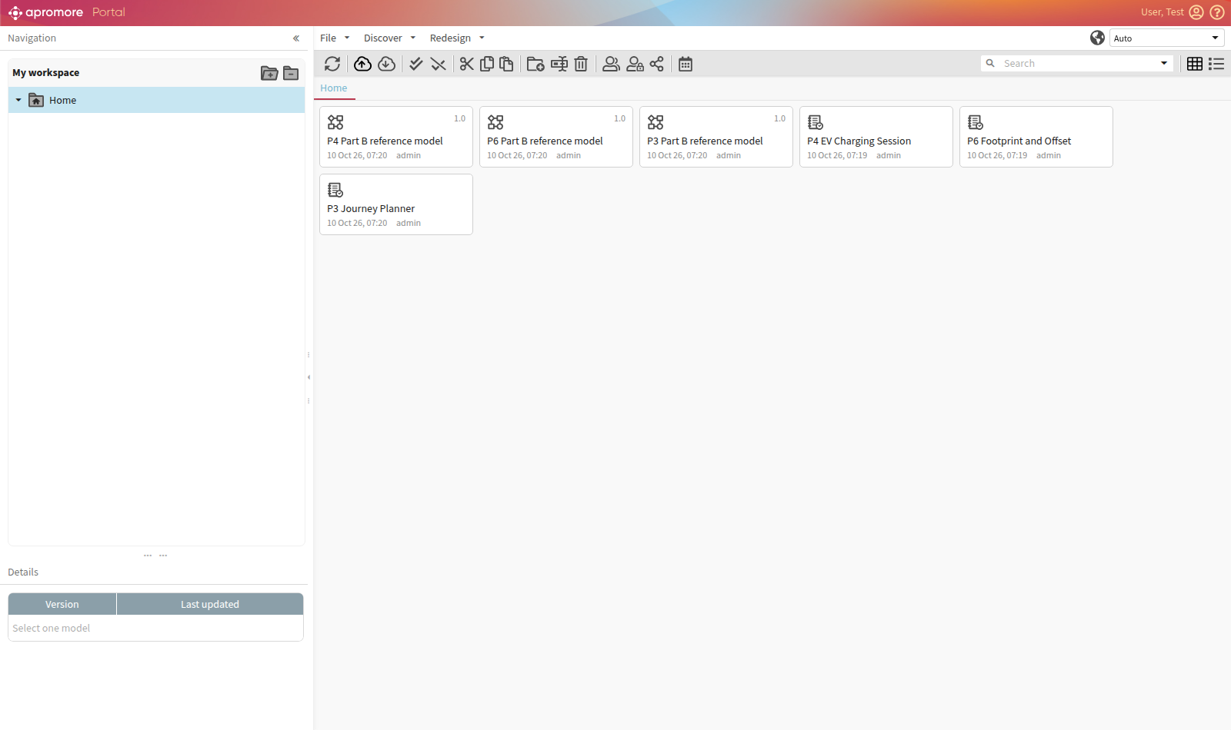
Figure F.6 — Apromore portal (local Docker instance) with the three event logs and three Part B reference models imported.
Apromore's Process Discoverer computes its statistics independently from the same XES files. Its figures agree with pm4py on every measure that both tools define the same way:
Measure | Process | Apromore | pm4py
Cases | P4 / P6 / P3 | 131 / 120 / 120 | 131 / 120 / 120
Activities | P4 | 14 | 14
Mean case duration | P4 | 59.70 min | 59.7 min
Mean case duration | P6 | 5.96 min | 6.0 min
Mean case duration | P3 | 46.58 s (≈0.78 min) | 0.8 min
Mean time, booking → arrival (Lock → Authenticate) | P4 | 35.88 min | 35.9 min
Mean charging session duration | P4 | 38.43 min | 38.4 min
Variants | P4 / P6 / P3 | 7 / 16 / 5 | 7 / 20 / 23

The variant counts differ only for the processes with concurrency, and the difference is explained by how each tool orders events. Apromore merges every start/complete pair into one activity instance and orders instances by start time. The pm4py analysis orders by completion. In P3, both upstream retrievals start in the same millisecond, so Apromore always sees them in the same order and finds 5 variants: exactly the five distinct combinations of transport modes prepared at the inclusive gateway. pm4py also distinguishes which retrieval and which mode preparation finished first, giving 23 interleavings of the same 5 behaviours. P6 is the same effect on a smaller scale, with the concurrent credit reservations completing in a different order from the one in which they started.
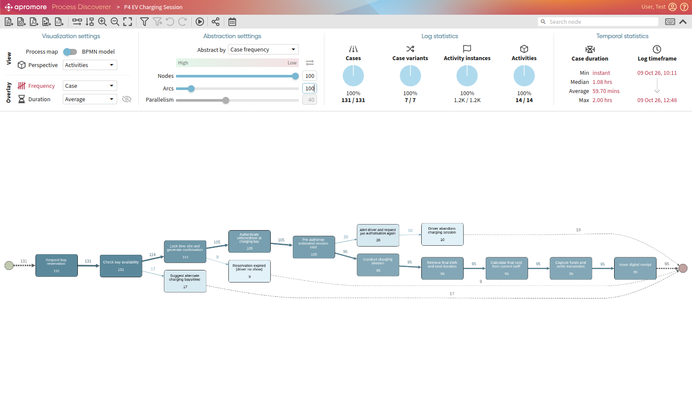
Figure F.7 — Apromore Process Discoverer, P4 frequency overlay (arcs 100%). The happy path carries 95 of 131 cases; the rejection (17), no-show (9), pre-authorisation retry (20 cases) and abandonment (10) branches are all visible.
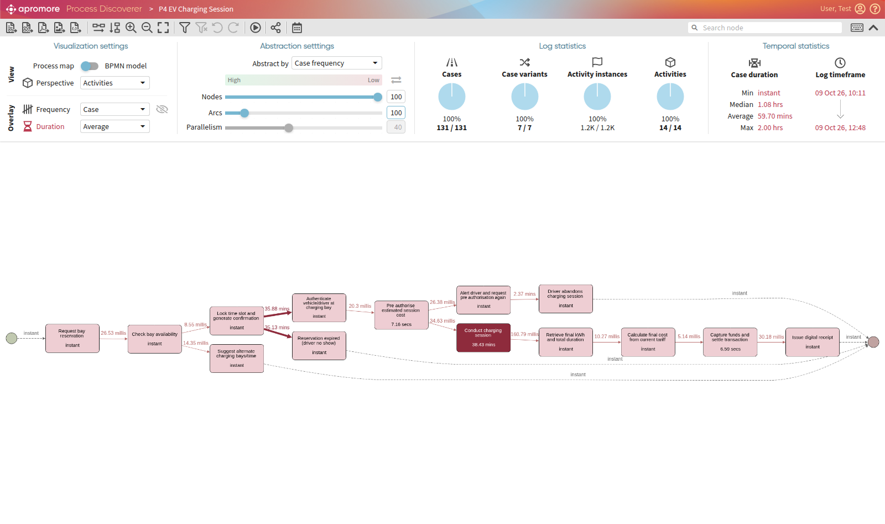
Figure F.8 — P4 duration overlay. The two dark arcs and the dark activity are the human waiting times (booking → arrival, about 36 min; the charging session, 38.4 min). All system steps take milliseconds to seconds.
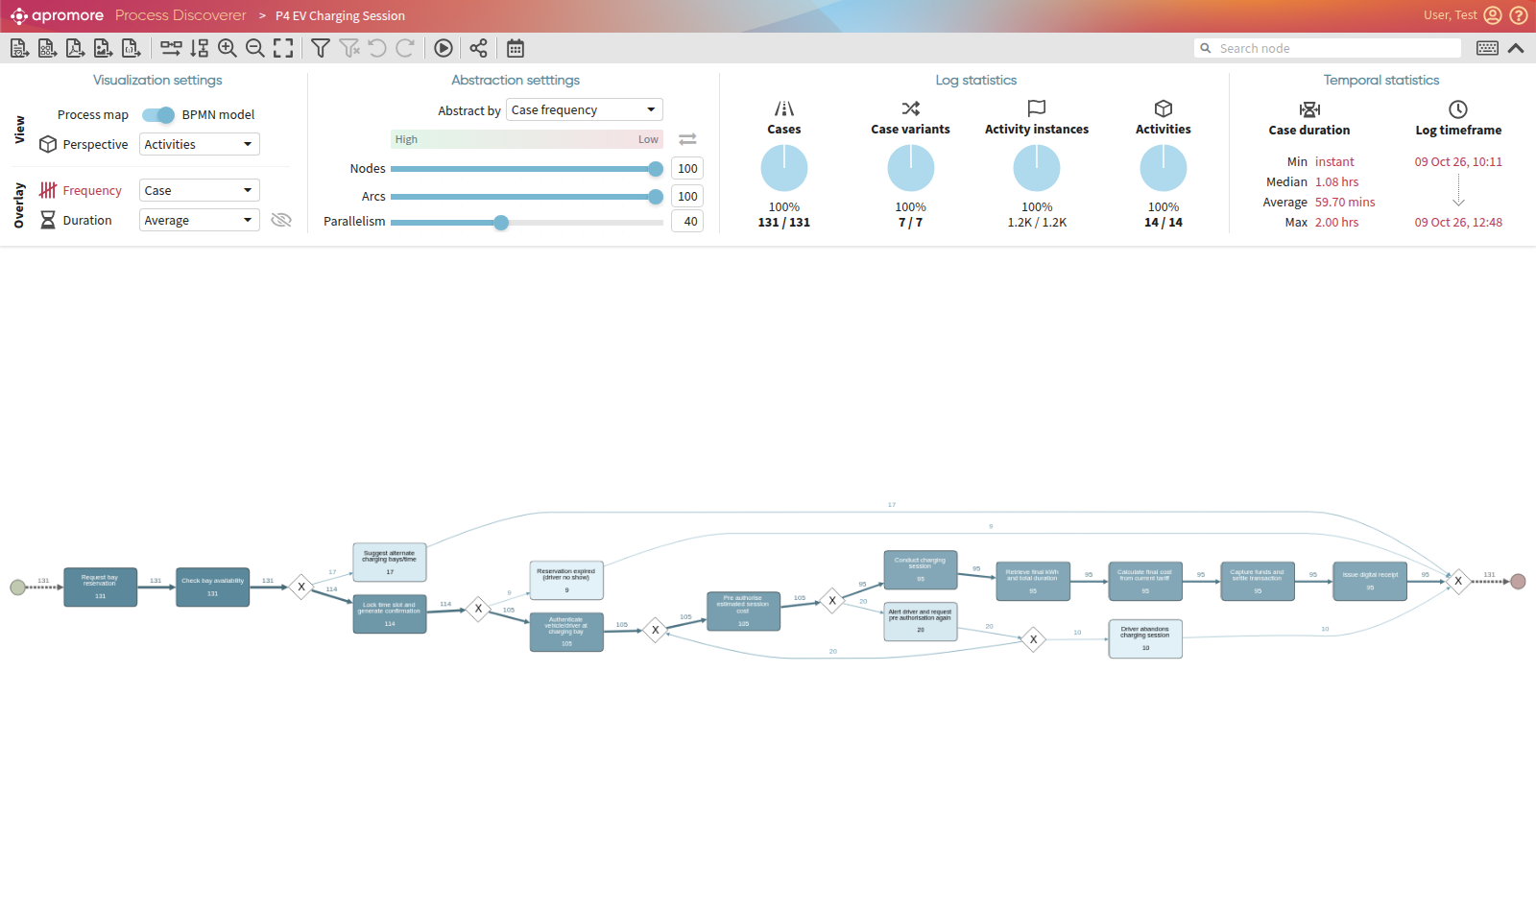
Figure F.9 — BPMN model discovered by Apromore (Split Miner) from the P4 log. Compare with the Part B reference model imported into Apromore (part-f-results/apromore/p4-0-reference-model.png): the discovered model has an extra exclusive branch after "Lock time slot…" (the no-show) and an exit from the pre-authorisation loop (the abandonment). These are the two deviations the pm4py alignments report (F.4.3).
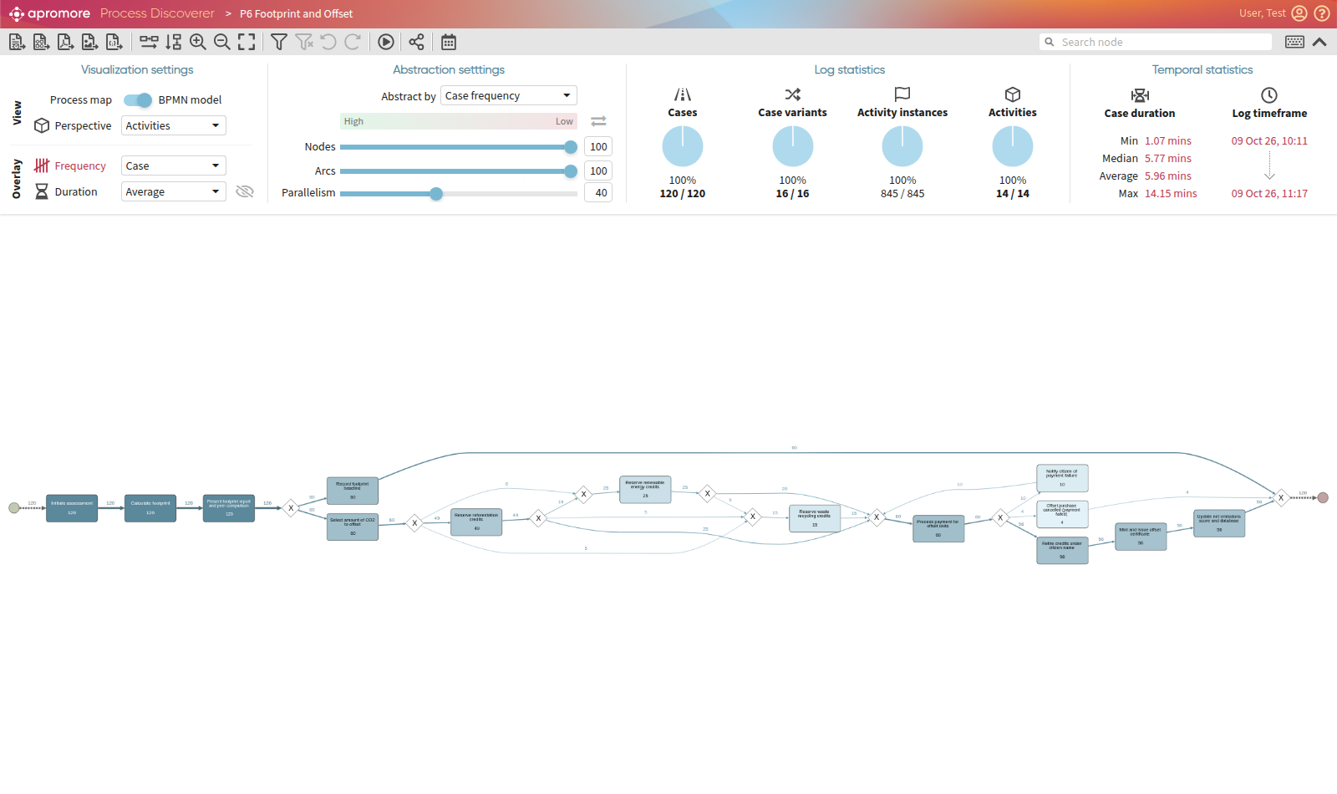
Figure F.10 — BPMN model discovered by Apromore from the P6 log: the exclusive choice at 6.4 (60 baseline / 60 purchase), the optional and concurrent project-type reservations, the payment retry loop, and the cancellation exit that Part B lacks.
The P3 and P6 frequency/duration maps and the P3 discovered model are in docs/part-f-results/apromore/ (p3-*, p6-*).

F.5 Insights and Recommendations
Process mining was used here both to analyse the processes and to check the design. The findings feed back into the earlier parts:
- Part B Process 4 should model the no-show. 7% of confirmed reservations expired. Add a timer boundary event on "Await vehicle arrival" (grace period) leading to "Release slot" and an end event "Reservation expired". Operationally, each no-show holds a bay for about 35 minutes while the same station pool turned away 13% of booking requests. A no-show fee or a shorter grace period would free capacity.
- Part B Process 4's retry loop needs an exit. 10 of the 105 drivers who arrived (9.5%) abandoned after declined pre-authorisations. Add an exit from 4.7a ("Driver cancels") with an end event, and consider offering a second payment method in the alert, since the alert-to-retry loop resolves within about 1.5 minutes when it succeeds.
- Part B Process 6 should bound its payment retries. The model loops on 6.9 indefinitely. The implementation (and any real payment gateway) gives up. Model "after n failures → Cancel purchase → Release reserved credits", which also keeps the reserved credits from being locked forever.
- The microservice boundaries hold up under analysis. The hand-over networks match the BPMN lanes one to one (RSVP Management → Billing, Offset Marketplace → Registry → Assessment Service), and the asynchronous hops cost milliseconds. The cost of splitting each process across two services is negligible compared with the external dependencies.
- Bottlenecks are external, so effort belongs there. To speed up offset certification, work on the registry integration (for example, batch retirements, or certify optimistically and reconcile later). To speed up journey planning, cache the timetable feed, which is the slowest of the two parallel calls.

F.6 Reproducing the Analysis
./partf.sh # stack up → simulate 120 cases/process → export → mine
CASES=200 SEED=7 ./partf.sh # a different/larger run
To analyse a fresh run in Apromore, start it with docker compose -f tools/apromore/docker-compose.yml up -d and upload the new exports/*.xes (see tools/apromore/README.md).
partf.sh archives earlier logs to logs/archive/<timestamp>/ before simulating, so each run's log is clean. Outputs: exports/*.xes, *.csv, *.activities.csv (business-time logs for Disco/Apromore), exports/raw/ (unscaled), and analysis/RESULTS.md plus figures and reference-model.bpmn per process. Each step can also be run on its own: docker compose run --rm simulator, docker compose run --rm -e TIME_SCALE=60 log-exporter, docker compose run --rm process-miner.

F.7 Limitations
- Human and external behaviour is simulated. Rates such as no-shows, card declines and offset uptake are assumptions, chosen to be plausible and to exercise every branch, so the business findings in F.5 are illustrative. The service-performance figures (F.4.4) are measured, but on one machine with mocked external systems.
- Time is compressed 60× and re-expanded linearly, so durations of human activities are accurate in proportion, but the absolute service latencies in the scaled logs are inflated (hence F.4.4 uses the raw logs).
- The reference models are hand-encoded from the Part B diagrams, and the inclusive gateways are approximated as parallel optional branches (the reason for the 0.917/0.923 precision values in P3/P6).

