AKADEMIA GÓRNICZO-HUTNICZA
IM. STANISŁAWA STASZICA W KRAKOWIE
Wydział Inżynierii Metali i Informatyki Przemysłowej

MULTISCALE MODELING

„Report II”

Name and surname of the student: Michał Pożarlik

Signature of the student: Signature of the reviewer:

Kraków 2019
Table of Contents
1. Technology 3
2. User Interface 4
3. Application outputs 8
3.1. Basic growth 8
3.2. Inclusions 10
3.3. Different micro structure types 12
3.4. Grain boundaries 13
4. Real structure compare 15
5. Conclusions 18

Technology

Project was creating using Windows Forms technology. Basic language was C#, application was writing using IDE: Microsoft Visual Studio 2015. UI have been designed using standard editor integrated with VS.
This technology is still popular for Windows desktop application. The most important think about this decision was chose simple and fast technology. Microsoft deliver a lot of libraries integrated with Windows Forms, so it was easy to create user friendly application for simulation of grain growth.
This project is open-source, so for repository is using GitHub website with public settings for repository. Visual Studio include tools for using GitGub, so all commits have been created using IDE.
The most important for decision about language was preference for developer. Knowledge is important for choose technology, especially, when project have quick deadline.
Project is continuation of preview grain growth application (CA method), so in theory from code and technology side this project is only extension for old implementation. In real, old code needed refactor to make it more scalable.

User Interface

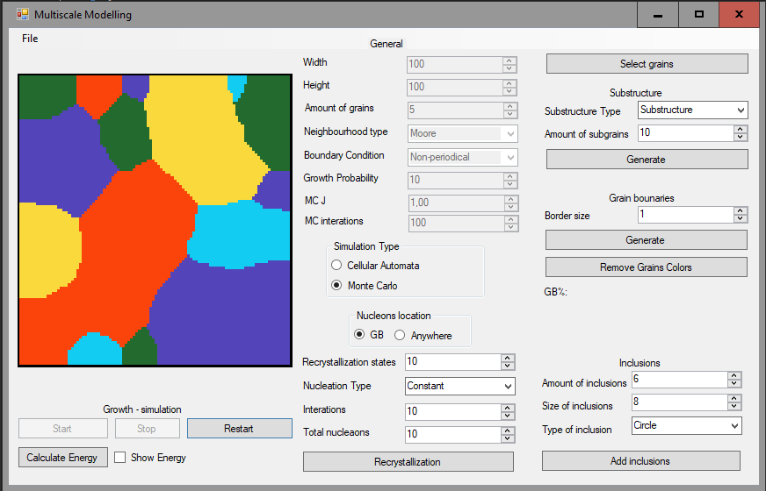Fig. 1: Application UI

From UI side application include 3 new sections (Fig 1). Currently user have possible to change type of simulation (Cellular Automate or Monte Carlo). After generate grains will be possible to start recrystallize or calculate and show energy for grains structure.

Simulation output – grains structure and energy

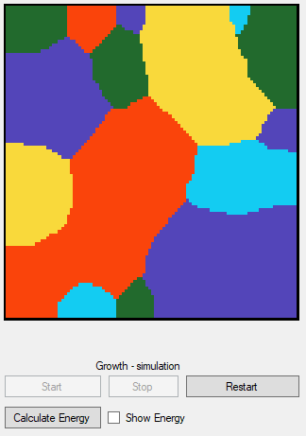Fig. 2: Output window
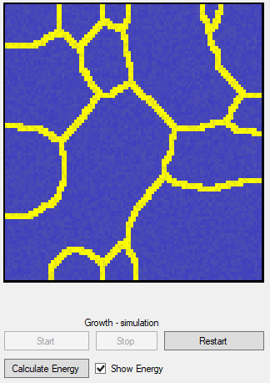Fig. 3: Output window – show energy

Main of them is simulation output on left side of application. Nucleons are represented by colorful pixels, user can change simulation size, but always will see bitmap in one size. It is possible, because application rescale generated map to bitmap in application. After generate structure (Fig 2) it is possible to calculate energy (by click button - “Calculate Energy”), and show it by select checkbox - “Show Energy” (Fig 3).

Basic simulation parameters
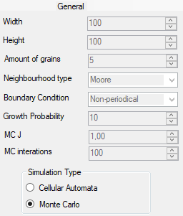Fig. 4: General parameters
Next section [Fig. 4] is about change mainly settings for growth simulation simulation.
More about each fields:

- Width – width of simulation map (output bitmap),
- Height – width of simulation map (output bitmap),
- Amount of grains – number of grains in map,
- Neighborhood type – type of grains neighborhood:
  - Von Neumann
  - Moore
  - Moore 2 - extension of Moore neighborhood
- Boundary Condition - currently unused – only implemented one option: Non-periodical BC
- Growth Probability – parameter for Moore extension neighborhood type
- MC J – physical value “J” for Monte Carlo simulation
- MC iterations – amount of Monte Carlo iterations
- Simulation Type – type of simulation: Cellular Automate or Monte Carlo

Recrystallization
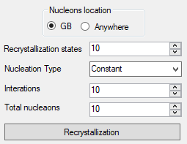Fig. 5: Recrystallization settings

Recrystallize section [Fig. 5] contain parameters for recrystallize process.
- Nucleons location – place for seeding new grains. We can seed new nucleons on Grains Boundaries, or Anywhere,
- Recrystallization states – amount of new grain states,
- Nucleation Type – type of grains seeding: Constant, Increasing, Begin Of Simulation,
- Iterations – number of Monte Carlo iterations,
- Total nucleons – total nucleons on the end of simulation.
Section include button to initialize recrystallization process - “Recrystallization”.

Application outputs

The application allows generate a lot of complex grains structure. This chapter contains basic capabilities with descriptions, how to use them.

Monte Carlo grain growth

For Monte Carlo simulation is important to setts three basic parameters: MC J, MC Iterations and select Simulation Type to “Monte Carlo”. The most important for Monte Carlo simulation is set iterations of simulation. For small value of this parameter (Fig 6.) we will generate a lot of small grains. When we will set higher number of iterations, we will see less grains (Fig 6). On extreme case, when we will set a large number we will see only one grain (Fig. 7).
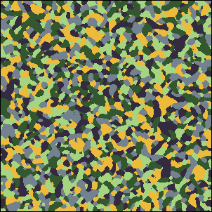Fig. 6: MC 10 iterations (300x300)
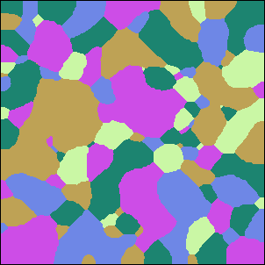Fig. 7: MC 100 iterations (300x300)
Fig. 8: MC 1500 iterations (100x100)

Dual phase microstructure

After generate grains structure, will be possible to generate substructure or dual phase. User need to select remaining grains, write amount of grains to generate and select type of new structure. Additional step is select type of simulation (MC or CA). Next step is click generate button and start simulation.
Possible is to generate dual phase structure between two different type of simulations: Monte Carlo and Cellular Automate. It is possible to generate complex combination between simulation, for example CA → MC (Fig 9.) or MC → CA (Fig 10.).
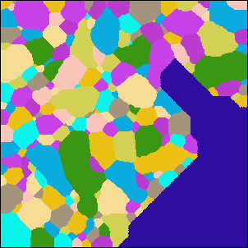Fig. 10: CA -> MC
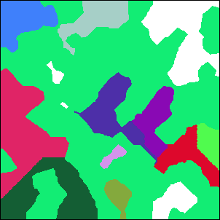Fig. 9: MC -> CA

SRX Monte Carlo

Nucleation and growth

After generate base structure (Fig 12) it is possible to simulation recrystalization process. User need to write parameters for simulation, like number of iterations (20 in example) and number of states (10 in example) Important is select type of nucleation, application have implementation for three nucleation methods:
- Constant – create new grains in constant batch per iteration (Fig 11),
- Increasing - create new grains in increasing batch per iteration (Fig 13),
- Begin Of Simulation – create all grains in first iteration (Fig 14).
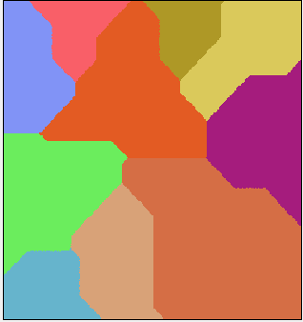Fig. 12: Base structure
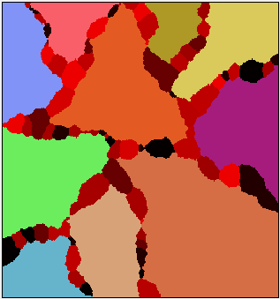Fig. 11: Constant nucleations (100 nucleaons)
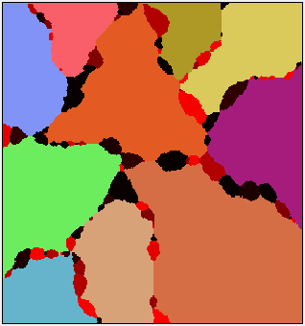Fig. 13: Incresing nucleations (100 nucleaons)
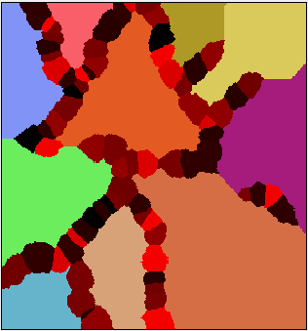Fig. 14: Begin Of Simulation nucleations (100 nucleaons)

Energy distribution

Application possible to calculate and show energy in structure. Energy for Fig. 16, you can see on Fig. 15. After recrystalization (Fig. 17) process we have other energy distribution (Fig. 15).

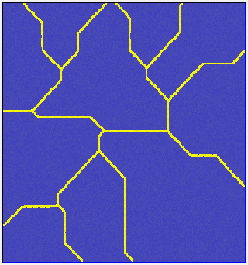Fig. 15: Energy for base structure
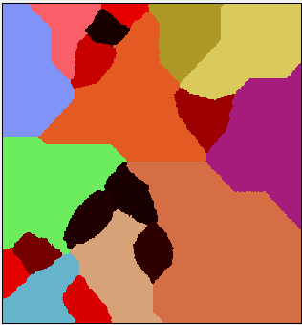Fig. 16: Structure after recrystalization (Begin Of Simulation nucleations)
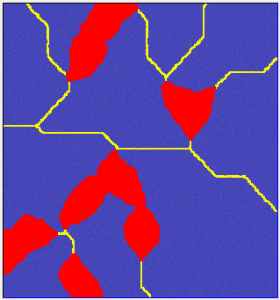Fig. 17: Energy after recrystalization
Where yellow color means more energy than blue. Red color means structure without energy.



Real structure compare

Conclusions

Grains in nature in material often are very complex, so it is huge problem for generate simulation for generate simple results. In this project used simple methods for create simulation. Results aren’t perfect, but after compare with real photos we can see similarities for generated structures.
Application implemented few neighborhoods method, more complex algorithm like Extended Moore, give us more natural grains form, but it complicate simulation, so we need more powerful machine to simulation bigger bitmaps.
Generated bitmaps can be used to next analysis, without specialist machine like expensive microscopes. Else application is generating clear output bitmaps, we don’t need to use filters and other graphic processing, like for data from microscope.
The biggest problem with application from technology side is about performance. Grains growth is very complex process and need optimal algorithm and technology. Created application need a lot of system resources and still need a lot of time for bigger simulation.

Illustration Index
Fig. 1: Application UI 4
Fig. 2: Output window - size 10x10 5
Fig. 3: Output window - size 300x300 5
Fig. 4: Growth settings 5
Fig. 5: Inclusion settings 6
Fig. 6: Substructure section 6
Fig. 7: Boundaries section 7
Fig. 8: File control section 7
Fig. 9: Application output - Von Neuman - small 8
Fig. 10: Application output - Von Neuman - huge 8
Fig. 11: Application output - Moore - small 9
Fig. 12: Application output - Moore - huge 9
Fig. 13: Application output - Extended Moore – small (probability 10%) 9
Fig. 14: Application output - Extended Moore – huge (probability 10%) 9
Fig. 15: Application output - Extended Moore - small (probability 90%) 10
Fig. 16: Application output - Extended Moore - huge (probability 90%) 10
Fig. 17: Application output - circle - before 11
Fig. 18: Application output - circle - after 11
Fig. 19: Application output - square - before 11
Fig. 20: Application output - square - after 11
Fig. 21: Application output - micro structure basic bitmap 12
Fig. 22: Application output - substructure 13
Fig. 23: Application output - Dual-Phase 13
Fig. 24: Application output - borders baseline bitmap 14
Fig. 25: Application output - all grains borders 14
Fig. 26: Application output - all grains borders after clear 14
Fig. 27: Application output - selected grains borders 15
Fig. 28: Application output - selected grains borders after clear 15
Fig. 29: Application output - microstructure 15
Fig. 30: Motor lamination steel before decarburization etched with (a) Marshall’s reagent ref1 15
Fig. 31: Application output - Dual-Phase 16
Fig. 32: Microstructure of as-Received Materials (a) Stainless Steel (b) Low Carbon Steel ref2 16
Fig. 33: Application output - borders 16
Fig. 34: Cementite or iron carbide (Fe3C) ref3 16
Fig. 35: Application output - Inclusions 17
Fig. 36: Micrograph of a polycrystalline metal; grain boundaries evidenced by acid etching ref4 17
Fig. 37: Application output - Substructures 17
Fig. 38: Abnormal grain growth observed in Rutile TiO2, induced by the presence of a zircon secondary phase ref5 17

Integrated Development Environment – software application for software developers.
User Interface - interface with which a person may interact
More details: https://opensource.org/ (active for day: 01.01.2019)
Url for repository: https://github.com/Micp95/MultiscaleModelling (active for day: 14.11.2018) ref1. url: https://vacaero.com/information-resources/metallography-with-george-vander-voort/1418-delineation-and-measurement-of-grain-size-by-ebsd.html (active for day: 14.11.2018) ref2. url: https://www.researchgate.net/figure/Microstructure-of-as-Received-Materials-a-Stainless-Steel-b-Low-Carbon-Ste_fig1_310766913 (active for day: 14.11.2018) ref3. url: http://www.cashenblades.com/metallurgy.html (active for day: 14.11.2018) ref4. url: https://en.wikipedia.org/wiki/Grain_boundary (active for day: 14.11.2018) ref5. url: http://www.wikiwand.com/en/Abnormal_grain_growth#/citenoteref14 (active for day: 14.11.2018)

