Report I
Multiscale Modeling

1. User Interface

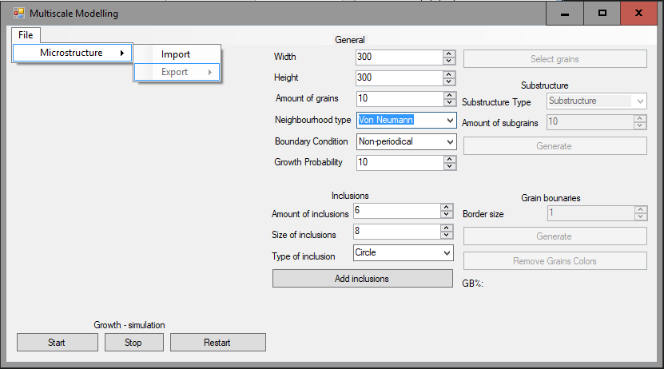

Advanced application for growth often needed much complicated interface. It is complex process, so user need to have access to change a lot of process parameters. Application should be easy to using and interface should be user friendly. Just to create interface more clear, user have active only needed options to current step of simulation.
You can find subsections for control process of grains growth.

Simulation output:

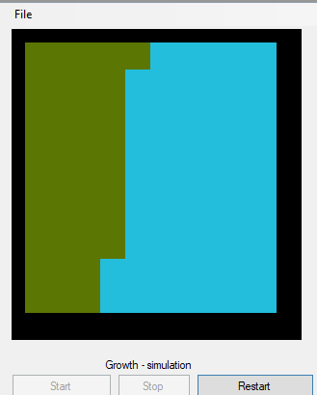
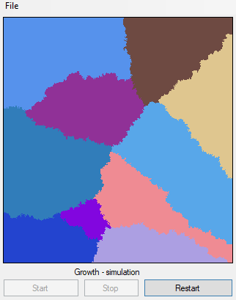

Main of them is simulation output on left side of application. Nucleons are represented by colorful pixels, user can change simulation size, but always will see bitmap in one size. It is possible, because application rescale generated map to bitmap in application.

Simulation buttons:

Below of output bitmap, user can find simulation buttons, for control process:
- Start – button for start simulation, you need to click it if you want to generate grains, or substructure.
- Stop – when process is simulating, user can click stop button to stop simulation,
- Restart – after simulation user have possibility to restart simulation.

General growth settings:

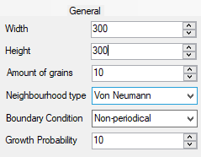
- Width – width of simulation map (output bitmap),
- Height – width of simulation map (output bitmap),
- Amount of grains – number of grains in map,
- Neighbourhood type – type of grains neighbourhood:
  - Von Neumann
  - Moore
  - Moore 2 - extension of Moore neighbourhood
- Boundary Condition - currently unused – only implemented one option: Non-periodical BC
- Growth Probability – parameter for Moore extension neighbourhood type

Inclusions settings:

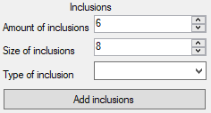
- Amount of inclusions – number of inclusions to add
- Size of inclusions – size of inclusions to add (diamater or side of the square)
- Type of inclusion:
  - square
  - circle

Substructure section:

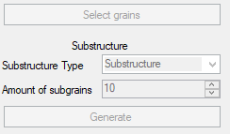

- Select Grains button – user need to use this button if want to select grains to processes, like: generate substructure, or generate boundaries for selected grains
- Substructure Type:
  - Substructure – clear unselected grains and generate substructure for empty fields
  - Dual phase – generate one grains from selected grains and generate new structure for other grains
- Amount of sub grains – number of grains to generate
- Generate button – initialize process

Grain Boundaries:

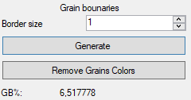
- Border size – size of border for each grains
- Generate button – add borders for: selected grains (if selected), or for each grains,
- Remove Grains Colors – remove colors for grains
- GB% - label with information about relation between boundaries and nucleons.

File control:

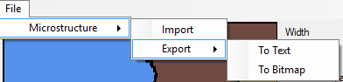

- import – user can load bmp or xt files
- export – user can generate file with extensions like: txt or bmp

2. Application outputs

- Basic growth

Number of grains: 10  Neighborhood: Von Neumann | Number of grains: 200  Neighborhood: Von Neumann
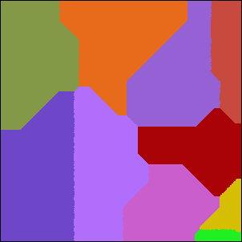 | 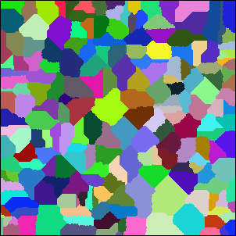
Number of grains: 10  Neighborhood: Moore | Number of grains: 200  Neighborhood: Moore
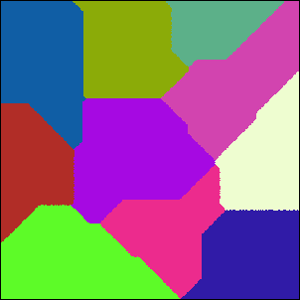 | 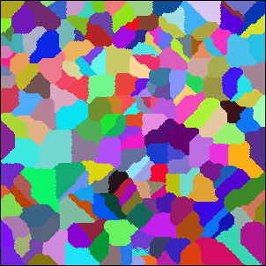
Number of grains: 10  Neighborhood: Moore 2  Probability: 10% | Number of grains: 200  Neighborhood: Moore 2  Probability: 10%
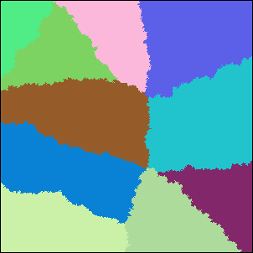 | 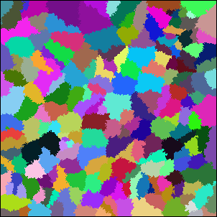
Number of grains: 10  Neighborhood: Moore 2  Probability: 90% | Number of grains: 200  Neighborhood: Moore 2  Probability: 90%
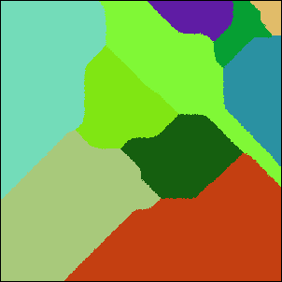 | 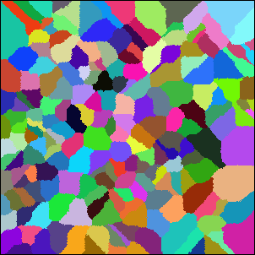

- Inclusions

Application is implementing two types of inclusions: circle and square. User have possibility to change size of inclusions and change amount of them to add. We have two options for add inclusions – before and after simulation. Inclusions added after simulation should be generated only on boundaries of grains.

Number of grains: 20  Neighborhood: Von Neumann  Type of inclusion: Circle  Inclusions generate before simulation | Number of grains: 20  Neighborhood: Von Neumann  Type of inclusion: Circle  Inclusions generate after simulation
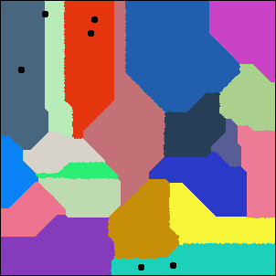 | 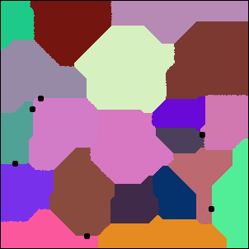
Number of grains: 20  Neighborhood: Von Neumann  Type of inclusion: Square  Inclusions generate before simulation | Number of grains: 20  Neighborhood: Von Neumann  Type of inclusion: Square  Inclusions generate after simulation
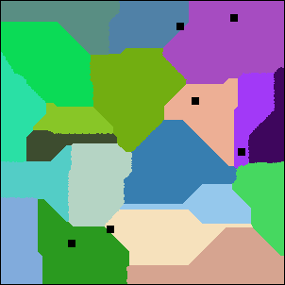 | 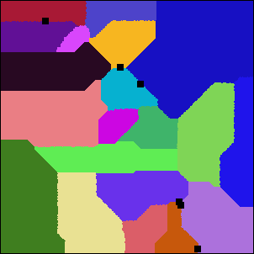

- Different microstructure types

After generate grains structure, will be possible to generate substructure or dual phase. User need to select remaining grains, write amount of grains to generate and select type of new structure. Next step is click generate button and start simulation.

Number of grains: 20
Neighborhood: Von Neumann
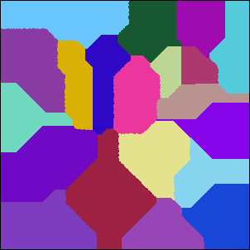
Number of grains: 20  Neighborhood: Von Neumann  Subsctucture type: Substructure  Amount of subgrains: 50  Amount of selected grains: 5 | Number of grains: 20  Neighborhood: Von Neumann  Subsctucture type: Dual Phase  Amount of subgrains: 10  Amount of selected grains: 8
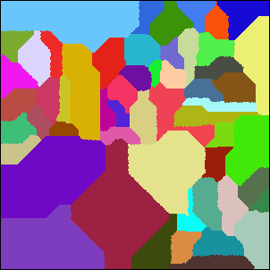 | 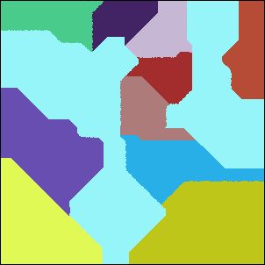

- Grain boundaries

Another implemented feature is grain boundaries. After generate basic structure is possible to generate grain boundaries. User can set border size and select grains to process, if user won’t select any grains, should be add for each grains. After process is possible to remove colors from grains.
If user add boundaries for grains, will be possible to see label with percent of relation between boundaries and other structures

Number of grains: 20
Neighborhood: Von Neumann
Number of grains: 20  Neighborhood: Von Neumann  Border size: 1  All grains  GB: 6,98% | Number of grains: 20  Neighborhood: Von Neumann  Border size: 1  All grains  Without grains colors  GB: 6,98%
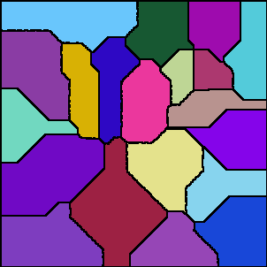 | 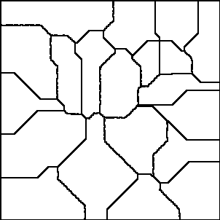
Number of grains: 20  Neighborhood: Von Neumann  Border size: 1  Selected grains  GB: 1,56% | Number of grains: 20  Neighborhood: Von Neumann  Border size: 1  Selected grains  Without grains colors  GB: 1,56%
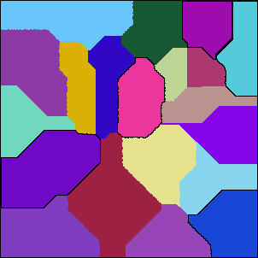 | 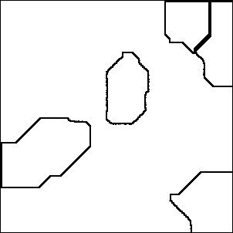

3. Real structure compare

Microstucture | Motor lamination steel before decarburization etched with (a) Marshall’s reagent [1]
 | 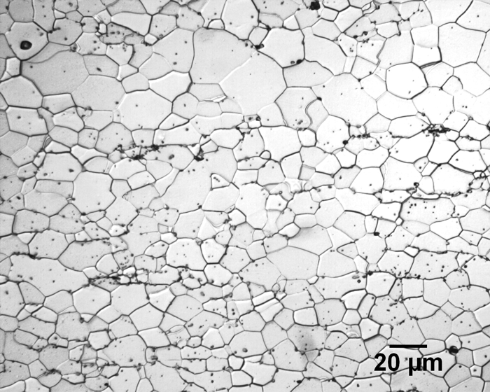
Dual Phase | Microstructure of as-Received Materials (a) Stainless Steel (b) Low Carbon Ste [2]
 | 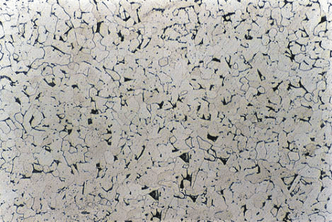
Grain Borders | Cementite or iron carbide (Fe3C) [3]
 | 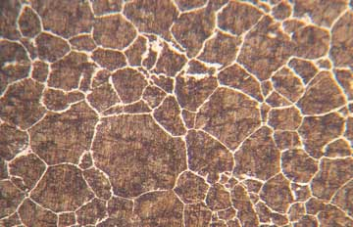
Inclusions | Micrograph of a polycrystalline metal; grain boundaries evidenced by acid etching. [4]
 | 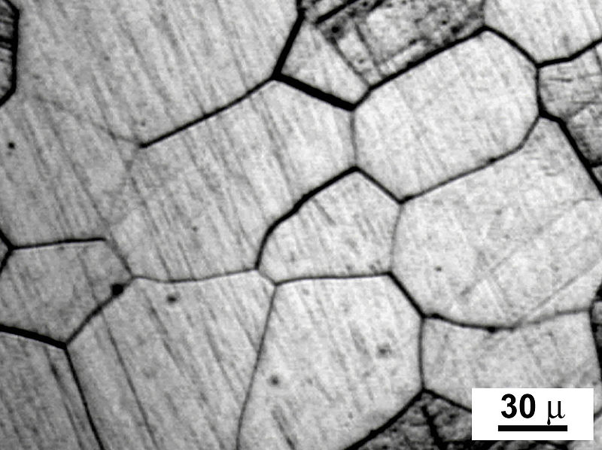
Substructures | Abnormal grain growth observed in Rutile TiO2, induced by the presence of a zircon secondary phase [5]
 | 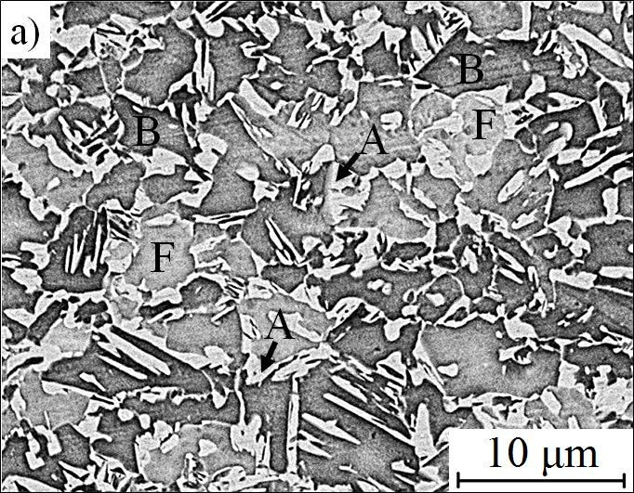

The application allows to generate structures similar to real, but still it will be very simplified structure. Grains in real are much complex it it is hard to simulate all process for generate exactly this same structure. The best results you can see in basic grains structure and with inclusions.
The biggest problem is with compare substructures effect with real photo, but probably exist better example, where structures will be similar.

1. https://vacaero.com/information-resources/metallography-with-george-vander-voort/1418-delineation-and-measurement-of-grain-size-by-ebsd.html
2. https://www.researchgate.net/figure/Microstructure-of-as-Received-Materials-a-Stainless-Steel-b-Low-Carbon-Ste_fig1_310766913
3. http://www.cashenblades.com/metallurgy.html
4. https://en.wikipedia.org/wiki/Grain_boundary
5. http://www.wikiwand.com/en/Abnormal_grain_growth#/citenoteref14

