# UNG8071_EVB NAND Flash Programming

# 1. Introduction

This document describes how to program the UNG8071_EVB on board NAND flash. The flash binaries and scripts UNG8071_EVB_Demo_Images_Vxx.xx.xx.tar.gz required for the flash programming needs to be downloaded from Microchip.com. The xx.xx.xx is the version of the switch software.

The SAM-BA GUI tool provides a means of programming various Atmel ARM processor-based microcontrollers.

# 2. Evaluation board

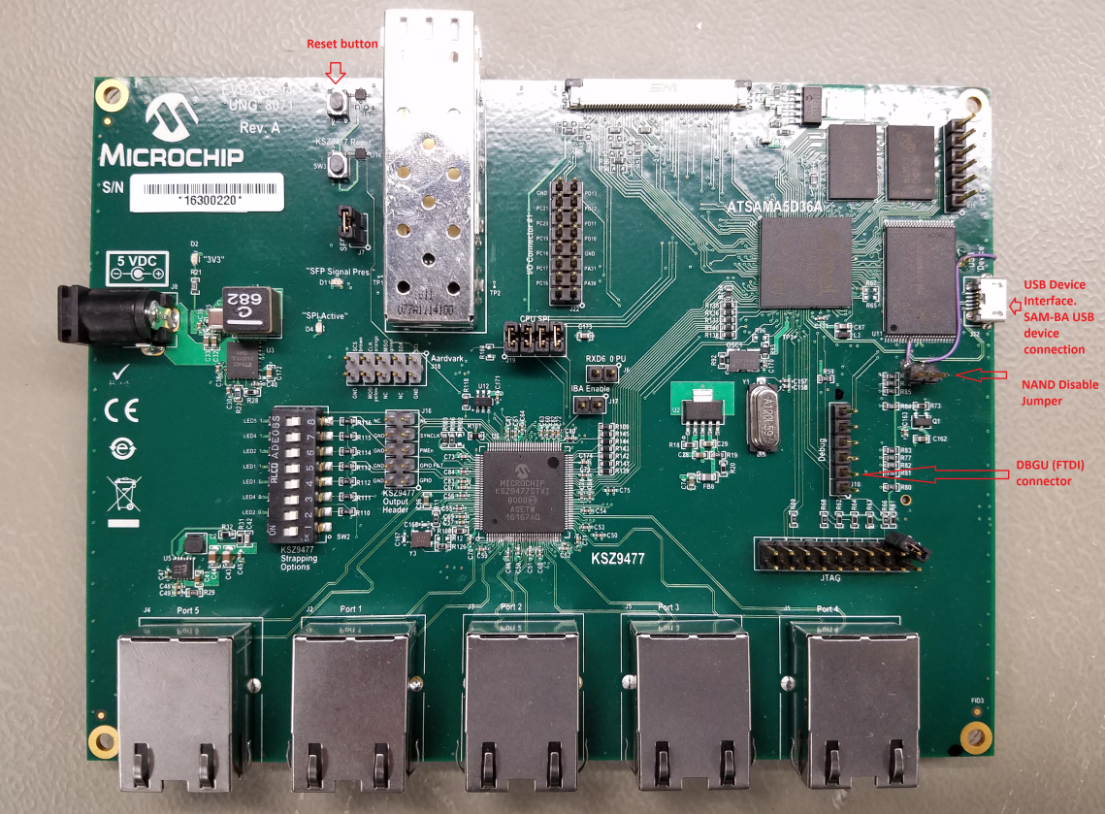

Note: The NAND disable jumper may be in different location on your board depending on the rework

# 3. Linux Users

The procedure below is tested with the Ubuntu 14.04.05 LTS distribution.

## 3.1. Flash Programming

1. Open a terminal window and extract the image and scripts.

$ tar –xzvf UNG8071_EVB_Demo_Images_vxx.xx.xx.tar.gz

$ cd UNG8071_EVB_demo_images/linux

1. Connect the micro usb connector of the UNG8071_EVB to the Linux PC.
2. Connect the 5V power to UNG8071_EVB board
3. Insert the NAND flash disable jumper and hit the reset MCU Reset button (the /dev/ttyACM0 created. You can see this by executing command ‘$ tail –f /var/log/kernel.log’)
4. Remove the NAND disable jumper
5. If you are using x86 system then run the 'flash_board' script in the terminal window. If you are using x64 system then run execute ‘flash_board_x64’ script.

$ sudo flash_board

Or

$ sudo flash_board_x64

1. Once you see "=== DONE. ===" message you hit the MPU Reset button to reboot the UNG8071_EVB board.

# 4. Windows Users

1. Open a terminal window and extract the image and scripts. Winzip or 7-zip tool can be used to extract the downloaded UNG8071_EVB_Demo_Images_vxx.xx.xx.tar.gz file.
2. Connect the micro usb connector of the UNG8071_EVB to the Windows PC.
3. Connect the 5V power to UNG8071_EVB board.
4. Insert the NAND flash disable jumper and hit the reset MCU Reset button.
5. Now Windows tries to install the driver. The device ‘AT91 USB to Serial Converter ‘should appear under Ports (COM & LPT). If you see ‘unknown device’ or ’Bossa Program port’ uninstall driver and install the driver present in the ‘windows\sam-ba_3.1.4\driver’ directory.

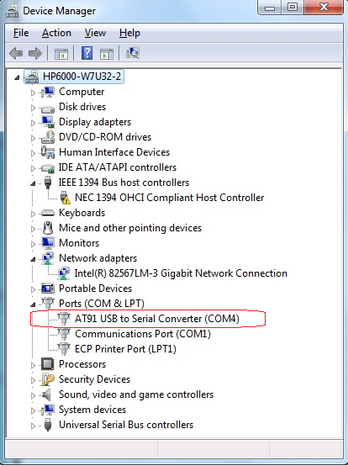

6. Run the below command to program the NAND flash.

# flash_board.bat