1. Program Exercise 4 Statement

**Calculate π**

Use the following formula to calculate an approximate value of π until the absolute value of the last term is less than 10^-5

hint：

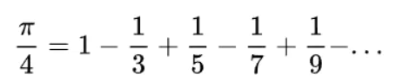

1. Program Exercise 5 Statement

**Output prime numbers**

Output all prime numbers in the specified range

Tip: >1, and is not divisible by other natural numbers except 1 and itself.

1. Program Exercise 6 Statement

**Determine leap year**

Determine whether a year is a leap year

Tip: Non-century years (years not divisible by 100) that are divisible by 4 are leap years. (For example, 2004 is a leap year, and 1999 is not a leap year)

A century year (a year divisible by 100) that is divisible by 400 is a leap year. (For example, 2000 is a leap year and 1900 is not a leap year)

1. Program Exercise 7 Statement

Output the power table

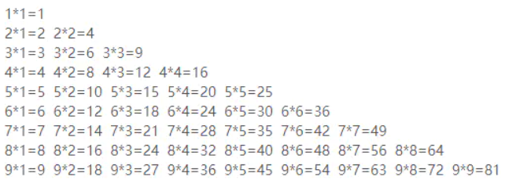

1. Calculation of the area of a circle, with the output retained to two decimal places.
2. Program running timing, record and output the running time of a program that loops 10 million times.