1. **Install Python or Setup Anaconda Environment (Python)**
2. **Windows Option 1: Using Python Environment**
3. Download Python 3.7.XX or Python 3.8.XX from the following website: <https://www.python.org/downloads/windows/>

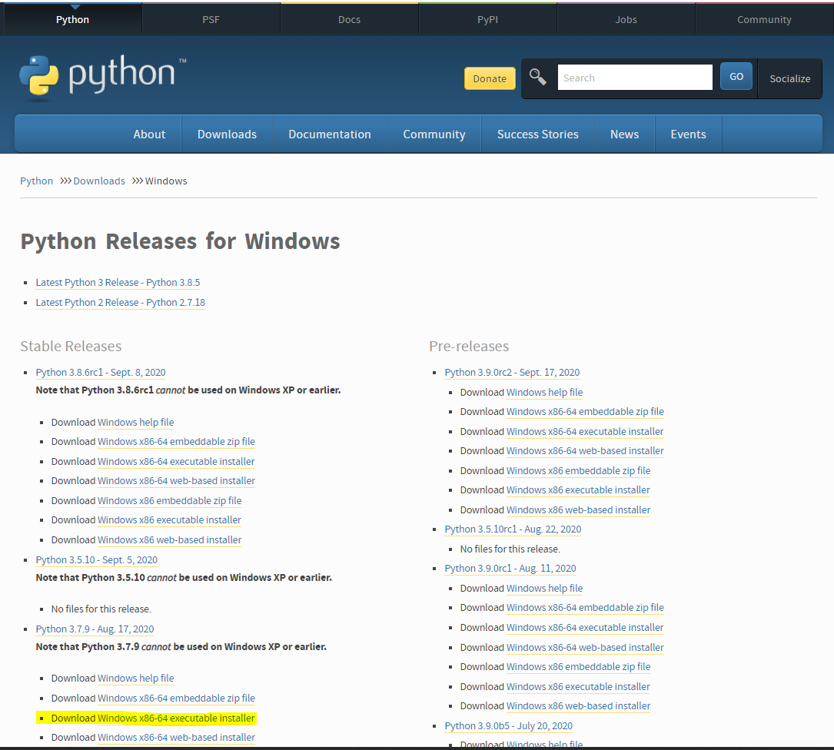

1. Run the downloaded installer file, ‘’Do Not check Install for all users”, may need administrative permissions for all users. This will create a local copy of python for the windows user account currently logged-in.

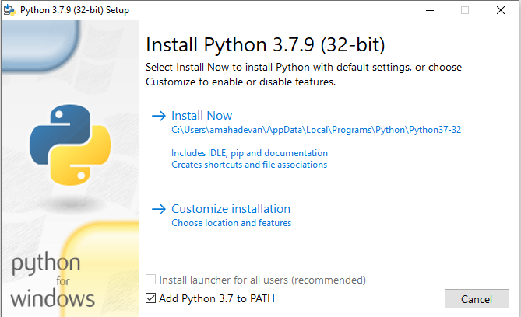

1. Install ‘pip’
   1. Open terminal or command prompt using: cmd
   2. Option 1:
      1. Try: py -m pip –version (check if this return the current pip version)
   3. Option 2:
      1. Run: >curl [https://bootstrap.pypa.io/get-pip.py -o get-pip.py](https://bootstrap.pypa.io/get-pip.py%20-o%20get-pip.py)
      2. Run: >py get-pip.py (or) >python get-pip.py
2. Install the required Packages
   1. Run: >py -m pip install ‘requirements.txt’
3. **Windows Option 2: Using Anaconda**
4. Download appropriate version from the following website:

<https://www.anaconda.com/products/individual#windows>

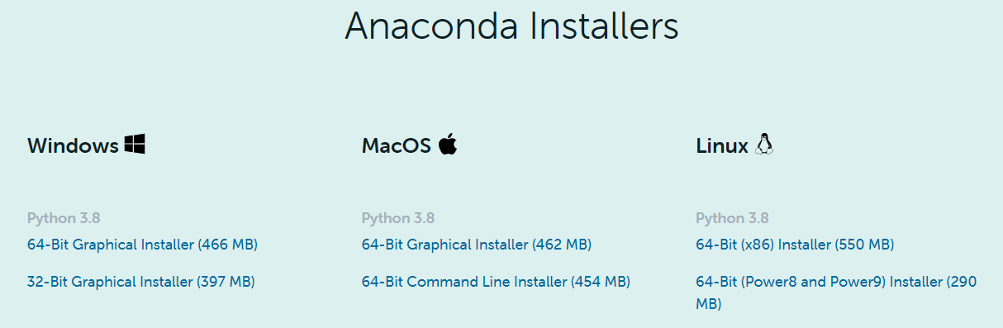

1. Run the Installer File (Anaconda3-2020.07-Windows-x86_64.exe)

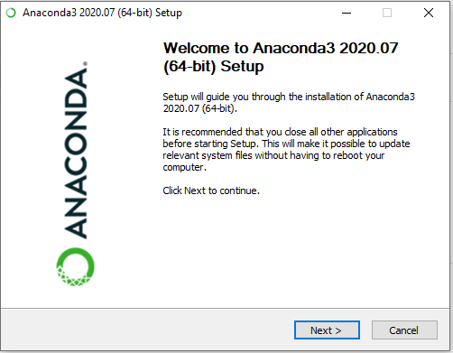

1. Select ‘Just Me (recommended)’ and continue to complete the installation.

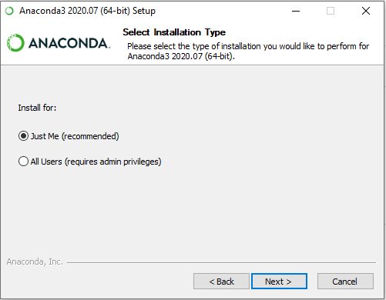

1. Open ‘Anaconda Prompt’

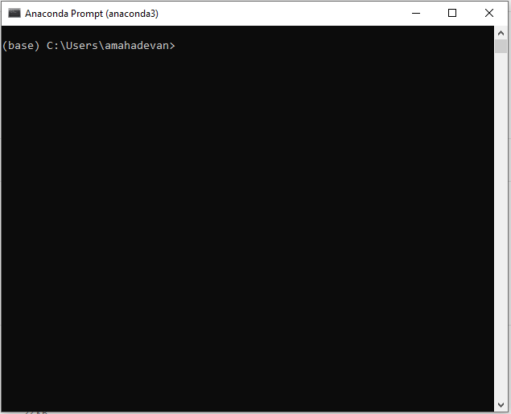

1. Install the required Packages
   1. Run: >py -m pip install ‘requirements.txt’