1. **Export Channels or Channel Groups for Down Sampling and Analysis from Brain Wave 4 Measurements**

The Brain Wave 4 MEA array contains 4096 channels sampled at ~11,000 Hz. The file size is in the order of ~250 GB uncompressed and 80 GB compressed). In order to reduce computation time and complexity, we export a group of channels (100 to 350) for analysis in python - Dash.

1. Open BrainWave 4 Software

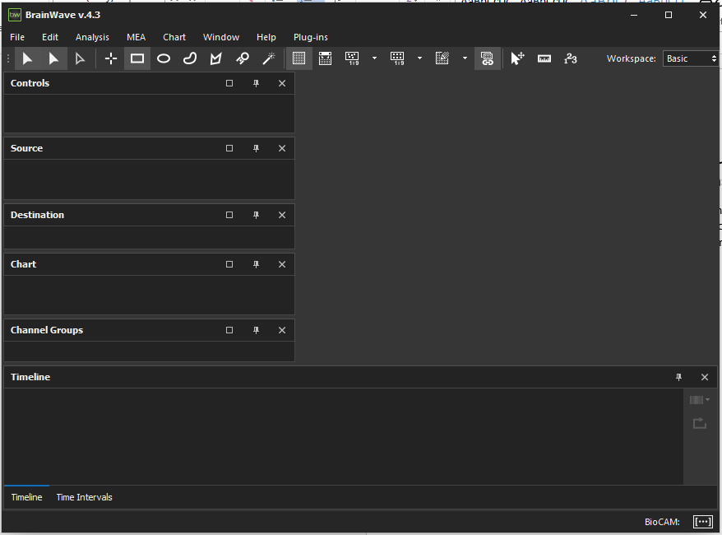

1. Open the BrainWave4 Compressed or Uncompressed .brw measurement file: File 🡪 Open

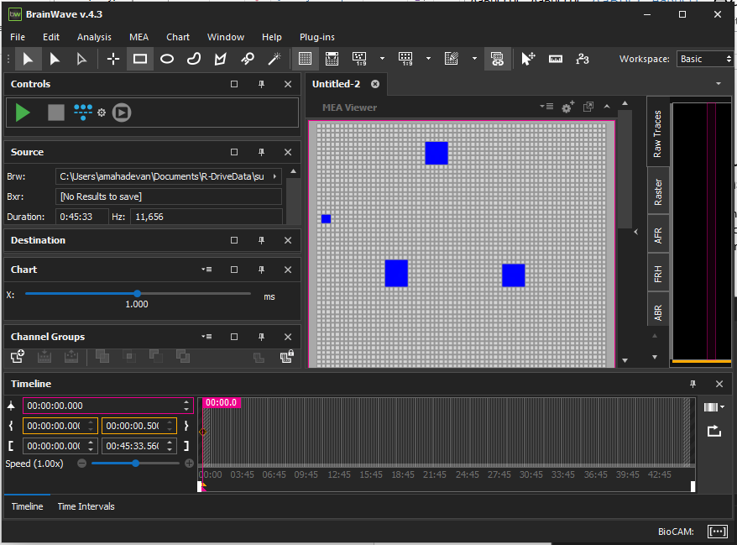

1. Export a group of channels: File 🡪Export 🡪Raw Data or Ctr + E

Select a subset of channels, give it a file name and ‘Export’.

