1. **Down Sample Exported Channels for MEA Explore & Analysis**
2. **Requirements:**
3. Install Python and all the required packages as per document ‘00-Python-Setup.pdf’
4. Export compressed (rawEncoded) ‘.brw’ file sampled at 11,000 Hz or greater using the BrainWave4 software as per document ’01-Export-Channel-Groups.pdf’.
5. Copy and paste emptyRaw.brw file in the working directory or in a convenient folder location to use as template.
6. The code file: **‘C:\\Users\\Documents\\sample_data\\ HD-MEA-DownSample.py’**
7. **Inputs:**

Once you run the code file you will need to input the following three arguments, have them ready or in a text file to input in the terminal/command prompt.

1. Folder/Directory path for ‘emptyRaw.brw’

**Example: C:\\Users\\Documents\\sample_data\\**

1. Full Path of the exported analysis file

**Example: C:\\Users\\Documents\\sample_data\\50.1_27-4-20_slice4_CBP.brw**

1. Down Sampling Frequency:

**Example: 2048**

1. **Instructions:**
2. Open Windows Command Prompt (cmd) if you are using Python base installation as per Option1, or Open Anaconda Command Prompt (anaconda) if you are working with Anaconda Option2

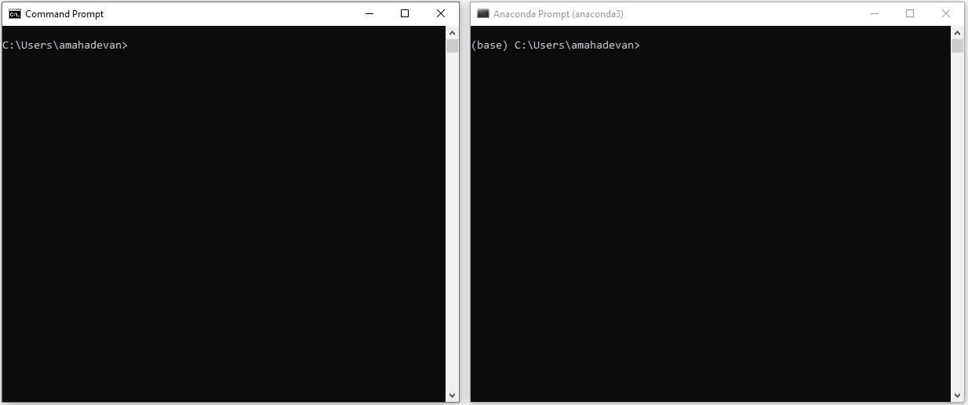

1. Run the below command use the full path of the code file “MEA-DownSample-Ver2.py” (enclose the full path in double quotation).

**python “C:\\Users\\Documents\\Code-File-path\\HD-MEA-DownSample.py” (or)**

**py “C:\\Users\\Documents\\Code-File-path\\HD-MEA-DownSample.py”**

1. On the prompt in blue enter the directory path for ‘emptyRaw.brw’. Please find emptyRaw.brw file (included in the code folder), copy the location and paste in terminal.

**Example: C:\\Users\\Documents\\sample_data\\**

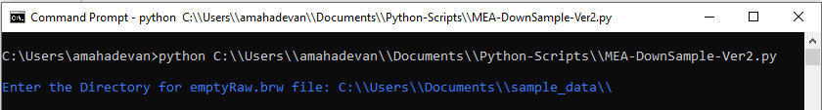

1. On the prompt in yellow enter the full path and file name for the analysis file to be downsampled

**Example: C:\\Users\\Documents\\sample _data\\Neocortex_EC_seizure_19-5-20_slice1.brw**

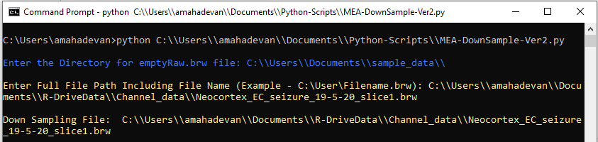

1. On the prompt in red enter the frequency you want to down sample to: **300**

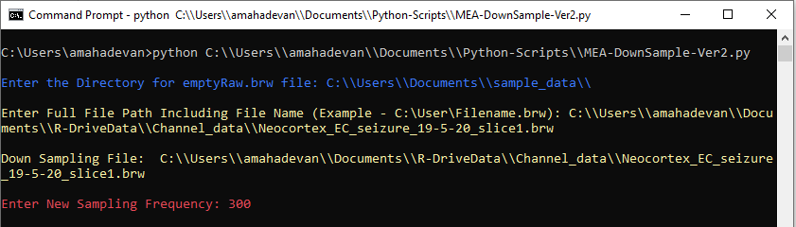

1. The code will run and save the output down sampled (.brw file) in the same location as the input file with a subscript as the resampled frequency.

