1. **Running Python-Dash Xenon-LFP-Analysis GUI**
2. **Requirements:**
3. Install Python and all the required packages as per document ’00-Python-Setup.pdf’
4. Export compressed (rawEncoded) ‘.brw’ file sampled at 11,000 Hz or greater using the BrainWave4 software as per document ‘01-Export-Channel-Groups.pdf’.
5. Generate a down sampled subset of data (.brw file) as per document ’02-DownSample.pdf’
6. **Inputs:**
7. Once you run the code file, you will need the file path and location of the down sampled (.brw) file.
8. **Instructions:**
9. Open Windows Command Prompt (cmd) if you are using Python base installation as per Option1, or Open Anaconda Command Prompt (anaconda) if you are working with Anaconda Option2

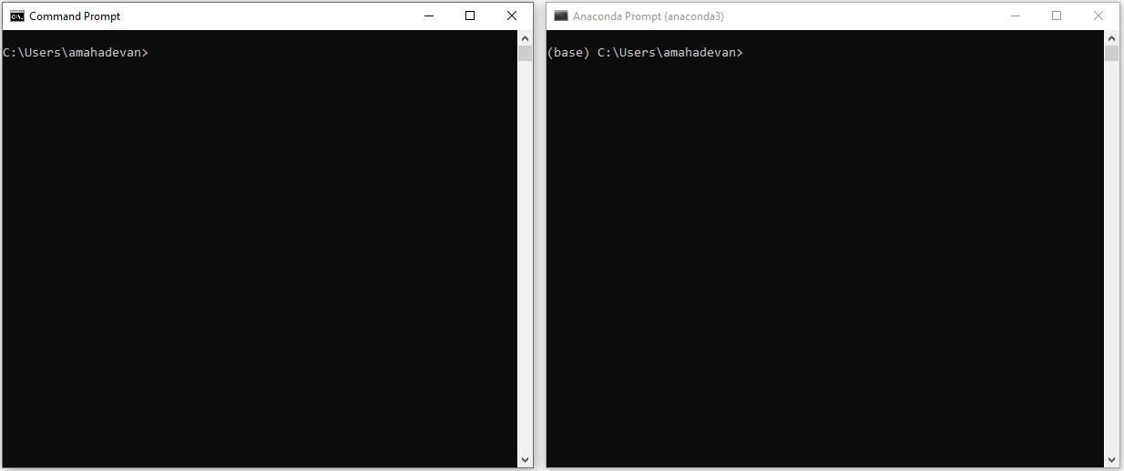

1. Run the below command use the full path of the code file (enclose the full path in double quotation).

**python “C:\\Users\\Documents\\Code-File-path\\Xenon-LFP-Analysis.py” (or)**

**py “C:\\Users\\Documents\\Code-File-path\\Xenon-LFP-Analysis.py”**

1. Copy and paste <http://127.0.0.1:8050/> in the browser (Firefox or Chrome). Repeat steps 1 to 3 if the program crashes or you want to restart analysis.