**04. MEA Recording Channel Explore Features and Instructions**

**Introduction:**

The ‘MEA Recording Channel Explorer’ GUI can be used to view, filter, build LFP activity raster plots with different threshold voltages, time durations setting and cluster channels with similar activity signature using a k-means clustering algorithm. This document can be used as a manual for the different features in the GUI The technical documentation (different document) details implementation and code elements of the Python and Dash.

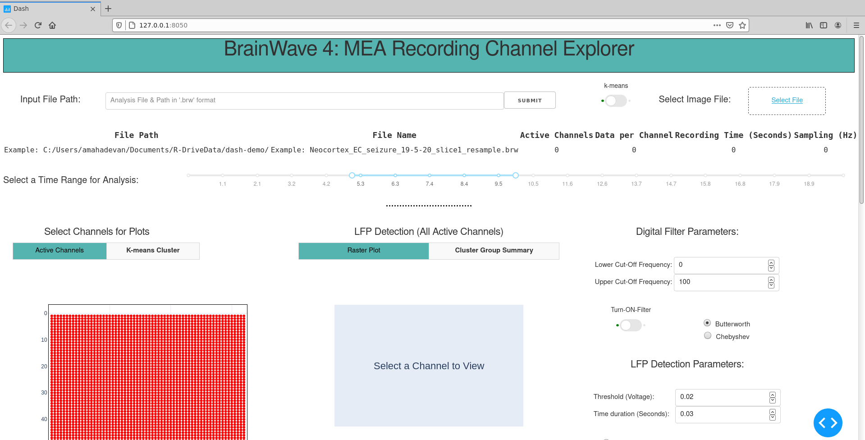

**Step1: Input file path and image file to start the analysis of the measurement of interest.**

1. Input File: Copy and paste the full input file path (#1).

(Example: C:\\Users\\Documents\\R-DriveData\\Neocortex_EC_slice1.brw)

1. Select the location of the image file (#2) (Optional)
2. If you are not using an image file, click ‘SUBMIT’ (#3)

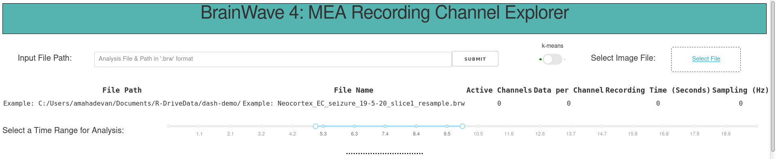

**#3**

**#2**

**#1**

Wait a couple of minutes (for large datasets) for the active channels **and** the LFP raster plot to update.

**Step2: Verify measurement settings and LFP activity raster for default time window, threshold and duration.**

1. File & Measurement Information: The file location, file name, active channels, total samples per channel, total recording time in seconds and the sampling frequency can be checked. The time slider range can be changed for the raster and time plots as discussed in Step 3.

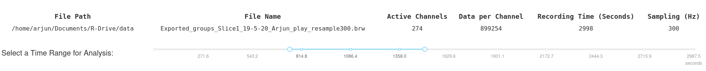

1. Check if the all the active channels are displayed, if you selected an image the image should display in the background. You can select the image anytime during the analysis and click ‘SUBMIT’ (#3) to update. The X, and Y axis correspond to the column, and row numbers of the MEA array respectively.

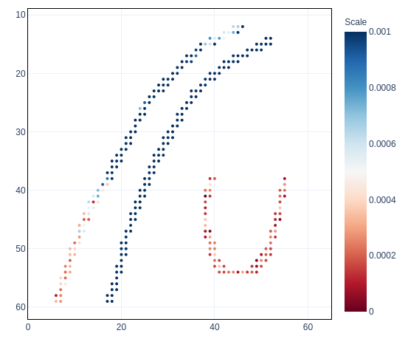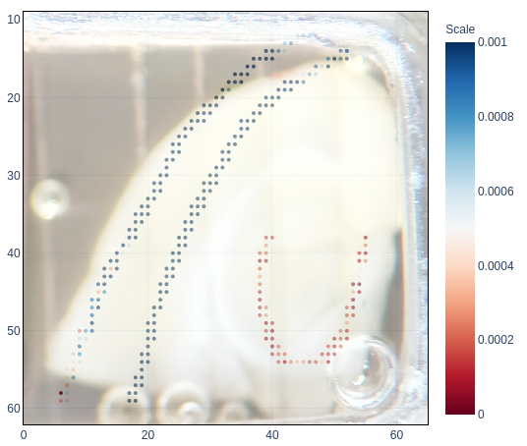

1. The slider (#4) below the active channel plot can be used to view the average activity of each channel (averaged over 2 minutes) at specific time points. (Red: No Activity, Blue: Active). The raster displays the LFP activity for all channels for a default voltage threshold of 0.03, and duration of 0.02 seconds. This and the time window for the plot can be changed to regenerate the raster as discussed in Step 3.

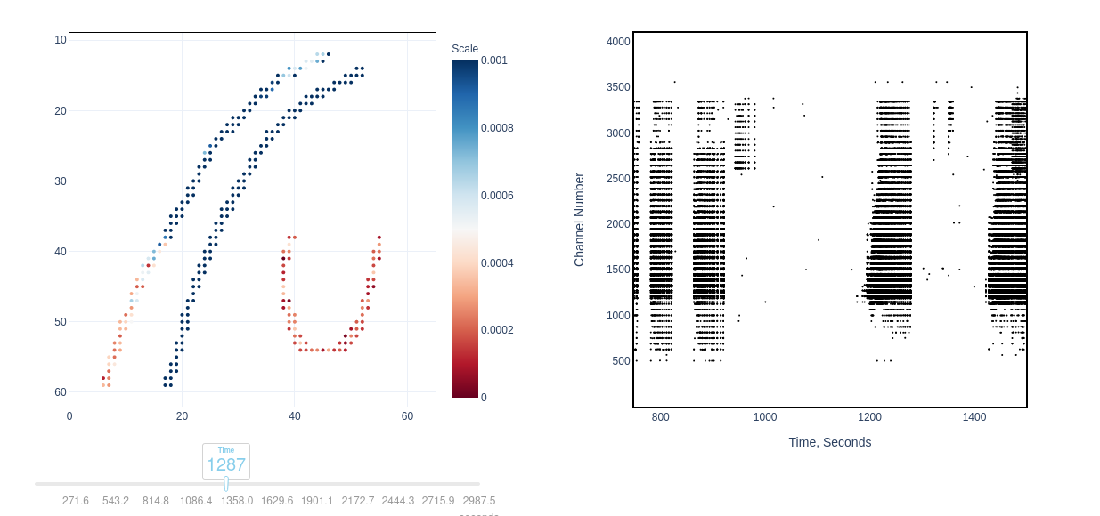

#4

**Step 3: Regenerate LFP raster with changes to time, threshold voltage and duration.**

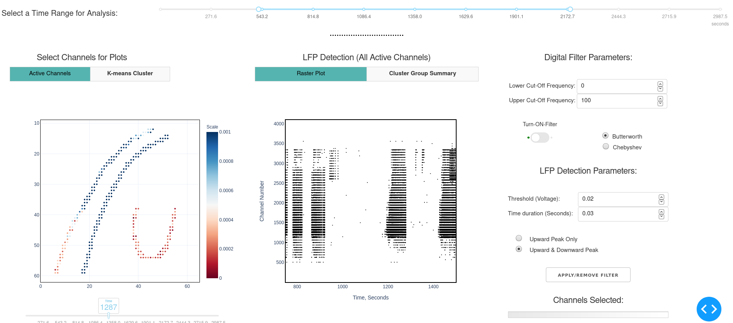

#6

#5

1. Set the time slider (#5) for a pre-defined range of interest by moving the end points. For a large measurement file (more than 300 channels sampled at greater than 2048 Hz), a smaller time range is recommended (~20 minutes) for optimum time and performance.
2. Set the desired Threshold (voltage), Time duration (seconds), Upward Peak or Upward and Downward Peak.
3. Click APPLY/REMOVE FILTER to update the raster for the selected time window and LFP settings (#6).

**Step 4: View channels time trace, generate FFT and view LFP activity peaks detected.**

1. Select a time window of interest

#5



1. To view a time trace for individual or multiple channels select points (#7): (SHIFT + SELECT WITH MOUSE). You can also select multiple points using the BOX or LASSO Tool while pressing down SHIFT. You may need to HOVER the MOUSE over to the top for plot for Tool Bar to appear. You can select up to 20 channels for smaller time window (20 minutes), or few channels (4 Nos for larger time windows > 20 minutes)

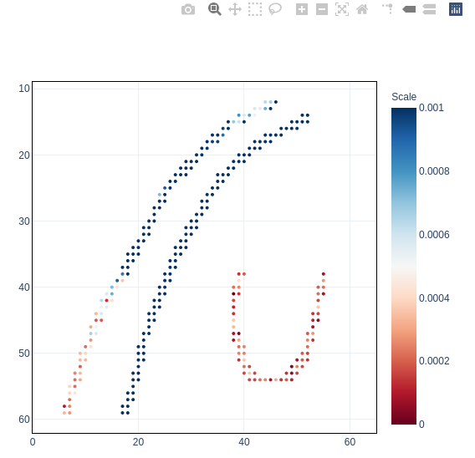

LASSO

BOX

#7

1. Wait for a few seconds for the time plots to appear. The plots are interactive, you can hover over the plots to view time stamp, voltage values, zoom in, zoom out, etc.

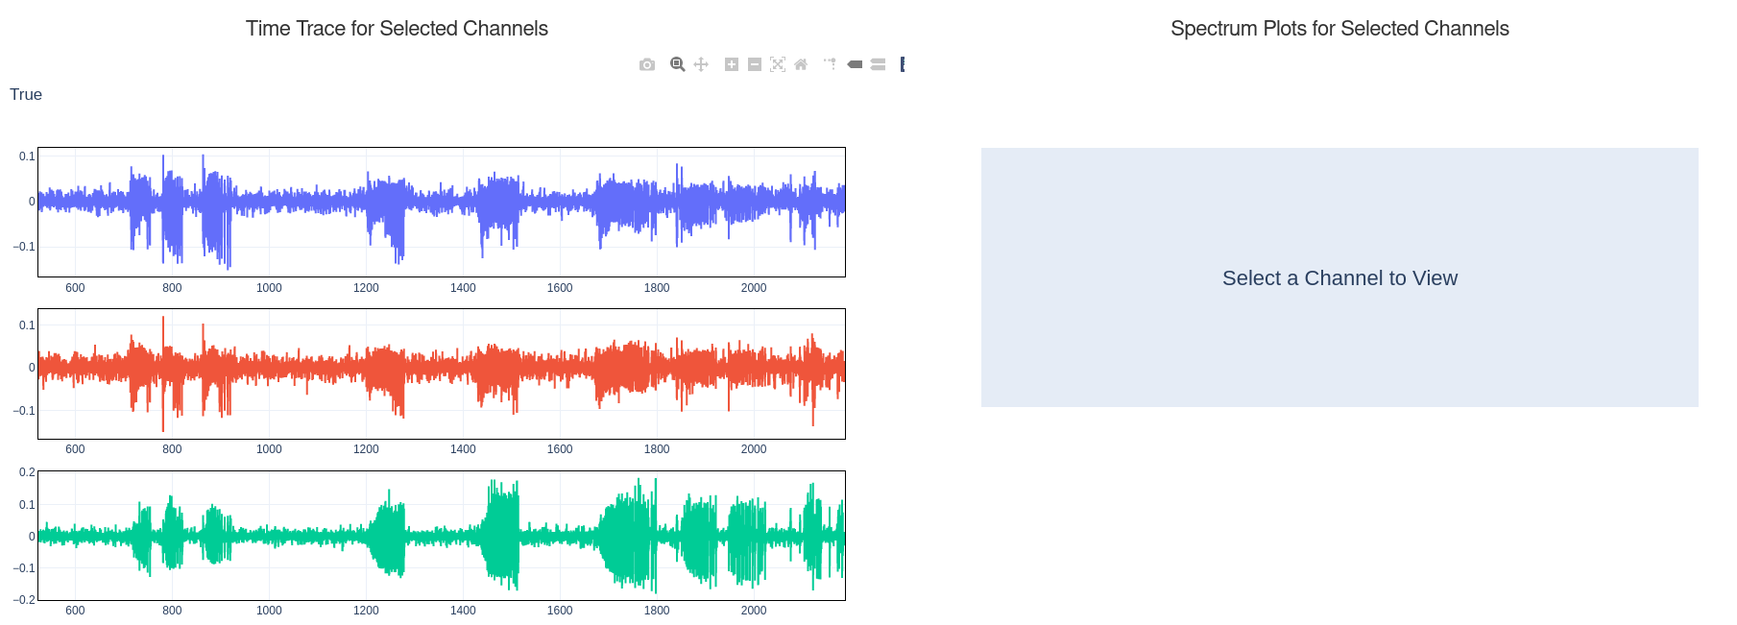

#8

1. To view the FFT for a select time range use the MOUSE to horizontally zoom the time window of interest (#8), this automatically generates the FFT and LFP activity points for the time trace for the selected time window.

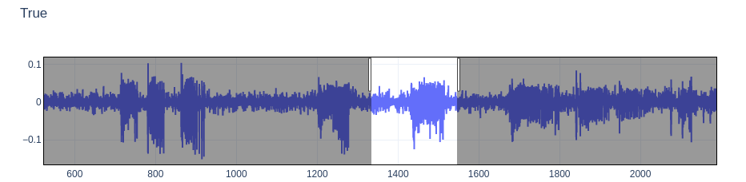

Horizontal Zoom Using Mouse

The FFT plots (#9) and the LFP peak overlay plot (#10) are interactive, you can zoom-in to select frequency ranges (#9, #10).

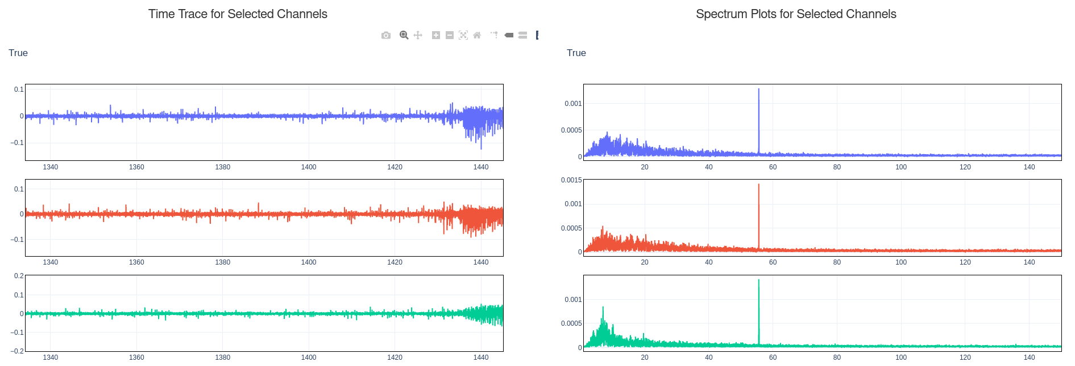

#8

#9

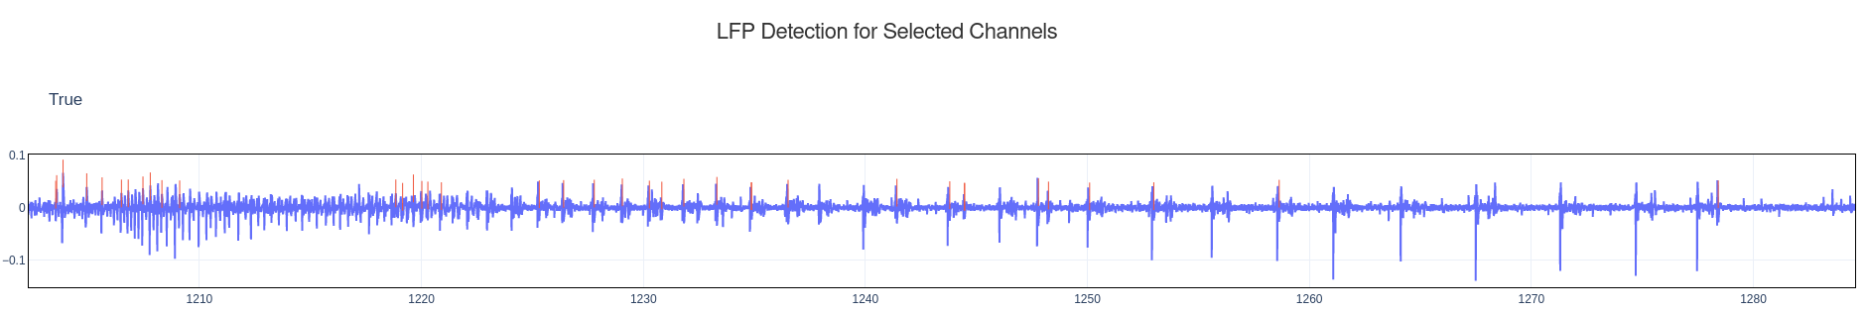

#10

1. To RESET and select another time window, or RESET any of the plots: Click on HOME in the plot toolbar (#8)

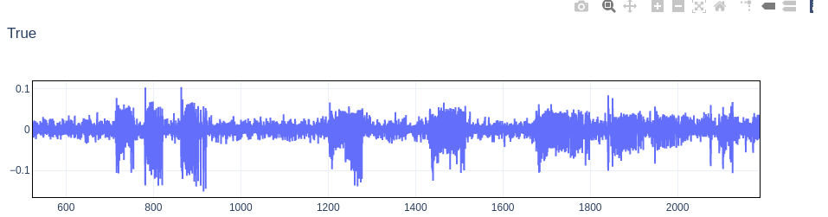

HOME

**Step5: Apply digital filter, change LFP detection settings:**

1. To regenerate time traces for select channels with filter (#11).
2. ‘Turn-ON-Filter’,
3. Input the Cut-Off Frequencies, and
4. Click ‘APPLY/REMOVE FILTER’

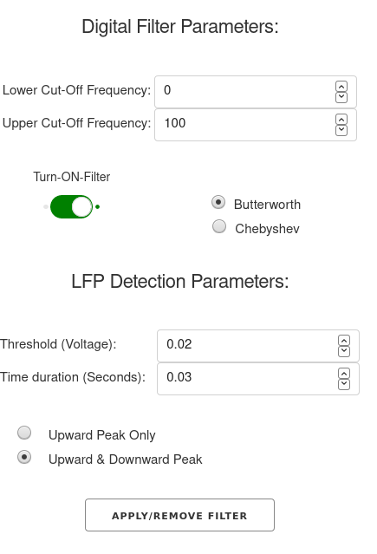

#11

#11

1. You can also ‘Turn-ON-Filter’ before selecting channels in Step4.

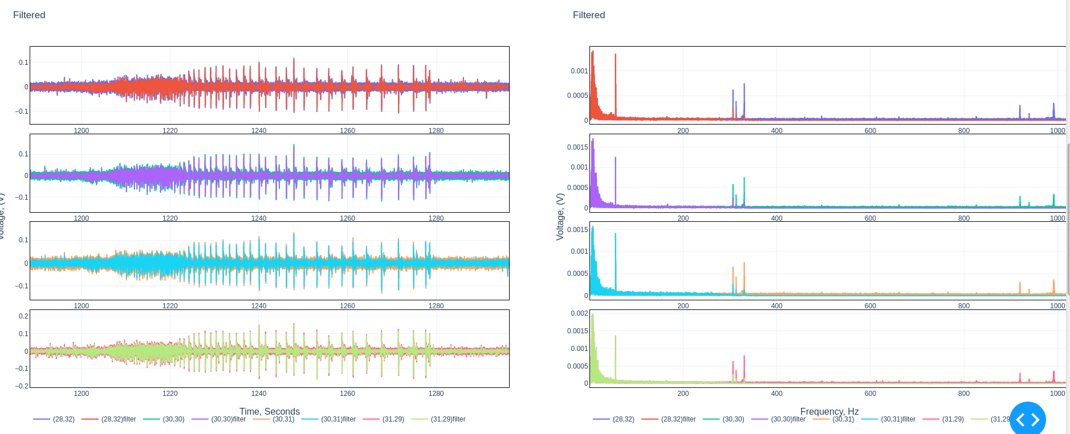

**Step 6: Tips & Tricks**

1. For large measurements there is a trade-off between time window (#5) and number of channels that can be selected, due to limitation of computer RAM memory. Use a smaller time window and fewer channels for large files with sampling rate > 1000 Hz.
2. All plots are interactive and you can zoom-in, reset using ‘HOME’ (on the plot tool bar).
3. Computation is indicated by the browser tab title: ‘Updating’, when computation is complete it will switch to ‘Dash’. It is best to wait for a computation to complete before changing or trying a select a different channel to view, or re-click ‘Apply/Remove Filter’ or ‘Submit’
4. If the system is crashing, you can restart analysis server by hitting CTRL+C on the terminal where the Python Code is running and restart the code by typing: >python “C:\\filepath\\filename.py”

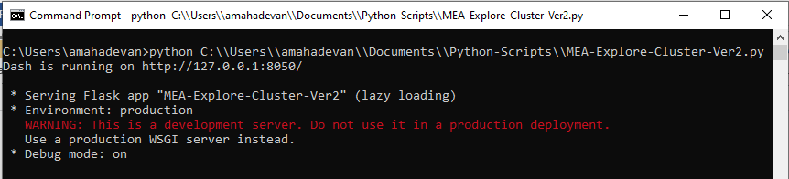

**python “C:\\Users\\Documents\\Code-File-path\\MEA-ExploreCluster-Ver2.py”**

Refresh Firefox/Chrome browser: <http://127.0.0.1:8050/>

1. To view large time windows and time traces, use a lower sampling rate (~300 Hz), which is useful to view a larger number of channels.
2. K-Means feature discussed in the next step can be used to identify clusters and threshold voltages for peak detection.

**Step 7: K-Means to identify channel groups with similar activity and get estimates for Threshold voltage for LFP activity.**

This feature may take significant time to compute, use it only if you want to view LFP activity threshold voltage and channels that have similar activity.

1. Close the browser and open a new session, this is to ensure cache memory is cleared and to improve computation speed: <http://127.0.0.1:8050/>
2. Enter the Input File Path, and Turn- ON – K-Means feature, this should be done before clicking ‘SUBMIT’

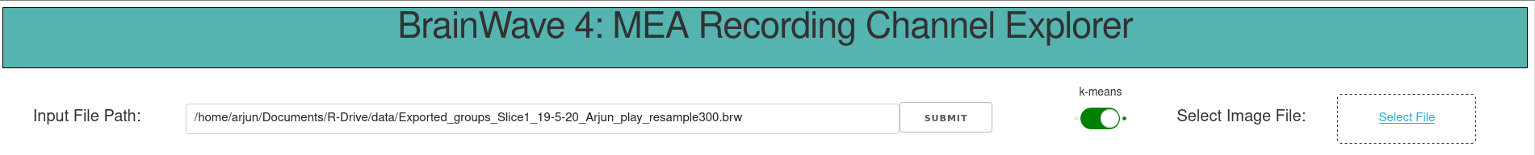

1. Wait a couple of minutes for the ‘Updating’ to change to ‘Dash’ at the top of the browser.

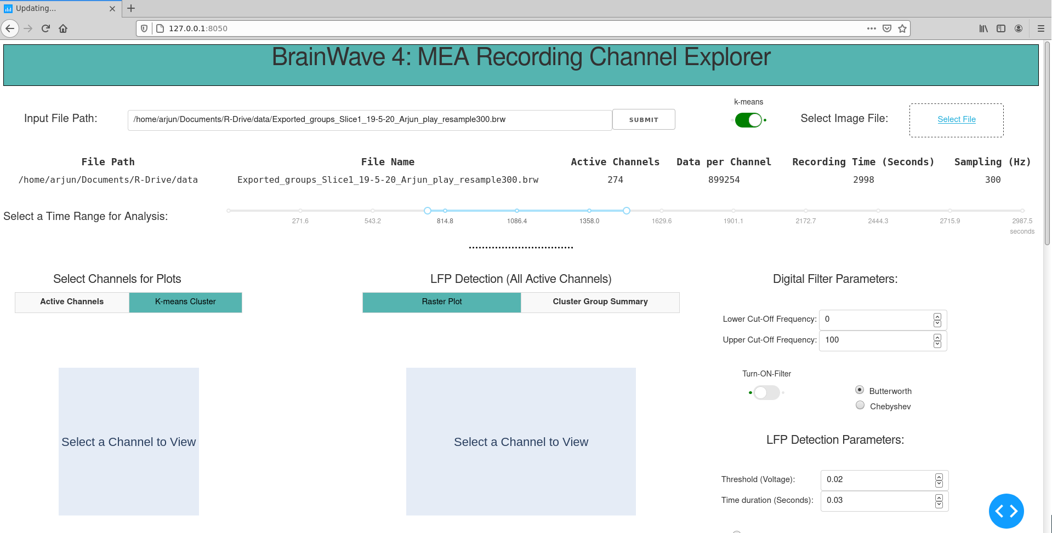

**#12**

**#13**

1. Once the plots updates, you can view the cluster by selecting the ‘K-means Cluster’ Tab (#12) and ‘Cluster Group Summary’ Tab (#13). Each cluster is identified with a unique color, you can HOVER over the colors on the plot (#14) to view Cluster number. The Threshold voltage for each cluster group is displayed in #15.

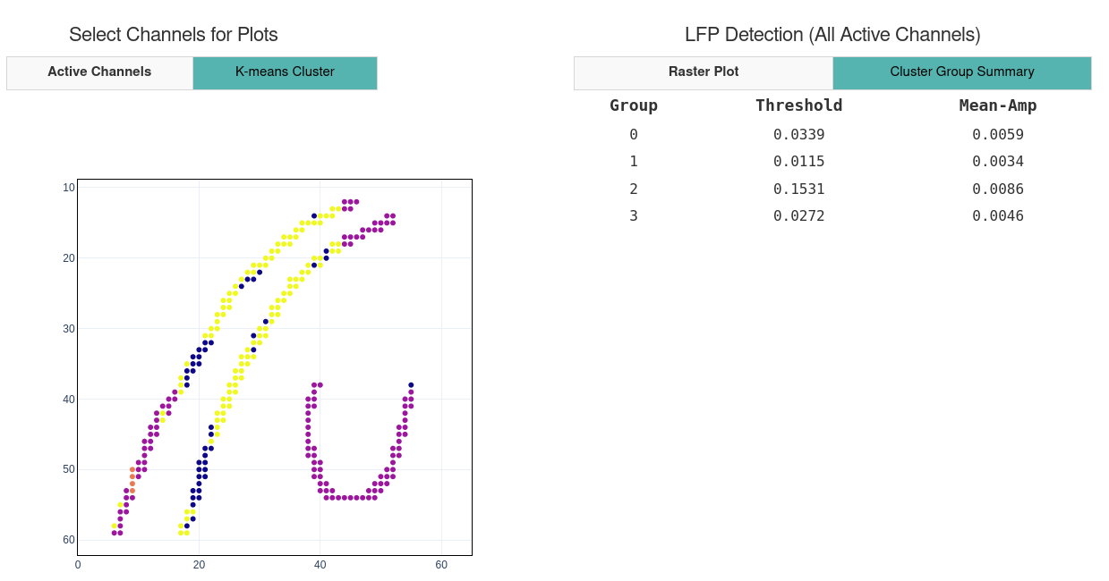

**#15**

**#14**

1. Save the plots and Turn –Off- k-means after the analysis is completed. This will reduce memory and enable faster processing for other analysis. 