**05. MEA Recording LFP Detection & Analysis**

**Introduction:**

The ‘MEA Recording LFP Detection & Analysis’ GUI can be used to identify optimum LFP activity thresholds and activity duration, generate raster plots with specific channel groups and time windows. This also generates LFP activity summary for channel groups for the given threshold voltage and duration. This document can be used as a manual for the different features in the GUI. The technical documentation (different document) details implementation and code elements of the Python and Dash.

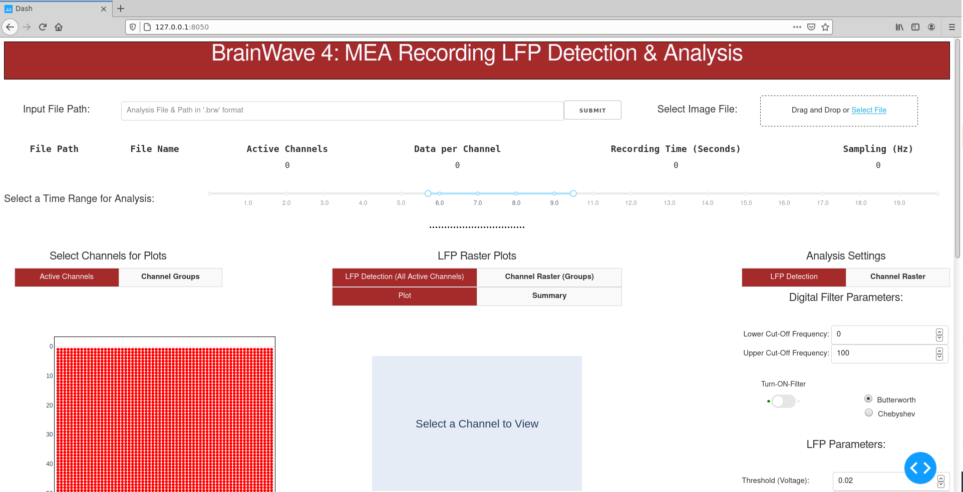

**Step1: Input file path and image file to start the analysis of the measurement of interest.**

1. Input File: Copy and paste the full input file path (#1).

(Example: C:\\Users\\Documents\\R-DriveData\\Neocortex_EC_slice1.brw)

1. Select the location of the image file (#2) (Optional)
2. If you are not using an image file, click ‘SUBMIT’ (#3)

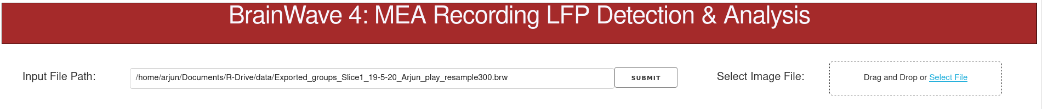

**#1**

**#3**

**#2**

Wait a couple of minutes (for large datasets) for the active channels **and** the LFP raster plot to update.

**Step2: Verify measurement settings and LFP activity raster for default time window, threshold and duration.**

1. File & Measurement Information: The file location, file name, active channels, total samples per channel, total recording time in seconds and the sampling frequency can be checked. The time slider range can be changed for the raster and time plots as discussed in Step 3.

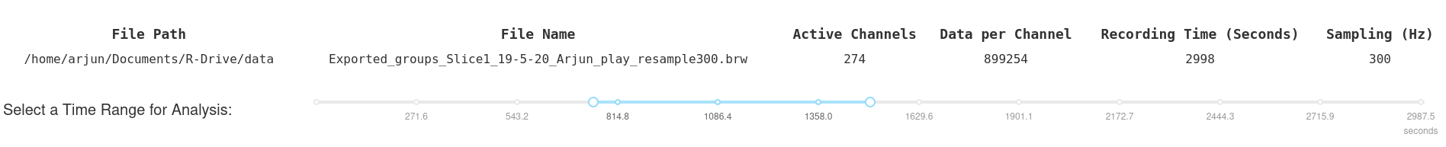

1. Check if the all the active channels are displayed, if you selected an image the image should display in the background. You can select the image anytime during the analysis and click ‘SUBMIT’ (#3) to update. The X, and Y axis correspond to the column, and row numbers of the MEA array respectively.

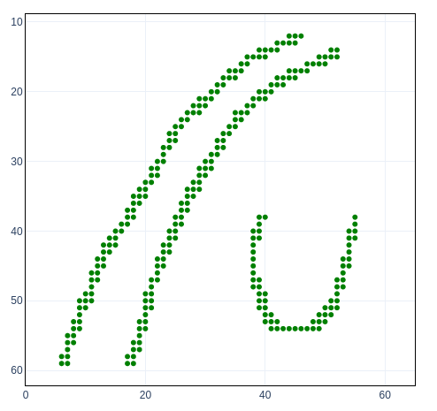 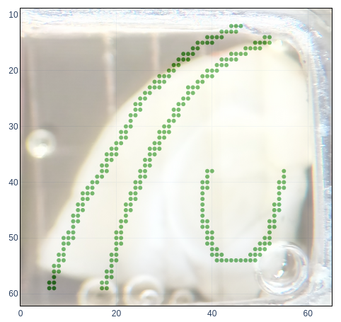

1. The ‘LFP Detection (All Active Channel)’ ‘Plot’ Tab (#4) displays the LFP activity raster for all channels for a default voltage threshold of 0.03, and duration of 0.02 seconds. The ‘LFP Detection (All Active Channel)’ ‘Summary’ Tab (#5) displays the summary metric summed over all the channels and averaged over the duration of selected time window. The tabs can be selected using the mouse. The threshold settings and the time window for the plot can be changed to regenerate the raster as discussed in the next Step 3.

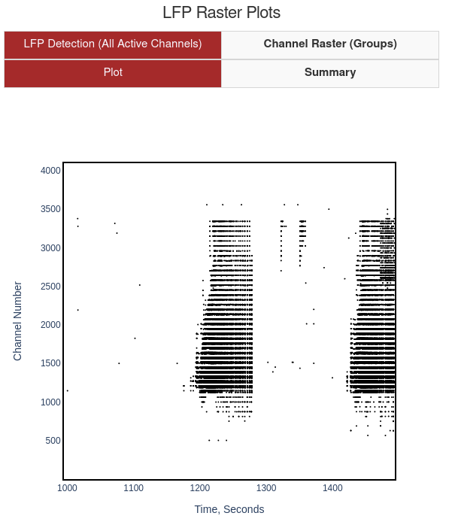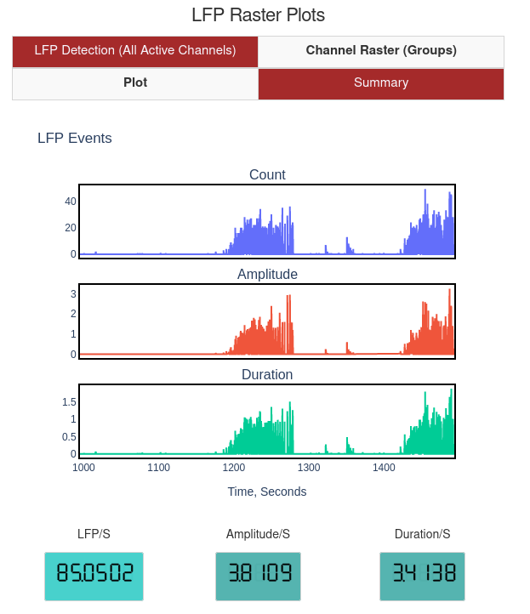

**#5**

**#4**

**Step 3: Regenerate LFP raster with changes to time, threshold voltage and duration.**

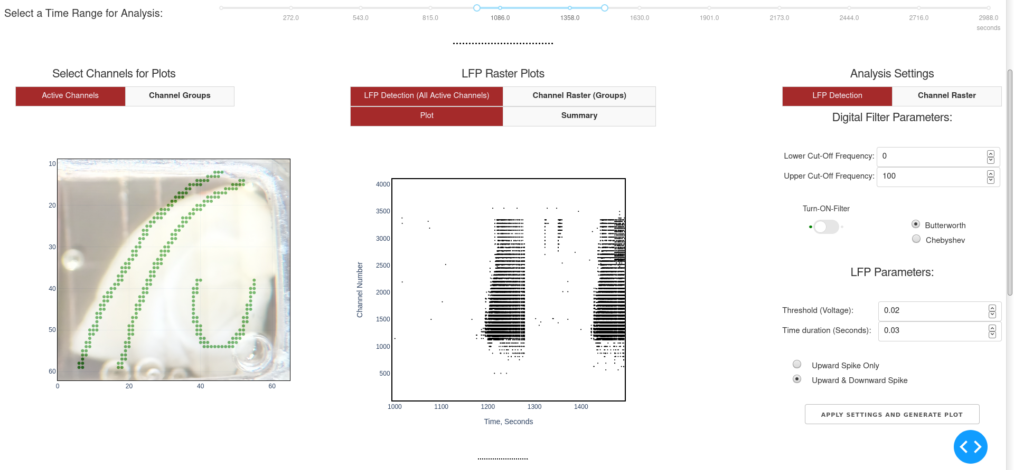

#7

#6

1. Set the time slider (#6) for a pre-defined range of interest by moving the end points. For a large measurement file (more than 300 channels sampled at greater than 2048 Hz), a smaller time range is recommended (~40 minutes) for optimum time and performance.
2. Set the desired Threshold (voltage), Time duration (seconds), Upward Peak or Upward and Downward Peak.
3. Click ‘APPLY SETTINGS AND GENERATE PLOT’ to update the raster plot and summary for the selected time window and LFP settings (#7).

**Step 4: View individual channels LFP activity peaks detected and change LFP parameters.**

1. Select a time window of interest in the LFP Activity View Tab.

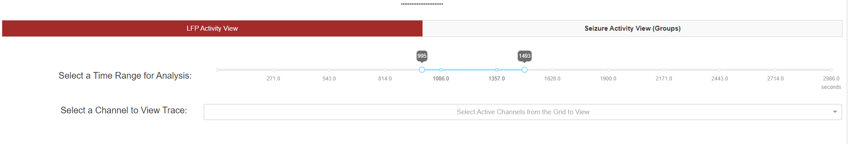

#8

1. To view the LFP activity for individual channels, you need to select the point on the ‘Active Channels’ Tab (#9) **and** Select the channel in the drop-down menu (#10). You can also select multiple points on the Active Channels plot using the BOX or LASSO Tool while pressing down SHIFT. You can type the row or column number n the drop down menu to select the channel. You can view only one channel at a time.

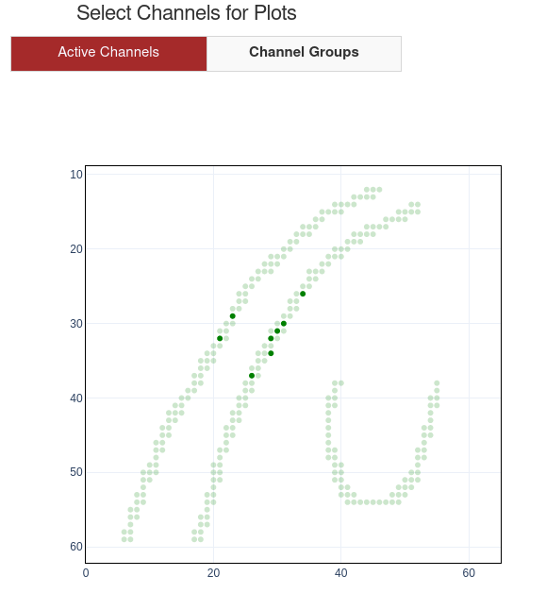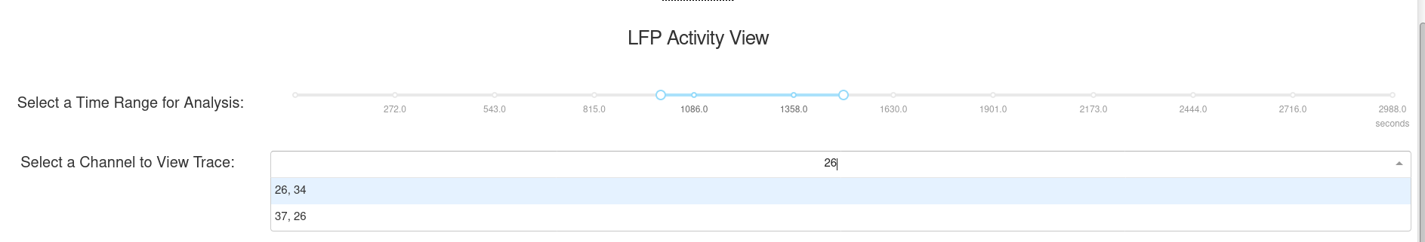

#10

#9

1. Wait for a few seconds for the time plots to appear. The plots are interactive, you can hover over the plots to view time stamp, voltage values, zoom-in, zoom-out, etc.

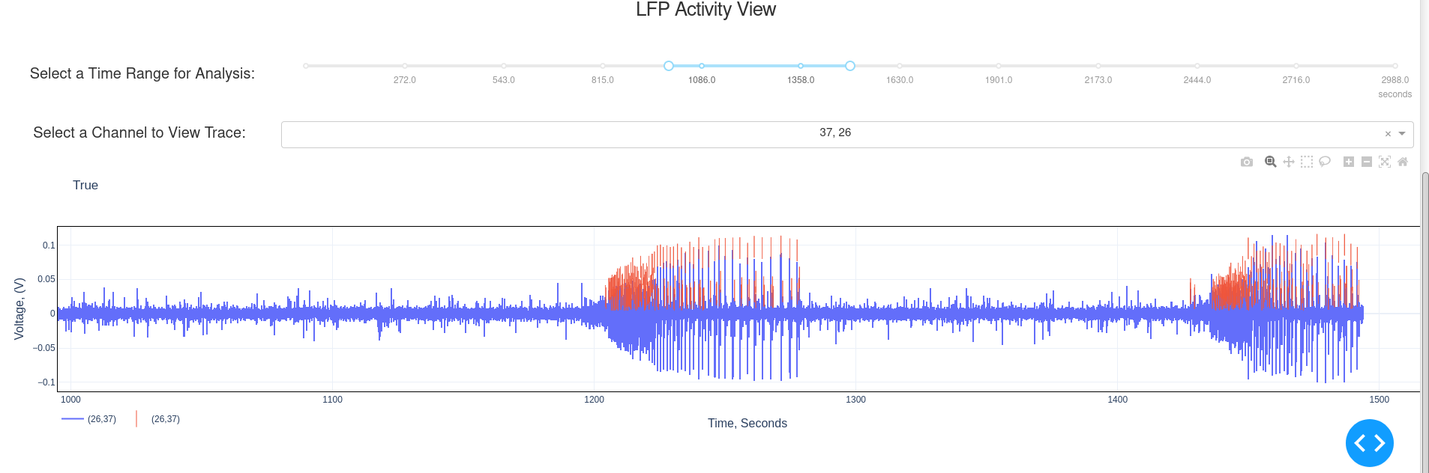

#11

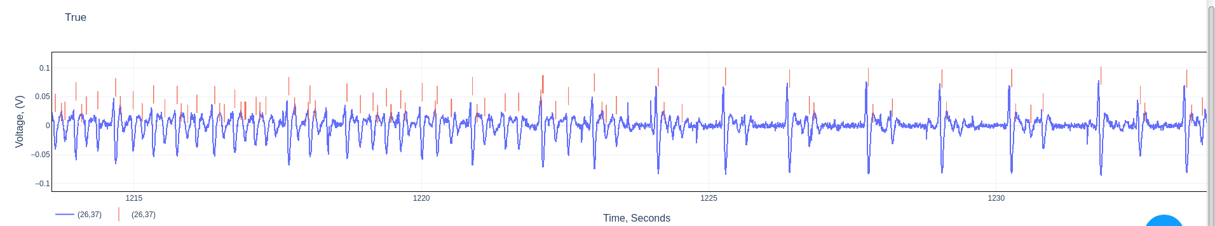

1. To RESET and select another time window, or RESET any of the plots: Click on REST AXIS button in the plot toolbar (#8)

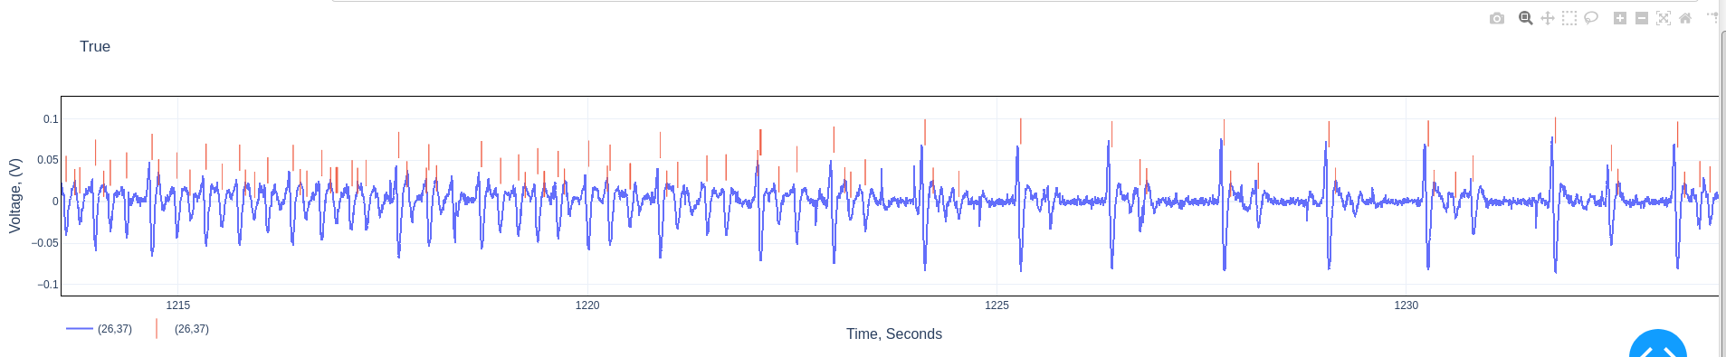

**RESET AXIS**

**Step5: Apply digital filter, change LFP detection settings:**

1. To regenerate time traces for select channels with filter (#11).
2. ‘Turn-ON-Filter’,
3. Input the Cut-Off Frequencies, and
4. Click ‘APPLY SETTINGS AND GENERATE PLOT’

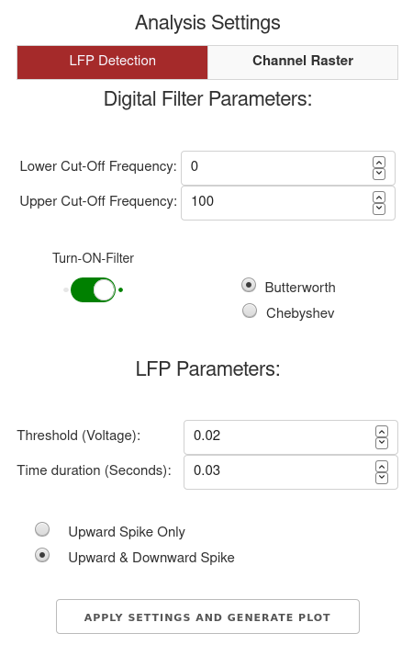

#11

#11

1. You can also ‘Turn-ON-Filter’ before selecting channels in Step4.

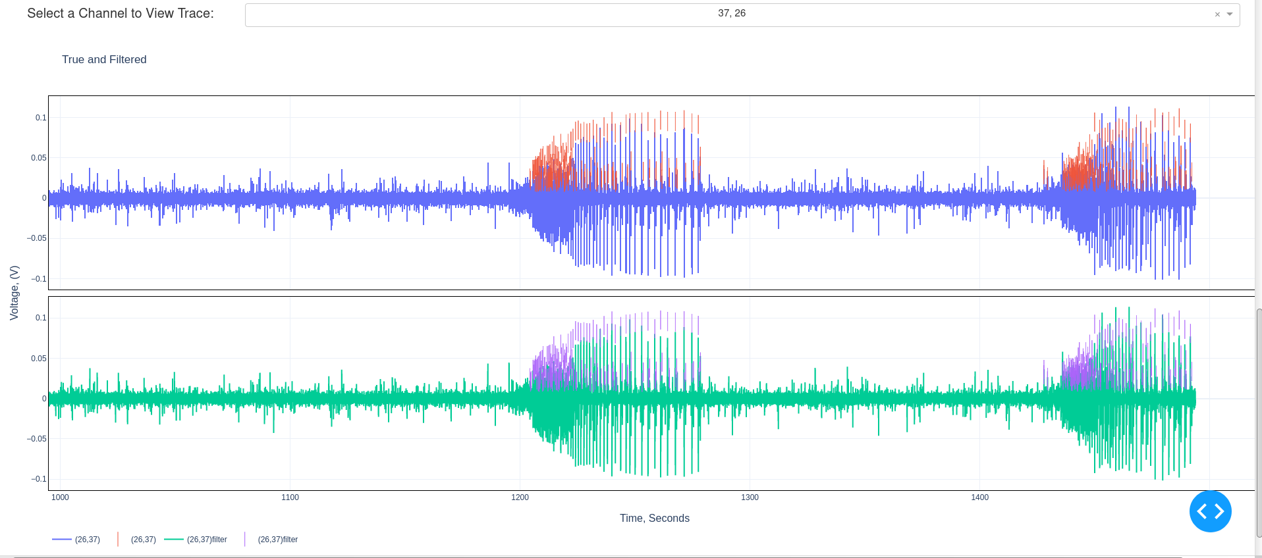

**Step 6: Generate raster plots of LFP activity for channel groups, and save summary statistics.**

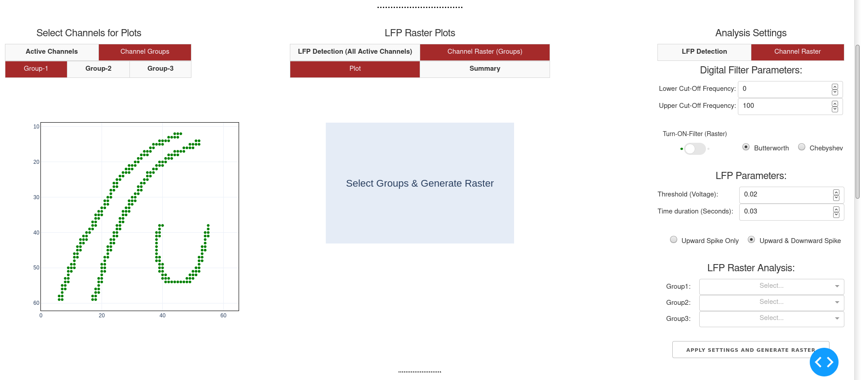

You can select three different groups of channels to generate a LFP activity raster to compare activity pattern in different regions, as well as generate summary statistics for the selected channel groups. This involves three steps:

1. Select ‘Group1’, ‘Group2’ or ‘Group3’ Tab under ‘Channel Groups’ Tab. You can click to select channels on the plot, hold down ‘SHIFT’ to select multiple points, or use the LASSO or BOX tool to select multiple points. You need to select the channels under three groups (Group1, Group 2, or Group3).

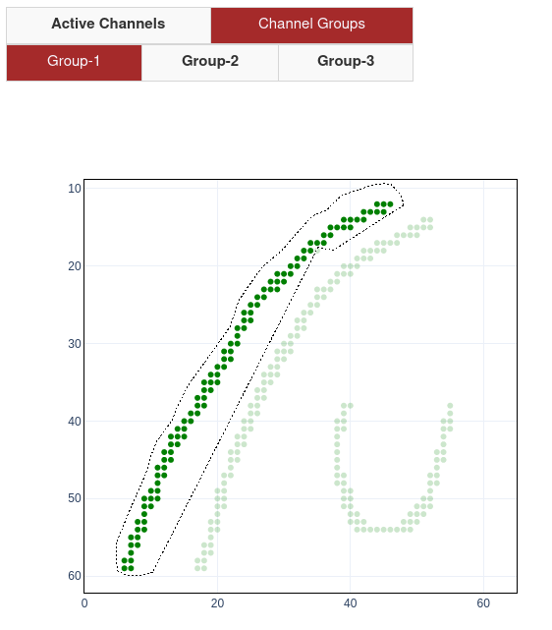 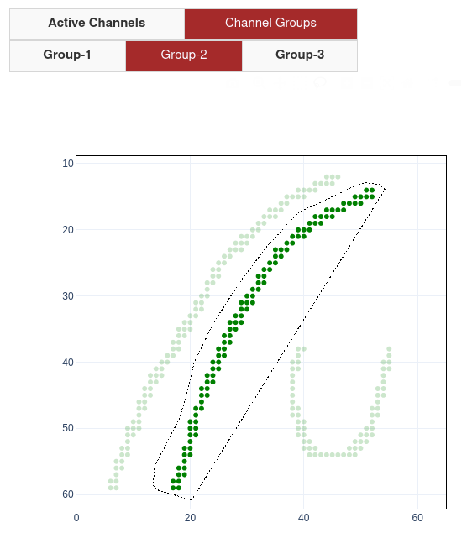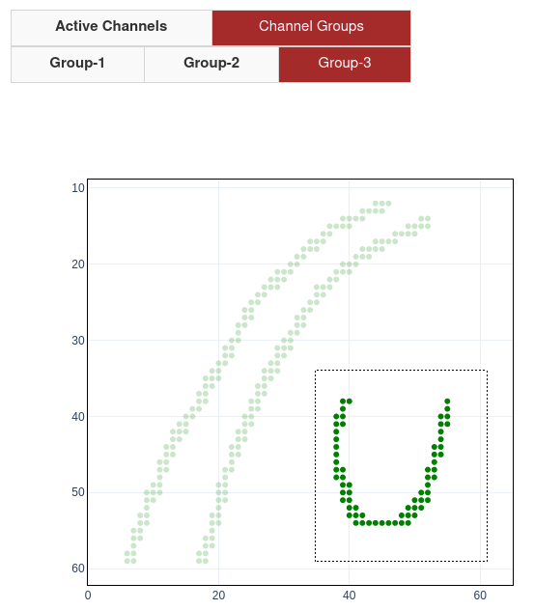

1. Once you have selected the channels for the respective groups, the channels for the corresponding group automatically populates under Raster Analysis. You can remove channels or add channels by clicking on the respective groups as in previous step.

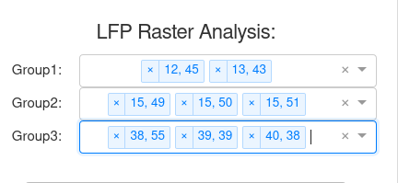

1. Make sure you are in the ‘Channel Raster’ Tab. Select the desired time window, the desired LFP settings, and Filter parameters and click ‘APPLY SETTINGS AND GENERATE RASTER’ Each time the ‘APPLY SETTINGS AND GENERATE RASTER’ is pressed, the summary statistics are saved in the same location as the input file. If you need you can re-name the file and move it to avoid different analysis files being overwritten.



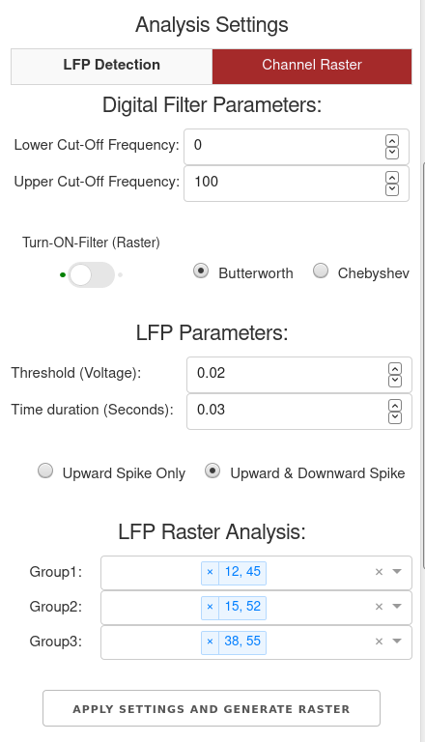

1. The results could take a few minutes depending on the number of channels and the input file sampling rate. The Channel Raster (Groups) 🡪 ‘Plot’ Tab displays the groups: (Group1: RED, Group2: PURPLE, Group3: Green). The Channel Raster (Groups) 🡪 ‘Summary’ Tab displays the summary statistics and individual channel statistics are saved as summary.csv excel file.

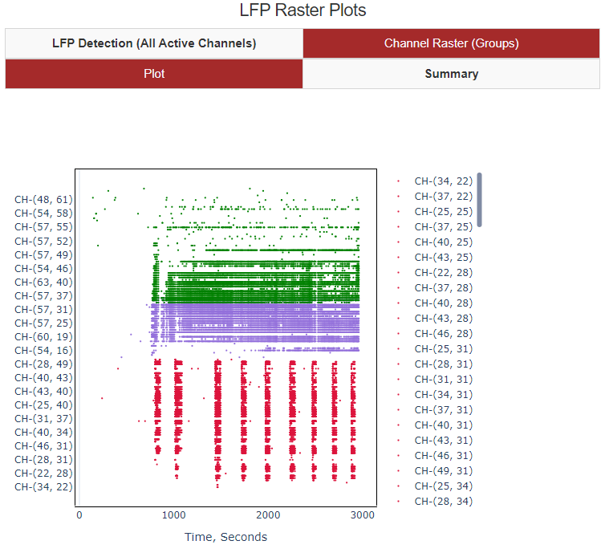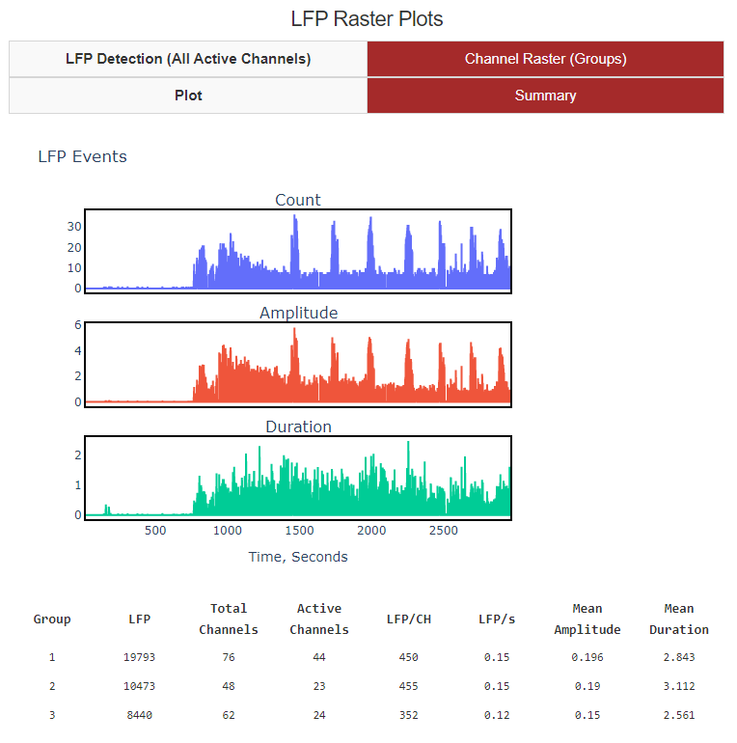

* 1. Measures & Calculations:

1. Group: Group number (1, 2 or 3)
2. LFP: Sum of Total count of local field potential activity using peak find (for given threshold and duration under ‘Channel Raster’), in the Time Range Selected for all the channels in the respective group.
3. Total Channels: Number of channels selected in the respective Group
4. Active Channels: Number of active channels of all the channels selected in the respective Group. Active channels are selected based on channels that have:
   1. ‘Greater than 20 peaks’ (>20) in peak detection for the given ‘Threshold Voltage’ and ‘Duration’. This omits in-active channels
   2. ‘Less than (< mean+5 standard deviations) of LFP count for the channels in the respective group within the time interval selected. This eliminates the noisy channels.
5. LFP/CH: Ratio of sum of LFP Count (#3) and Active Channels (#4)
6. LFP/S: Ratio of LFP Count (#3) and [Time Range Selected * Active Channels(#4)]
7. Mean Amplitude: Ratio of sum of ‘Mean Peak Prominences – peak heights( in Voltage)’ and Active Channels (#4) for the all the channels in the respective group
8. Mean Duration : Ratio of sum of ‘Mean Peak Prominences – peak widths(in milli-Seconds)’ and Active Channels (#4) for the all the channels in the respective group

**Step 7: Automatic Seizure Detection in Select Channels and Seizure Summary Metrics**

As a part of channels groups, ‘Seizure Activity View’ assists in exploring seizure summary metrics and seizure envelop for individual channels.

1. The channels selected in Step 6 is used to generate measures. This tab has two components: 1) Seizure Envelop and 2) Seizure Summary metrics.
2. Seizure Envelop: Two sliding convolution windows are used to develop the seizure envelop along with LFP activity detection, and derivative of LFP activity detection. The default parameters for the convolution window1 and Convolution Window 2 are for a sampling frequency of 100 Hz. For other sampling frequencies, the window size can be adjusted appropriately. For a pre-defined convolution window and cut-off settings ‘Select a Channel to View Trace’ (#12) for a list of channels in the respective Group.

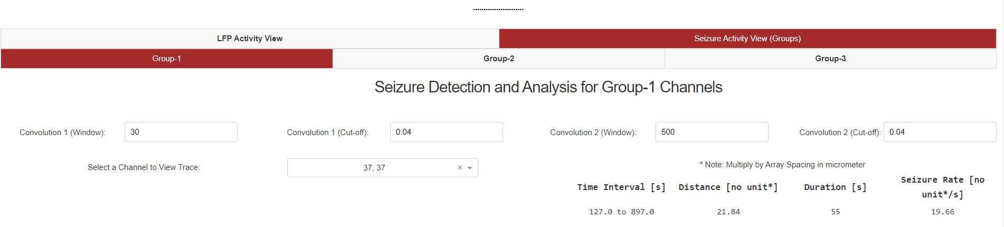

#12

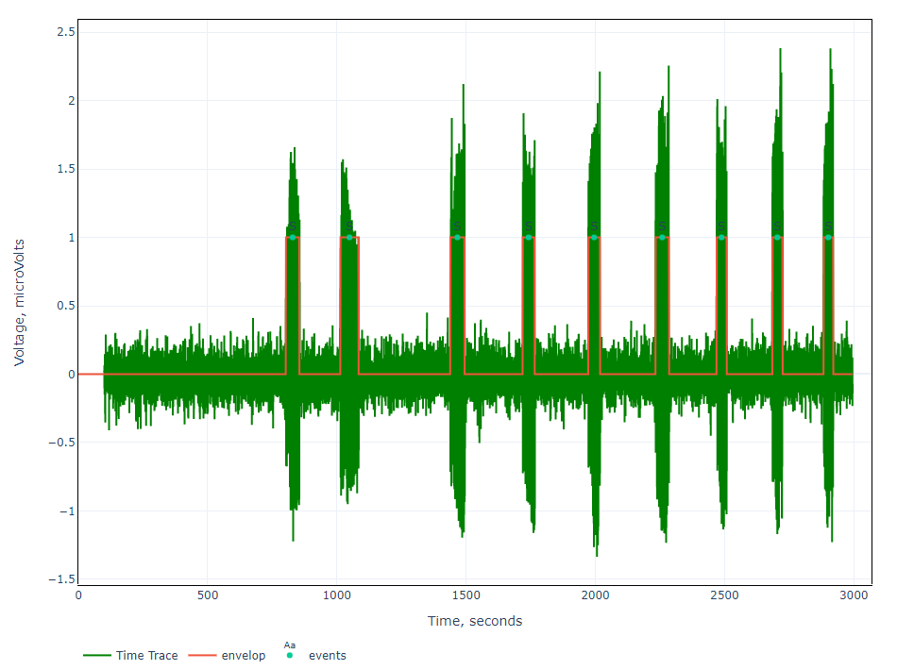

1. To get seizure metrics for channels in the respective groups use Step 6.4, to select channel and generate the raster plot.
   1. Select a time range in the raster plot corresponding to a seizure event using the cursor zoom in the interactive plot. (Eg: 50 seconds to 891 seconds.). The start and end time of the seizure
   2. Important Note: Select only a single seizure within time interval, selecting more than 1 seizure could give in-accurate measures.

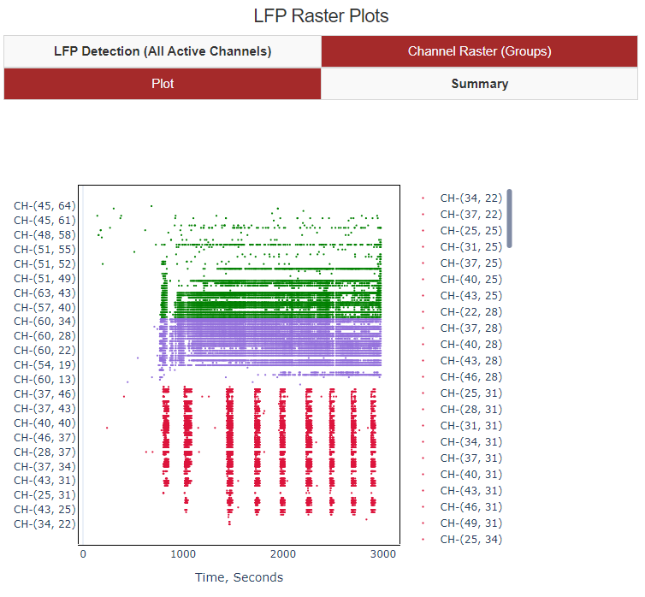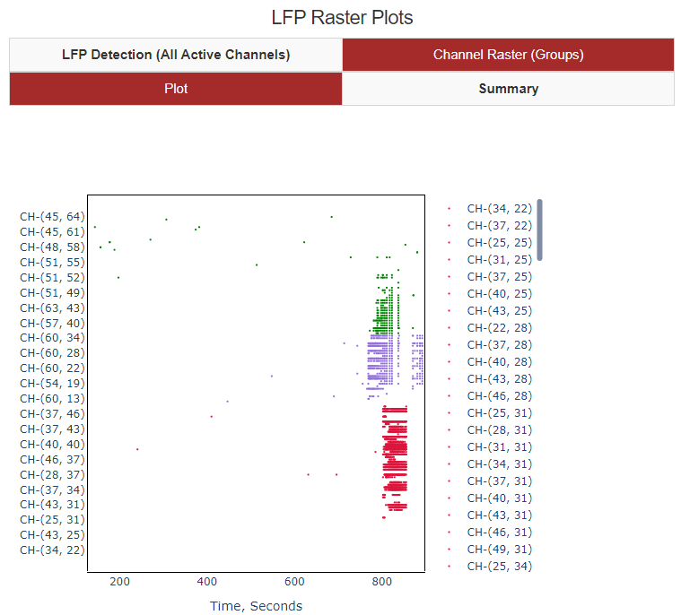

1. Select required ‘Group’ tab under ‘Seizure Activity View (Groups)’. The summary measures are shown in the table below:
   1. Time Interval: The time interval selected from the Groups Raster Plot in Step 7.3
   2. Distance: The maximum distance from the point of initiation (first start of seizure) to the furthest point in all direction the respective groups where the seizure has spread. The unit needs to be multiplied by the array spacing of the sensor (Eg: 40 micrometer) to get the true distance in micrometer.
   3. Duration: Mean duration of the seizure for all channels that got recruited in the seizure for the respective group.
   4. Seizure Rate: Ratio of the maximum distance to mean time difference from the point of initiation to spread of seizure to all channels recruited. This also need to be multiplied by the array spacing of the sensor (Eg: 40 micrometer) to get the true rate of spread
   5. All Active Channels (GREY): All channels in the measurement file
   6. Group 1 Channels (BLUE): Channels selected in the respective Group
   7. Channels Recruited (RED): Channels that had a seizure event in the time interval (Eg: 102 seconds to 931 seconds)
   8. Point of Initiation (GREEN): The start of the seizure or the first channel where the seizure event initiated.

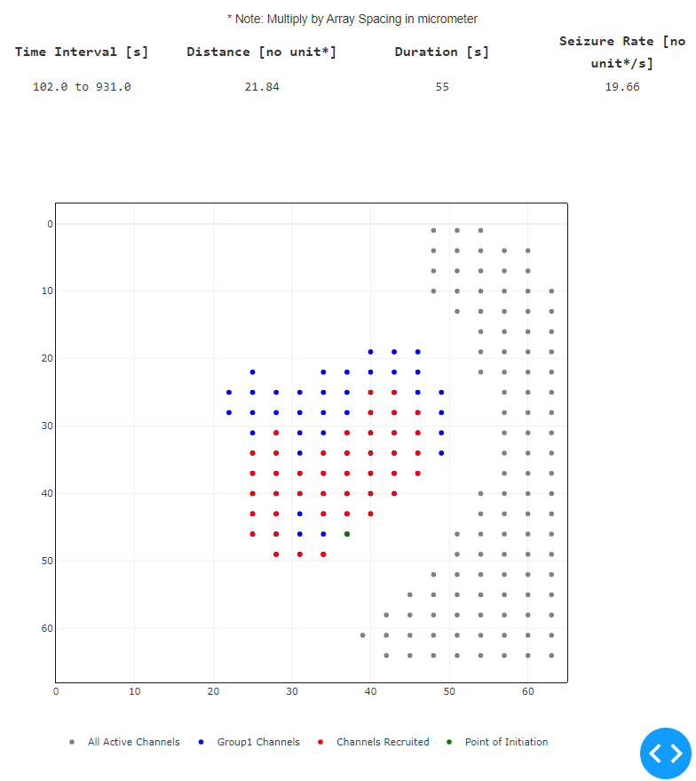

**Step 8: Tips & Tricks**

1. For large measurements there is a trade-off between time window (#5) and number of channels that can be selected, due to limitation of computer RAM memory. Use a smaller time window and fewer channels for large files with sampling rate > 1000 Hz.
2. All plots are interactive and you can zoom-in, reset using ‘HOME’ (on the plot tool bar).
3. Computation is indicated by the browser tab title: ‘Updating’, when computation is complete it will switch to ‘Dash’. It is best to wait for a computation to complete before changing or trying a select a different channel to view, or re-click ‘Apply/Remove Filter’ or ‘Submit’
4. If the system is crashing, you can restart analysis server by hitting CTRL+C on the terminal where the Python Code is running and restart the code by typing: >python “C:\\filepath\\filename.py”

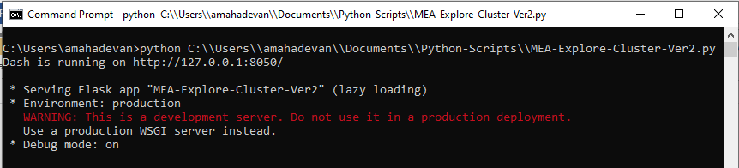

**python “C:\\Users\\Documents\\Code-File-path\\MEA-SpikeDetection-Ver3.py”**

Refresh Firefox/Chrome browser: <http://127.0.0.1:8050/>

1. To view large time windows and time traces, use a lower sampling rate (~300 Hz), which is useful to view a larger number of channels.