MicroCore Labs

MCL86

Datasheet

Document Versions

1.0 9/12/2015 Initial version
2.0 3/2/2016 Added notes about the minimal BIU ported to Lattice XO2

Introduction

The MCL86 is a high performance 32-bit microsequencer that emulates the Execution Unit (EU) of the original 8086 microprocessor. This EU is independent from the Bus Interface Unit (BIU) which allows the user to create a customized bus interface to suit their design. As an example, MicroCore Labs supplies a sample BIU that is equivalent to the 8088 microprocessor bus interface.

The MCL86 EU core partitions registers in the same way as the original 8086/8088, with general purpose and pointer register held in the EU and segment registers held in the BIU along with the prefetch queue and the optional cycle compatibility counter.

The signals between the EU and BIU are synchronous to the CORE_CLK and many of them can have pipeline registers added or subtracted to assist in achieving timing closure.

The EU communicates with the BIU using two methods: Strobing and Requests. The EU will strobe the BIU to perform functions such as updating segment registers. No response from the BIU is required. The EU can also make requests to the BIU to perform functions such as read and writes from the local bus as well as requests to Jump to new addresses.

The sample 8088 BIU that is supplied with the MCL86 is cycle and structurally compatible with the original processor. The four-byte prefetch queue, interrupt structure, bus interface and instruction timing are equivalent to the original 8088. Please note that the core is cycle compatible, not cycle exact. The MCL86 will be within a clock or two accurate with the original microprocessor.

The MCL86 EU core with the supplied 8088 BIU core can achieve over 180Mhz timing on a Xilinx Kintex-7 FPGA. The core can be run at any clock speed, however if cycle accuracy to the original 8088 processor is required then the CORE_CLK must be run at 100Mhz.

The MCL86 is also supplied with an example minimum BIU interface that is ported to the Lattice XO2 Breakout Board. This implementation contains a UART, on-chip RAM, a reduced set of local bus option which demonstrates a minimal logic design.

Signal Definitions

input CORE_CLK_INT // Global clock for the core
input RESET_INT // Synchronous reset for the core
input TEST_N_INT // x86 TEST_n input pin

// EU to BIU communication
output [15:0] EU_BIU_COMMAND // Primary request path from EU
output [15:0] EU_BIU_DATAOUT // Data to be written to BIU
output [15:0] EU_REGISTER_R3 // Target address to the BIU
output EU_PREFIX_LOCK // LOCK prefix output signal
output EU_FLAG_I // x86 Interrupt flag

// BIU to EU response signals
input BIU_DONE // BIU has completed the EU request
input BIU_CLK_COUNTER_ZERO // Cycle compatibility reached zero
input BIU_NMI_CAUGHT // NMI sampled by BIU
output BIU_NMI_DEBOUNCE // EU debounce for NMI
input BIU_INTR

// Prefetch Queue signals
input [7:0] PFQ_TOP_BYTE // Top of prefetch queue
input PFQ_EMPTY // Prefetch queue is empty
input[15:0] PFQ_ADDR_OUT // Current Instruction pointer (IP)

// x86 Segment Registers
input [15:0] BIU_REGISTER_ES
input [15:0] BIU_REGISTER_SS
input [15:0] BIU_REGISTER_CS
input [15:0] BIU_REGISTER_DS
input [15:0] BIU_REGISTER_RM // Internal addressing mode registers
input [15:0] BIU_REGISTER_REG

input [15:0] BIU_RETURN_DATA // Returned read data

EU/BIU Communication

The EU communicates with the BIU over the EU_BIU_COMMAND bus.

EU_BIU_COMMAND Bit
[14] Segment Override for the current BIU Request
[13:12] BIU Strobe
[11:10] Segment for current BIU Request
[9] BIU Request
[8:4] BIU Request/Strobe Type
[3:2] Queue Status[1:0] *Currently not supported
[1:0] Segment Override register value

EU Strobes

There are three strobes that the EU can send to the BIU. The strobe may be asserted for multiple clocks and must return to “00” when inactive.

Strobe=”10” Update the Clock Cycle Counter
Strobe=”11” Update a Segment Registers
Strobe=”01” Indicate that EU has fetched a byte from the prefetch queue

Example of EU Strobing BIU to update the CS segment register to 0xFFF0:
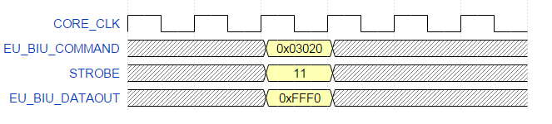

EU Requests

There are fourteen types of request that the EU can make to the BIU. The register EU_REGISTER_R3 typically holds the address and EU_BIU_DATAOUT holds the data values to be sent to the BIU. Read data is returned to the EU on the BIU_RETURN_DATA bus. This data should be held stable until the next request from the EU.

0x08 IO Read Byte
0x0A IO Write Byte
0x0C Memory Read Byte
0x0E Memory Write Byte
0x10 Memory Read Word
0x11 Memory Read Word from Stack Segment
0x12 Memory Read Word from Segment=0x0000
0x13 Memory Write Word
0x14 Memory Write Word to Stack Segment
0x16 Interrupt ACK Cycle
0x18 Halt State
0x19 Jump Request
0x1A IO Read Word
0x1C IO Write Word

Example of EU Requesting BIU to Jump to address 0x1234:

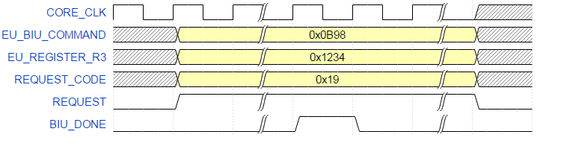

Example of EU Requesting BIU to write 0xABCD to I/O address 0x0380:
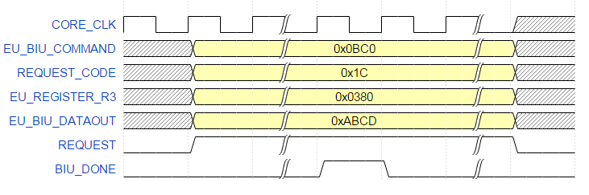

Integration

Integration of the MCL86 core is straightforward. The user only needs to supply a 4096 deep by 32 bit wide ROM to hold the microsequencer's instructions. There are no PLLs, DLL's or other additional resources required by the core.

The supplied 8088 BIU is an example of a full implementation that supports all local bus modes, interrupts, segment registers, prefetch queue, and cycle compatibility. It has been ported to a Kintex FPGA and can run in place of the original 8088 processor running on an IBM Personal Computer.

The supplied minimum BIU demonstrates an implementation that has on-board RAM, no prefetch queue, no interrupts, a reduced set of local bus options, and a single segment register. It is ported to the Lattice XO2 Breakout Board where it can run a small amount of code from on-chip RAM that is sufficient to perform simple tasks such as communicating with a host over a UART while controlling other on-chip resources.

Cycle Compatibility

For the MCL86 core to be cycle acurate to the original 8088 microprocessor, the CORE_CLK needs to be run at 100Mhz. If this is not required then CORE_CLK can be run at any clock speed. The sample design can run in the smallest Kintex-7 at 180Mhz.

Most instructions are emulated to take the same number of clocks are the original 4.77Mhz 8088. Please note that because the MCL86 is not a clone of the original 8088 there are a few instances where the MCL86 deviates by a clock or two. In addition instructions that have a range of clocks such as Multiple and Divide, the MCL86 will consistently perform the instruction using a clock value in the middle of the range as reported in the original 8088 datasheet. In these cases it will appear that the MCL86 is faster than the original 8088.

The cycle compatibility can be easily disabled by removing the counter logic in the BIU and asserting the CLOCK_COUNT_ZERO signal high. In this case the microsequencer will not be cycle compatible and will run significantly faster than the original 8088.

MCL86 Notes:

- Will handle interrupts and single stepping the same way as the original processor.
- Allows for interrupts in the middle of repeated string instructions.
- Will only restart the last prefix when a repeated string instruction is interrupted.
- All prefix instructions are supported.
- Software should detect the MCL86 an a genuine 8088.
- Original x86 undocumented and redundant opcodes are supported.
- Multi-prefixed instructions will restart the last prefix after an interrupt.
- After segment and interrupt flag updates, interrupts are gated until end of next instruction.
- Prefixes are part of the following instruction so interrupts are prohibited between them.
- The Queue Status signals are not fully supported, so interfacing to an 8087 Floating Point Co-Processor is not available at this time.

