# High-Level Design Document for Shelby Web-Application

Version: 0.2.0 Updated: 04/03/2024

**SUBMITTED BY**

Afreen Taj

ALAPATI THEERTHA VENU GOPAL

Amirisheƫty, Satya Vardhan Chinnadurai, Ramya

G, Swetha Himanshu Kakkar

Nalband, Abhinay Kumar Shashtrani Thoom Bhavana Prabhakar Guntamadugu Bhavya

**SUBMITTED TO**

ALCHEMY TEAM



## Table of Contents

1. Introduction 4
   1. Purpose 4
   2. Scope 4
2. Business Objectives 5
   1. Core Objectives 5
   2. Stakeholders 5
3. Assumptions and Prerequisites 6
4. Requirements 7
   1. Functional Requirements 7
      1. User Authentication and Profile Management 7
      2. Buyer Interface 7
      3. Seller Dashboard 8
      4. Admin Dashboard 8
   2. Non-Functional Requirements 9
5. High-Level Design 10
   1. Architectural Overview 10
      1. Technology Stack 10
   2. System Components 12
   3. Flow Chart 14
      1. Buyer Flow 15
      2. Seller Flow 15
      3. Admin Flow 16
6. Risks and Mitigation Strategies 17
7. Future Enhancements 18
8. Conclusion 19
9. References 20

**List of Figures**

### Shelby - System Architecture 7

* 1. **Shelby - Flow Chart 11**

# High Level Design Document

## Introduction

Shelby is an application which is a web-based micro e-commerce platform, aims to provide a simplified and user-friendly interface for buying and selling niche products and services. Buyers can browse, search for items, read product reviews and make online shopping ease. Sellers can add their product and develop a business effectively.

### Purpose

This high-level design document provides an overview of the architecture and design principles for the development of a Shelby application. It focuses on its main components, data flows, user interfaces and external integrations. This provides a conceptual overview of how the system works. It serves as a guide for developers, architects and stakeholders involved in understanding and implementing Shelby architecture.

### Scope

The Shelby application will cater to small-scale sellers and buyers, offering a streamlined platform for quick transactions. It will support a limited product catalogue and prioritize simplicity in the buying and selling processes.

## Business Objectives

## Core Objectives

Business objectives for small-scale sellers and buyers in the context of a web- based e-commerce platform may vary, but generally, they revolve around achieving success and satisfaction in their respective roles. Here are some common business objectives for each:

### Small-Scale Sellers:

* + - Provides an user-friendly platform for small-scale sellers to showcase their products or services.
    - Generate revenue and grow their business by selling products or services to customers.
    - Increase brand visibility and recognition among potential customers through product listings and customer engagement.
    - Safeguard customer payment information and secure payment processing systems and compliance with industry standards.
    - Be agile and responsive to changes in consumer preferences, market dynamics, and regulatory requirements to remain competitive.

### Buyers:

* + - Discover and purchase high-quality products or services that meet their needs and preferences.
    - Access responsive and helpful customer support services to resolve inquiries, issues, or concerns related to their orders or account.
    - Implement secure payment transactions.
    - Support small-scale sellers and local businesses by purchasing from independent sellers , contributing to their growth and success.
    - Offers a straightforward and efficient shopping experience.

## Stakeholders

* + - **Small-scale Sellers –** Essential stakeholders supply inventory and contribute to the platform’s revenue.
    - **Buyers –** Crucial stakeholders as they determine the platform’s success through their purchasing decisions and satisfaction.
    - **Payment Service providers –** Facilitate transactions between sellers and buyers & ensures secure payment process.
    - **Customer Support –** Efficiently resolve customer issues, complaints, or disputes to the customer’s satisfaction.

## Assumptions and Prerequisites

Assumptions and prerequisites for the Shelby application development project include:

1. Internet-Connectivity

Users are assumed to have reliable internet connectivity to access the platform and perform transactions.

1. Supported Devices and Operating Systems

The app is designed to run on various devices, including smartphones, tablets laptops, and desktop computers. It should be compatible with popular operating systems such as iOS, Android, and web browsers (chrome, Firefox).

1. Product Availability

The platform which showcased the products is assumed to be readily available for purchase, maintaining user trust and satisfaction.

1. Third-party Services and Testing

The platform may rely on third-party services for functionalities like payment processing, shipping, and analytics. Develop and execute testing plans to ensure functionality, performance, and security.

1. Payment Gateway Integration

The platform’s functionality relies on seamless integration with trusted payment gateways for efficient transaction processing and user convenience.

1. Security Measures

Robust security measures will be implemented to safeguard user data and ensure secure transactions, maintaining the integrity of this platform.

## Requirements

### Functional Requirements

### User Authentication and Profile Management

* + - * Users should be able to register, login accounts with their unique usernames, email & passwords and which follows the email verification.
      * The user can recover the password if they forgot it.
      * Able to manage their accounts with appropriate security measures.

### Buyer Interface

1. Product Searching and Details
   * Users should be able to browse products by category or brand. The system must support search functionality to help users find products efficiently.
   * Users should be able to view detailed product information, including descriptions, specifications, and images.
2. Shopping Cart and Checkout
   * Users should be able to add items to their shopping cart, view cart contents, and update quantities or remove items and proceed to checkout.
   * The system must calculate the total order amount and users should be able to choose various payment methods and shipping addresses.
3. Order Management

Users should to able to view their order history and track the status of their orders and receive order confirmation notifications to users.

1. Payment Management

The system should provide secure payment process such as credit/debit cards and UPI.

1. Rating and Review Management

The system should enable users to leave reviews and ratings for the products they have purchased after receiving the order.

1. Customer Support Management

Buyers should able to contact customer support for assistance with their orders and products. The system should provide channels for buyers to submit inquiries or report issues.

.

### Seller Dashboard

1. Product Listing
   * The system should enable the sellers to easily add, edit, and delete product listings.
   * Should support for uploading product images and setting prices.
2. Inventory Management
   * The system should provide basic inventory tracking to avoid overselling.
   * It should alert the sellers if there’s a low stock for their products.
3. Order Management
   * The system should enable the seller to view and manage incoming orders for their products.
   * They should get and view the total payment revenue for their product.
   * It should mark orders as shipped and track delivery status.
4. Check Reviews

The system should enable the seller to view customer reviews for their product.

1. Customer Support Management

Sellers should able to contact customer support for assistance with their products and orders. The system should provide channels for users to submit inquiries or report issues.

### Admin Dashboard

1. Approve Seller

The admin can approve the seller to make their product to be purchased and showcased.

1. Manage User Details

The admin can view the buyer and seller information who have accessed the system.

1. Check Reviews

The admin can view the customer reviews for products which are ordered by the customer.

1. Customer Care Messages

The admin can receive the customer’s issues and queries and submit to the customer support representatives access relevant order and user information to provide assistance.

1. View Sold Product Details

The admin can view the product details which are purchased by the customer which includes the most sold and least sold.

1. Shipment/Order Tracking

The admin can view the order tracking and shipping details of the product which is ordered by the customer.

### Non-Functional Requirements

1. Performance

The system should ensure fast loading times, respond promptly to user interactions and able to handle a large of concurrent users and transactions without significant performance degradation.

1. Scalability

The system should be able to handle a large number of concurrent users and fluctuating traffic loads. Utilize scalable cloud infrastructure and horizontal scaling techniques.

1. Reliability

The system should be reliable, with minimal errors, crashes, or data inconsistencies. Automated monitoring and alerting systems should be in place to detect and respond to issues proactively, minimizing the impact on users.

1. Security

For data security and user privacy from unauthorized access, it should be encrypted using industry-standard protocols.

1. Usability and Maintainability

The user interface should be responsive and accessible across different devices and screen sizes. Support multiple languages and testing should be done.The system should be modular and well-documented to facilitate future maintenance and enhancements. Version control systems should be used to ensure code quality.

## 5 High-Level Design

The high-level design presents the structure of the system, such as the database architecture, application architecture (layers), application flow(navigation), and technology architecture. The HLD uses intermediate technical terms which should be understandable to the administrators of the system.

### 5.1 Architectural Overview

The Shelby e-commerce platform follows a three-tier architectural pattern, consisting of multiple interconnected components that work together to fulfil the system’s objectives. The architecture ensures separation of concerns and modularity, facilitating scalability, maintainability, and extensibility.

### Technology Stack

* + - * **Frontend:** HTML, CSS, JavaScript, AngularJS, NodeJS.
      * **Backend:** Java, Spring Boot.
      * **Database:** MySQL, MongoDB.
      * **Design:** Canva.
      * Jenkins.
      * AWS.
      * Docker.
      * Junit.

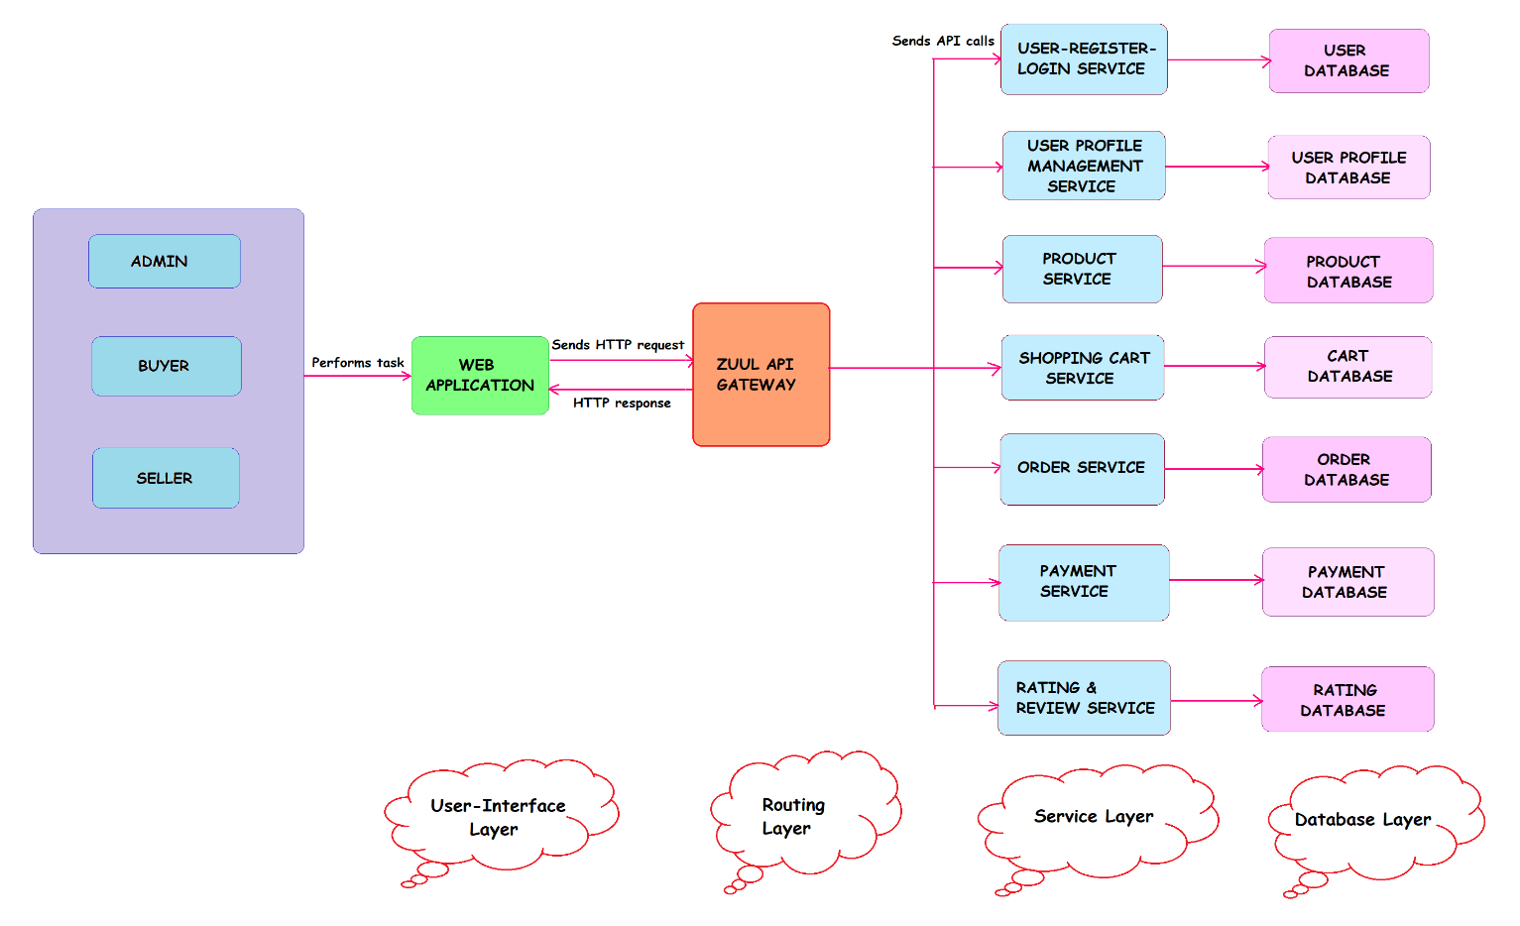

### Figure 1. Shelby – System Architecture

1. **Presentation Layer**

The presentation layer is responsible for handling user interactions and rendering the user interfaces. It includes front-end components such as web pages, that allow customers to interact with the system. The presentation layer communicates with the back-end components to retrieve and display relevant data.

* + Web Interface

A responsive web application accessible through browsers on various devices, designed for browsing products, managing accounts, and placing orders.

### Routing Layer

The routing layer acts as a single-entry point for clients to access various services and provides features like routing, authentication, and API composition. It manages requests from clients, route them to appropriate services, and perform tasks like authentication, rate limiting, and logging. It enables clients to interact with the system, without needing to know the individual service endpoints.

* **API gateway** creates APIs at any scale.
* **Service Discovery** finds dynamically assigned network locations of microservices instances.
* **Load Balancer** distributes API calls among microservices.
* **Security** safeguards microservices from external threats.

### Business/Service Layer

* The business/service layer contains the core functional logic and rules with each service responsible for a specific business function or domain, that enables users to shop conveniently and securely.
* It processes user requests, applies business rules, and orchestrates interactions between various components.
* Services are designed to be independent, scalable, and deployable units, often managed by separate development teams.
* This layer encapsulates domain-specific operations, including user register & login service, user profile management service, product service management, shopping cart service, order processing, customer service management, shopping cart service, ratings & reviews service, and payment service.

### Data Layer

The data layer consists of the database and associated components responsible for data storage and retrieval. It stores product information, customer information, order details, payment details, review details , cart details, and customer care message details,. The data layer interacts with the business logic layer to provide data persistence and retrieval functionality.

* + Databases

Utilizes a relational database (e.g., MySQL) for storing user data, product information, orders, reviews and payments.

**5.2 System Components**

The Shelby System is composed of several interconnected components, each serving specific functions and contributing to the overall system’s capabilities. These components work together to provide a seamless and efficient retail store management solution. The following are the key components of the Shelby System:

1. User Interfaces Component

The User Interface Component encompasses the front-end elements of the system, enabling customers to interact with the store’s products, browse catalogs, add items to the cart, and complete the checkout process. It provides an intuitive and responsive web-based interface that allows customers to search for products, filter based on categories or specifications, view product details, and manage their shopping cart. The User Interface Component also includes an administrative interface that enables store managers to perform various tasks, such as managing inventory, processing orders, and generating reports.

1. Zuul API Gateway

The Spring cloud Gateway can be used as a both load balancer and an API gateway. A gateway which built on Spring framework and Spring boot providing routing of the large number of incoming HTTP requests from clients to the respective backend microservices, performs authentication and authorization, and then returning the service’s response back to the client used for the application.

1. Eureka Server

It is a microservice registration tool, like the eureka server is itself a microservice that is used to register and store the location of other microservices within the same system. The services register themselves to the server where they

can be identified and located by other microservices when required. It acts as a service discovery.

1. User Service and User Profile Management Component

The Customer Management Component facilitates the management of customer information, including registration, profile updates, and order history. It provides customer account creation and authentication mechanisms, allowing customers to securely access their account details.

1. Product Management Component
   * The Product Service Component facilitates the seller to manage the product listings where he can add, edit and delete products.
   * It facilitates the buyer to search the desired product and view the product details.
   * It facilitates the admin to view the details to approve the seller for the product to be showcased.
2. Shopping Cart Management Component

The Shopping Cart Management Component facilitates the buyers to manage the user’s shopping cart, including adding, removing, and updating items. It provides the checkout process, including order summary, shipping options, and payment methods.

1. Payment Management Component

The Payment Management Component facilitates buyers to integrate with payment gateways to securely process payments. It supports various payment methods such as credit/debit cards and UPI. It handles payment authorization, capture, and settlement processes.

1. Order Processing Management Component
   * It facilitates the buyers for ordering the product has secure capture and validation of customer information, including shipping addresses, payment details, and receives order confirmation mail and check the order status. The buyer can also view the previous order history.
   * It facilitates the seller to manage the incoming orders and mark the orders as shipped and track delivery status and view the total payment revenue.
   * It facilitates the admin to view the order tracking and shipping details of the product which is ordered by the customer.
2. Ratings & Reviews Management Component
   * It facilitates the buyers to leave the review for the products once the order placed.
   * It facilitates the seller and admin to view & manage the review of the products.
3. MySQL Relational Database

The MySQL relational database is used to store all the application details like buyer’s order information, seller’s product information, cart details, buyer and seller and admin details, review details, customer care messages details, payment details by configuring in the application properties of the Spring boot.

**5.3 Flow Chart**

**Figure 2. Shelby – Flow Chart**

The above flow chart explains the typical process flow in this Shelby platform.

### Buyer flow

1. The buyer interact with the Shelby platform through a web browser in any devices.
2. The buyer may need to register or login to access certain features like saving addresses, buying the product, and viewing order history and to manage their account.
3. The buyers search for products using the search bar or browse through categories. They select products they want to purchase and view the product details and then they can add it to shopping cart if they like to buy.
4. They can proceed to checkout from the cart page if they like to buy or keep shopping and searching the product they need.
5. After proceeding to checkout, the buyers can enter shipping details and select the payment method.
6. Payment information is securely transmitted to a payment gateway. The payment gateway processes the transaction and communicates with the user’s bank to authorize the payment.
7. Once payment is authorized, the user receives an order confirmation with details such as order number and estimated delivery date.
8. The buyers can track the status of their order using a tracking number provided in the order confirmation mail. They can see the delivery status of their package.
9. The buyer can logout the system if they need.

### Seller flow

1. The seller interact with the Shelby platform through a web browser in any devices.
2. The seller may need to register or login to access certain features like saving addresses, adding the product, selling the product and viewing order details and to manage their account.
3. The seller can add the product which they need to sell.
4. In the dashboard, they can receive the order and mark as status and track the delivery status.
5. And the overall payment revenue can be viewed by them.
6. They can receive the reviews for their product which were ordered by the buyers.

### Admin Flow

1. The admin uses the Shelby platform through a web browser in any devices.
2. The admin need to register or login to access the platform and to manage account.
3. The admin can view all the user details who are accessing the platform. 4.They approve the seller who have added the product.
4. They can manage the shipping details and order tracking status of the product which is marked order.
5. They can manage the customer care messages which involves the customer queries and issues and submit it to the customer support representatives.
6. They can view all the product details and based on the products which are most sold.
7. They can manage the reviews for the ordered products by the customer.

### Risks and Mitigation Strategies

* 1. Risks

1. Payment Processing Issues

There are some potential challenges in integrating with the payment gateway with our platform.

1. Low User Adoption

Users might find the platform too simple for their needs.

* 1. Mitigation Strategies

1. Payment Processing Issues

Engage closely with payment gateway providers and conduct thorough testing.

1. Low User Adoption

Implement a robust marketing strategy.

## Future Enhancements

For a micro e-commerce project, here are some potential future enhancements you could consider:

**Mobile App Development:** Create a dedicated mobile app to improve accessibility and user experience.

**Personalized Recommendations:** Implement algorithms to suggest products based on user browsing and purchase history.

**Social Media Integration:** Allow users to share products on social media platforms and integrate social login options.

**Enhanced Search Functionality**: Implement advanced search filters and predictive search to help users find products more efficiently.

**Inventory Management System:** Implement a robust inventory management system to track stock levels and prevent overselling.

**Chatbot Integration:** Integrate a chatbot to provide real-time customer support and assistance with product inquiries.

## Conclusion

The Shelby application is designed to provide a simple and efficient platform for small-scale sellers and buyers to conduct e-commerce transactions. The high- level design for the Shelby’s e-commerce platform illustrates a robust and scalable system built on a foundation of modern technologies and best practices. By leveraging a layered architecture, the Shelby system achieves flexibility, reliability, and performance while providing a seamless shopping experience for users. Overall, the architecture of the Shelby app reflects a holistic approach to build a web-based micro e-commerce platform that prioritizes user experience, performance, and security.

### References

1. An Article “High-level Solution Design (HLD) Documents : What Is It and When Do You Need One” published on January 25 ,2024 by author *Georges Lteif*.
2. An Article “High-level design document and how it can help us to structure your design artifacts” published on July 22,2023 by author Svosh.