Add List Items to ALM Project lists

1. Install the TDConnectivity from your ALM instance.

https://<server>/qcbin/TDConnectivity_index.html

1. Bring up the macro on a 32-bit Excel application.
2. Navigate to the List tab and specify the items you want to add.

Example:

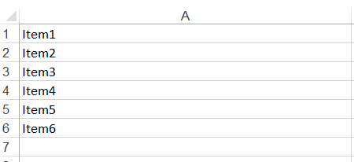

1. In the Connection tab, click on Execute button. Authentication dialog window appears.

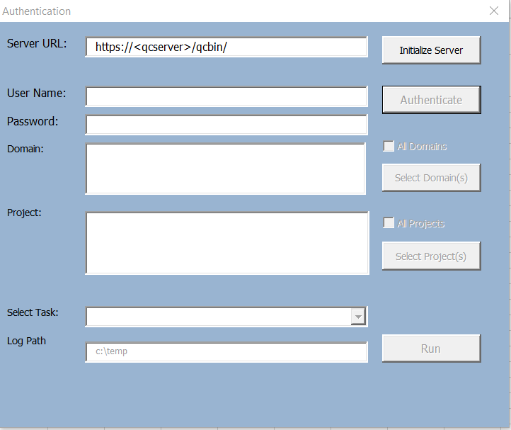

1. Enter the ALM URL and authentication credential. You will need a user with Customization permission in order to add list items to the project.

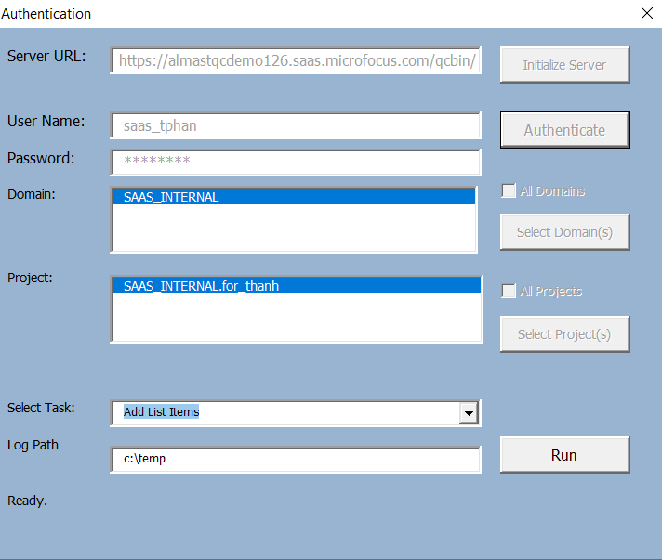

1. Click on Run button. Customization dialog button will appear.
2. In “Lookup List Name”, specify the list you want to modify.

Example:

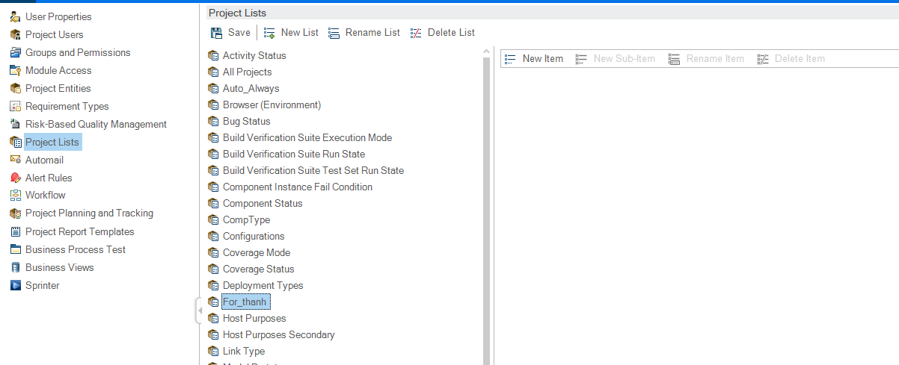

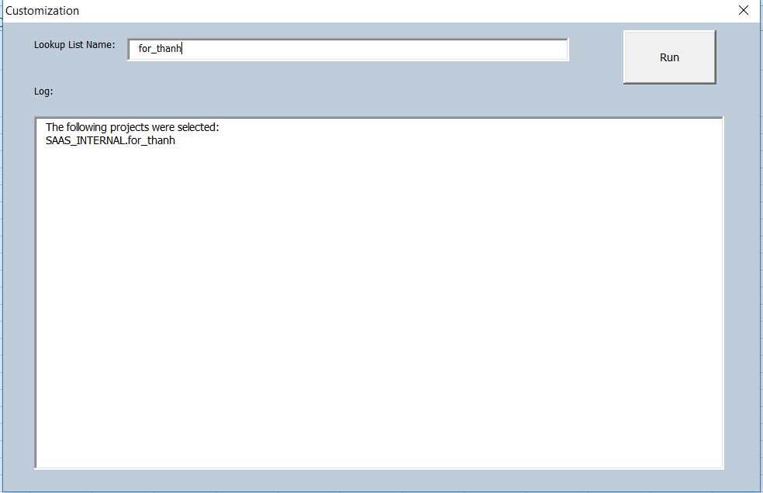

1. Click on “Run” button to execute. Log will display actions taken.

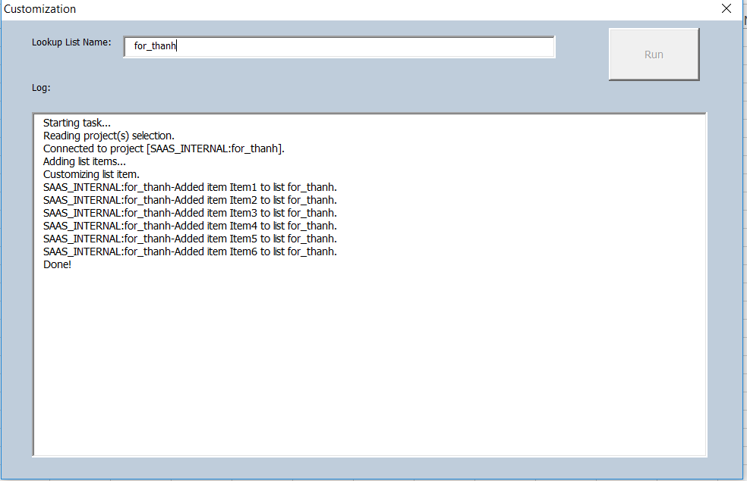

1. Review customization in ALM project.

