Add List Items to ALM Project lists

1. Install the TDConnectivity from your ALM instance.

https://<server>/qcbin/TDConnectivity_index.html

1. Bring up the macro on a 32-bit Excel application.
2. In the Connection tab, click on Execute button. Authentication dialog window appears.

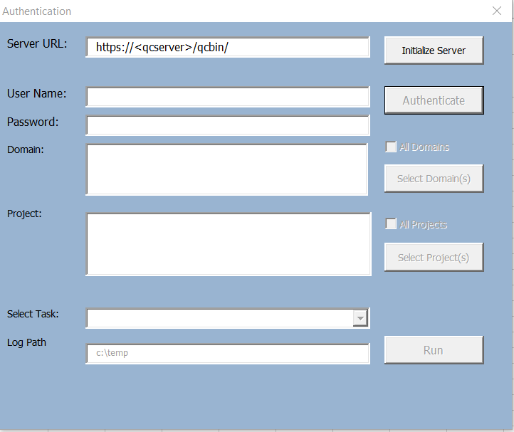

1. Enter the ALM URL and authentication credential. You will need a user with Customization permission in order to add list items to the project.

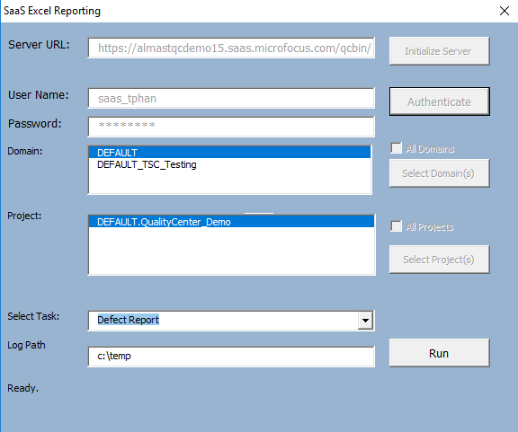

1. Click on Run button. Customization dialog button will appear.

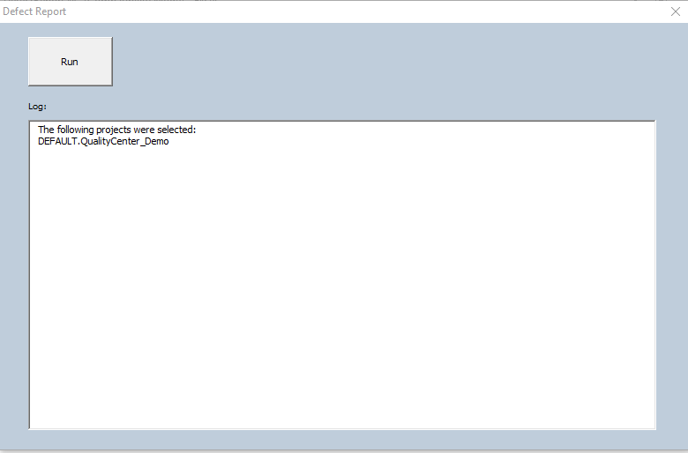

1. Click on the Run button in the Defect Report Dialog to generate the report. The report will generate a new tab for each project.