Export ALM QC Test Plan to Octane format

1. This tool requires OTA to be registered

https://<servername>/qcbin/addins.html

1. Launch the Excel Macro

Note: This macro only works on Excel 32-bit due to OTA limitation.

1. In the Connection tab, click on Execute.

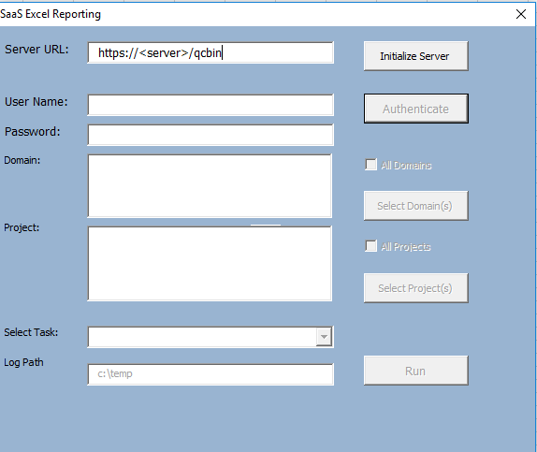

1. Enter you login credential and select “Test List Report” from task lookup list.
2. Click on Run. “Test List Report” dialog will appear.

There are 2 filters that need to be input:

1. Subject Folder Path – The location of the tests to be exported starting with “Subject\”
2. Creation Date – Test creation date with mm/dd/yyyy format

Specify the string to remove from Product Area path:

Example:

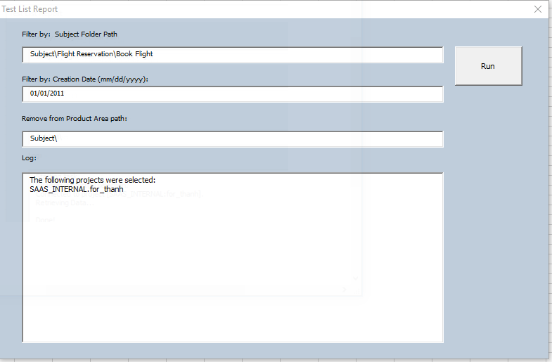

1. Click on Run to being the data export. The manual tests will be exported to the “manual tests” tab. The folder\test hierarchy will be exported to the “test suites”. The subject path minus “Subject\” will be added to the product_areas column.

Manual Tests:

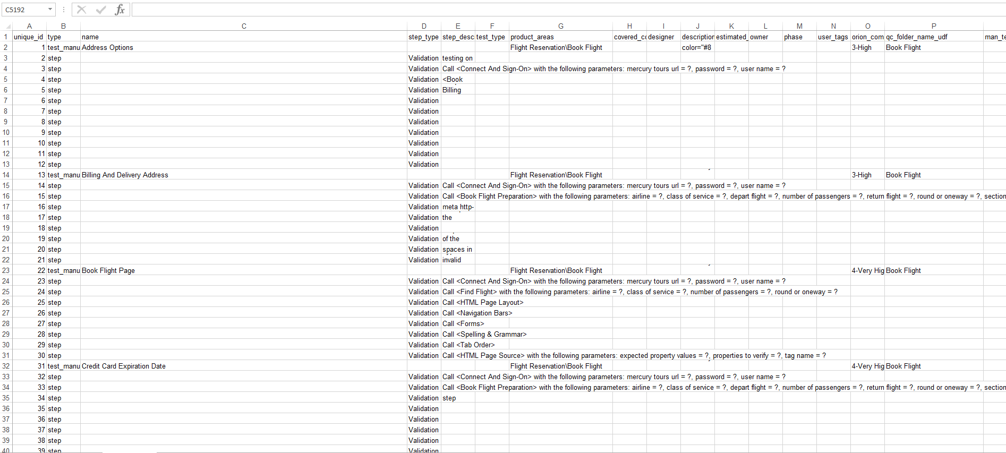

Test suites:

