Export Tests Macro:

Requirements:

1. This example uses OTA. OTA is a DCOM object that needs to be install on the machine. You can install OTA by either running the TDConnectivity or ALM Client installation.

TDConectivity:

https://<serverurl>/qcbin/TDConnectivity_index.html

ALM Client Registration (click on Register ALM link):

https://almsydqcmt15-1.saas.microfocus.com/qcbin/CommonMode_index.htmlOpen the Excel

1. Excel 32-bit only
2. Excel 64-bit requires following the steps discussed in the link below:

https://community.microfocus.com/t5/ALM-QC-User-Discussions/Workaround-OTA-amp-64-Bit-Applications-Excel-Word-etc/m-p/1639028/thread-id/97290/highlight/true

1. SSO is not supported in this example Excel macro

Usage:

1. Run the TestReport.xlsm. You should now see a Connection tab.

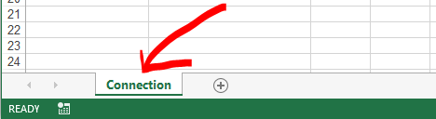

Note: You will need to enable macro if prompted.

1. Click on “Execute” button.

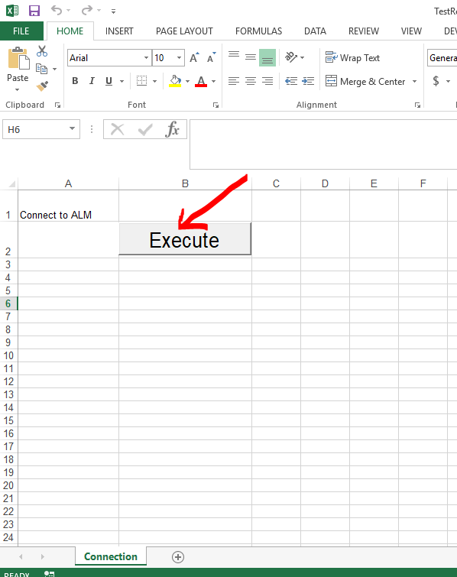

1. Enter the Server URL and click on “Initialize Server”.

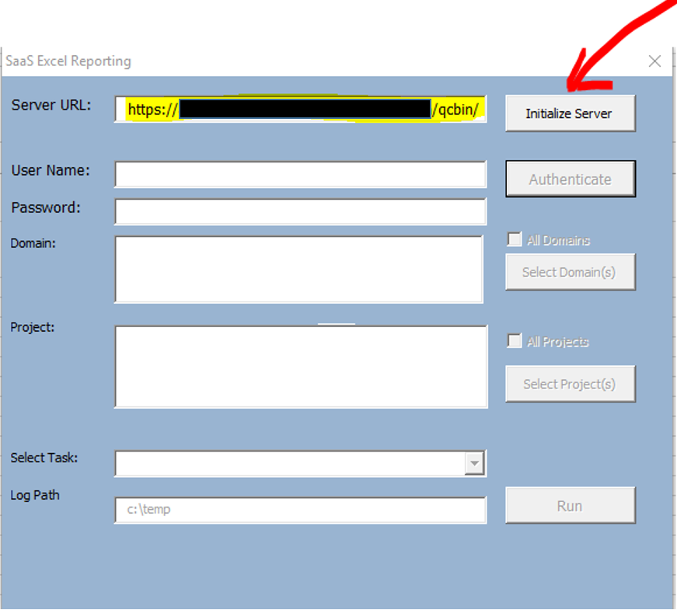

1. Enter your user name and password. Click on “Authenticate”

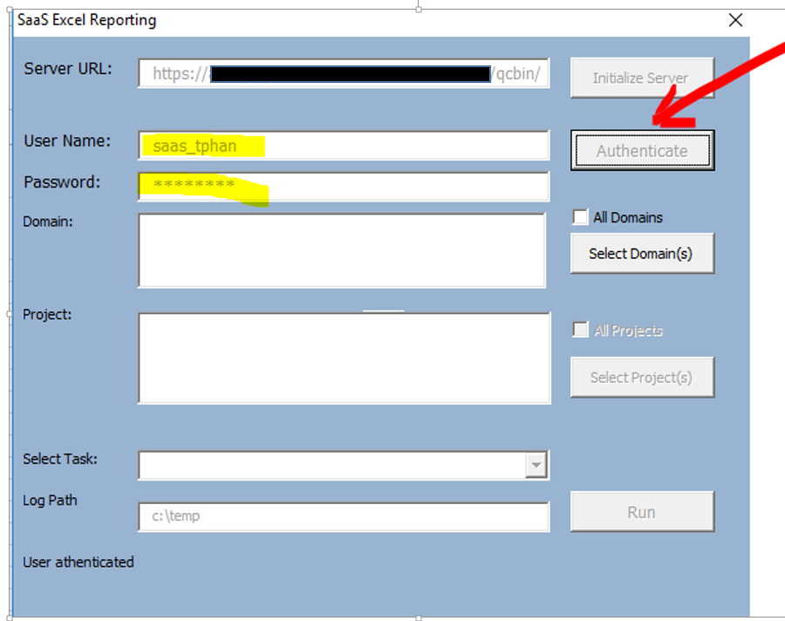

1. Select your domain(s) and click on “Select Domain(s)” button.
2. Select your project(s) and click on “Select Projects” button.

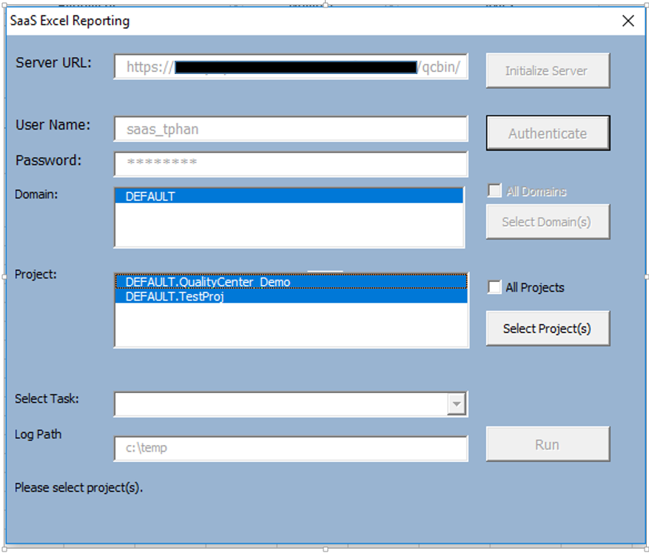

Notes: Hold down shift key to multi-select items from list or click on checkbox to select all.

1. Select “Test Report” task. Click on “Run” button.

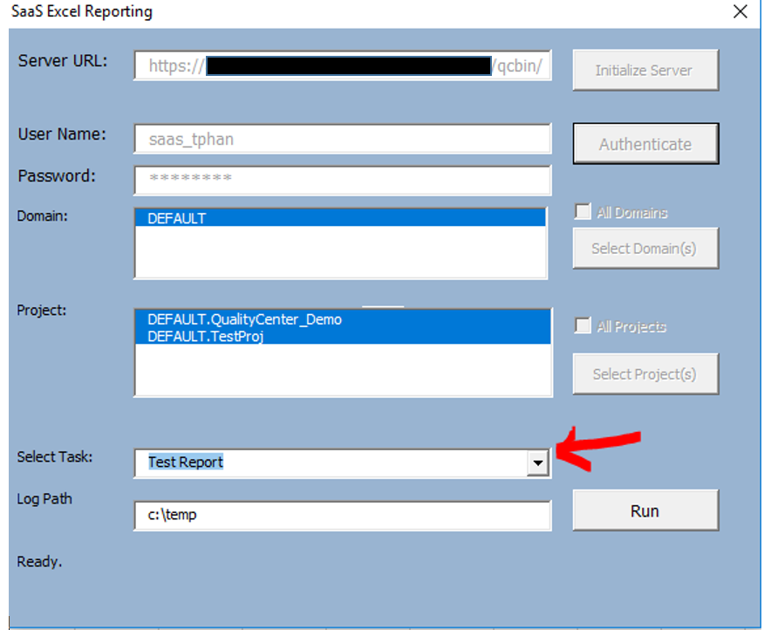

1. Enter the path of the Subject you want to generate the report for. Tool will filter based on the Subject path.

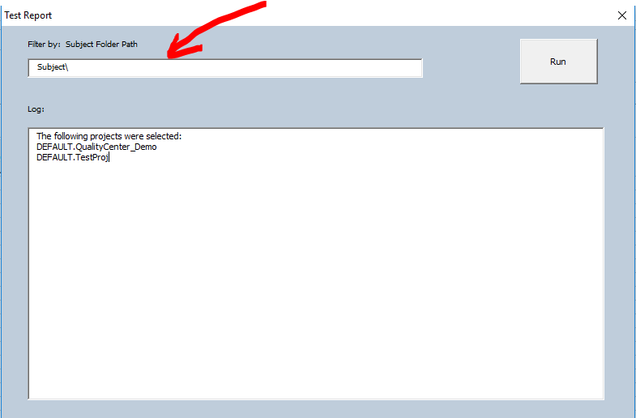

Note: Accept default Subject\ to generate report for all folders below the Subject node.

1. Click on Run button to generate the report.

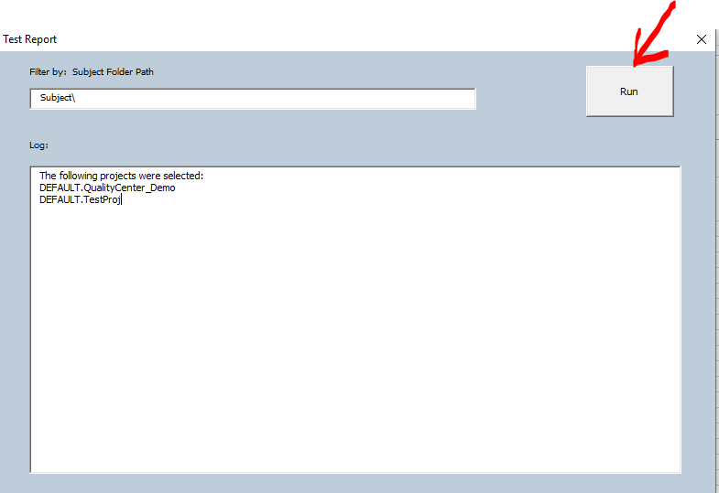

1. Report will be generated and log file will be stored under c:\temp. Log entries will also visible in the GUI. A message box with “Done” text will be displayed upon completion.

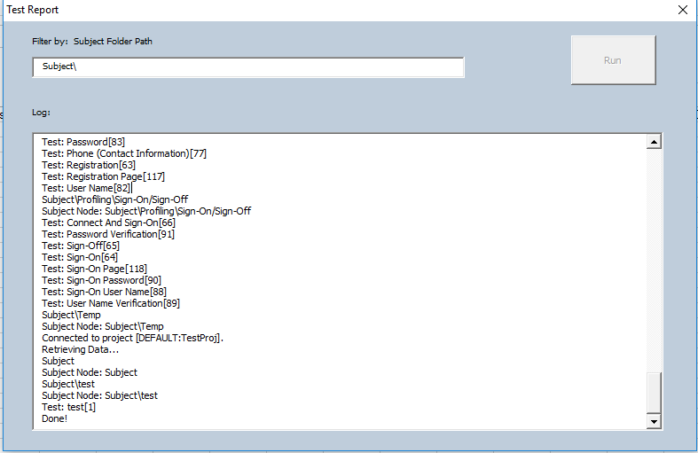

1. In the Excel file, you should now see a separate tab for each project selected.

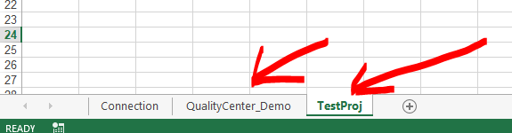

1. Test report with design steps are displayed in the individual project tab.

