Module Count

1. Install the TDConnectivity from your ALM instance.

https://<server>/qcbin/TDConnectivity_index.html

1. Bring up the Excel macro using 32-bit Excel.
2. In the Connection tab, click on Execute button. Authentication dialog window appears.

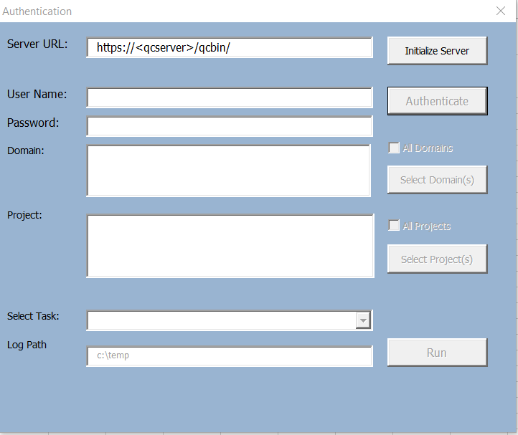

1. Enter the ALM URL and authentication credential. You will need a user with Customization permission in order to add list items to the project.

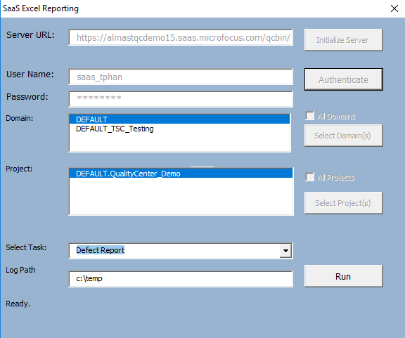

1. Click on Run button. A new dialog button will appear displaying projects selected.

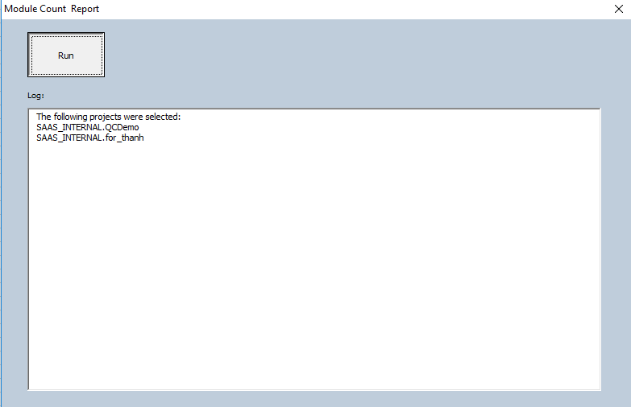

1. Click on the Run button. Report will be displayed in the “Module Count” tab.

