How to import users to SaaS Administrator Add-on using REST API

1. Create an API Key used for authentication. Make sure to select a Customer Admin user.

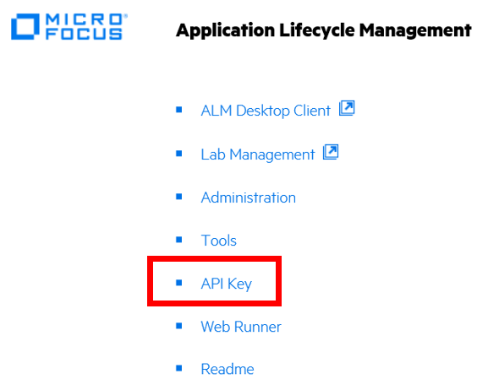



1. Bring up the QC_RESTAddonAddUsersToSite.xlsm
2. Click on the enable macro button.
3. Navigate to the Users tab and enter the users you want to add to the SaaS Administration add-on.

Example:

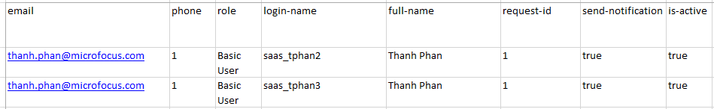

1. Navigate to the Projects tab and enter the users you want to add to projects.

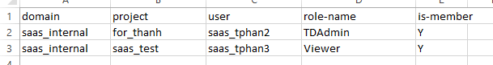

1. Navigate to the Connection tab and enter the connection information.

Notes:

* The URL should not have a trailing backslash.

Example: https://almastqcdemo15.saas.microfocus.com/qcbin

* You will need the API key and secret create in Step 1.
* Request the Customer ID from the SaaS Support. Here we are using 0 (SaaS) but yours will be different.
* Select the option to “Add User(s) to Site Admin” or “Add User(s) to Project(s)”

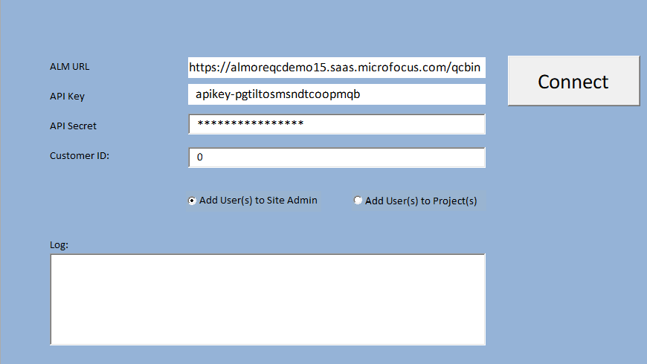

1. Log pane will display the result of tool execution.

Here we executed the option to add user to Site Admin.

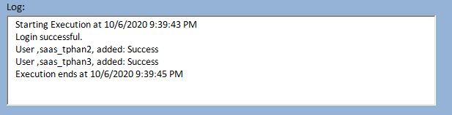

Here we executed the option to add users to projects.

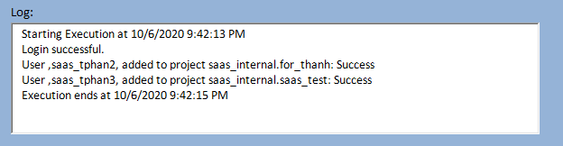

1. Confirm the users were added to Site and projects.

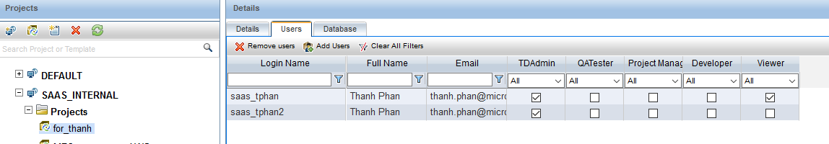

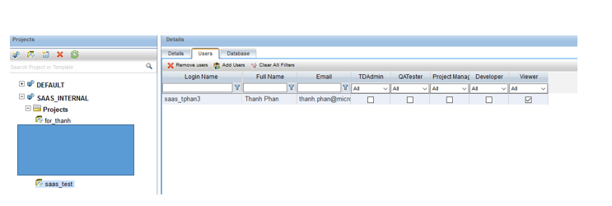

1. Users will get 2 emails containing their login credentials.

