Add List Items to ALM Project lists
- Install the TDConnectivity from your ALM instance.
https://<server>/qcbin/TDConnectivity_index.html
- Bring up the macro on a 32-bit Excel application.

- In the Connection tab, click on Execute button. Authentication dialog window appears.
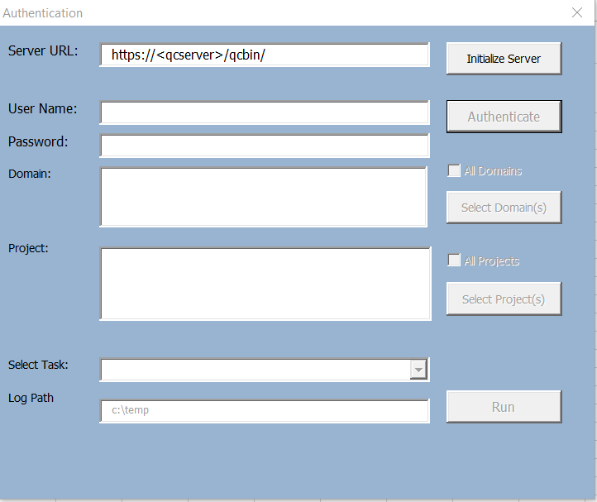
- Enter the ALM URL and authentication credential. You will need a user with Customization permission in order to add list items to the project.
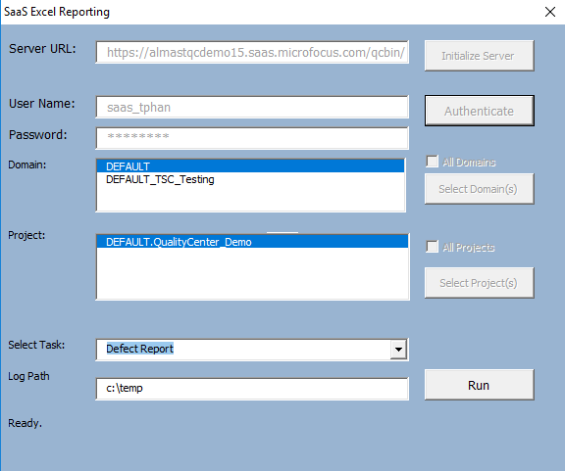

- Click on Run button. Customization dialog button will appear.
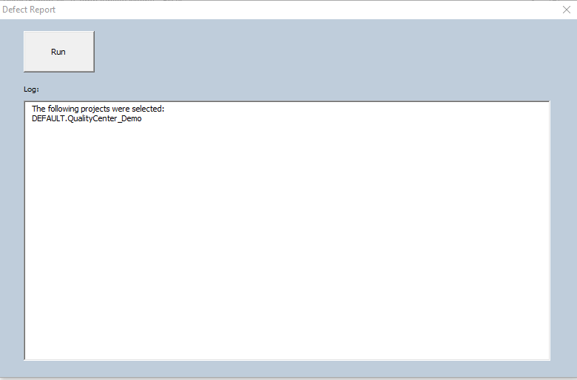
- Click on the Run button in the Defect Report Dialog to generate the report. The report will generate a new tab for each project.

