Export Tests Macro:
Requirements:
- This example uses OTA. OTA is a DCOM object that needs to be install on the machine. You can install OTA by either running the TDConnectivity or ALM Client installation.

TDConectivity:
https://<serverurl>/qcbin/TDConnectivity_index.html

ALM Client Registration (click on Register ALM link):
https://almsydqcmt15-1.saas.microfocus.com/qcbin/CommonMode_index.htmlOpen the Excel
- Excel 32-bit only
- Excel 64-bit requires following the steps discussed in the link below:
https://community.microfocus.com/t5/ALM-QC-User-Discussions/Workaround-OTA-amp-64-Bit-Applications-Excel-Word-etc/m-p/1639028/thread-id/97290/highlight/true

- API Key for SSO authentication. If you don’t have an API Key , then you can request your Administrator to create one.
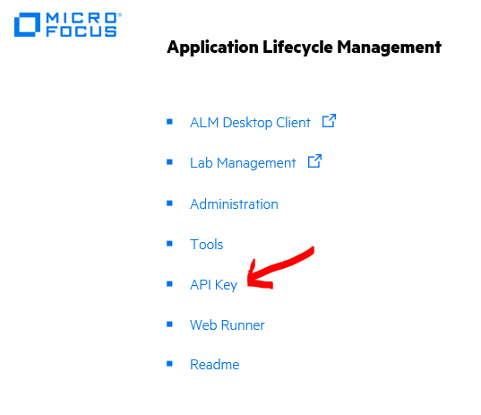

Usage:

- Run the TestReport.xlsm. You should now see a Connection tab.
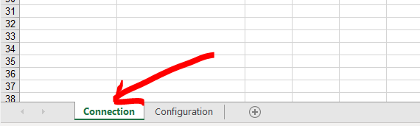

Note: You will need to enable macro if prompted.

- Click on “Execute” button.
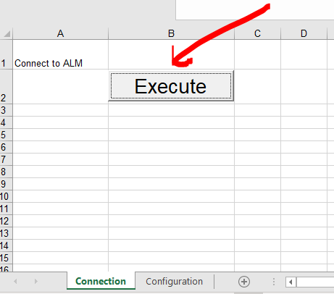
- Enter the Server URL and click on “Initialize Server”.
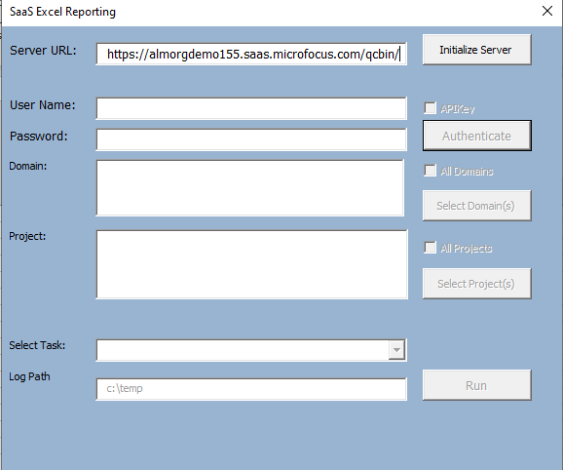
- Enter your user name and password. Click on “Authenticate”.
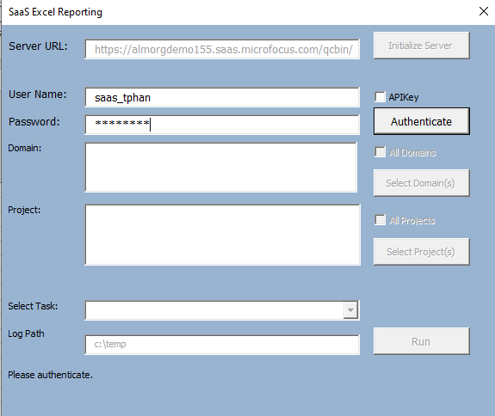

Notes: For SSO, you need to enable the “APIKey” checkbox and enter your API Key and Secret.

- Select your domain(s) and click on “Select Domain(s)” button.
- Select your project(s) and click on “Select Projects” button.
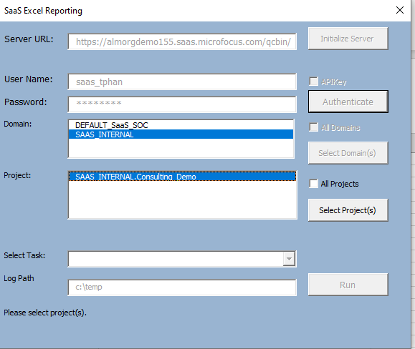

Notes: Hold down shift key to multi-select items from list or click on checkbox to select all.

- From the “Select Task” dropdown, select “Set Configuration”. Click on “Run” button.

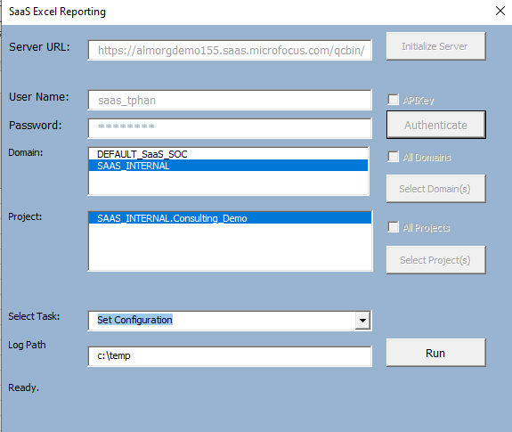
- Make your fields selection. Use the buttons to move the fields from “Available” list to “Selected” list. You can move a field up and down by clicking on corresponding buttons. Click on “Save”.
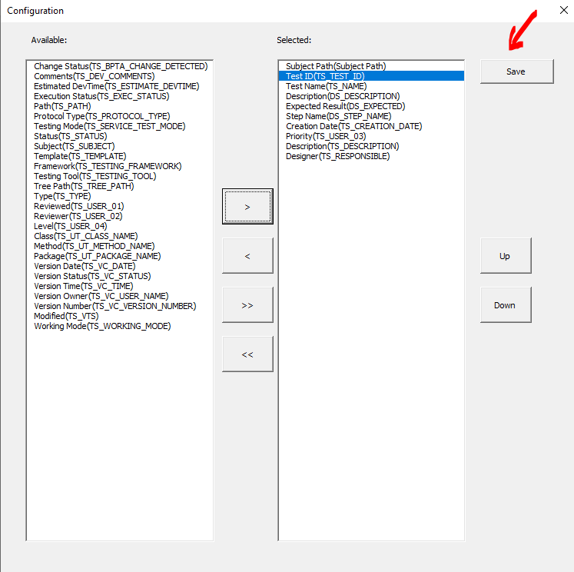
- The fields you selected will be saved to the “Configuration” tab. You do not need to run this again for subsequent reports if no changes are needed. You can manually edit the Configuration tab to do field selection.
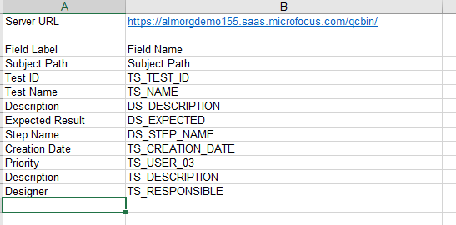

- Select “Test Report” task. Click on “Run” button.
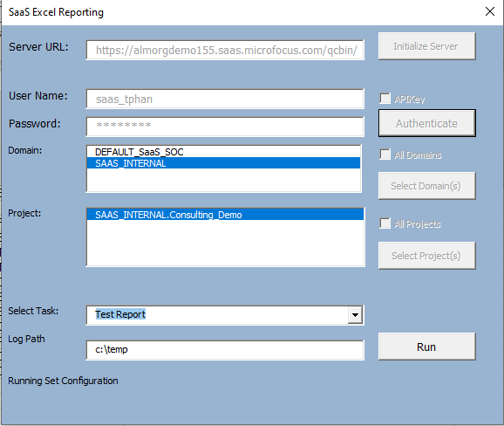
- Report default to all folders under Subject. You can edit the Subject Path to filter.
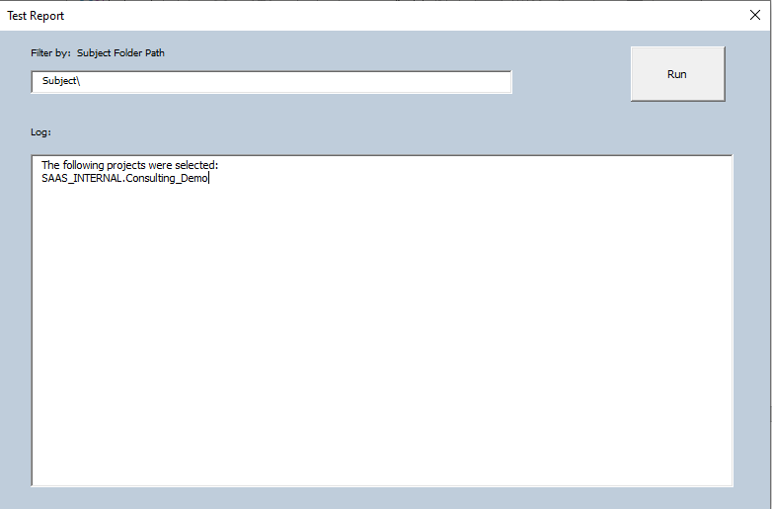

Note: Accept default Subject\ to generate report for all folders below the Subject node.

- Click on Run button to generate the report.

- Log entries will be generated and saved to c:\temp.
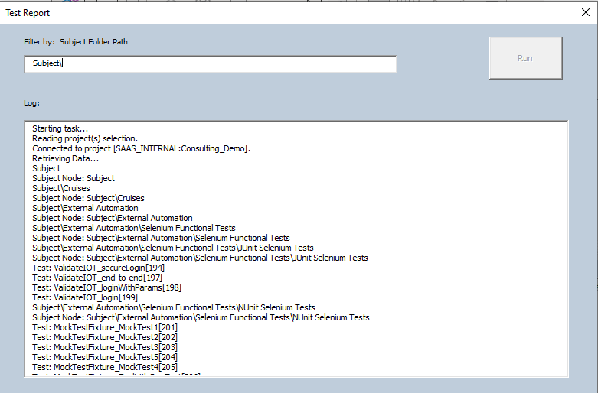

- Upon completion, a new tab with the project name is created. The report with the fields selected will be displayed in this tab.
