Module Count
- Install the TDConnectivity from your ALM instance.
https://<server>/qcbin/TDConnectivity_index.html
- Bring up the Excel macro using 32-bit Excel.

- In the Connection tab, click on Execute button. Authentication dialog window appears.
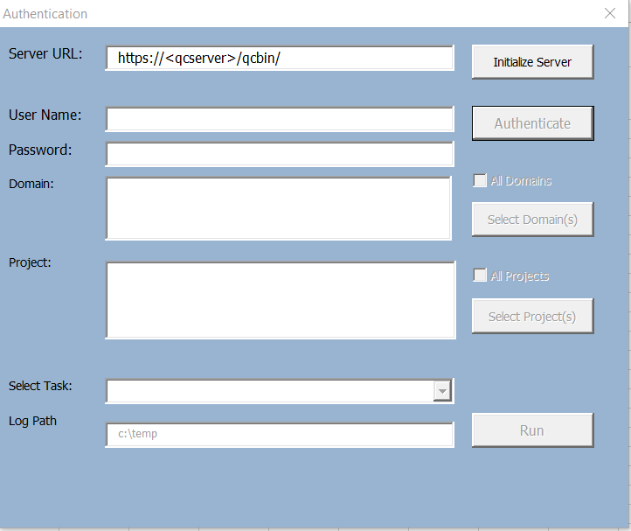
- Enter the ALM URL and authentication credential. You will need a user with Customization permission in order to add list items to the project.
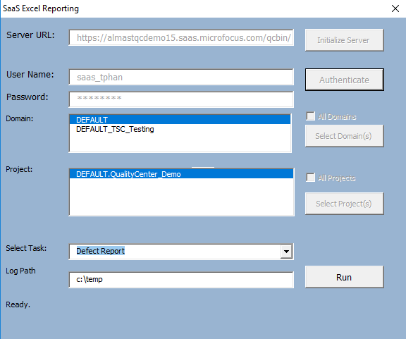

- Click on Run button. A new dialog button will appear displaying projects selected.

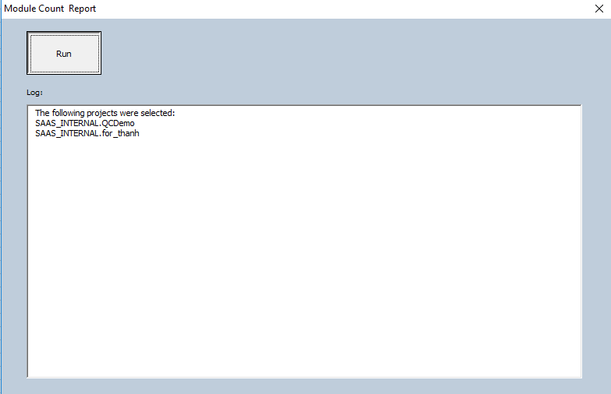
- Click on the Run button. Report will be displayed in the “Module Count” tab.

