Usage:

- Download SaaSToolKit_RennameUser.exe
- Double click on the RenameUser.exe. You should now see as followed:
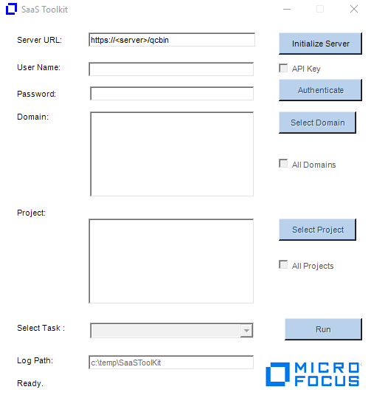
- Enter your ALM URL and click on Initialize Server.
- Authenticate. You will need a TDAdmin account that has access to the project since the tool will need to run a number of SQL update statements. The project you select in this dialog will be used just for authentication.
Notes: For SSO, you will need to create an API key and enable the API Key check when authenticating.

- Select the domains and projects you want to update.
- Under Select Task, you need to select “Rename Users” and then click on Run button. The Rename Users Dialog will appear.
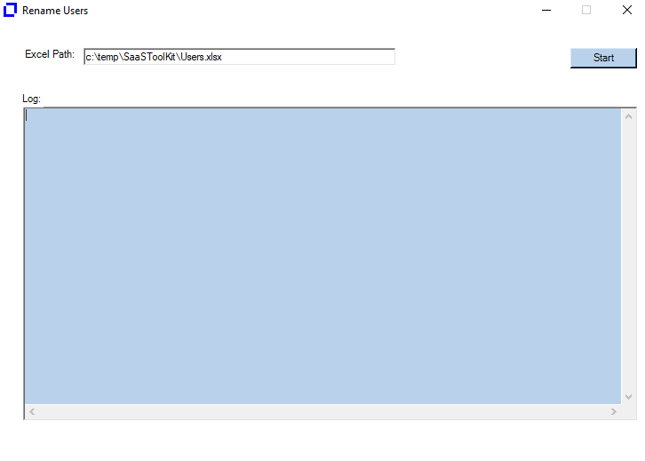
- Enter the path of the Users.xlsx file containing the users you want to replace. The default path it is expecting the file is under c:\temp\SaaSToolKit\Users.xlsx

ColumnA = Task to perform which in this case is “Rename User”
ColumnB = olderuser:newuser
Here I am replacing saas_tphan with saas_tphan2
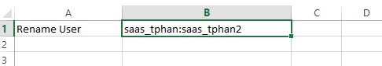

- Click on Start button to execute the task. The log file generated will be under c:\temp\SaaSToolKit.

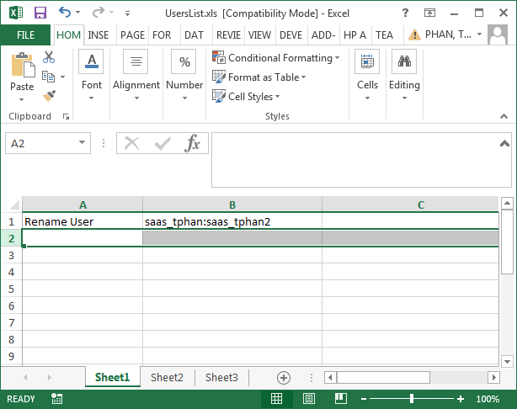
- Enable the “Rename Users” checkbox.
- Click Update.
- The log files will be written to the c:\temp\RenameUsers folder.

Notes:
The utility works as followed:
- The Old user must exist in the project.
- The New user must NOT exist in the project.
- Both users much already exist in the Site Admin.
- The Old user will be removed from the project and the New user will replace it in all places where the Old user was previously.
- Log file generated (Ex. C:\temp\renameusers\AutomatedChange.txt) will identified what queries were ran and how many records were updated.
- You will need to delete the old users from ALM Add-on or Site Admin after the tool has been ran.
- The tool will not update history entries

