How to import users to SaaS Administrator Add-on using REST API

Notes: There are 2 examples provided in this repository. Please use QC_RESTAddonAddUsersToSite.xlsm for ALM 15.x. The example, QC_RESTAddonAddUsersToSite – alm16(version2).xlsm, should be used for ALM 16 and above.
- Create an API Key used for authentication. Make sure to select a Customer Admin user.
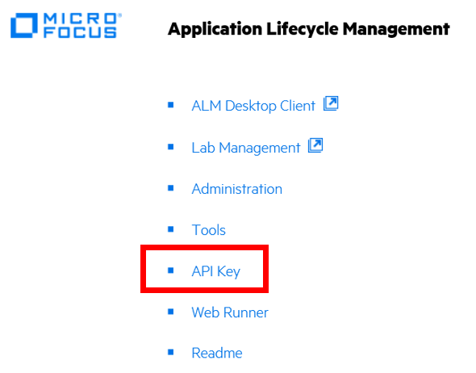
- Bring up the QC_RESTAddonAddUsersToSite.xlsm
- Click on the enable macro button.
- Navigate to the Users tab and enter the users you want to add to the SaaS Administration add-on.
Example:
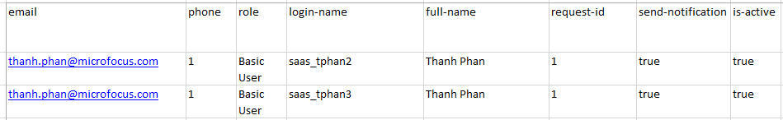
- Navigate to the Projects tab and enter the users you want to add to projects.
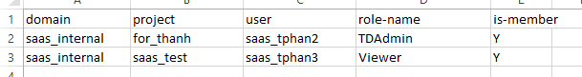
- Navigate to the Connection tab and enter the connection information.
Notes:
- The URL should not have a trailing backslash.
Example: https://almastqcdemo15.saas.microfocus.com/qcbin
- You will need the API key and secret create in Step 1.
- Obtain the Customer ID from the Administration Addon -> SaaS Information -> Reports -> Parameters -> Customer ID report.
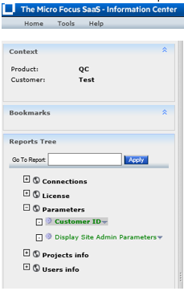

- Select the option to “Add User(s) to Site Admin” or “Add User(s) to Project(s)”
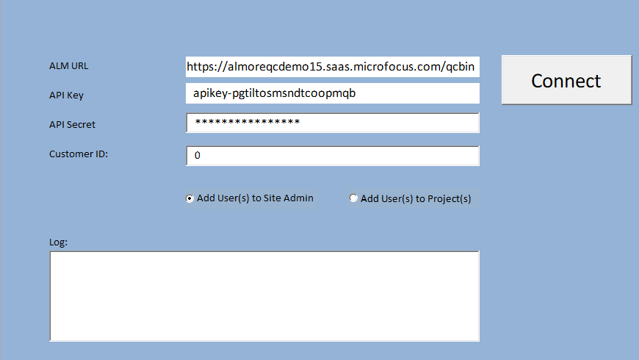

- Log pane will display the result of tool execution.

Here we executed the option to add user to Site Admin.
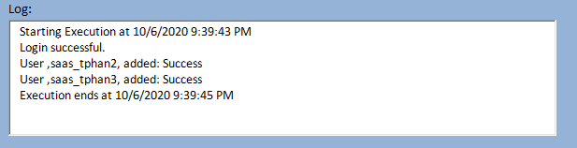

Here we executed the option to add users to projects.

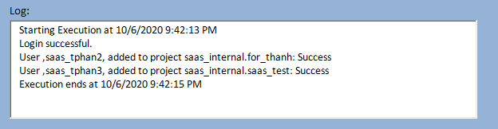

- Confirm the users were added to Site and projects.
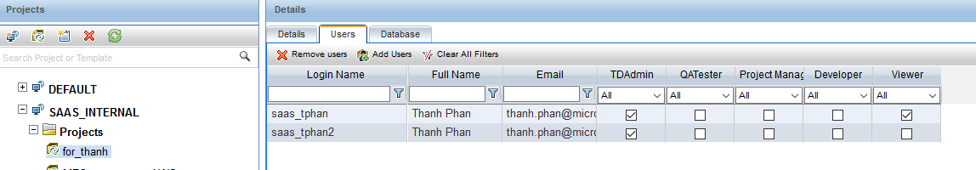

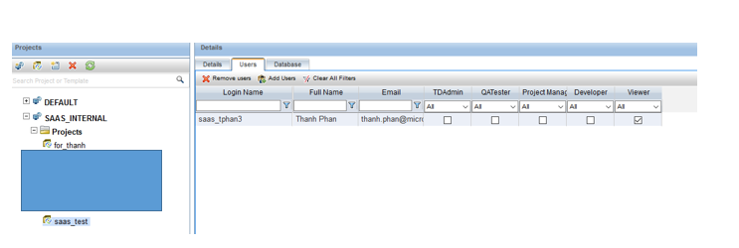

- Users will get 2 emails containing their login credentials.

