Add List Items to ALM Project lists
- Install the TDConnectivity from your ALM instance.
https://<server>/qcbin/TDConnectivity_index.html
- Bring up the macro on a 32-bit Excel application.
- Navigate to the List tab and specify the items you want to add.
Example:
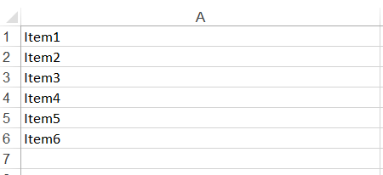
- In the Connection tab, click on Execute button. Authentication dialog window appears.
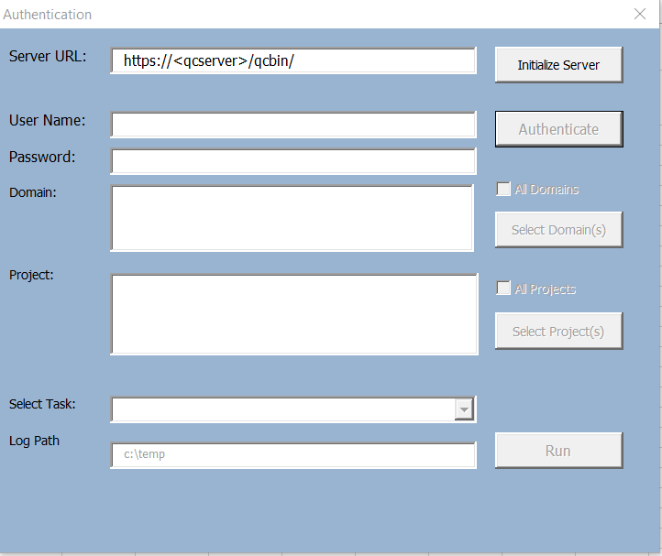
- Enter the ALM URL and authentication credential. You will need a user with Customization permission in order to add list items to the project.
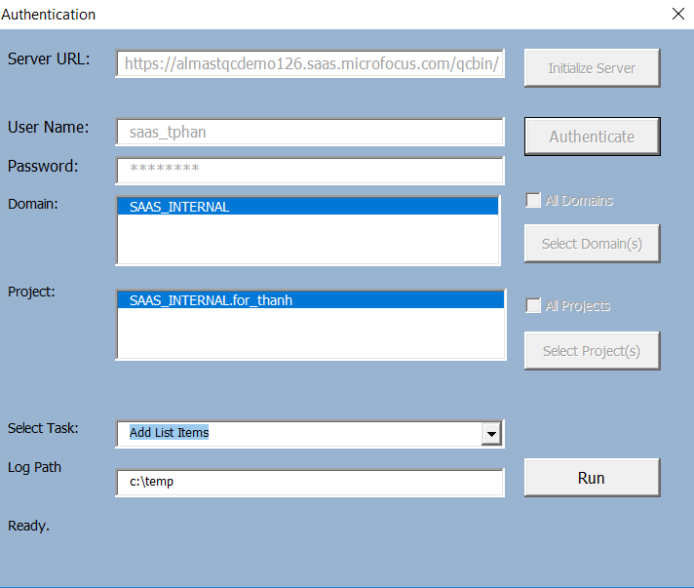

- Click on Run button. Customization dialog button will appear.
- In “Lookup List Name”, specify the list you want to modify.
Example:
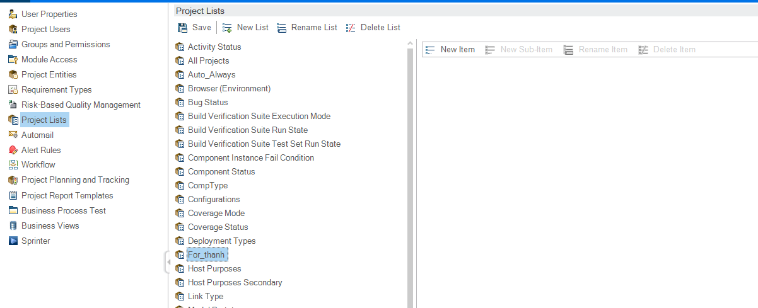
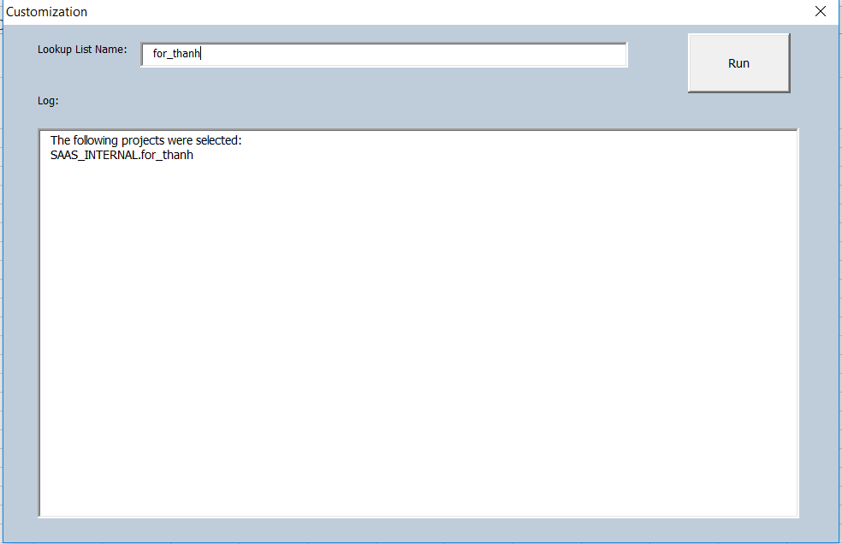

- Click on “Run” button to execute. Log will display actions taken.
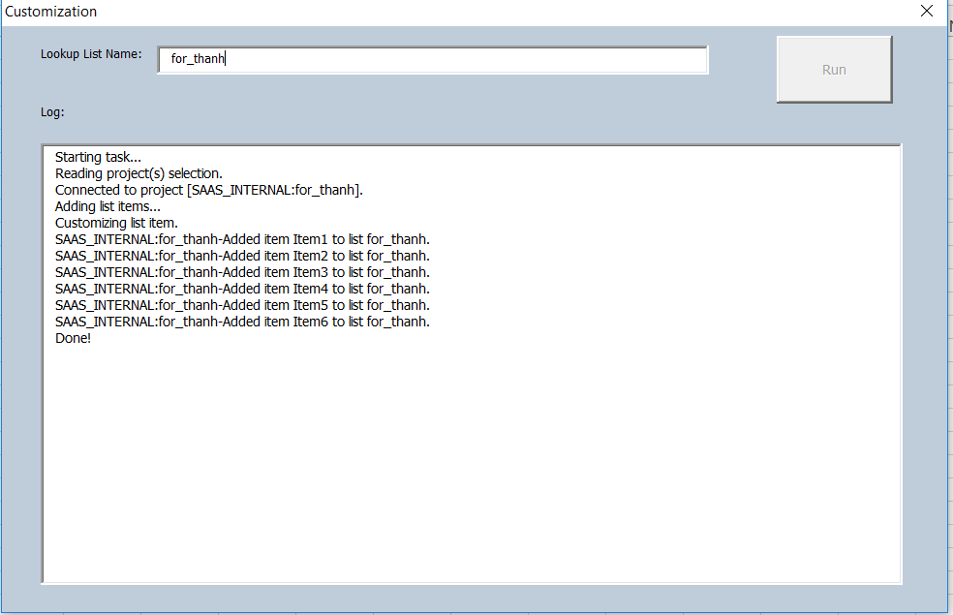

- Review customization in ALM project.
