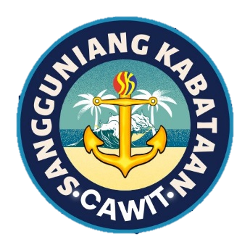

REPUBLIC OF THE PHILIPPINES
Province of Sorsogon
Municipality of Casiguran
4702
BARANGAY CAWIT

What: Third Sangguniang Kabataan Meeting for 2025
When: February 10, 2025
Where: Cawit Barangay Health Center at Second floor, Brgy. Cawit Casiguran Sor.
Time starts: 8:00 P.M
Time end: 9:00 P.M

Presiding Officer:
SK Chairperson: Mariane Habolin

Agenda:

- Release of SK LEAP
- Seminar of SK Chairperson and SK Treasurer

Attendees:

SK Chairperson: Mariane Habolin
SK Members:
- Diane Lagata
- John Michael Bunao
- Mildred Matuba
- Klarenz Luis Habal
- Aila Marie Matuba
- Charles Bocaya
- Randel Grefalda

Others:
- Rongie H. Murallos – SK secretary
- Desiree Doctor – SK treasurer

(No Absent)

At 8:00 P.M: The meeting started with a prayer led by SK member, Diane Lagata.

First Agenda: Release of SK LEAP
The SK Council has decided to release cash assistance to all beneficiaries of the SK LEAP program this February. The SK chairperson will meet with all beneficiaries to discuss important matters and the requirements necessary for them to receive their cash assistance.
As part of the new rules that need to be implemented, beneficiaries will be required to participate in activities such as tutoring day care students or assisting teachers at the day care center. Beneficiaries will be organized into groups, with each group consisting of three members. Additionally, a detailed documentation report will be required to ensure compliance with these new rules.

Second Agenda: Seminar of SK Chairperson and SK Treasurer
All SK chairpersons and SK treasurers of Casiguran are encouraged to participate in the upcoming seminar in Baguio City. This seminar aims to enhance the skills of SK leaders. The expenses for this seminar will be deducted from the supplemental fund of SK. The SK Council has agreed to this arrangement.

Meeting Adjourned by 9:00 P.M

Prepared by: Noted by:

Rongie H. Murallos Mariane B. Habolin
SK Secretary SK Chairperson

CONCURRED BY:

HON. DIANE H. LAGATA HON. KLARENZ LUIS HABAL
SK MEMBER SK MEMBER

HON. MILDRED H. MATUBA HON. JOHN MICHAEL Q. BUNAO
SK MEMBER SK MEMBER

HON. RANDEL O. GREFALDA HON. AILA MARIE MATUBA
SK MEMBER SK MEMBER

HON. CHARLES L. BOCAYA
SK MEMBER

