Sangguniang Kabataan Information Management System for Barangay Cawit

Ayala Kate
Fucio Ellamae Jade
Murallos Rongie Saule Yssaliah

- Background
Context and Relevance

Across many barangays, Sangguniang Kabataan (SK) records and communications still rely on paper files and scattered messages, which slows updates, increases errors, and makes it hard to share information when decisions are needed. In Barangay Cawit, tasks like posting announcements, showing SK achievements, collecting feedback, profiling KK members, organizing minutes and budget files, and tracking purchased items create heavy paperwork and fragmented data flows.

This proposal introduces a web-based SK Information Portal designed around three parts. First, a public webpage lets KK members see announcements and SK achievements, send feedback or suggestions, and submit KK profiling forms using one-time unique codes to keep submissions valid. Second, a secure SK council dashboard allows officials to log in with their account; upload and organize files under clear labels (Budget, Minutes of Meeting, Purchase Papers, Others); add, edit, or delete announcements and achievement photos; maintain an inventory of purchased items; view KK profiles with real-time updates; and download KK data in CSV for reporting; Generates codes and Manage feedbacks and suggestions. Lastly, the Admin dashboard where can do all including account management and activity logs.

By moving from paper processes to a structured, searchable, and role-based web system, the SK can find accurate records faster, keep documents organized and protected, and maintain clear public communication. More than an administrative update, this web-based approach improves data quality, speeds up service delivery, strengthens accountability through activity logs and labeled records, and invites direct youth participation via feedback and streamlined KK profiling, supporting inclusive, efficient, and trustworthy community engagement online.

Targeted Sustainable Development Goals

Primary SDG: Organization and Efficiency
This research aims to help SK officials to organize data and information for easy sharing and retrieval. Organizing data reduces the risk of losing information and having scattered documents in the workplace.

Secondary SDG: Environmental Sustainability
The proposed system aims to provide environmental sustainability that significantly decreases the paper usage contributing to consumption patterns, lower carbon footprints through reduced physical transportation for document sharing and storage and optimizing resource allocation through better data management and program coordination.

Existing Challenges

  - Manual Record Handling - Paper-based systems are prone to errors, loss, and inefficiency.
  - Data Fragmentation - Information scattered across different sources and formats.
  - Less Accessibility - Difficulty in retrieving and sharing information quickly.

Opportunities and Proposed Approach

Opportunities

- Unified youth services: A single web portal for announcements, SK achievements, feedback, and KK profiling reduces paper, walk-ins, and delays.
- Clean, exportable records: Labeled documents, KK profiles, and CSV exports speed up reporting and coordination.
- Trust and accountability: Public updates plus internal audit logs improve transparency and oversight.

Proposed approach

- Three-part web architecture:
  - Public portal (KK): Announcements, achievements, feedback form, and KK profiling secured by one-time submission codes.
  - Admin dashboard (SK): Account login; manage announcements/achievements; upload and label files (Budget, Minutes, Purchase Papers, Others); inventory; KK profiles; CSV export; Generate Codes; Manage Feedback & Suggestions; activity logs and manage user accounts.
  - SK dashboard (SK council): Account login; manage announcements/achievements; upload and label files (Budget, Minutes, Purchase Papers, Others); inventory; KK profiles; CSV export; Generate Codes and Manage Feedback & Suggestions.

- What’s novel
  - Code-based verification: One-time codes for KK submissions.
  - Purpose-built labeling: SK-specific categories and fast search make files easy to find and audit.
  - Transparency by design: Public pages plus activity logs and versioning provide visibility with minimal overhead.

Discussion of Areas

  - Normalization - To avoid redundancy and provide consistency along with the ACID properties. Applying normalization across the system ensures system reliability across different challenges and future workloads.
  - Storage and Memory - To maintain security and efficiency of data inside the system, this includes different documents and other materials. Keeping data in a well-established system to avoid data loss and data fragmentation across the workplace.

  - Database Security and Privacy - Developing a system with consistent security and privacy for the data inside the system. This ensures authorized access for SK official members, to keep all information safe and available.
  - Optimization and Performance- Developing a system with fast and efficient performance that allows users to navigate the system easily with faster optimization and performance.

II. Introduction of the Proposed System

The Barangay Cawit SK Information Portal is a web-based, role-aware information management system that centralizes announcements, SK achievements, KK profiling, document handling, and inventory. It comprises four primary components:

- Public Engagement Portal
A mobile-friendly web interface where KK members can view announcements and SK achievements, submit feedback, and complete KK profiling using one-time submission codes. Forms apply server-side validation and rate limiting to ensure clean, authentic entries.
- Secure SK Dashboard
An authenticated workspace for SK officials using credentials, enabling management of announcements and achievements, labeled document uploads (Budget, Minutes of Meeting, Purchase Papers, Others), inventory tracking, KK profile viewing, and one-click CSV exports for reports, generate codes and manage feedback and suggestions.
- Data and Storage Layer
A relational database for structured records (KK profiles, content, inventory, file metadata, users/roles, audit logs) with normalized schemas and transactional consistency, paired with object storage for uploaded files (PDFs/images) using content hashes, labels, and lifecycle policies.
- Audit and Export Services
Background processes that capture detailed activity logs (create/edit/delete/download), generate signed download links, and produce filtered CSV exports. Periodic integrity checks verify file hashes to ensure tamper-evidence and reliable reporting.

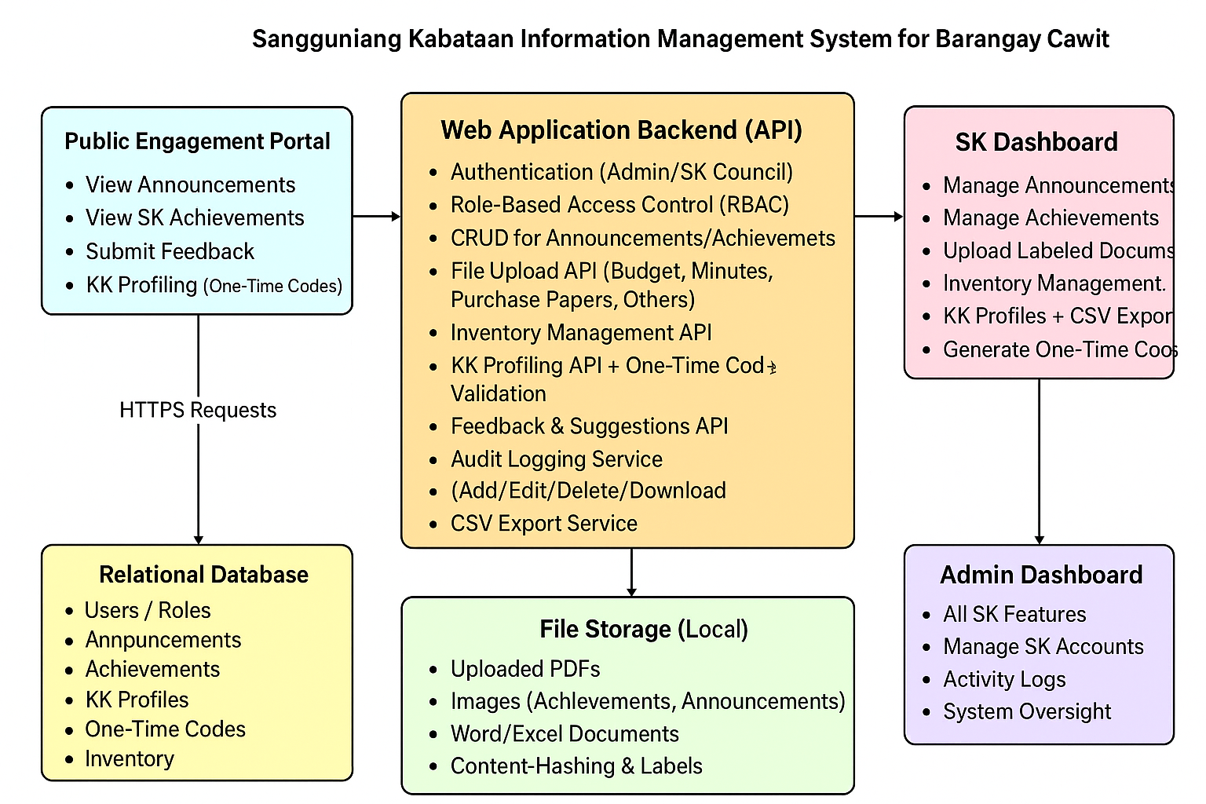

The system runs in a standard three-tier web architecture: responsive front ends, a stateless API enforcing validation and role-based access, and a durable data layer. What differentiates this solution is its code-based verification for KK submissions (simple, secure, low-overhead), SK-specific labeling for documents that mirror real workflows, and transparency-by-design through public pages combined with internal audit logs and immediate CSV reporting.

III. General Objectives

Primary Objective:
To design and implement a centralized SK Information Portal that streamlines announcements, document handling, KK profiling, and inventory management for Barangay Cawit.

Secondary Objectives:
- To enhance transparency and accountability through labeled records, audit logs, and accessible public updates.
- To improve data accuracy and efficiency by replacing paper-based processes with a secure, structured database system.
- To promote environmental sustainability by reducing paper usage and minimizing manual document handling.

IV. Scope and Limitations

Scope

- Public portal features: Shows announcements and SK achievements, accepts feedback, and lets KK members fill out a profiling form using a one-time code for security.
- SK dashboard features: SK officials log in with credentials to post or edit announcements and photos, upload labeled documents (Budget, Minutes, Purchase Papers, Others), manage inventory, view KK profiles, and download KK data as CSV, generate codes and answer feedback or suggestions.
- Data integrity and security: Uses a structured database for records, role-based access, and an audit log for every add/edit/delete/download.
- Usability: Public pages work well on phones; forms are accessible, with clear required fields and helpful error messages.

Limitations

- Limited to SK barangay Cawit, Casiguran Sorsogon only.
- Can upload one image at a time only.
- Many tables which is not good to cellphone size.
- No batch deletion in generated codes and activity logs.
- It only allows PDF, Word, Excel, Images with maximum 10MB.
- Notifications: emails, or push alerts; all updates are shown inside the website.
- Offline use: Needs internet to work; no offline mode or automatic syncing when the internet returns.
- The SK council images and information in landing page are hardcoded.
- Compliance: Follows privacy-by-design practices, but no formal compliance audits or full legal policy rollouts are included in the prototype.
- CSV has no logo in KK profile; it needs manual insertion.
- It only allows JPG, PNG, GIF. Max size: 5MB in adding announcement.

