

TARGET ENRICHMENT PROTOCOL
Single-Capture
&
Double-Capture

Using SureSelect XT HS2 DNA kit (Agilent Technologies)
DNA Library Preparation and Target Enrichment for Illumina Paired-End Multiplexed Sequencing

Prepared by: VERO
Updated: 02/06/2025
Based on Agilent Technologies protocols
VERO notes and alterations in blue text

Overview of the Workflow

The SureSelect XT HS2 DNA workflow is summarized in Figure 1.

Figure 1. Overall target-enriched sequencing sample preparation workflow.
- To prevent contamination of reagents by nucleases, always wear powder-free laboratory gloves and use dedicated solutions and pipettors with nuclease-free aerosol-resistant tips.

- Use best-practice to prevent PCR contamination of samples throughout the workflow.

- Assign separate pre-PCR and post-PCR work areas and use dedicated equipment, supplies, and reagents in each area. In particular, never use materials designated to post-PCR work areas for pre-PCR segments of the workflow.

- Clean pre-PCR surfaces that pose the highest risk of contamination daily using a 10% bleach solution, or RNase Away.

- Always use dedicated pre-PCR pipettors with nuclease-free aerosol-resistant tips to pipette dedicated pre-PCR solutions.

- Wear powder-free gloves. Use good laboratory hygiene, including changing gloves after contact with any potentially contaminated surfaces.

- Several reagent solutions used in the SureSelect XT HS2 protocols are highly viscous. Make sure to follow the mixing instructions provided in the protocols.

- For each protocol step that requires removal of tube cap strips, reseal the tubes with a fresh strip of domed caps. Cap deformation may result from exposure of the cap strips to the heated lid of the thermal cycler and from other procedural steps. Reuse of strip caps can cause sample loss, sample contamination, or imprecision in sample temperatures during thermal cycler incubation steps.

- Possible stopping points, where samples may be stored at 4°C or –20°C, are marked in the protocol. Do not subject the samples to multiple freeze/thaw cycles.

- ONLY use DOMED lids on strip caps during Hybridization/Capture. Extra lid space is needed to ensure proper mixing during 30-minute vortex step. Reaction will not fit in a standard 96-well plate for this step. Flat caps result in a much weaker reaction. Orbital shaking is important. The BioShaker XP Plate Mixer (Bull-dog Bio, Portsmouth, NH) used in this protocol.

- Flat strip caps may be used instead of domed strip caps for steps performed outside of the hybridization/capture segment of the protocol.
This section describes the steps to prepare, quantify, qualify, and fragment input DNA samples prior to SureSelect XT HS2 library preparation and target enrichment. The following protocol is for mechanical shearing of DNA using the Covaris M220 or ME220.

Step 1. Prepare and analyze quality of genomic DNA
- Prepare high-quality gDNA using Qiagen’s PowerSoil Pro DNA extraction kit (automated with QIAcube Connect) following the manufacturer’s protocol.
- Use the Qubit 1X dsDNA, high sensitivity Assay Kit (Thermo Fisher Sci, Q33231) to determine the concentration of each gDNA sample.

Step 2. Fragment the DNA
Mechanical DNA shearing using Covaris M220 or ME220

Note: Shearing protocols have been optimized using a Covaris model M220 and ME220 instruments with the 55μL Covaris microtube or 8 microTUBE-50 AFA Fiber H-Slit Strip V2 (55μL). Consult the manufacturer’s recommendations for use of other Covaris instruments or sample holders to achieve the desired target DNA fragment size.

M220 Protocol:
- Set up the Covaris instrument. Refer to the instrument user guide.
  - Check that the water in the Covaris tank is filled with fresh deionized water to the appropriate fill line level according to the manufacturer’s recommendations.
Note: Water must cover the visible glass part of the Covaris tube.
  - Select the pre-programmed Covaris 250-350bp program. Verify shearing parameters are correct.
Peak Incidence Power=75W
Duty Factor=20%
Cycles Per Burst=200
Temperature= min 4°C max 8°C
Treatment time=100s
(55μL Covaris microTubes hold 56L)
- Prepare the DNA samples for shearing by diluting 2000ng of each sample with 1X Low TE buffer (10 mM Tris-HCl, pH 7.5-8.0, 0.1 mM EDTA) to a final volume of 56μL. Vortex well to mix, then spin briefly to get liquid off the sides of the tubes. Keep the samples on a cold block.

Note: Do not dilute samples to be sheared with water, as it reduces the overall library prep yield.

Note: Can safely shear 600ng-5µg genomic DNA in 1 shear volume. 600ng is the minimum due to ~50% expected losses after shearing and SPRI bead clean. Will need 250ng sheared and cleaned DNA to begin library prep.

- Complete the DNA shearing steps below for each of the samples:
  - Transfer the full 56μL DNA sample to a Covaris microTUBE-55, using a tapered pipette tip to slowly transfer the sample through the pre-split septum of the cap.
  - If necessary, spin down the tube to collect liquid at bottom and remove any bubbles.
Caution: Glass MicroTUBEs break easily. Make sure tube is very secure in centrifuge and counter balanced. Lab tape ‘safety belt’ is highly recommended. Spin down usually not needed at this step.

  - Secure the tube in the tube-holder and shear the DNA using the pre-selected (250-350bp) program.
  - After shearing is complete, remove the MicroTUBE to the MicroTUBE Prep Station.
  - Insert a pipette tip through the pre-split septum and slowly remove the 56μL sheared DNA to a clean 1.5mL microcentrifuge tube (or well of a strip tube or 96-well plate). If less than 56μL is recovered measure and record the volume. Keep samples on ice.
Note: The MicroTUBE cap can also be carefully unscrewed to aid in sample removal.
Note: If needed, the MicroTUBE can spin down briefly to collect any missing volume.
Caution: Glass MicroTUBEs break easily. Make sure tube is very secure in centrifuge and counter balanced. Lab tape ‘safety belt’ is highly recommended.

Note: It is important to avoid loss of DNA at this point. Visually inspect the shearing tube to be certain all DNA has been recovered. If droplets remain, repeat step e.

ME220 Protocol
- Set up the Covaris instrument. Refer to the instrument user guide.
- ME220 motion system must be initialized, and a method (350bp continuous) must be selected.
- The proper rack, consumables and waveguide must be in place.
- Water must be at the level required by consumables and within the acceptable min and max limits. The safety cover must be closed.
Verify shearing parameters are correct.
Temperature=12°C
Peak Incidence Power=50W
Duty Factor=20%
Cycles Per Burst=1000
Duration=100s-140s
Note: VERO start a new project with 100s and increase by 10s up to 140s if peak bp larger than 350bp.
Note: Expect ME220 to work well with 100s duration to begin with and then usually drifts to resulting in higher bp size peaks. Adjusting duration up to 140s results in peaks within the expected size range.
8 microTUBE-50 AFA Fiber H-Slit Strip V2 (55µL) wells hold 56μL
- Prepare the DNA samples for shearing by diluting 2000ng of each sample with 1X Low TE buffer (10 mM Tris-HCl, pH 7.5-8.0, 0.1 mM EDTA) to a final volume of 56μL. Vortex well to mix, then spin briefly to get liquid off sides of tubes. Keep the samples on a cold block.

*Note: Do not dilute samples to be sheared with water, as it reduces the overall library prep yield.

Note: Can safely shear 600ng-5µg genomic DNA in 1 shear volume. 600ng is the minimum due to ~50% expected losses after shearing and SPRI bead clean. Will need 250ng sheared and cleaned DNA to begin library prep.

- Complete the DNA shearing steps below for each of the samples:
- Transfer the full 56µL of 8 diluted DNA samples to each well of the 8 microTube-50, using a tapered pipette tip to slowly transfer each sample through the pre-split septum of each cap.
- Secure the microtube strip in the rack. The 8 microTUBE strip is fitted to its rack as a unit. Open the hinged rack and insert the 8 microTUBE strip. The strip is keyed to fit the rack in the correct orientation.
- Place the strip tube and rack assembly into the ME220 sample tray. Rotate the weight 90° counterclockwise and lower onto the sample tubes.
- Run the selected method.
- Once the shearing method is complete, remove the rack from the sample holder and place it on a clean, dry surface. Remove the waveguide.
- Insert a pipette tip through the pre-split septum of each strip tube well, slowly remove the sheared DNA to a fresh strip tube.
- Transfer the volume of sheared DNA (56μL). If less than 56μL is recovered measure the volume and record. Keep samples on ice.
VERO: If using a multichannel pipette to recover sheared DNA, aim for a lower volume than 56μL such as 53μL that can equally be recovered from all wells. Recovering an equal volume of sheared samples will enable an equal volume of SPRI beads to be added in the next step. Aim for the highest volume possible that can be removed equally from all 8 wells at once.

Step 3. Purify the sheared DNA

Bead clean with Mag-Bind TotalPure NGS beads
- Verify that the Mag-Bind TotalPure NGS beads have been sitting at room temperature for at least 30 minutes.
- Prepare 500μL of fresh 80% ethanol per sample for use in step 8.
Note: The freshly prepared 80% ethanol may be used for all purification steps run on
the same day.
- Mix the room temperature MAG-BIND TOTALPURE NGS bead suspension well (vortex at least 10-20 seconds) so that the reagent appears homogenous and consistent in color.
- VERO: Use SPRI beads at a 0.84 ratio to selectively bind larger DNA fragments. If the full 56μL of sheared DNA was recovered, add 47μL of the bead suspension to the sample well. Refer to the project spreadsheet for calculation of volume of beads needed for each sample.
- Mix by pipetting up and down 15-20 times or cap the wells and vortex at high speed for 5-10 seconds then spin briefly to collect the samples, being careful not to pellet the beads.
- Incubate the bead suspensions for 5 minutes at room temperature.
- Put the plate or strip tube into a magnetic separation device. Wait for the solution to clear. (approximately 5-10 min).
- With the samples still on the magnetic stand, carefully remove and discard the cleared solution from each well. Do not touch the beads while removing the solution.
- While keeping the samples on the magnetic stand, dispense 200μL of freshly prepared 80% ethanol to each sample well. Pipette the stream of EtOH directly onto the wall of the well where the beads are clustered.
- Wait ~1 min to allow any disturbed beads to settle, then carefully remove the ethanol.
- Repeat steps 8 and 9 once for a total of two washes.
- Seal the wells with strip caps, then briefly spin the samples to collect the residual ethanol. Return the samples to the magnetic stand for 30 seconds. Remove the residual ethanol with a P20 or P10 pipette.
Note: In the drying step below, do not dry the bead pellet to the point that the pellet
appears cracked. Elution efficiency is significantly decreased when the bead
pellet is excessively dried.
- Dry the samples briefly by leaving the wells unsealed at room temperature for 2-3 minutes.
- Elute the DNA by adding 52μL of nuclease-free water to each sample well.
- Mix by pipetting up and down 10–15 times or cap the wells and vortex at high speed for
5 seconds. Verify that all beads have been resuspended, with no visible clumps in the
suspension or bead pellets retained on the sides of the wells. If samples were vortexed, spin
briefly to collect the liquid, being careful not to pellet the beads.
If the bead pellet was over dried and showing cracks, the beads can usually be resuspended with some extra pipetting and/or vortex to mix the nuclease-free water and beads back to a homogenous suspension.
- Incubate the plate or strip tubes for 2 min at room temperature.
- Put the plate or strip tube in the magnetic stand and leave until the solution is clear (up to 5 minutes).
- Remove the cleared supernatant (approximately 52μL) to a fresh plate or strip tube and keep on ice or cold block. You can discard the beads at this time.

Step 4. Assessing quality and quantity of DNA
Quantify 1μL of purified sheared DNA using TapeStaion 4200 (Agilent), D5000 screentapes.
Note: For best results ensure that all reagents are allowed to equilibrate to room temperature
for 30 min prior to use.

- Prepare the samples as instructed in the reagent kit guide. Combine 10μL of D5000 sample buffer with 1μL of sheared and cleaned sample. Vortex to mix using IKA vortexer and adaptor at 2000 rpm for 1 min. Use lab tape to safely ‘seatbelt’ in plates or strip tubes.
- Load the prepared TapeStation plate or strip tubes, D5000 screentapes, ladder prepared in a strip tube if using a 96 well plate for samples, and TS loading tips as instructed in the reagent user guide. Start the run.
Note: If using the TapeStation 4200 for 15 samples or less, samples and ladder can be set up in strip tubes rather than a 96 well plate.
- Verify that the electropherogram shows the expected DNA fragment size peak position.

STOPPING POINT: If you don’t want to continue to the next step, seal the sample wells and store at 4°C overnight, or at -20°C for extended periods.

Note: Samples that are sheared and cleaned can be set up in strip tubes or a 96 well plate prior to library prep and stored at -20°C until ready for processing. In a fresh well of a PCR plate, dilute each sample to 250ng of DNA with nuclease-free water to a final volume of 50μL.

This section describes the steps to prepare NGS libraries from gDNA fragments for sequencing using the Illumina paired-end platform. Libraries are prepared using adaptors that include molecular barcodes (MBCs). After adaptor ligation, the libraries are amplified using dual indexing primers. For each sample to be sequenced, an individual dual-indexed library is prepared.

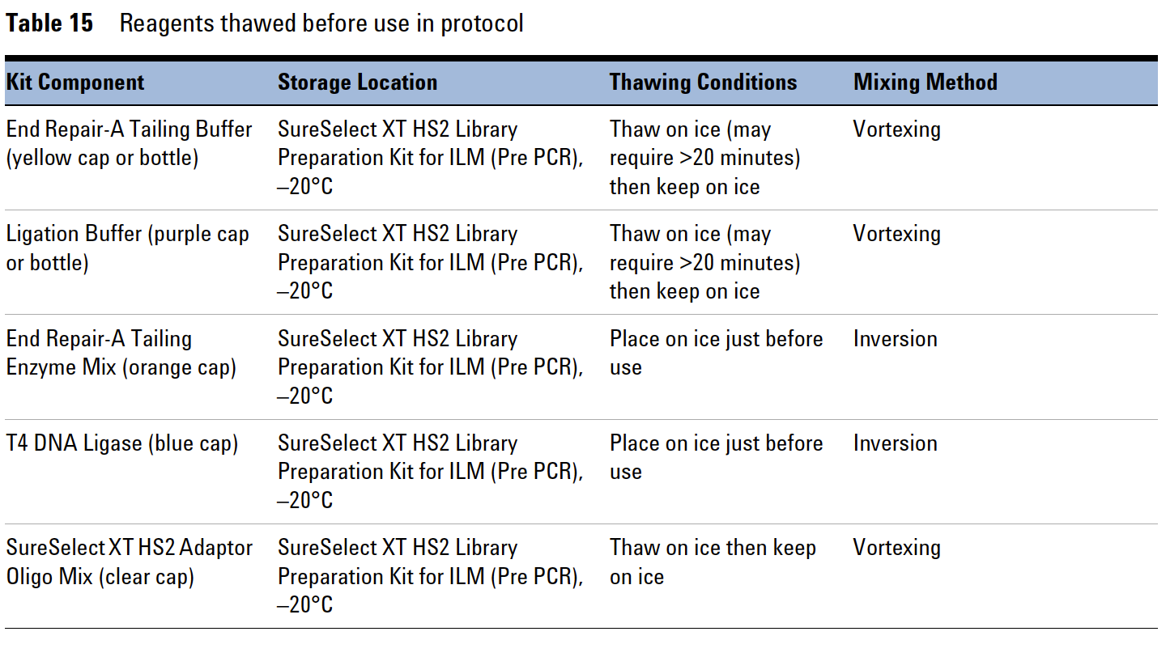

Step 1. Prepare the Ligation master mix

Prepare the Ligation master mix to allow equilibration to room temperature while the end repair/dA-tailing step is completing. Leave DNA samples on ice while completing this step.

Caution: The Ligation Buffer used in this step is viscous. Make sure to follow the mixing instructions in step 1 and step 2 below.

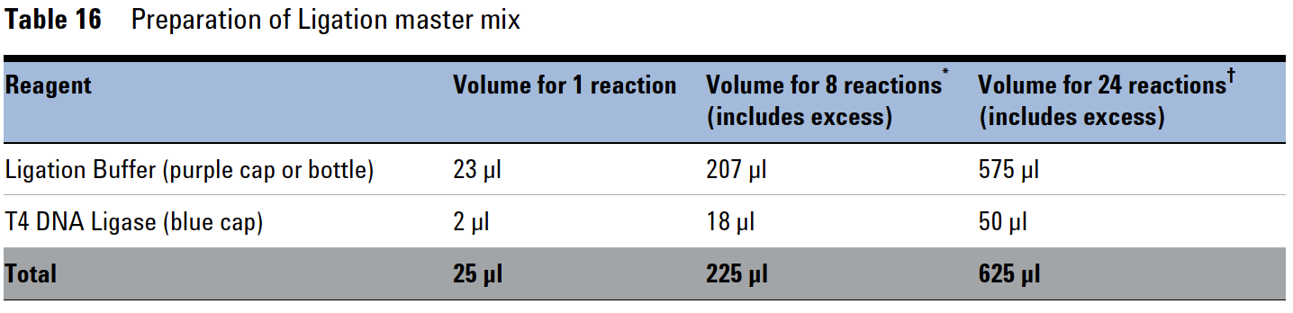

- Vortex the thawed vial of Ligation Buffer for 15 seconds at high speed just before use.
- Prepare the appropriate volume of ligation master mix by combining the reagents in Table 16.
VERO: High throughput with 2-48 samples. To calculate enough master mix overage, multiply the number of samples being prepped by 1.1. For ex. if 10 samples are being prepped, multiply the volume of reagent required for 1 reaction from Table 16 by ‘11’ rather than the actual 10 samples to maintain enough master mix for multiple pipette additions. Refer to VERO Master Mix Calculator. Inexperienced pipettors may need to increase by 1.2 or 1.3.

Slowly pipette the Ligation Buffer into a 1.5-mL tube, ensuring that the full volume is
dispensed. Slowly add the T4 DNA Ligase, rinsing the enzyme tip with buffer solution after
addition. Mix well by slowly pipetting up and down 15–20 times or seal the tube and vortex at
high speed for 10–20 seconds. Spin briefly.

Note: Use flat top vortex mixers when vortexing strip tubes or plates throughout the protocol. If reagents are mixed by vortexing, visually verify that adequate mixing is occurring.

Keep at room temperature for 30-45 minutes before use. ERAT thermal cycling program takes ~30min.

Step 2. Repair and dA-tail the DNA 3’ends (ERAT)

Use the previously set up strip tubes or 96 well plate of 250ng sheared and cleaned gDNA in a final volume of 50μL nuclease-free water.

Caution: The End Repair-A Tailing Buffer used in this step is viscous. Make sure to follow the mixing
instructions in step 2 and step 3.

- Select and start the thermal cycler program for ERAT. Cycling conditions are provided in Table 17. Start the program. Immediately pause and keep paused until samples are loaded in step 5.

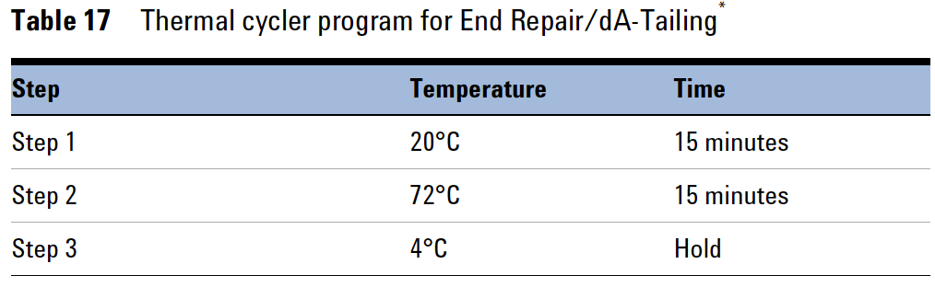
*When starting the program select tube, not block, and set reaction volume to 70μL.

- Vortex the thawed vial of End Repair-A Tailing Buffer for 15 seconds at high speed to ensure homogeneity. Visually inspect the solution; if any solids are observed, continue vortexing until all solids are dissolved.

- Prepare the appropriate volume of ERAT master mix calculated in Table 18.
VERO: High throughput with 2-48 samples. To calculate enough master mix overage, multiply the number of samples being prepped by 1.1. For ex. if 10 samples are being prepped, multiply the volume of reagent required for 1 reaction from Table 18 by ‘11’ rather than the actual 10 samples to maintain enough master mix for multiple pipette additions. Refer to VERO Master Mix Calculator. Inexperienced pipettors may need to increase by 1.2 or 1.3.
Slowly pipette the End Repair-A Tailing Buffer into a 1.5-mL tube, ensuring that the full volume is dispensed. Slowly add the End Repair-A Tailing Enzyme Mix, rinsing the enzyme tip with buffer solution after addition. Mix well by pipetting up and down 15–20 times or seal the tube and vortex at high speed for 5–10 seconds. Spin briefly to collect liquid and keep on ice.

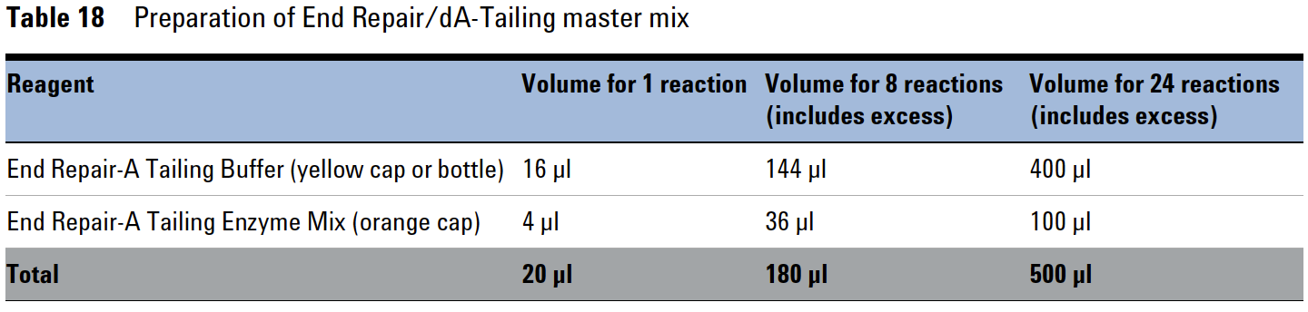
* If Sequins used - sequins are spiked into the ERAT master mix at a selected concentration as noted in Master Mix Calculator spreadsheet. (0.17pg/sample for resp swabs, 1.7pg/sample for fecal samples).

- Add 20μL of the end repair/dA-tailing (ERAT) master mix to each sample well containing 250ng of DNA in a 50μL volume. Mix by pipetting 15-20 times with a pipette set to 50μL or cap the wells and vortex at high speed for 5-10 seconds.

- Briefly spin the samples, then immediately place the plate or strip tube in the thermal cycler and resume the ERAT thermal cycling program in Table 17.

Step 3. Ligate the molecular-barcoded adaptor

- Once the thermal cycling program from Table 17 reaches the 4°C Hold step, transfer the samples to ice (or a cold block). Preprogram the cycler as shown in Table 19; pause until use in step 4.
Start the ligation protocol on the thermal cycler. Immediately pause the program and keep paused until samples are loaded in step 4.

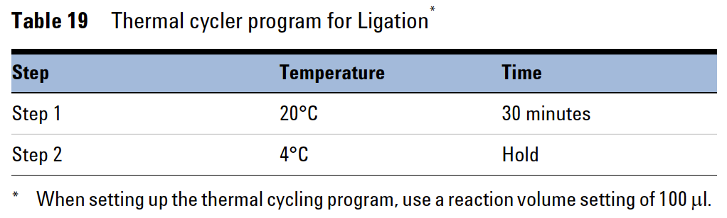

- To each end-repaired/dA-tailed (ERAT) DNA sample (~70μL), add 25μL of the ligation master mix that was prepared in Step 1 on page 8 and kept at room temperature. Mix by pipetting up and down at least 10 times or cap wells and vortex for 5-10 seconds. Briefly spin the samples.

- Add 5μL of SureSelect XT HS2 Adaptor Oligo Mix (clear-capped tube) to each well containing sample and master mix.
Mix by pipetting up and down 15-20 times or cap the wells and vortex at high speed for 5-10 seconds.

Note: Make sure to add the Ligation master mix and the Adaptor Oligo Mix to the samples in separate addition steps as directed above, mixing after each addition.

- Briefly spin the samples, then immediately place the plate or strip tube in the thermal cycler and resume the thermal cycling program from Table 19.
Upon completion, remove samples and place on a cold block while preparing bead clean.

Note: The SPRI Beads used in the next step must be equilibrated to room
temperature for at least 30 minutes before use.

STOPPING POINT: If you do not continue to the next step, seal the sample wells and store overnight at either 4°C or -20°C.

Step 4. Purify libraries using SPRI Beads
Once the thermal cycler program in Table 19 reaches the 4°C hold step, purify the libraries using
room-temperature Mag-Bind TotalPure NGS (Mag-Bind TotalPure NGS Bio-Tek) or AMPure XP Beads.

- Verify that the Mag-Bind TotalPure NGS beads have been sitting at room temperature for at least 30 minutes.

- Prepare 500μL of fresh 80% ethanol per sample for use in step 8.
Note: The freshly prepared 80% ethanol may be used for all purification steps run on
the same day.
- Mix the room temperature MAG-BIND TOTALPURE NGS bead suspension well (vortex at least 10-20 seconds) so that the reagent appears homogenous and consistent in color.
- Transfer the DNA samples from the thermal cycler to room temperature, then add 80μL of the bead suspension to each sample well.
- Mix by pipetting up and down 15-20 times or cap the wells and vortex at high speed for 5-10 seconds then spin briefly to collect the samples, being careful not to pellet the beads.
- Incubate the bead suspensions for 5 minutes at room temperature.
- Put the plate or strip tube into a magnetic separation device. Wait for the solution to clear. (approximately 5-10 min).
- With the samples still on the magnetic stand, carefully remove and discard the cleared solution from each well. Do not touch the beads while removing the solution.
- While keeping the samples on the magnetic stand, dispense 200μL of freshly prepared 80% ethanol to each sample well. Pipette the stream of EtOH directly onto the wall of the well where the beads are clustered.
- Wait ~1 min to allow any disturbed beads to settle, then carefully remove the ethanol.
- Repeat steps 8 and 9 once for a total of two washes.
- Seal the wells with strip caps, then briefly spin the samples to collect the residual ethanol. Return the samples to the magnetic stand for 30 seconds. Remove the residual ethanol with a P20 or P10 pipette.
Note: In the drying step below, do not dry the bead pellet to the point that the pellet
appears cracked. Elution efficiency is significantly decreased when the bead
pellet is excessively dried.
- Dry the samples briefly by leaving the wells unsealed at room temperature for 2-3 minutes.
- Elute the DNA by adding 35μL of nuclease-free water to each sample well.
- Mix by pipetting up and down 10–15 times or cap the wells and vortex at high speed for
5 seconds. Verify that all beads have been resuspended, with no visible clumps in the
suspension or bead pellets retained on the sides of the wells. If samples were vortexed, spin
briefly to collect the liquid, being careful not to pellet the beads.
If the bead pellet was over dried and showing cracks, the beads can usually be resuspended with some extra pipetting and/or vortex to mix the nuclease-free water and beads back to a homogenous suspension.
- Incubate the plate or strip tubes for 2 min at room temperature.
- Place samples back on the magnetic stand and let sit until the solution has cleared (up to 5 minutes).
- Remove the cleared supernatant (approximately 34μL) to a fresh plate or strip tube and keep on ice or cold block. You can discard the beads at this time.

STOPPING POINT: If you do not continue to the next step, seal the sample wells and store overnight at either 4°C or -20°C.

Step 5. Amplify and index the Pre-Capture libraries

Thaw the reagents listed below and keep on a cold block.
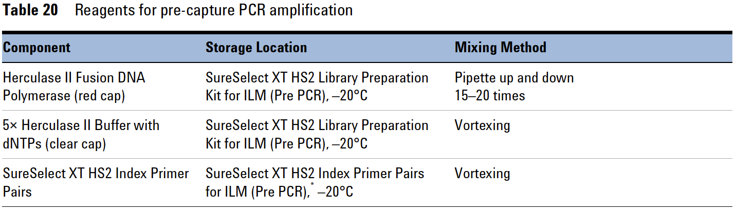
The index primer pairs are in their own 96-well plate. Thaw on a separate cold block.

Note: The indexed primers are what allow us to differentiate samples after sequencing. Make sure they do not cross contaminate, and make sure you know which primer (i.e., A1, B1, etc.) goes with which sample.

- Assign an indexed primer pair to each sample making sure that each sample gets a different primer pair if sequenced in the same lane.

- Start the Pre-Capture PCR protocol on the thermal cycler. Cycling conditions are provided in Table 21. Start the program and immediately pause until samples are loaded.
VERO lab use 6 cycles for Pre-Capture PCR.

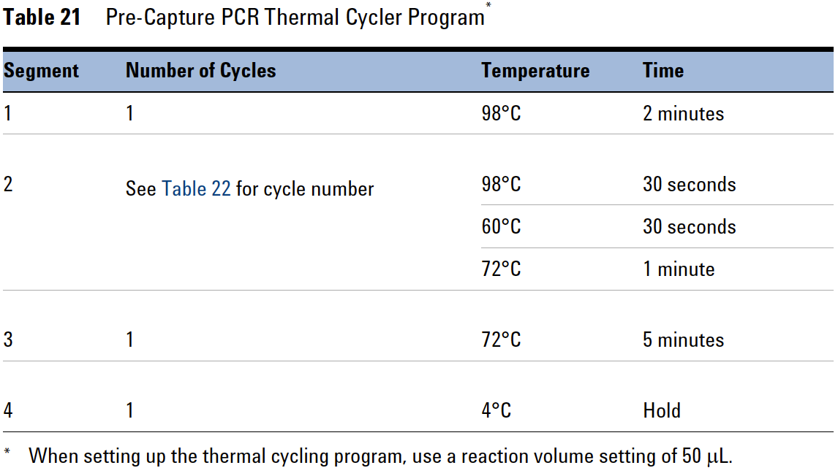

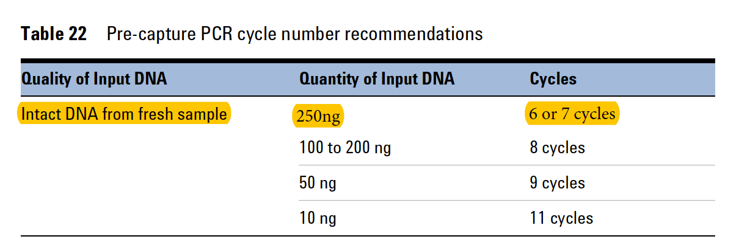
Caution: To avoid cross-contaminating libraries, set up PCR reactions in a dedicated clean area or PCR hood with UV sterilization and positive air flow.

- Prepare the appropriate volume of PreCap PCR master mix, Table 23. Mix well on a vortex mixer and keep on ice.
VERO: High throughput with 2-48 samples. To calculate enough master mix overage, multiply the number of samples being prepped by 1.1. For ex. if 10 samples are being prepped, multiply the volume of reagent required for 1 reaction from Table 23 by ‘11’ rather than the actual 10 samples to maintain enough master mix for multiple pipette additions. Refer to VERO Master Mix Calculator. Inexperienced pipettors may need to increase by 1.2 or 1.3.

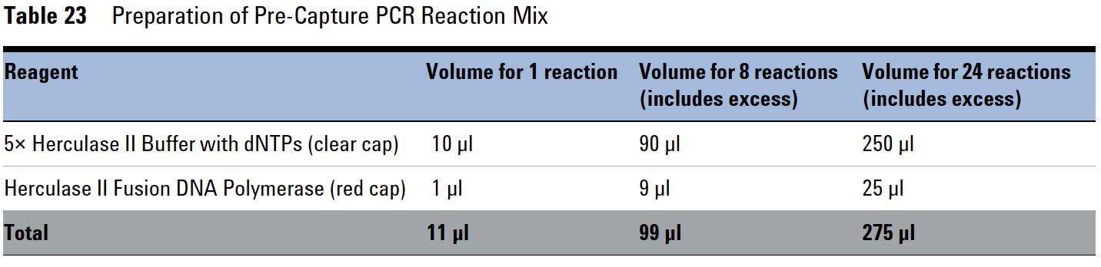

- Add 11μL of Pre-Capture master mix to each sample well containing purified DNA (34μL).

- Add 4.5μL of the appropriate SureSelect XT HS2 Index Primer Pair to each reaction.

Cap the wells, then vortex at high speed for 5 seconds. Spin briefly to collect the liquid and release any bubbles.

- Before adding the samples to the thermal cycler, ensure the block is heated to 98°C. Once the thermal cycler has reached 98°C, immediately place the sample plate or strip tube in the thermal block, close the lid and resume the Pre-Capture PCR.

STOPPING POINT: If you do not continue to the next step, seal the sample wells and store at 4°C overnight or at –20°C for prolonged storage.
Step 6. Purify amplified libraries using SPRI Beads
Once the thermal cycler program in Table 21 reaches the 4°C hold step, purify the libraries using
room-temperature Mag-Bind TotalPure NGS (Mag-Bind TotalPure NGS Bio-Tek) or AMPure XP Beads.
- Verify that the Mag-Bind TotalPure NGS beads have been sitting at room temperature for at least 30 minutes.
- Prepare 500μL of fresh 80% ethanol per sample for use in step 8.
Note: The freshly prepared 80% ethanol may be used for all purification steps run on
the same day.
- Mix the room temperature MAG-BIND TOTALPURE NGS bead suspension well (vortex at least 10-20 seconds) so that the reagent appears homogenous and consistent in color.
- Transfer the DNA samples from the thermal cycler to room temperature, then add 50μL of the bead suspension to each sample well.
- Mix by pipetting up and down 15-20 times or cap the wells and vortex at high speed for 5-10 seconds then spin briefly to collect the samples, being careful not to pellet the beads.
- Incubate the bead suspensions for 5 minutes at room temperature.
- Put the plate or strip tube into a magnetic separation device. Wait for the solution to clear. (approximately 5-10 min).
- With the samples still on the magnetic stand, carefully remove and discard the cleared solution from each well. Do not touch the beads while removing the solution.
- While keeping the samples on the magnetic stand, dispense 200μL of freshly prepared 80% ethanol to each sample well. Pipette the stream of EtOH directly onto the wall of the well where the beads are clustered.
- Wait ~1 min to allow any disturbed beads to settle, then carefully remove the ethanol.
- Repeat steps 8 and 9 once for a total of two washes.
- Seal the wells with strip caps, then briefly spin the samples to collect the residual ethanol. Return the samples to the magnetic stand for 30 seconds. Remove the residual ethanol with a P20 or P10 pipette.
Note: In the drying step below, do not dry the bead pellet to the point that the pellet
appears cracked. Elution efficiency is significantly decreased when the bead
pellet is excessively dried.
- Dry the samples briefly by leaving the wells unsealed at room temperature for 2-3 minutes.
- Elute the DNA by adding 15μL of nuclease-free water to each sample well.
- Mix by pipetting up and down 10–15 times or cap the wells and vortex at high speed for
5 seconds. Verify that all beads have been resuspended, with no visible clumps in the
suspension or bead pellets retained on the sides of the wells. If samples were vortexed, spin
briefly to collect the liquid, being careful not to pellet the beads.
If the bead pellet was over dried and showing cracks, the beads can usually be resuspended with some extra pipetting and/or vortex to mix the nuclease-free water and beads back to a homogenous suspension.
- Incubate the plate or strip tubes for 2 min at room temperature.
- Place samples back on the magnetic stand and let sit until the solution has cleared (up to 5 minutes).
- Remove the cleared supernatant (approximately 15μL) to a fresh plate or strip tube and keep on ice or cold block. You can discard the beads at this time.

STOPPING POINT: Seal the wells and store at 4°C overnight or at –20°C for prolonged storage (remove an aliquot for QC analysis before storage).

Step 7. Assessing quality and quantity of DNA

Analyze 1μL of a five-fold or six-fold dilution of each sample. A six-fold dilution is needed for high biomass samples like feces. All lower biomass samples, such as nasal swabs, reproductive swabs, water bowl swabs, and ropes need a five-fold dilution. This analysis method results in an electropherogram showing the size distribution of fragments in the sample and tools for determining the concentration of DNA in the sample.
The expected average fragment size for pre-capture libraries resulting from mechanical shearing of intact DNA is 350-450bp.

Observation of a low molecular weight peak, in addition to the expected library fragment peak, indicates the presence of primer-dimers in the library. It is acceptable to proceed to target enrichment with library samples for which adaptor-dimers are observed in the electropherogram at low abundance.

Use TapeStation 4200 with D5000 screen tapes and reagents. D1000 screen tapes and reagents can also be used.

Note: For best results ensure that all reagents are allowed to equilibrate to room temperature
for 30 min prior to use.

VERO Pre-Capture library QC with TapeStation 4200:
- Prepare a five-fold or six-fold dilution of each Pre-Capture PCR amplified sample. Use a six-fold dilution for fecal libraries, use five-fold for respiratory and reproductive swabs (low biomass).
Dilute 1μL of each prepared library in 4μL nuclease-free water (5μL total for five-fold dilution).
Dilute 1μL of each prepared library in 5μL nuclease-free water (6μL total for six-fold dilution).
- Prepare the samples as instructed in the reagent kit guide. Combine 10μL of D5000 sample buffer with 1μL of the diluted sample from step 1. Vortex to mix using IKA vortex and adaptor at 2000 rpm for 1 min. Use lab tape to safely ‘seatbelt’ in plates or strip tubes.
- Load the prepared TapeStation plate or strip tubes, D5000 screen tapes, ladder prepared in a strip tube if using a 96 well plate for samples, and TS loading tips as instructed in the reagent user guide. Start the run.
- Verify that the electropherogram shows the expected DNA fragment size peak position, 350-450bp.
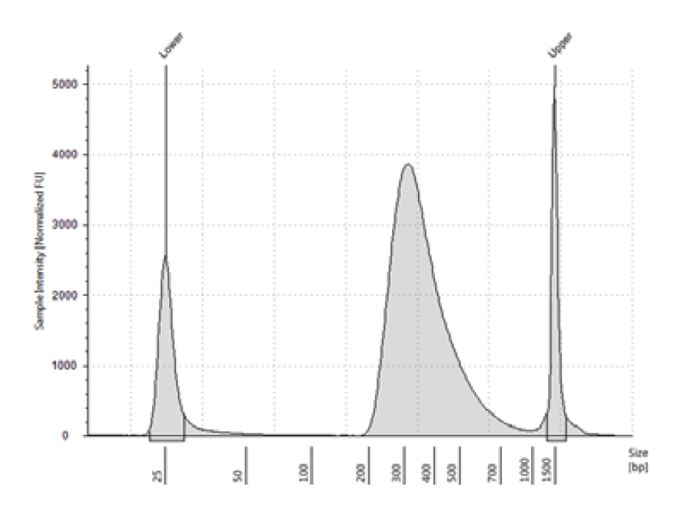
Figure 5. PreCapture library prepared from a sheared high-quality DNA sample as analyzed with a D1000 ScreenTape assay.

STOPPING POINT: If you don’t want to continue to the next step, seal the sample wells and store at 4°C overnight, or at -20°C for extended periods.

Hybridization Set Up
PreCapture libraries can be diluted to 1000ng in 12μL of Nuclease Free water in fresh strip tubes or a PCR plate ahead of time and held at -20°C until ready for the hybridization reaction.
- Calculate how much nuclease-free water is needed to dilute each prepared DNA library sample to 1000ng DNA in 12μL total volume. Add the proper amount of nuclease-free water to a fresh hybridization tube or plate.

- Add 1000ng (or maximum possible) of each sample to the hybridization plate or tubes.
Note: It may be necessary to increase the DNA concentration using a Vacufuge so that there is 1000ng in 12μL or less. If 1000ng is not available for any of the samples, use the maximum amount available with the 500-1000ng range in 12μL volume. VERO has found that using 1600ng input often works well after a failed 1000ng input library. 1200ng input following a failing library outcome with 1000ng input still resulted in a failed library.

In this workflow segment, the prepared gDNA libraries are hybridized with a target-specific probe.
After hybridization, the targeted molecules are captured on streptavidin beads and then
PCR-amplified. Each DNA library sample is hybridized, captured, and amplified individually, prior to
pooling for multiplex NGS.
The standard single-day SureSelect XT HS2 protocol includes the hybridization step immediately
followed by capture and amplification steps. If required, the hybridized samples may be held
overnight with capture and amplification steps completed the following day.
The hybridization reaction uses the maximum amount of prepared library available in the
500–1000 ng range in a volume of 12μL.

Caution: The ratio or probe to prepared gDNA library is critical for successful capture.

Note: The master mix values listed in the protocol represent a full concentration of probes (baits). If performing half-concentration, modify the amount of probe and nuclease-free H₂O accordingly. Follow VERO Master Mix Calculator spreadsheet.

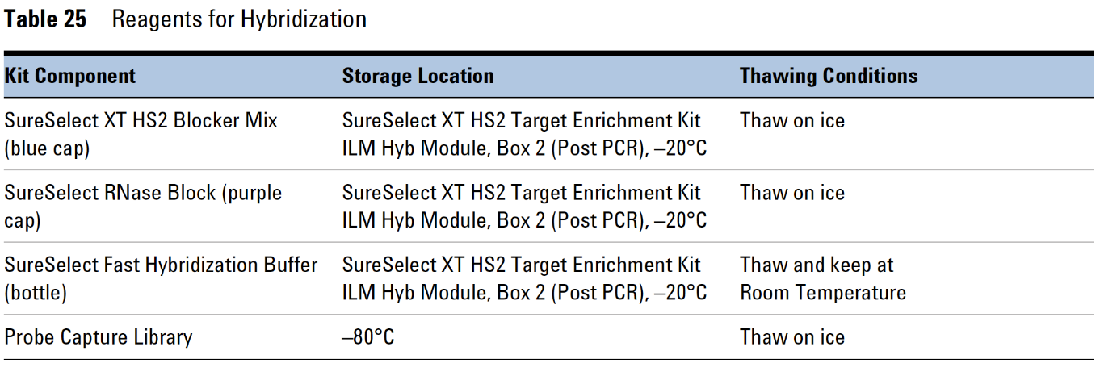

Step 1. Hybridize libraries to the SureSelect Probe

This step uses the components listed in Table 25. Thaw each component under the conditions indicated in the table. Vortex each reagent to mix, then spin tubes briefly to collect the liquid.

- Remove the Pre-Capture library samples that have been diluted to 1000ng in 12μL from -20°C storage. Thaw on cold blocks, vortex and spin down.
- Start the Hybridization protocol on the thermal cycler. Cycling conditions are provided in Table 27. Start the program and immediately hit pause.
- Add 5μL of SureSelect Blocker mix (blue cap) to each sample well, bringing the total volume to 17μL. Seal the wells then vortex at high speed for 5 seconds. Spin briefly to collect the liquid and release any bubbles.
- Place the samples in the thermal cycler and resume the Hybridization thermal cycling program.

IMPORTANT: THE CYCLER NEEDS TO BE MANUALLY PAUSED DURING SEGMENT 3 TO ALLOW ADDITIONAL REAGENTS TO BE ADDED AS DESCRIBED IN STEP 6
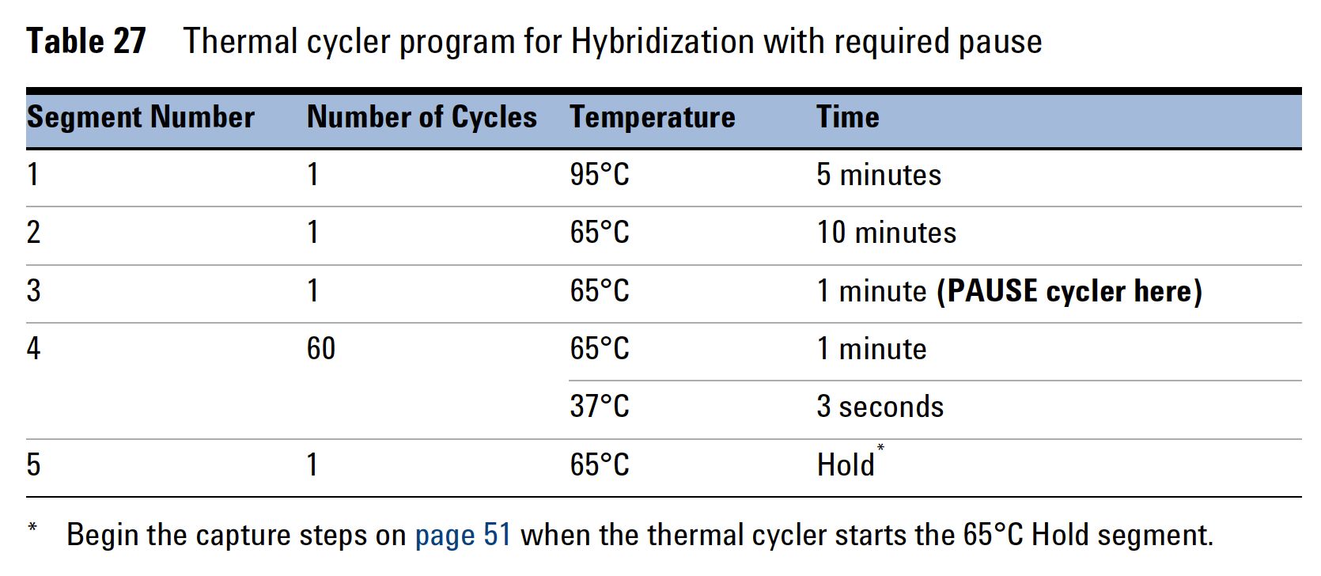
Use a reaction volume setting of 30μL (final volume of hybridization reaction).
*Hold reaction briefly at 65°C until ready to begin capture steps.
Note: Hybridization at 65°C is optimal for probes designed for the SureSelect XT HS2/XT HS/XL Low Input platforms. Reducing the hybridization temperature (Segments 4 and 5) may improve performance for probes designed for the SureSelect XT platform, including SureSelect XT Human All Exon V6 (62.5°C), SureSelect XT Clinical Research Exome V2 (62.5°C) and custom probes originally designed for use with SureSelect XT system (60°C–65°C).

Note: The Hybridization reaction may be run overnight with the following protocol modifications:
•In the final segment of the thermal cycler program, replace the 65°C Hold step with a 21°C Hold step.
•The hybridized samples may be held at 21°C for up to 16 hours. Begin the capture preparation steps on day 2, after the overnight hold.

Note: During segments 1 and 2 of the cycling program (15 minutes total), begin preparing the reagents described in steps 5 and 6. Keep the mixture at room temperature until it is added to the samples, but do not keep it at room temperature for long periods of time (not longer than 15 minutes).
- Prepare the appropriate amount of Capture Hybridization Mix (calculated in the VERO Master Mix Calculator spreadsheet) for the total number of samples, by combining the reagents listed in Table 30. Combine the reagents at room temperature. Mix well by vortexing for 5 seconds then spin down briefly. Proceed immediately to step 6.

*Use tier 3 probes as if design is <3Mb.
Table 30 Preparation of Capture Library Hybridization Mix for Probes <3Mb
Reagent | Volume for 1 Reaction
SureSelect RNase Block | 0.5μL
Probe (design <3Mb) | 2μL
SureSelect Fast Hybridization Buffer | 6μL
Nuclease-free water | 4.5μL
Total | 13μL
If using less than a full concentration of probe, then adjust the volume of water accordingly. Example: for ½ concentration baits use 1μL of probe and 5.5μL of NF water. (Use VERO master mix spreadsheet to calculate volumes).
- Once the thermal cycler starts segment 3 (65°C for 1 minute), pause the program. With the cycler paused, and while keeping the DNA + blocker samples in the cycler, transfer 13μL of the room temperature Probe Hybridization Mix from step 5 to each sample well.
Mix well by pipetting up and down slowly 8-10 times.
The hybridization reaction wells now contain approximately 30μL.
- Seal the wells with fresh domed caps. Vortex briefly, then spin the plate or tubes to remove any bubbles from the bottom of the wells. Immediately return to the thermal cycler.
- Resume the thermal cycling program to allow hybridization of the prepared DNA samples to the probe.

Note: Start preparing the streptavidin beads one hour after starting hybridization (~30-35 minutes before the thermal cycler ends). For large batches allow an hour.

Step 2. Preparing the streptavidin-coated beads

The remaining capture steps use the components listed in Table 31.

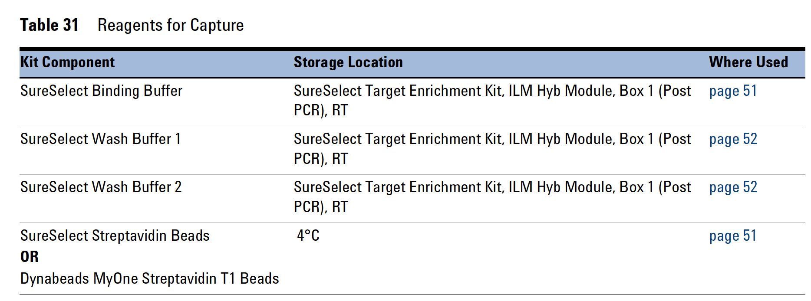

Batch Wash Protocol
- Vigorously resuspend the streptavidin beads with a vortex mixer. The magnetic beads settle during storage.
- For each hybridization sample, 50μL of resuspended beads is required. Add the appropriate volume of beads to a 15mL tube (1.5mL tubes or 50mL tubes can be used for smaller or larger batches or if needed to match the available magnetic separation device). (Follow VERO Master Mix Calculator spreadsheet).
- Calculate how much Binding Buffer needs to be added to the 15mL tube (200μL Binding Buffer per 50μL of beads) to wash the beads. 1.5mL tubes and 50mL tubes can also be used. Mix the binding buffer and the suspended beads by vortexing. Spin briefly.
- Place the tubes in a magnetic separator device.
- Wait until the solution clears (~5 minutes), then remove and discard the supernatant.
- Repeat steps 3-5 two more times for a total of 3 washes.
- Resuspend the beads in binding buffer (200μL per sample) and transfer to fresh strip tubes.
ONLY Use DOMED lids and strip caps during Hybridization/Capture. Extra lid space is needed to ensure proper mixing during 30-minute vortex step. Reaction will not fit in a standard 96-well plate for this step.
Step 3. Capture the hybridized libraries using the streptavidin-coated beads

(strip tubes – with domed lids)
- After all streptavidin bead preparation steps are complete, and the hybridization thermal cycling program is in the final hold segment, transfer samples to room temperature.
- Immediately transfer the entire volume (~30μL) of each hybridization mixture to wells containing 200μL of washed streptavidin beads using a multichannel pipette.
Pipette up and down 5 to 8 times to mix, then cap the tubes with fresh domed caps.
- Incubate the capture strip tube on a plate mixer, VERO use BioShaker XP Plate Mixer (Bull-dog Bio, Portsmouth, NH). Mix vigorously at 1400-1900rpm for 30 minutes at room temperature. Make sure the samples are properly mixing in the wells. Orbital shaking pattern is important for this step. Beads should not be pelleting at the bottom of wells. Consider pausing the mixing to check for pelleting beads if new to protocol or using a different mixer.
- During the 30-minute incubation for capture, prewarm SureSelect Wash Buffer 2 at 70°C as described below.
- Place 200μL aliquots of Wash Buffer 2 in wells of fresh strip tubes or a 96 well plate. Aliquot 6 wells of buffer for each DNA sample in the run.
- Top off wells with extra Wash Buffer 2 to compensate for expected evaporation. Cap the wells.
Note: Wash Buffer 2 can be aliquoted into strip tubes ahead of time.
- Near the end of the 30-min shaking incubation, start the 70°C hold program on the thermal cycler for the 5-minute incubations in the following steps. Prewarm Wash Buffer 2 aliquots to 70°C.
- Following the 30-minute capture incubation, spin samples briefly to collect the liquid.
- Place the strip tubes in a magnetic separator to collect the beads. Wait until the solution is clear (~1-2 minutes), then remove and discard the supernatant.
- Remove samples from magnetic rack and resuspend the beads in 200μL of SureSelect Wash Buffer 1. Mix by pipetting up and down 15-20 times until the beads are fully resuspended.
- Place the strip tubes on the magnetic rack and wait for the solution to clear (~ 1 min), then remove and discard the supernatant.

Caution: It is important to maintain the bead suspension at 70°C during the upcoming washing procedure below to ensure specificity of capture.
- Make sure that the SureSelect Wash Buffer 2 is pre-warmed to 70°C before use.
- Do not use a tissue incubator, or other devices with significant temperature fluctuations, for the incubation steps.

Note: When processing 96 samples at a time. 2 thermal cyclers are needed. 1 thermal cycler to Prewarm 70°C Wash Buffer 2 and 1 thermal cycler for 5-minute 70°C incubations. Split the strip tubes between 2 people to perform washes simultaneously and maintain 70°C.

Note: Prepare Post-Capture Master Mix during 5-minute incubations. Post-Capture Master Mix is needed at the end of 70°C washes.

- Remove the strip tubes or plate from the magnetic separator and transfer to a rack at room temperature. Wash the beads with Wash Buffer 2, using the steps below.
- Resuspend the beads in 200μL of 70°C prewarmed Wash Buffer 2. Pipette up and down 15-20 times, until beads are fully resuspended.
- Seal the wells with fresh caps and vortex at high speed for 8 seconds. Spin the plate or strip tube briefly to collect the liquid without pelleting the beads.
Make sure the beads are in suspension before proceeding.
- Incubate the samples at 70°C for 5 minutes on the thermal cycler with the heated lid on. During the 5-minute incubation, make sure the next round of Wash Buffer 2 strip tubes is prewarming in the thermal cycler. Gather reagents to make Post-Capture Mater Mix. Thaw reagents, vortex, spin down and begin to make Post-Capture Master Mix. Keep careful track of what was done to prep for Post-Capture Master Mix during each 5-minute incubation and pick up where you left off at the next incubation until Master Mix is complete. Hold on ice until needed.
- Remove from thermal cycler and place on magnetic separator at room temperature.
- Wait 1 minute for solution to clear, then remove and discard supernatant.
- Repeat steps a-e five more times for a total of 6 washes.

Post-Capture Master Mix (follow VERO Master Mix Calculator Spreadsheet). Thaw reagents and keep on ice.

Note: Rather than resuspending the captured hybridized libraries in 25μL nuclease-free water and then adding the Post-Capture Master Mix, the VERO lab resuspends the captured libraries in Post-Capture Master Mix that includes an extra 25μL nuclease-free water.

Reagent | Volume for 1 Reaction
Nuclease-free water | 38μL
5x Herculase II Buffer w/dNTPs (clear cap) | 10μL
Herculase II Fusion DNA Polymerase (red cap) | 1μL
SureSelect Post-Capture Primer Mix (clear cap) | 1μL
Total | 50μL

- After verifying that all wash buffer has been removed, add 50μL of Post-Capture Master Mix to each sample well. Mix the PCR reactions well by pipetting up and down until the bead suspension is homogenous. Avoid splashing samples onto well walls; do not spin the samples at this step. Try to use a pipette tip to push droplets back down into solution. A very brief spin down is ok. Ensure no pelleting has occurred. If pelleting, re-pipette to mix.
Note: Captured DNA is retained on the streptavidin beads during the post-capture amplification step.

Step 1. Amplify the captured libraries
- Load the Post-Capture PCR program on the thermal cycler (Table 33). Edit the number of cycles if needed. VERO refer to the Project specific Spreadsheet for number of cycles. Start the program and then immediately pause until samples are loaded.
VERO: High biomass such as Feces- 16 cycles for 1st Post-Capture PCR
Low biomass such as Nasal swabs, Reproductive Swabs, Water Bowl Swabs, Ropes- 18 cycles for 1st Post-Capture PCR
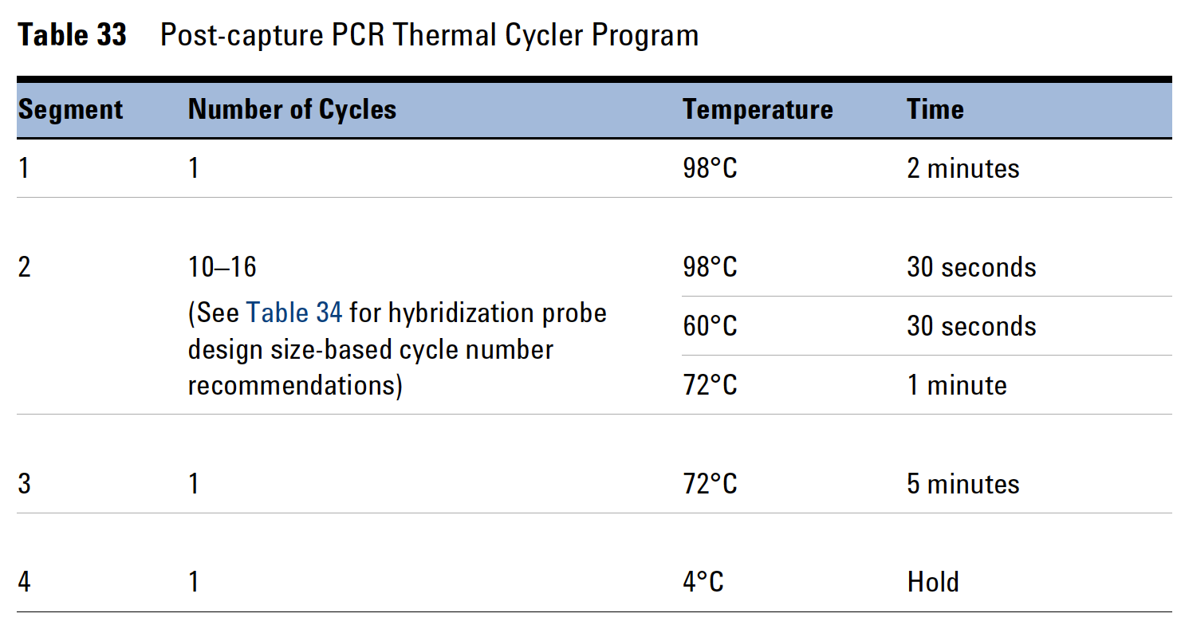
* Thermal cycler reaction volume setting of 50μL.
- Place the strip tubes in the thermal cycler and resume the Post-Capture thermal cycling program. Ensure the thermal cycler is at temperature (98°C). Press Resume or Start to begin PCR. If not at temperature, allow thermal cycler to heat until it reaches 98°C and then add samples.

*Remove the Mag-Bind TotalPure NGS beads from cold storage and equilibrate to room temperature for at least 30 min.
- When PCR amplification is complete, spin the tubes briefly. Remove the streptavidin beads by placing the strip tubes on the magnetic stand at room temperature. Wait for solution to clear (~2 min).
- Transfer each supernatant (~50μL) to wells of fresh strip tubes. The streptavidin beads can be discarded at this time.
Caution: Make sure to retain the supernatant for each sample at this step for further processing.
Note: If a few streptavidin beads remain in the supernatant after transferring to fresh strip tubes, this is ok since the next step will be an SPRI Bead Clean.

STOPPING POINT: The Post-Capture reaction can remain on the thermal cycler overnight on the 4°C hold if needed.

Step 2. Purify the final libraries using SPRI Beads
- Verify that the Mag-Bind TotalPure NGS beads have been sitting at room temperature for at least 30 minutes.

- Prepare 500μL of fresh 80% ethanol per sample for use in step 8.
Note: The freshly prepared 80% ethanol may be used for all purification steps run on
the same day.
- Mix the room temperature MAG-BIND TOTALPURE NGS bead suspension well (vortex at least 10-20 seconds) so that the reagent appears homogenous and consistent in color.
- Add 50μL of the bead suspension to each amplified DNA sample (~50μL) in the strip tube well.
- Mix by pipetting up and down 15-20 times or cap the wells and vortex at high speed for 5-10 seconds then spin briefly to collect the samples, being careful not to pellet the beads.
- Incubate the bead suspensions for 5 minutes at room temperature.
- Put the strip tube into a magnetic separation device. Wait for the solution to clear. (approximately 2-5 min).
- With the samples still on the magnetic stand, carefully remove and discard the cleared solution from each well. Do not touch the beads while removing the solution.
- While keeping the samples on the magnetic stand, dispense 200μL of freshly prepared 80% ethanol to each sample well. Pipette the stream of EtOH directly onto the wall of the well where the beads are clustered.
- Wait ~1 min to allow any disturbed beads to settle, then carefully remove the ethanol.
- Repeat steps 8 and 9 once for a total of two washes.
- Seal the wells with strip caps, then briefly spin the samples to collect the residual ethanol. Return the samples to the magnetic stand for 30 seconds. Remove the residual ethanol with a P20 or P10 pipette.
Note: In the drying step below, do not dry the bead pellet to the point that the pellet
appears cracked. Elution efficiency is significantly decreased when the bead
pellet is excessively dried.
- Dry the samples briefly by leaving the wells unsealed at room temperature for 5 minutes or until the residual ethanol has just evaporated.
- Single Capture: Elute the library DNA by adding 32μL of Low TE buffer to each sample well.
Double Capture: Elute the library DNA by adding 13μL of nuclease-free water to each sample well.
- Mix by pipetting up and down 10–15 times or cap the wells and vortex at high speed for
5 seconds. Verify that all beads have been resuspended, with no visible clumps in the
suspension or bead pellets retained on the sides of the wells. If samples were vortexed, spin
briefly to collect the liquid, being careful not to pellet the beads.
If the bead pellet was over dried and showing cracks, the beads can usually be resuspended with some extra pipetting and/or vortex to mix the nuclease-free water or TE buffer and beads back to a homogenous suspension.
- Incubate the plate or strip tubes for 2 min at room temperature.
- Place samples back on the magnetic stand and let sit until the solution has cleared (up to 5 minutes).
- Remove the cleared supernatant (approximately 32μL if Single Capture and 13μL if Double Capture) to a fresh strip tube and keep on ice or cold block. You can discard the beads at this time.

Note: The post-capture DNA library will be used as input for Hybridization/Capture 2 if performing Double Capture. Hold libraries at 4°C overnight, when performing 2nd day of Double Capture the next day.

STOPPING POINT: Seal the sample wells and store at 4°C overnight, or at -20°C for extended period.
Single Capture - Assess Final library QC before storing samples at -20°C until library pooling.
Double Capture – no need to assess QC at this point. Store samples at 4°C overnight, or at -20°C for an extended period.

Step 3. Assessing quality and quantity of DNA
Use D5000 ScreenTape to assess size distribution of fragments in the sample and concentration of DNA.
Note: The presence of high molecular weight peak, in addition to the expected peak indicates library concatamerization (i.e., PCR bubble formation). This typically arises from the over-amplification of a sample. A reconditioning PCR can be done to get rid of the 2nd larger bp size peak. Refer to Section IV Reconditioning PCR on page 33.

Continuing on to Double Capture:
Hybridize libraries to probes and bead capture a 2nd time. Libraries held at 4°C overnight.

Note: The master mix values listed in the protocol represent a full concentration of probes (baits). If performing half-concentration, modify the amount of probe and nuclease-free H₂O accordingly. Follow VERO Master Mix Calculator spreadsheet.


Step 1. Hybridize libraries to the SureSelect Probe

This step uses the components listed in Table 25. Thaw each component under the conditions indicated in the table. Vortex each reagent to mix, then spin tubes briefly to collect the liquid.

- Remove the Single Capture libraries that have been stored overnight at 4°C. Vortex and spin down.
- Start the Hybridization protocol on the thermal cycler. Cycling conditions are provided in Table 27. Start the program and immediately hit pause.


Use a reaction volume setting of 30μL (final volume of hybridization reaction).
*Hold reaction briefly at 65°C until ready to begin capture steps.

- Add 5μL of SureSelect Blocker mix (blue cap) to each sample well, bringing the total volume to 18μL. Seal the wells then vortex at high speed for 5 seconds. Spin briefly to collect the liquid and release any bubbles.
- Place the samples in the thermal cycler and resume the Hybridization thermal cycling program.

IMPORTANT: THE CYCLER NEEDS TO BE MANUALLY PAUSED DURING SEGMENT 3 TO ALLOW ADDITIONAL REAGENTS TO BE ADDED AS DESCRIBED IN STEP 6.

Note: During segments 1 and 2 of the cycling program (15 minutes total), begin preparing the reagents described in steps 5 and 6. Keep the mixture at room temperature until it is added to the samples, but do not keep it at room temperature for long periods of time (not longer than 15 minutes).

- Prepare the appropriate amount of Capture Hybridization Mix (calculated in the VERO Master Mix Calculator spreadsheet) for the total number of samples, by combining the reagents listed in Table 30. Combine the reagents at room temperature. Mix well by vortexing for 5 seconds then spin down briefly. Proceed immediately to step 6.

*Use tier 3 probes as if design is <3Mb.
Table 30 Preparation of Capture Library Hybridization Mix for Probes <3Mb
Reagent | Volume for 1 Reaction
SureSelect RNase Block | 0.5μL
Probe (design <3Mb) | 2μL
SureSelect Fast Hybridization Buffer | 6μL
Nuclease-free water | 4.5μL
Total | 13μL
If using less than full concentration of probe, then adjust the volume of water accordingly. Example: for ½ concentration AMR baits use 1μL probe and 5.5μL water. (Use VERO master mix spreadsheet to calculate volumes).

- Once the thermal cycler starts segment 3 (65°C for 1 minute), pause the program. With the cycler paused, and while keeping the DNA + blocker samples in the cycler, transfer 13μL of the room temperature Probe Hybridization Mix from step 5 to each sample well.
Mix well by pipetting up and down slowly 8-10 times.
The hybridization reaction wells now contain approximately 30μL.

- Seal the wells with fresh domed caps. Vortex briefly, then spin the plate or tubes to remove any bubbles from the bottom of the wells. Immediately return to the thermal cycler.

- Resume the thermal cycling program to allow hybridization of the prepared DNA samples to the probe.

Note: Start preparing the streptavidin beads one hour after starting hybridization (~30-35 minutes before the thermal cycler ends). For large batches allow an hour.

Step 2. Preparing the streptavidin-coated beads

The remaining capture steps use the components listed in Table 31.



Batch wash Protocol
- Vigorously resuspend the streptavidin beads with a vortex mixer. The magnetic beads settle during storage.
- For each hybridization sample, 50μL of resuspended beads is required. Add the appropriate volume of beads to a 15mL tube (1.5mL tubes or 50mL tubes can be used for smaller or larger batches or if needed to match the available magnetic separation device). (Follow VERO Master Mix Calculator spreadsheet).
- Calculate how much Binding Buffer needs to be added to the 15mL tube (200μL Binding Buffer per 50μL of beads) to wash the beads. 1.5mL tubes and 50mL tubes can also be used. Mix the binding buffer and the suspended beads by vortexing. Spin briefly.
- Place the tubes in a magnetic separator device.
- Wait until the solution clears (~5 minutes), then remove and discard the supernatant.
- Repeat steps 3-5 two more times for a total of 3 washes.
- Resuspend the beads in binding buffer (200μL per sample) and transfer to fresh strip tubes.
ONLY Use DOMED lids and strip caps during Hybridization/Capture. Extra lid space needed to ensure proper mixing during 30-minute vortex step. Reaction will not fit in a standard 96-well plate for this step.

Step 3. Capture the hybridized libraries using the streptavidin-coated beads

(strip tubes – with domed lids)
- After all streptavidin bead preparation steps are complete, and the hybridization thermal cycling program is in the final hold segment, transfer samples to room temperature.
- Immediately transfer the entire volume (~30μL) of each hybridization mixture to wells containing 200μL of washed streptavidin beads using a multichannel pipette.
Pipette up and down 5 to 8 times to mix, then cap the tubes with fresh domed caps.
- Incubate the capture strip tube on a plate mixer, VERO use BioShaker XP Plate Mixer (Bull-dog Bio, Portsmouth, NH). Mix vigorously at 1400-1900rpm for 30 minutes at room temperature. Make sure the samples are properly mixing in the wells. Orbital shaking pattern is important for this step. Beads should not be pelleting at the bottom of wells. Consider pausing the mixing to check for pelleting beads if new to protocol or using a different mixer.
- During the 30-minute incubation for capture, prewarm SureSelect Wash Buffer 2 at 70°C as described below.
- Place 200μL aliquots of Wash Buffer 2 in wells of fresh strip tubes or a 96 well plate. Aliquot 6 wells of buffer for each DNA sample in the run.
- Top off wells with extra Wash Buffer 2 to compensate for expected evaporation. Cap the wells.
Note: Wash Buffer 2 can be aliquoted into strip tubes ahead of time.
- Near the end of the 30-min shaking incubation, start the 70°C hold program on the thermal cycler for the 5-minute incubations in the following steps. Prewarm Wash Buffer 2 aliquots to 70°C.
- Following the 30-minute capture incubation, spin samples briefly to collect the liquid.
- Place the strip tubes in a magnetic separator to collect the beads. Wait until the solution is clear (~1-2 minutes), then remove and discard the supernatant.
- Remove samples from magnetic rack and resuspend the beads in 200μL of SureSelect Wash Buffer 1. Mix by pipetting up and down 15-20 times until the beads are fully resuspended.
- Place the strip tubes on the magnetic rack and wait for the solution to clear (~ 1 min), then remove and discard the supernatant.

Caution: It is important to maintain the bead suspension at 70°C during the upcoming washing procedure below to ensure specificity of capture.
- Make sure that the SureSelect Wash Buffer 2 is pre-warmed to 70°C before use.
- Do not use a tissue incubator, or other devices with significant temperature fluctuations, for the incubation steps.

Note: When processing 96 samples at a time. 2 thermal cyclers are needed. 1 thermal cycler to Prewarm 70°C wash buffer 2 and 1 thermal cycler for 5-minute 70°C incubations. Split the strip tubes between 2 people to perform washes simultaneously and maintain 70°C.

Note: Prepare Post-Capture Master Mix during 5-minute incubations. Post-Capture Master Mix is needed at the end of 70°C washes.

- Remove the strip tubes or plate from the magnetic separator and transfer to a rack at room temperature. Wash the beads with Wash Buffer 2, using the steps below.
- Resuspend the beads in 200μL of 70°C prewarmed Wash Buffer 2. Pipette up and down 15-20 times, until beads are fully resuspended.
- Seal the wells with fresh caps and vortex at high speed for 8 seconds. Spin the plate or strip tube briefly to collect the liquid without pelleting the beads.
Make sure the beads are in suspension before proceeding.
c Incubate the samples at 70°C for 5 minutes on the thermal cycler with the heated lid on. During the 5-minute incubation, make sure the next round of Wash Buffer 2 strip tubes is prewarming in the thermal cycler. Gather reagents to make Post-Capture Mater Mix. Thaw reagents, vortex, spin down and begin to make Post-Capture Master Mix. Keep careful track of what was done to prep for Post-Capture Master Mix during each 5-minute incubation and pick up where you left off at the next incubation until Master Mix is complete. Hold on ice until needed.
- Remove from thermal cycler and place on magnetic separator at room temperature.
- Wait 1 minute for solution to clear, then remove and discard supernatant.
- Repeat steps a-e five more times for a total of 6 washes.
Post-Capture Master Mix (follow VERO Master Mix Calculator Spreadsheet). Thaw reagents and keep on ice.
Note: Rather than resuspending the captured hybridized libraries in 25μL nuclease-free water and then adding the Post-Capture Master Mix, the VERO lab resuspends the captured libraries in Post-Capture Master Mix that includes an extra 25μL nuclease-free water.

Reagent | Volume for 1 Reaction
Nuclease-free water | 38μL
5x Herculase II Buffer w/dNTPs (clear cap) | 10μL
Herculase II Fusion DNA Polymerase (red cap) | 1μL
SureSelect Post-Capture Primer Mix (clear cap) | 1μL
Total | 50μL

- After verifying that all wash buffer has been removed, add 50μL of Post-Capture Master Mix to each sample well. Mix the PCR reactions well by pipetting up and down until the bead suspension is homogenous. Avoid splashing samples onto well walls; do not spin the samples at this step. Try to use a pipette tip to push droplets back down into solution. A very brief spin down is ok. Ensure no pelleting has occurred. If pelleting, re-pipette to mix.

Note: Captured DNA is retained on the streptavidin beads during the post-capture amplification step.

Step 1. Amplify the captured libraries

- Load the Post-Capture PCR program on the thermal cycler (Table 33). Edit the number of cycles if needed. VERO refer to the Project specific Spreadsheet for number of cycles. Start the program and then immediately pause until samples are loaded.
VERO: Low biomass such as Nasal Swabs, Reproductive Swabs, Water Bowl Swabs, Ropes- 14 cycles for 2nd Post-Capture PCR


* Thermal cycler reaction volume setting of 50μL.

- Place the strip tubes in the thermal cycler and resume the Post-Capture thermal cycling program. Ensure the thermal cycler is at temperature (98°C). Press Resume or Start to begin PCR. If not at temperature, allow thermal cycler to heat until it reaches 98°C and then add samples.

*Remove the Mag-Bind TotalPure NGS beads from cold storage and equilibrate to room temperature for at least 30 min.

- When PCR amplification is complete, spin the tubes briefly. Remove the streptavidin beads by placing the strip tubes on the magnetic stand at room temperature. Wait for solution to clear (~2 min).
- Transfer each supernatant (~50μL) to wells of fresh strip tubes. The streptavidin beads can be discarded at this time.
Caution: Make sure to retain the supernatant for each sample at this step for further processing.
Note: If a few streptavidin beads remain in the supernatant after transferring to fresh strip tubes, this is ok since the next step will be an SPRI Bead Clean.

STOPPING POINT: The Post-Capture reaction can remain on the thermal cycler overnight on the 4°C hold if needed.

Step 2. Purify the final libraries using SPRI Beads
- Verify that the Mag-Bind TotalPure NGS beads have been sitting at room temperature for at least 30 minutes.

- Prepare 500μL of fresh 80% ethanol per sample for use in step 8.
Note: The freshly prepared 80% ethanol may be used for all purification steps run on
the same day.
- Mix the room temperature MAG-BIND TOTALPURE NGS bead suspension well (vortex at least 10-20 seconds) so that the reagent appears homogenous and consistent in color.
- Add 50μL of the bead suspension to each amplified DNA sample (~50μL) in the strip tube well.
- Mix by pipetting up and down 15-20 times or cap the wells and vortex at high speed for 5-10 seconds then spin briefly to collect the samples, being careful not to pellet the beads.
- Incubate the bead suspensions for 5 minutes at room temperature.
- Put the strip tube into a magnetic separation device. Wait for the solution to clear. (approximately 2-5 min).
- With the samples still on the magnetic stand, carefully remove and discard the cleared solution from each well. Do not touch the beads while removing the solution.
- While keeping the samples on the magnetic stand, dispense 200μL of freshly prepared 80% ethanol to each sample well. Pipette the stream of EtOH directly onto the wall of the well where the beads are clustered.
- Wait ~1 min to allow any disturbed beads to settle, then carefully remove the ethanol.
- Repeat steps 8 and 9 once for a total of two washes.
- Seal the wells with strip caps, then briefly spin the samples to collect the residual ethanol. Return the samples to the magnetic stand for 30 seconds. Remove the residual ethanol with a P20 or P10 pipette.
Note: In the drying step below, do not dry the bead pellet to the point that the pellet
appears cracked. Elution efficiency is significantly decreased when the bead
pellet is excessively dried.
- Dry the samples briefly by leaving the wells unsealed at room temperature for 5 minutes or until the residual ethanol has just evaporated.
- Double Capture: Elute the library DNA by adding 32μL of Low TE buffer to each sample well.
- Mix by pipetting up and down 10–15 times or cap the wells and vortex at high speed for
5 seconds. Verify that all beads have been resuspended, with no visible clumps in the
suspension or bead pellets retained on the sides of the wells. If samples were vortexed, spin
briefly to collect the liquid, being careful not to pellet the beads.
If the bead pellet was over dried and showing cracks, the beads can usually be resuspended with some extra pipetting and/or vortex to mix the nuclease-free water or TE buffer and beads back to a homogenous suspension.
- Incubate the plate or strip tubes for 2 min at room temperature.
- Place samples back on the magnetic stand and let sit until the solution has cleared (up to 5 minutes).
- Remove the cleared supernatant (approximately 32μL) to a fresh strip tube and keep on ice or cold block. You can discard the beads at this time.

STOPPING POINT: Seal the sample wells and store at 4°C overnight, or at -20°C for extended period.
Assess Final library QC before storing samples at -20°C until library pooling.

Step 3. Assessing quality and quantity of DNA
Use D5000 ScreenTape to assess size distribution of fragments in the sample and concentration of DNA.
Note: The presence of high molecular weight peak, in addition to the expected peak indicates library concatamerization (i.e., PCR bubble formation). This typically arises from the over-amplification of a sample. A reconditioning PCR can be done to get rid of the 2nd larger bp size peak. Refer to Section IV Reconditioning PCR on page 33.

STOPPING POINT: Store final libraries at -20°C until Pooling.

Reconditioning PCR
If samples have a 2nd peak of higher molecular weight in addition to the library peak of interest, run Post-Capture PCR again on 1μL final library with 1 cycle.
- Note: Because of overamplification, primers become exhausted and PCR products anneal to each other forming ‘PCR bubbles’. PCR bubbles cannot be removed by SPRI beads or Blue Pippin.
- Consider optimizing the Library Prep protocol for a lower # of PCR cycles to avoid PCR bubble formation.

SPRI Bead Clean is needed after the Reconditioning PCR
- Verify that the Mag-Bind TotalPure NGS beads have been sitting at room temperature for at least 30 minutes.

Reconditioning Master Mix Table (Post-Capture Master Mix) – VERO follow VERO Master Mix Calculator Spreadsheet. Thaw reagents and keep on ice.
Reagent | Volume for 1 Reaction
Nuclease-free water | 37μL
5x Herculase II Buffer w/dNTPs (clear cap) | 10μL
Herculase II Fusion DNA Polymerase (red cap) | 1μL
SureSelect Post-Capture Primer Mix (clear cap) | 1μL
Total | 49μL

- Prepare the appropriate amount of Reconditioning Master Mix (calculated in the VERO Master Mix Calculator spreadsheet) for the total number of samples needing Reconditioning, by combining the reagents listed in the Reconditioning Master Mix Table. Mix well by vortexing for 5 seconds then spin down briefly.
- Add 49μL of Post-Capture Master Mix to a fresh PCR well.
- Add 1μL of the Final Library that needs Reconditioning to each sample well containing 49μL Post-Capture Master Mix. Mix the PCR reactions well by pipetting up and down, vortex well and spin down.
- Load the Reconditioning PCR program on the thermal cycler (Table 33). Start the program and then immediately pause until samples are loaded.
Segment | Cycle # | Temperature | Time
1 | 1 | 98°C | 2 min
2 | 1 | 98°C | 30 sec
 |  | 60°C | 30 sec
 |  | 72°C | 1 min
3 | 1 | 72°C | 5 min
4 | 1 | 4°C | Hold
* Thermal cycler reaction volume setting of 50μL.
- Place the plate or strip tube in the thermal cycler and resume the reconditioning thermal cycling program. Ensure the thermal cycler is at temperature (98°C). Press Resume or Start to begin PCR.
If not at temperature, allow thermal cycler to heat until it reaches 98°C and then add samples.
- When PCR amplification is complete, spin the tubes briefly.
Purify the reconditioned libraries using SPRI Beads
- Verify that the Mag-Bind TotalPure NGS beads have been sitting at room temperature for at least 30 minutes.

- Prepare 500μL of fresh 80% ethanol per sample for use in step 8.
Note: The freshly prepared 80% ethanol may be used for all purification steps run on
the same day.
- Mix the room temperature MAG-BIND TOTALPURE NGS bead suspension well (vortex at least 10-20 seconds) so that the reagent appears homogenous and consistent in color.
- Add 50μL of the bead suspension to each amplified DNA sample (~50μL) in the strip tube well.
- Mix by pipetting up and down 15-20 times or cap the wells and vortex at high speed for 5-10 seconds then spin briefly to collect the samples, being careful not to pellet the beads.
- Incubate the bead suspensions for 5 minutes at room temperature.
- Put the strip tube into a magnetic separation device. Wait for the solution to clear. (approximately 2-5 min).
- With the samples still on the magnetic stand, carefully remove and discard the cleared solution from each well. Do not touch the beads while removing the solution.
- While keeping the samples on the magnetic stand, dispense 200μL of freshly prepared 80% ethanol to each sample well. Pipette the stream of EtOH directly onto the wall of the well where the beads are clustered.
- Wait ~1 min to allow any disturbed beads to settle, then carefully remove the ethanol.
- Repeat steps 8 and 9 once for a total of two washes.
- Seal the wells with strip caps, then briefly spin the samples to collect the residual ethanol. Return the samples to the magnetic stand for 30 seconds. Remove the residual ethanol with a P20 or P10 pipette.
Note: In the drying step below, do not dry the bead pellet to the point that the pellet
appears cracked. Elution efficiency is significantly decreased when the bead
pellet is excessively dried.
- Dry the samples briefly by leaving the wells unsealed at room temperature for 5 minutes or until the residual ethanol has just evaporated.
- Elute the library DNA by adding 32μL of Low TE buffer to each sample well.
- Mix by pipetting up and down 10–15 times or cap the wells and vortex at high speed for
5 seconds. Verify that all beads have been resuspended, with no visible clumps in the
suspension or bead pellets retained on the sides of the wells. If samples were vortexed, spin
briefly to collect the liquid, being careful not to pellet the beads.
If the bead pellet was over dried and showing cracks, the beads can usually be resuspended with some extra pipetting and/or vortex to mix the nuclease-free water or TE buffer and beads back to a homogenous suspension.
- Incubate the plate or strip tubes for 2 min at room temperature.
- Place samples back on the magnetic stand and let sit until the solution has cleared (up to 5 minutes).
- Remove the cleared supernatant (approximately 32μL) to a fresh strip tube and keep on ice or cold block. You can discard the beads at this time.

Assessing quality and quantity of DNA
Use a D5000 ScreenTape to assess size distribution of fragments in the sample and concentration of DNA.

