1. git clone <https://AzureRTOS-Partners@dev.azure.com/AzureRTOS-Partners/External-Microchip-MSFT/_git/External-Microchip-MSFT>

git checkout wen/wfi32iot-adu.

1. Open application and bootloader projects with MPLAB 6.0 compile 4.0.

config the AP credential in app.c. IOT hub credential in sample_config.c, and installed version to 3.0.0 in sample_azure_iot_embeded_sdk_adu.c

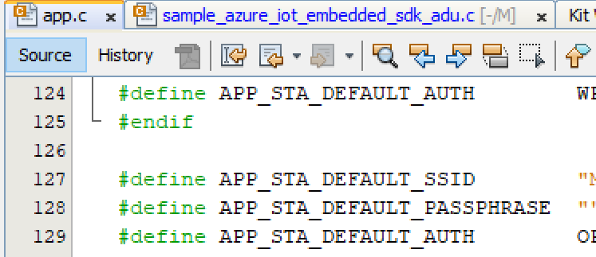

1. Build the application project and move the binary file to tools directory, I rename the binary file to 3.0.0 just for convenience. Then run the CreateSAME54Update.ps1. the generated files are used to upload to ADU service.

1. Add the bootloader hex as the loadable file and revert the installed criteria version to 1.0.0. Then build and download to the board.

1. After running, we should disable the mass storage device to avoid competition of flash operation between PC and ADU.

Then start the deployment from ADU service. Then we can monitor the result from the serial port.

