RS232 Interface for IDE harddisks

Interface Description

Version: 0.3.0
Date: May 4th, 2002
Written by: Stefan Heesch, heesch@cybervillage.de

Copyright (C) 2000-2002 Stefan Heesch (heesch@cybervillage.de)

This software/hardware is free software/hardware; you can redistribute it and/or
modify it under the terms of the GNU Lesser General Public License as published by the Free Software Foundation; either version 2.1 of the License, or (at your option) any later version.

This library is distributed in the hope that it will be useful, but WITHOUT ANY WARRANTY; without even the implied warranty of MERCHANTABILITY or FITNESS FOR A PARTICULAR PURPOSE. See the GNU Lesser General Public License for more details.

You should have received a copy of the GNU Lesser General Public
License along with this library; if not, write to the Free Software
Foundation, Inc., 59 Temple Place, Suite 330, Boston, MA 02111-1307 USA

Table of Contents

Overview 4
Hardware description of the RS232 - IDE interface 4
Schematics: 6
Table: Connection of the IDE-hard disk(s) to AVR 90S8515 7
Data transmission protocol 7
State diagram for data transmission 8
Commands 8
Data set descriptions 9
Get software version 9
Command 9
Response 9
Initialize Hardware 9
Command 9
Response 9
Write register 10
Command 10
Response 10
Read register 11
Command 11
Response 11
Write Sector 12
Command 12
Response 12
Read Sector 12
Command 12
Response 12
Get Status 13
Command 13
Response 13
Get Error Status 14
Command 14
Response 14
Drive Diagnostics 15
Command 15
Response 15
Get Configuration Sector 16
Command 16
Response 16
Sleep Mode 16
Command 16
Response 16
Normal Operating Mode 17
Command 17
Response 17

Overview

The RS232 to IDE interface can be used to connect IDE hard disks to micro controllers:

Micro controller with serial port

Seriell / IDE Interface
serial data transmission
IDE harddisk

The micro controller is physically connected to the IDE hard disk over a serial line. For data transmission a software protocol is used.

Hardware description of the RS232 - IDE interface

On the interface side a micro controller converts the serial data into control signal for the IDE hard disk.

A micro controller consists of the central processing unit (CPU), several IO-ports, memory (RAM) and program memory(FLASH, (E)EPROM or ROM). For the RS232 interface a suitable micro controller was selected, so that the number of integrated circuits could be limited to two ICs:

A driver IC MAX 232 converts the RS232 signals at connector X1 in TTL signals. A charge pump creates +/- 10 Volts out of the 5Volts supply voltage.

As micro controller the AVR 90S8515 from ATMEL is used. This RISC-Controller holds 512 Byte RAM and 8Kbyte program memory (FLASH). A quartz generates the processor clock of 8 MHz. The capacitors C1 and C2 let the oscillator start properly.

The FLASH memory can be programmed over a serial port. The programming cable must be connected to X2. During the programming the transistor Q2 set the Reset-line to low. The reset switch can be used to reset the AVR 90S8515 manually.

Connector X3 can be used to connect one or two hard disks to the micro controller. The onboard IDE-controller of the hard disk(s) is directly connected to the micro controller’s ports. One LED monitors the access to the hard disk.

Schematics:
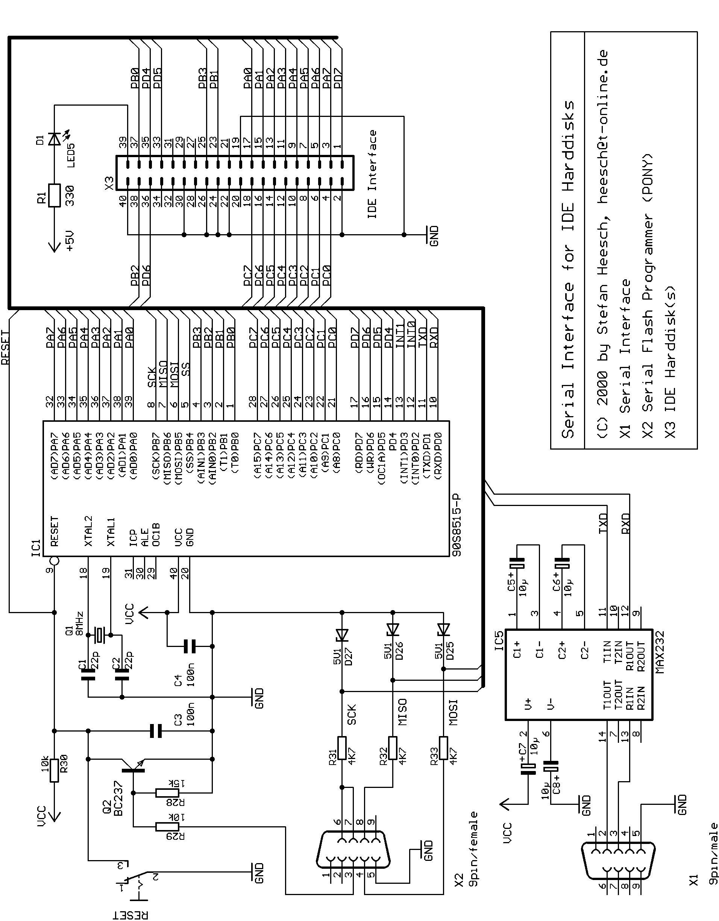

Table: Connection of the IDE-hard disk(s) to AVR 90S8515

IDE-Controller | ATMEL AVR 8515 | Meaning
DD0 .. DD7 | Port A0 .. A7 | IDE Data bus Bit 0..7
DD8.. DD15 | Port C0 .. C7 | IDE Data bus Bit 8 ..15
/DIOW | Port B1 | IDE Write (active low)
/DIOR | Port B3 | IDE Read (active low)
/CS0 | Port B2 | IDE chip select 0
/CS1 | Port B4 | IDE chip select 1
DA0 | Port D4 | IDE Address bus Bit 0
DA1 | Port D5 | IDE Address bus Bit 1
DA2 | Port D6 | IDE Address bus Bit 2
/RESET | Port D7 | IDE Reset (active low)

As power supply a voltage of constant 5 Volts has to be used. If you connect 2.5 inch hard disks to the interface, the hard disks can be supplied from the same power supply. For 3.5 inch hard disks an additional 12 Volts power supply may be needed.

Data transmission protocol

Data frames are used for transmitting data. These frames have to conform to the „Serial Line Internet Protocols (SLIP)”. This protocol is described in the Internet Standard RFC 1055, June 1988:

END
END
Data Frame
Serial data stream Datenstrom

Begin and end of a data frame is marked with the END character (decimal 192). Two End characters are ‘framing’ the actual data.

In case that an END characters occurs itself in the data it has to be escaped by sending the characters ESC (decimal 219) and ESC_END ( decimal 220). An ESC character is escaped by the sequence of an ESC character and an ESC_ESC character (decimal 221).

State diagram for data transmission

The master-slave principle is used for the data transmission: The interface is waiting for a request over the interface’s serial port. A received data frame is decoded and executed. The response is send back over the interface’s serial port:

Response
Query
Wait for command
Execute command
Send response zurück
Slave: Interface RS232 - IDE
Send Query
Wait for response
Master: Micro controller

In case that the interface receives a faulty or unknown command it answers by sending a NAK.

Commands
Code | Command | Description
V | Get software version | Query the Software Version
I | Initialize hardware | Initialize the Interface and hard disks
W | Write register | Write a single register
R | Read register | Read a single register
W | Write sector | Write a sector on the hard disk
R | Read sector | Read a sector from the hard disk
S | Get status | Read the IDE state register
E | Get error status | Read the IDE error register
D | Drive Diagnostics | Execute drive diagnostics
C | Get configuration sector | Load the hard disk’s configuration sector
Z | Sleep mode | Activate sleep mode
N | Normal operating mode | Activate normal operating mode

Data set descriptions

Get software version
Query the software version of the RS232-Interface for IDE hard disks.

Command
Byte No. | Contents | Meaning
0 | 'V' | Command: 'Get software version'

Response
Byte No. | Contents | Meaning
0 | Error code | '0' OK  '1' Error
1 .. n | String[n] | Software version

Initialize Hardware
Initialize RS232-Interface and connected IDE hard disks.

Command
Byte No. | Contents | Meaning
0 | 'I' | Command: 'Initialize Hardware'

Response
Byte No. | Contents | Meaning
0 | Error code | '0' OK  '1' Error

Write register
Write a single IDE register. For writing a data register 16 bits are used, writing all other register is done with 8 bits.

Command
Byte No. | Contents | Meaning
0 | 'w' | Command: 'Write register'
1 | '0' .. 'B' | Select register (hex 0 .. B):  0 Data register (16 bit)  1 Error register  2 Feature register  3 Sector register  4 Sector number register  5 Cylinder register (low)  6 Cylinder register (high)  7 Drive/head register  8 Status register  9 Command register  A Alt. Status register  B Address register (ATA-1)
2 – 5 | '0000' .. 'FFFF' | Parameter value

Response
Byte No. | Contents | Meaning
0 | Error code | '0' OK  '1' Error

Read register
Read a single IDE register. Reading a data register returns 16 bits, for reading all other only the lower 8 bits a relevant, the higher 8 bits are set to zero.

Command
Byte No. | Contents | Meaning
0 | 'r' | Command: 'Read register'
1 | '0' .. 'B' | Register (hex 0 .. B):  0 Data register (16 bit)  1 Error register  2 Feature register  3 Sector register  4 Sector number register  5 Cylinder register (low)  6 Cylinder register (high)  7 Drive/head register  8 Status register  9 Command register  A Alt. Status register  B Address register (ATA-1)

Response
Byte No. | Contents | Meaning
0 | Error code | '0' Error  '1' OK
1 .. 4 | '0000' .. 'FFFF' | Register value, in case of an error always '0000'

Write Sector
Write a single sector to the IDE hard disk.

Command
Byte No. | Contents | Meaning
0 | 'W' | Command: 'Write sector'
1 | '0' or '1' | Select hard disk
2 | '0' .. 'F' | Select head
3 .. 4 | '00' .. 'FF' | Select sector number
5 .. 8 | '0000' .. 'FFFF' | Select cylinder number
9 .. 520 | 512 x  0x00 .. 0xFF | 512 data bytes

Response
Byte No. | Contents | Meaning
0 | Error code | '0' Error  '1' OK

Read Sector
Read a single sector of the IDE hard disk.

Command
Byte No. | Contents | Meaning
0 | 'R' | Command: 'Read sector'
1 | '0' or '1' | Select hard disk
2 | '0' .. 'F' | Select head
3 .. 4 | '00' .. 'FF' | Select sector number
5 .. 8 | '0000' .. 'FFFF' | Select cylinder number

Response
Byte No. | Contents | Meaning
0 | Error code | '0' Error  '1' OK
1 .. 512 | 512 x  0x00 .. 0xFF | 512 data bytes

Get Status
Read the IDE controller’s state register.

Command
Byte No. | Contents | Meaning
0 | 'S' | Command: 'Get Status'

Response
Byte No. | Contents | Meaning
0 | Error code | '0' OK  '1' Error
1 | State | Contents of the IDE state register, meaning according to the ATA standard:  Bit 7 Busy  Bit 6 Drive ready  Bit 5 Drive fault  Bit 4 Drive seek complete  Bit 3 Data request  Bit 2 Corrected data  Bit 1 Index  Bit 0 Error

Get Error Status
Read the IDE controller’s error register.

Command
Byte No. | Contents | Meaning
0 | 'E' | Command: 'Get Error Status'

Response
Byte No. | Contents | Meaning
0 | Error code | '0' OK  '1' Error
1 | Error state | Contents of the IDE error register, meaning according to the ATA standard:  Bit 7 Bad block detected (ATA1)  Bit 6 Uncorrectable data error  Bit 5 Media change  Bit 4 ID not found  Bit 3 Media change request  Bit 2 Aborted command  Bit 1 Track 0 not found  Bit 0 Address mark not found

Drive Diagnostics
Execute drive diagnostics.

Command
Byte No. | Contents | Meaning
0 | 'D' | Command: 'Drive Diagnostics'

Response
Byte No. | Contents | Meaning
0 | Error code | '0' OK  '1' Error
1 | Result | 0x01 Drive 0 OK, Drive 1 OK or not connected  0x81 Drive 0 OK, Drive 1 defective  otherwise:  < 0x80 Drive 0 defective, Drive 1 OK or not connected  > 0x82 Drive 0 defective, Drive 1 defective

Get Configuration Sector
Read the IDE configuration sector. This pseudo sector consists of 512 bytes, described in the ATA standard.

Command
Byte No. | Contents | Meaning
0 | 'C' | Command: 'Get Configuration Sector'
1 | '0' or '1' | Select drive

Response
Byte No. | Contents | Meaning
0 | Error code | '0' OK  '1' ERROR
1 .. 512 | Configuration data | IDE configuration sector

Sleep Mode
Activate drive’s sleep mode, switch of the drive’s motor.

Command
Byte No. | Contents | Meaning
0 | 'Z' | Command: 'Sleep mode'
1 | '0' or '1' | Select drive

Response
Byte No. | Contents | Meaning
0 | Error code | '0' OK  '1' Error

Normal Operating Mode
Activate drive’s normal operating mode. Switch off an eventually activated sleep mode, switch on the drive’s motor.

Command
Byte No. | Contents | Meaning
0 | 'N' | Command: 'Normal operating mode'
1 | '0' or '1' | Select drive

Response
Byte No. | Contents | Meaning
0 | Error code | '0' OK  '1' Error

