Digital Motor Driver
The motor driver consists on a microcontroller that is connected to an LCD (liquid crystal display), the motor, a photodiode, and to the computer by the serial port. The LCD is used to display the speed of the actual speed of the motor and the desired speed. The motor is driven by the microcontroller by PWM (pulse width modulation) and a MOSFET. The photodiode is installed in a way that makes a pulse proportional to the speed of the motor. And finally the serial port of the computer is connected to the microcontroller passing by an interface circuit and into the microcontroller’s UART. That is, it consists on two outputs; the LCD and the PWM for the motor control, and two inputs; the frequency coming from the photodiode and the communication with the computer.

The LCD
The LCD (liquid crystal display) is connected to the microcontroller by a 4-bit bus plus 3 control lines. The LCD is connected to Port B, which is an 8-bit port in which all the lines are connected to the LCD except bit 3. The LCD is alphanumerical and has 2 lines of 16 characters each that are used to display the current speed of the motor and the desired speed.

The Motor
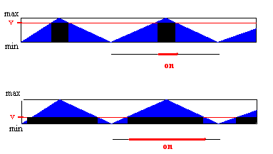The motor is connected to a MOSFET and the MOSFET to the microcontroller because the digital signal of the microcontroller cannot source current to drive the motor. That is, the MOSFET serves as a switch, which is opened or closed (off or on) depending on the state of the microcontroller’s pin. If the microcontroller’s pin is low, that is 0 volts, the switch is off, if the pin is in logic level high, 5 volts, the switch is open. The pin used to control the motor is bit 3 of Port B, the only bit of Port B that is not used by the LCD. This is also the only line of the microcontroller that can be used for PWM. Since the microcontroller is digital, it can only turn the MOSFET driving the motor on and off. Here is where pulse width modulation (PWM) comes in. What it does is that it turns the on and off, at a certain frequency, but one is able to adjust the percentage of the time it is on or off by changing the value of v, without changing the frequency. See the figure below.

The Photodiode
The method used to input the velocity of the motor’s shaft into the microcontroller is by means of a pulse that varies proportionally to the velocity of the shaft generated by a photodiode. The system consists of a LED (light emitting diode) and a photodiode, each on different side of a rotating shaft with eight wholes in it. The bit 3 of Port D is connected to the photodiode and it is set to logic high (5 volts) and the other lead of the photodiode is connected to ground. When the shaft rotates to a position where the light of the LED is allowed to pass through a hole and hit the photodiode, the resistance across the photodiode becomes zero pulling the microcontroller’s pin to logic 0 or ground. As the shaft rotates a bit more, the light of the LED is covered again and the microcontroller’s pin goes to its normal state (5 volts). Therefore, when the shaft is in continuous rotation, there is a pulse being generated that is linearly proportional to the shaft’s speed. The microcontroller reads this pulse and adjusts the motor to the desired speed. See the figure below.

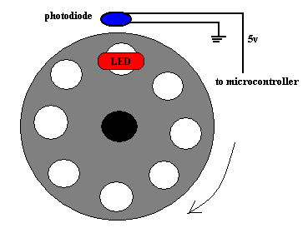

Overview
Now that I have described how each individual component of the system works, I will the overall function and how all the electronics comes together. First the circuit into which the microcontroller was embedded and the techniques used to wire all the components will be described. Then the software, that is the code that was downloaded into the microcontroller will be analyzed. Finally a description of what is happening when the system is running will be made, including the automatic control.

All the components where wired by soldering, but the main components needed for the microcontroller to work, where attached into a DT104 SimmStick®, that is connected to the main circuit by a 30 pin bus. The use of the SimmStick® facilitated much of the programming by being able to easily remove the microcontroller from the circuit and reprogram it. The SimmStick® contains the microcontroller, the oscillator, the RS-232 serial interface (to interface with the computer), and a reset capacitor; it outputs all the microcontroller ports into the bus and is also supplied power by the bus connected to the main circuit.
SimmStick®

Below is the illustration of the distribution of the pins in each port. Port B is used as the LCD driver, except for pin 3 which is the pin used for the PWM. The LCD is driven by a 4-bit bus (B4-B7) and 3 control lines (B0-B2). The only bit used in Port D is bit3, which is used to read the frequency coming from the photodiode to determine the shaft’s speed.

