CUBOID
By Michael Clift
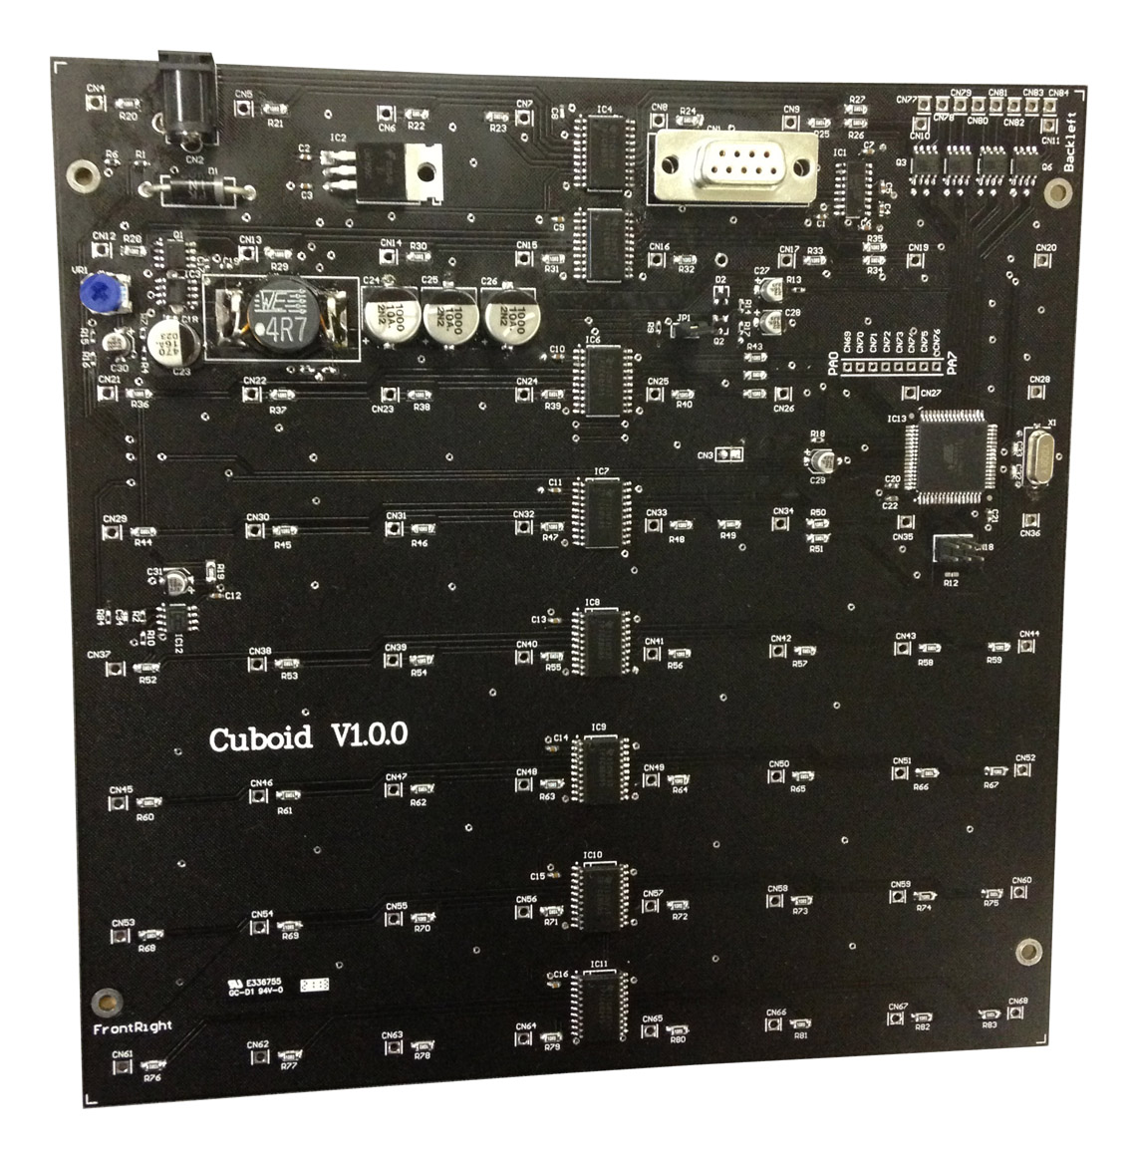

Description:
Cuboid, is a controller for 8x8x8 single color LED cubes. It uses the an Atmega64 microcontroller, which is popular among hobbyists. It comes with schematics, and full featured open source firmware. It is intended for capable hobbyists who are planning to build a cube, and need hardware to drive it. The development tools used (WinAVR) are free, and the device comes pre-programmed with a boot loader, so no special hardware is required for re-programming the device.
FEATURES

Switch mode PSU:
Driving 64 LEDs at a time requires a high current, low voltage supply. Many existing cube controllers must be powered by 5V power packs rated at 3A or more. Cuboid can run very efficiently from a regular 12V supply (or battery) rated at 1A. This makes your cube cheap enough to run 24/7.

MCU control of LED voltage:
The Atmega64 is able to control the output voltage of the Cuboid LED supply. This allows the firmware to implement push button control of LED brightness. The maximum LED voltage is set by potentiometer in hardware, so a firmware malfunction can’t destroy your LEDs.
The Atmega64 is also able to measure the peak LED current, and LED forward voltage drop. This information is provided via a serial terminal, which assists with power supply configuration.

High current LED outputs:
The Cuboid uses TPIC6B595 shift registers. These have an open drain output capable of sinking 150mA. Normally the safe operating current for a LED is around 20-30mA, however as the cube LEDs are multiplexed 1/8, they can safely be driven with 40-50mA.

Hardware watchdog:
If the processor stops running due to a crystal failure or some other fault, your cube may be left with 1 plane of LEDs on continuously. If you are driving your LEDs with more current than they can handle continuously, this would burn them out. In this situation, the hardware watchdog will disable the LED outputs to prevent this from happening. This feature can be disabled with a jumper setting.

Ambient light measurement:
The Atmega64 is able to measure the ambient light level. This can be used to control pattern sequences and LED brightness. This means your cube can automatically display bright active sequences during the day, and dim soft patterns when you are sleeping or watching a movie.

Physical convenience:
The PCB itself is able to form the base of an 8x8x8 cube. The LED outputs have 1.5mm plated holes spaced apart on a 1” grid. No messy ribbon cables or connectors are required to wire your LEDs up to an external controller.

Serial RS232 console:
A simple menu is available using a serial port terminal program. This can be used to upload a new firmware hex file via the boot loader, configure light level thresholds for day/night operation, measure supply voltages and adjust LED voltage.

LED configuration:
Cuboid drives 8 horizontal planes of 64 LEDs each. Each horizontal plane should be the Anode connection (switched+), each vertical column should be the cathode connection (switched-).

