The XY Pen Plotter to HPGL translation
Version 0.10 4 feb 2007
By Emile van der Laan
www.emsign.nl

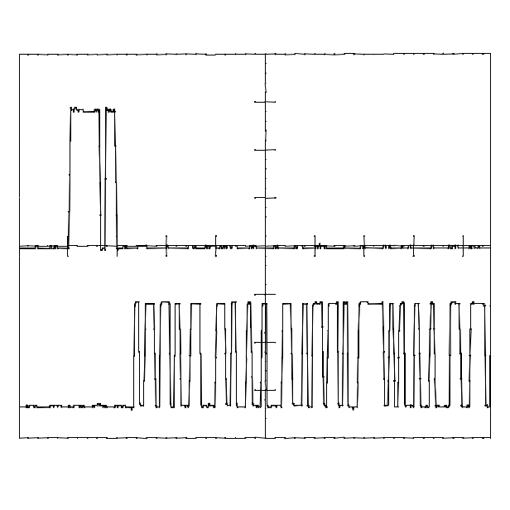

Introduction 1
Capture file 1
Software Design 2
RS232 interface 2
Plotter commands 2
Hardware Design 2

Introduction
I have made this project for the Philips PM3355 scoop as it only has a XY output,
And the version that I have does not a printer output.
But it has a simple XY Plotter output.
It will convert a XY Input and Pen Up/Down to a HPGL file.
This file you can include in a Word document, this is not standard any more. But if you install the KB196506 then you still can do it on 32 Bits Windows versions.
I have chosen this format as it is one of the vector formats that have not so much overhead on initialization.
As the AVR Tiny13 only has 1 KB of flash Rom and then every byte counts.

Capture file
The Baud Rate is about 9600 baud.
Set up the terminal program in that way that it will capture all the communication.
Send a character this will send the HPGL initialization commands back to you
Then start the XY plot function.
When the Plot function is ready send a character this will stop the sending of new coordinates.
And close the capture file.

Insert in word
After you have the capture file you can insert the picture From file in word.
Then a pop up box will appear en then you will need to select the HP Graphics Language.

Software Design
The software will send the internalization commands they are simple HPGL commands.
The Sample rate will need to be set in software.

RS232 interface
The Baud Rate is 9600 baud, but you can have it faster if you want you will need to change in the PcRs232.S file.
I have used a software Uart, This is both because then I do not need a RS232 level converter, And that the Avr Tiny does not have a Uart.
The Receive code is in the PcRs232.S file but is not used.
The “Problem” is that depending on the internal RC oscillator this can be a bit off.
Then you will need to change the divider that is in the PCRs232.S file.
And this is also why having this in a production unit is not really recommended.

Plotter commands
Some explanation you can find at the HPGL Wiki location.

IN; Initialize, start a plotting job
IP; Set the initial point (origin), in this case the default 0,0
DI;
SP1; Select pen 1
SC0,1024,0, 1024; Set the scale so the page is 1024,1024 in both X and Y directions
PU0,0; Lift the pen and move to 0,0
PD931,0; Put down the pen and move to the following locations draw a box
PD931,931;
PD0,931;
PD0,0;

Hardware Design
The X and Y inputs will have a sensibility from 0 Volt to 1 Volt
The Pen Up/Down has a Pullup resistor so that it can handle an opencollector Output form the Scoop.
I have added a 1K resistor in the X and Y line, This is just to protect my Tiny.
The schematic:
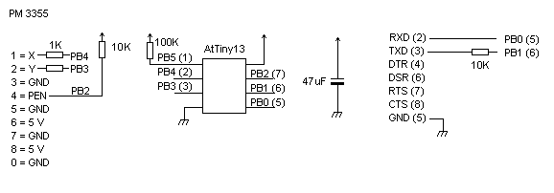

Programming the Tiny 13
I have included a batch file to program the Tiny 13 avrdudeprog.cmd.
And the communicationpoort9600.ht as this will start hyperterminal.

Have fun ☺!

