Tiny13 Design Idea

Hi Freaks.. “ Ohm sweet Ohm “

Take a look at the following Classic Lie Detector Circuit. Elegant and simple, isn’t it ?

Now cast your eyes at the Tiny13 Circuit below. Just as simple but even more elegant.
And, of course, we’ve included a serial RS232 10-Bit digital value output for good measure.

I won’t bore you with the technical details, especially if you’ve been following the Tiny13 Design Idea series so far, as the circuit and code itself are rather self explanatory. I simply suggest that you suck it and see !

Galvanic Skin Response Sensor.
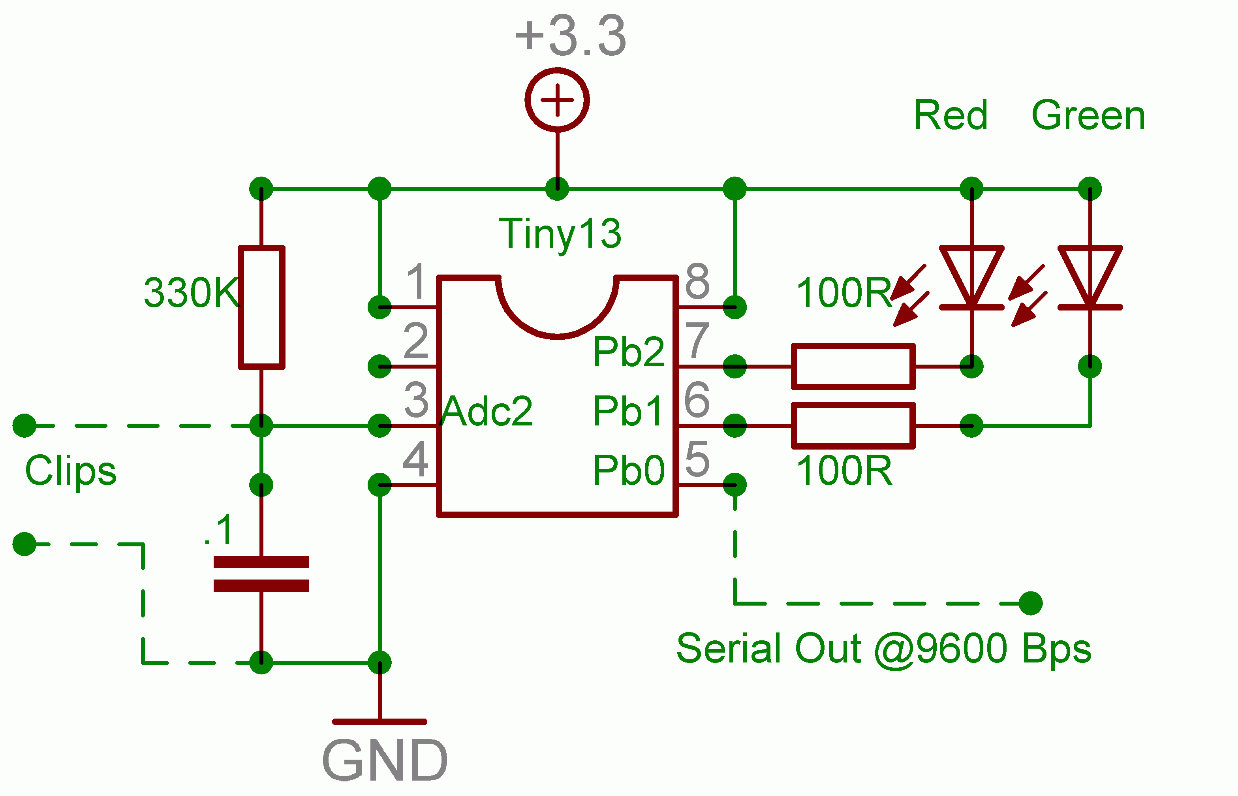

The necessary Clips can be made like this Sensor

May the resistance be always with you..

John-Alfred Ullasmann

Government Health Warning
Under NO circumstance is this educational device to be used when connected and powered by any other power source apart from Batteries and Rechargable cells.

