Introduction 1
Hardware 1
Software 1

Introduction
This project is made to control 3 or more servos from a RS232 device what can be a PC.

Hardware
The hardware is made from an AVR tiny13 this can control 3 servos and you van link up more Tiny’s to control more servos. This can be done on one RS232 line this is because the devices can be connected parallel so they all receive the same information.
The following schematic is for a single device.
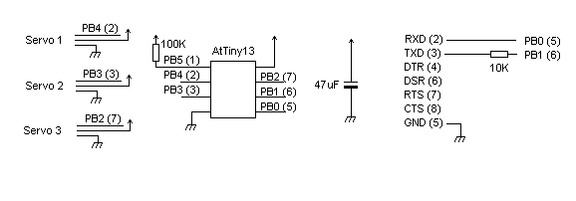
And this is for the Multiple devices

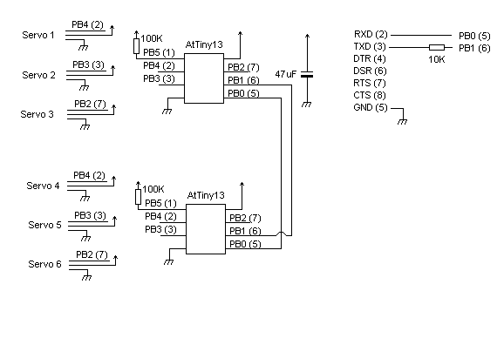
You can connect more devices but is only limited by the commands that I have implemented.

Software
The software is based on a timer that will be used every 13.2 us or 125 clock cycles.
This will receive and transmit of the RS232 and will also control the servos.

At startup of the Controllers you will receive a message from each of the controllers connected.
In this case from the two devices.
Servo 00
Servo 01

Controlling the servos
By sending a Capital letter ‘A’ wil increase the servo 1 and an ‘a’ will decrees the servo 1
This is a ‘B’ and ‘b’ for servo 2 and ‘C’ and ‘c’ for servo 3.
The ‘D’ or ‘d’ will return the current setting of the servos,
In the following format
<Device ID>,<Servo1>, <Servo2>,<Servo3><CRNL>

Controlling more servos
For the devices 0x01 and more this is a bit different Servo4 you will set by sending a letter ‘E’ or ‘e’
And Servo 5 by ‘F’ or ‘f’, And 6 by ‘G’ or ‘g’.
Getting the servo status information you will need to send a ‘H’ or ‘h’

In short this is ‘A’+(Device ID * 4) to control the servos.

Rs232
The software RS232 will use the data direction register to send the data to the PC.
So when the device will not send any thing the PC receive line is floating.
The PC will try to hold the line low ( as the RS232 line is inverted )

What is wrong
The base frequency is from the internal oscillator and this has a large fluctuation.
To compensate this it can be necessary that you fine tune it by the OSCCAL register.
What you need to do is test the Pin 7 and see if this is 50 Hz if this is to lower then 49 Hz or higher then 51 Hz you will need to tune the Tiny13.
This is also the reason why this is not suitable for a production.

